The European Disability Card – State of play 2018

European Disability Card: State of play 2018
  - EDF | December 2018
35 square de Meeûs tel +32 2 282 46 00 info@edf-feph.og
1000 Brussels - Belgium fax +32 2 282 46 09 www.edf-feph.org

...................................................................................................................
The European Disability Forum is an independent NGO that represents the interests of 80 million Europeans with disabilities. EDF is a unique platform which brings together representative organisations of persons with disabilities from across Europe. EDF is run by persons with disabilities and their families. We are a strong, united voice of persons with disabilities in Europe.

Contents
The European Disability Card – State of play 2018 1
Status in the different participating Member States 5
Belgium 5
Cyprus 7
Estonia 8
Finland 9
Italy 10
Malta 11
Romania 12
Slovenia 12
Reported benefits of the Card 13
Reported challenges 13
Looking ahead: Next steps and EDF recommendations 13
Related documents and links 14
Acknowledgments 15
Contact person at the EDF secretariat: 15

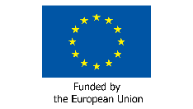
This publication has received financial support from the European Union. The information contained in this publication does not necessarily reflect the official position of the European Commission.

Background

EDF started first campaigning for the introduction of a European Disability Card (then known as “European Mobility Card”) in 2011 as part of the Freedom of Movement campaign, publishing the first position paper on this topic. The campaign was accompanied by a thorough Analysis Report in 2012, comparing the existing types of Disability Cards in different EU Member States as well as possible solutions for the introduction of such a Card on EU level. EDF followed up on the initial paper with an update report in 2014.

The core demand of EDF’s campaign was to establish a Card which is recognized throughout the EU and gives its holders the same disability related rights and discounts as a national of the Member States that the person is visiting. Similar to the already long established European Parking Card, the Disability Card was aimed at bridging the gap for persons who were only temporarily staying in another Member States such as tourists, students studying abroad, or interns, that would not be able to benefit from the advantages that national with disabilities have due to the difference in rules and lack of recognition of their disability status.

In mid-2014 the European Commission established a Project Working Group (PWG) of Member States who were potentially interested in introducing such a Card and had regular meetings throughout 2014 and 2015. The participating Member States were initially Belgium, Bulgaria, Cyprus, Estonia, Finland, France, Germany, Greece, Hungary, Italy, Malta, Portugal, Slovakia, Slovenia and Spain. Poland and Romania joined at a later stage, too. The task of the PWG was to compare the current situation in the Member States and try to reach an agreement on the format of a potential Card and who would be the beneficiaries.

As a result of the discussions in the PWG, it was finally decided that Member States would retain almost all of the decision power and the only common feature would be the format of the Card as well as the principle that all other participating Member States would mutually recognize the Card holders based on the national criteria, since these criteria differed significantly from one Member States to another.

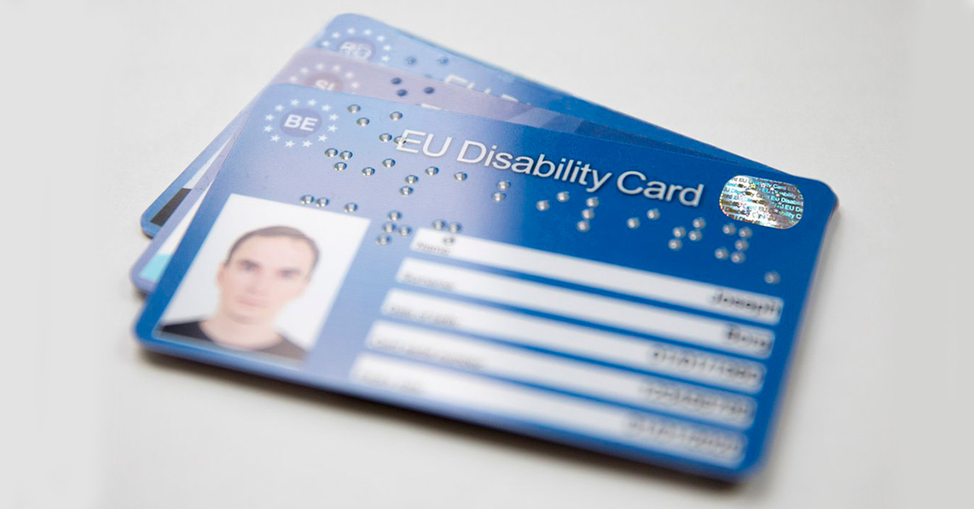
1Standard model of the EU Disability Card (photo: European Commission)

Recent developments
In order to launch the Card, the European Commission published a call for proposals in July 2015 to provide funding to interested Member States so that they could set up their systems and take the necessary preparations. It is important to note, that the call was only open to existing members of the PWG, i.e. the 17 Member States mentioned above. Unfortunately, due to the timing of the publication of the call, out of 17 eligible candidates only eight Member States applied for the funding and decided ultimately to launch the Card in their Member State. The participants are:

- Belgium
- Cyprus
- Estonia
- Finland
- Italy
- Malta
- Romania
- Slovenia

Some of the participating Member States already have an established Card system for persons with disabilities residing in their territory, others such as Finland are starting from a blank canvas without a pre-existing Card. Due to the national differences, each Member States decides independently who will become eligible as a Card holder. They also decide each what kind of advantages will be connected to this Card. The European Commission only indicates that the following areas can be included:

- Culture
- Leisure
- Sport
- Transport

In the last two years, the participating Member States have worked on their projects and the results are now there. Not every project was identical, e.g. Estonia’s project was limited to the mapping of potential partners and discounts and establishing a database with this information but not issuing the actual Card. Other Member States, such as Finland or Belgium are already issuing the Card to persons with disabilities. To get a more precise overview we will in the following section present the state of play by Member State.

Status in the different participating Member States

Belgium
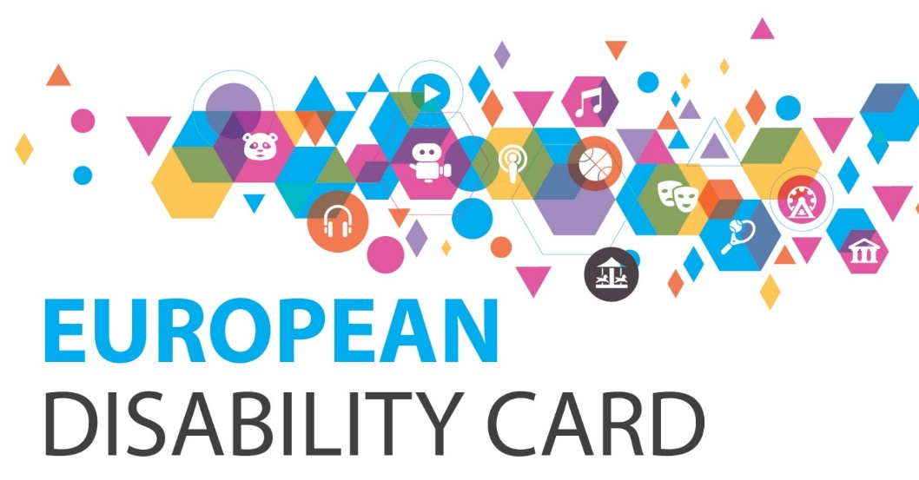
2Visual of the EU Disability Card in Belgium (photo: https://eudisabilitycard.be )

Belgium has completed the project and launched the Card. It has been distributed to ca. 27000 citizens with disabilities and over 200 venues and institutions collaborate in the Card scheme. The three objectives under the project were to establish a system managing the card, do an awareness raising campaign for service providers, as well as an information campaign for users. The campaigns included the creation of a website with a database of available discounts, a media campaign, as well as an information brochure for users.

The project was implemented by the Belgian government, more precisely a consortium of 5 different government institutions. No new legislation was passed to introduce the Card, instead the project relied on voluntary collaboration. The Belgian project paid attention to accessibility of the information, publishing material in “easy-to-read” format, certifying the website for its accessibility (WCAG level AA; certified by “Anysurfer”), and translating the information in 4 different languages: French, Dutch, German, and English.

Other good practice examples included a label and a sticker that participating venues can display so Card holders can identify them more easily. It was also important to mainstream the project in other policy areas to create a wider awareness of disability issues and closely collaborate with DPOs. The DPOs in return involved their members in the work on the Card by e.g. putting the Card on the agenda of meetings of the Belgian Disability Forum, which also helped to spread the information. Another unexpected positive side-effect was that the project improved collaboration also within the Belgian government and the different institutions involved, all of whom deal with disability issues but are normally not working together.

As a challenge it was mentioned that more EU Member States should be participating to make the Card more useful, especially in a small country like Belgium. Also the awareness raising campaign has to be continued and accessibility of the venues must be improved to make the Card more meaningful. The website of the Card as well as the websites of service providers and venues should also provide more information about accessibility in order to prepare a trip.

Finally, together with the development of the Card there should also be the development of standardized symbols and signage in the EU. For example a person that takes the TGV train from Brussels to Paris is faced with completely different signage in the stations, which is confusing. The same is true in airports. It would make persons with disabilities more independent in their travels if they could rely on a single, harmonized system of signage.

More information at: https://eudisabilitycard.be

Cyprus
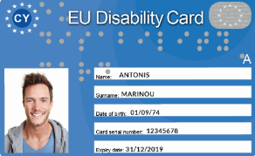
3 Model of the Disability Card in Cyprus - front (photos: http://www.eudisabilitycard.gov.cy/en/page/europaiki-karta-anapirias)
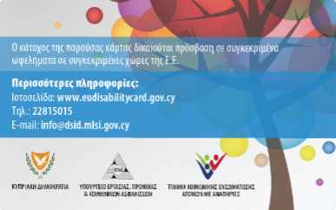

4 Model of the Disability Card in Cyprus - back (photos: http://www.eudisabilitycard.gov.cy/en/page/europaiki-karta-anapirias)

We did not receive any additional information from our Cypriot members. But the following information is published on the Disability Card website:

Eligibility is assessed on a case-by-case basis but no further certification is required for the beneficiaries receiving the following benefits, unless this is deemed necessary:
- Severe motor disability allowance scheme
- Care allowance for quadriplegic people
- Care allowance for paraplegic people
- Special allowance for blind persons
- Mobility allowance
- Allowance for the provision of a disability car
- Scheme for the provision of financial assistance for the purchase of a wheelchair
- Guaranteed Minimum Income – Disablement allowance

The Card also includes transport.

More information at: http://www.eudisabilitycard.gov.cy/en/page/europaiki-karta-anapirias

Estonia

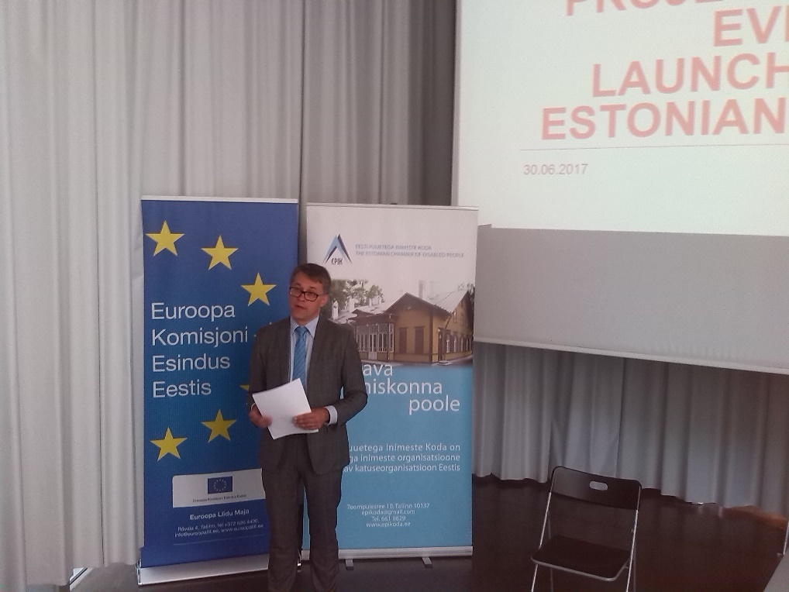
5 Launch event in Tallinn, June 2017 (photo: Marie Denninghaus)

In Estonia, the Disability Card project was limited to a preparatory action to set up the
card. Work was done to research and map the potential benefits but not to actually
issue the card itself. The mapping of the benefits has been finished and a website with
the database containing all the benefits has been published. The benefits include mainly
culture and leisure facilities such as theatres, museums, etc. Transport is not included.
In general, the response was very positive from the benefit providers.

The Ministry of Social Affairs and the Social Insurance Board are also positive and have
given green light politically to go ahead and start issuing the card. The main issue is that
there is some extra cost involved and it is not clear yet how this is covered. The Estonian Chamber of Disabled People (EPIK) hasbeen in constant dialogue with the government and a decision should be taken soon to go ahead with the issuing of the card.

There is a strong interest from users in the card and they have already heard about it.
Unfortunately, there has been a delay and now people are waiting for the card to be
issued.

In terms of actually issuing the card, in principle, everything is ready and the Social
Insurance Board could issue a two-sided card as it has been done in other Member
States such as Slovenia. Technically this is not a problem. However, the EU Disability
Card requires a photo and this means apparently that it is more costly to print. It is not
clear yet who will pay for those extra costs.

More information at: https://www.epikoda.ee/discounts/?lang=en#

Finland

In Finland, the Service Foundation for People with Intellectual Disabilities (KVPS), an NGO, is the coordinator of the project and responsible for the development of the Card. However, the Finnish Disability Forum is closely involved in the decision-making. KVPS also coordinates the work with the Ministry and the service providers for which the role of coordinator was crucial to define the role of each partner. It was also important to take time for conversations and discussions to find consensus.

The Finnish project included both the research, the setting up of the distribution system for the Card, as well as an information campaign for both potential Card holders as well as service providers. As of November 2018, about 5000 Cards have been issued and around 150 service providers are participating, including the Finnish National Railway Company (VR). The campaign in Finland included a “tour” to different regions and cities to promote the Card also far away from the capital and to ensure good implementation in remote areas.

The biggest challenge was to define the eligibility criterial. There was no national disability card scheme before the European project which means many things had to be discussed from the beginning. And in spite of those challenges the participants of the project decided to go ahead and start with implementing the Card while learning by doing so. In Finland, one of the biggest added benefits of the Card was that it would help giving recognition to invisible disabilities.

Some good practice examples include that Finland has included transport in the eligible benefits and the national railway operator VR recognizes the Card. The project also managed to secure sustainable funding from the Finnish ministry; the European Commission grant served as a “kickstarter” but was then followed up with national funding. It was also helpful to have a strong collaboration with local and regional partners to promote the card, as well as using social media to share stories, videos, and information.

The Finnish Card also has a special feature to improve communication: a QR code that can be scanned as well as symbols that are meant to facilitate communication for persons with cognitive disabilities.

More information at www.vammaiskortti.fi

Italy
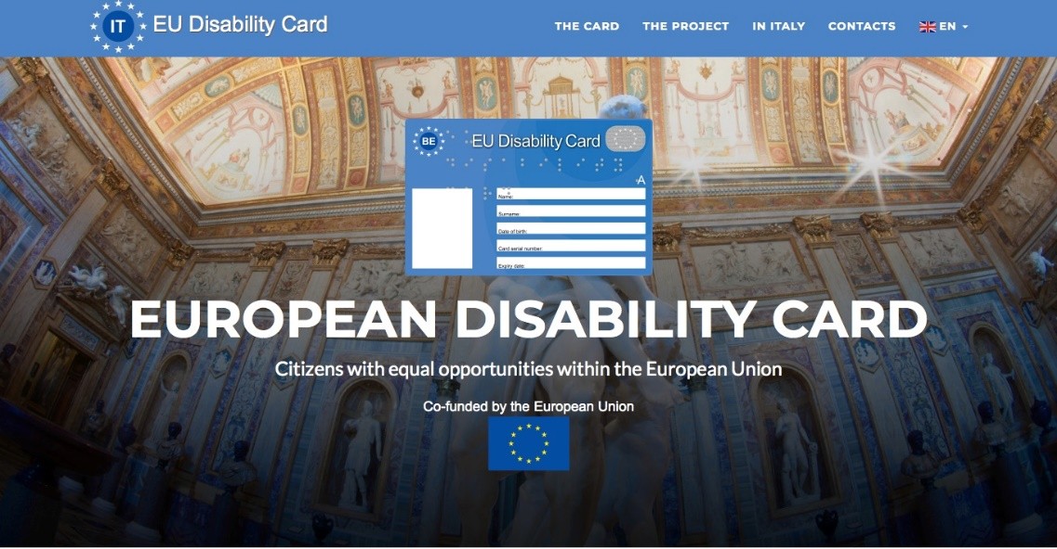
6 http://www.disabilitycard.it/it/

In Italy, the Disability Card project was limited to a feasibility study which included the research and setting up of a website to record possible benefits. The Card has not been issued to persons with disabilities yet. The Italian Federation on Disability (FISH) has performed and delivered the report to the Government and is awaiting further action.

The study included:
- An analysis of the current situation in Italy
- A shared proposal with main stakeholders on potential beneficiaries of the Card and on main benefits
- Who would be eligible for the Card, at least in the first implementation phase
- Implementing an online publication of a website for the dissemination of information on the project “Disability Card also in Italy”, and subsequently on the Disability Card
- Setting up a Disability Card prototype, presentation of the technical specifications and preliminary indication of production cost
- Identifying the possible managing body of the collection and analysis of requests and distribution service of the Disability Card (National social security institution - INPS)

In order to be actually set up the Disability Card, it needs to be adopted by a public act at national level. The end of the current project “Disability Card also in Italy “coincided with the term of the legislature and, subsequently, with a radical change of the government. It was not even possible to start the experimental phase of the Disability Card’s implementation before the end of the previous legislature. The current government is now evaluating the Card’s implementation possible modalities.

Engagement with potential Card holders has been made through the website “www.disabilitycard.it” which registered many contacts and mainly a consistent number of persons asking for information on the Card and urging its adoption in Italy. Interest and consent that have been registered around the project confirmed the value of the initiative and of the idea.

The Italian experience suggests the importance of making public decisions that are necessary to ensure the effective adoption of the Card to be undertaken in the first phase of the implementation process, as well as the clear identification of the responsible public body and the allocation of necessary funds.

More information at: http://www.disabilitycard.it/it/

Malta

As of now, the Disability Card has successfully been implemented, according to Maltese
authorities. However, the Malta Federation of Organisations Persons with Disability
(MFOPD) was not involved in the process. Ideally, concludes Malta, the card should be
widened to all EU Members States.

In terms of a personal anecdote about the Disability Card in Malta: One user heard about the card from the Commission for the Rights of Persons with Disability. This user explained that their daughter, who has an intellectual impairment, has applied for the card but has not yet been able to use it in practice. They note that the card can be improved upon if it was acknowledged
by more countries and perhaps including more benefits.

More information at: https://www.eudisabilitycard.org.mt/

Romania

As of now, the Card is available in Romania and the procedure in order to obtain it is not
very difficult. But the respondent to the survey (who is not a Card holder him/herself but helps others to apply) believes there should be more transparency.

Some of the main difficulties of setting up the card has been a bit of confusion surrounding the process. For example, some requests for cards have been submitted to the wrong institution, and the process was delayed because of that. The respondent has personally only distributed 2 cards, but made contact with more card holders.

People are optimistic about it; they think it is a good idea, but at the same time they are a little worried about the recognition of these cards. Mostly young men and women seem to have a greater interest in getting a card, observes the respondent. The respondent also “absolutely” believes the card should be widened to all EU Member States. There should be unity between the States in this area.

Cultural integration of people with disabilities has to be a top priority for EU. Each Member State should invest some time and resources for this initiative. One user of the card responded that found out about Disability Card through ANSR- Ploiesti Branch. They noted that while they own the card, they have not yet put it into practice and therefore cannot offer sufficient feedback.

The General Directorate of Social Assistance and Child Protection has more
information. They are the ones who process the requests: registratura@dgas.ro

More information at: http://dizab.eurocard.gov.ro/

Slovenia

The Slovenian National Disability Council (NSIOS), a member of EDF, together with the Ministry of Social Affairs, is responsible for the development and the issuing of the Card. The project was implemented according to plan and in December 2016, coinciding with the European and International Day of Persons with Disabilities, NSIOS prepared the database of entities that will give discounts and benefits. The database will be in the form of an accessible website with the information about the discounts and geolocating mobile applications for iOS and android respectively. The Card as such has been launched in the second half of 2017.

More information at: http://www.invalidska-kartica.si/

Reported benefits of the Card

For users:
- Easier identification of invisible disabilities
- Easier communication especially abroad to claim your rights
- Better inclusion in community and participation due to discounts
- Higher level of awareness of disability issues by service providers
- Improvement of accessibility of venues due to increased participation and awareness
- Recognized even in some Member States that are not participating in the scheme yet

For national authorities:
- Improved coordination and dialogue between different government agencies
- Single document as proof of disability facilitates work of government agencies
- Higher visibility of disability issues

For service providers:
- Increased number of visitors/passengers/clients
- Improved customer experience results in better ratings and recommendations
- Staff is more aware of disability issues and accessibility

For EU institutions:
- Strengthening of a European identity
- Citizens perceive a practical benefit coming from the EU
- Persons with disabilities gain confidence to travel and move abroad

Reported challenges

- Defining the eligibility criteria is not always easy, especially in Member States that do not have a national Disability Card yet
- Information about how to apply for the Card has not reached all users yet and can be confusing
- While there may be discounts for certain events, activities, or venues, the lack of accessibility often limits the enjoyment of the benefits in practice
- Lack of coherence in the government has stopped the project from progressing and slows down implementation
- Finding a source of funding to continue the project once the Commission funding stops

Looking ahead: Next steps and EDF recommendations

Following the end of the pilot project, the European Commission will launch an independent study to evaluate the initiative. There will also be a targeted stakeholder consultation going more into detail than the EDF survey. The results of the study should be presented at the end of 2019.

The European Disability Card has already come a long way and the pilot project is advancing well in the participating member states. However, EDF is of the opinion that the Disability Card has not reached its full potential yet. There are several factors that could still make this project more meaningful for persons with disabilities in the EU and EDF is thus making the following recommendations:

- The Commission should establish a second round of funding for following up on the preparatory actions such as in Estonia and to allow the remaining Member States to join
- The Commission should also create a permanent network for exchange of good practices and experience between the Member States that are already participating. The network should also include representatives of users or their representative organisations.
- The European Parliament can help to actively promote the use of the Card to make sure there is an added value
- All actors can encourage Member States to include a maximum range of services under the card, especially including transport

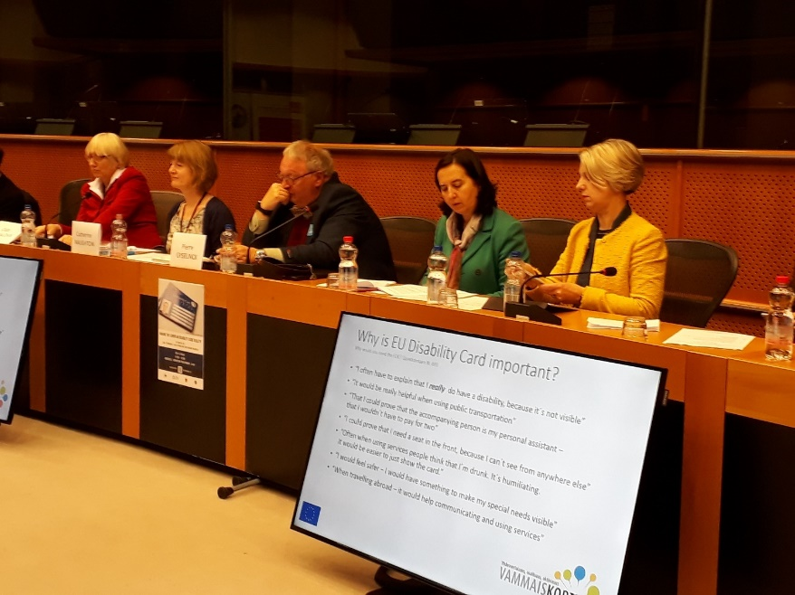
7 Event "Making the European Disability Card reality" at the European Parliament, 28 November 2018

Related documents and links

- European Commission webpage on the Disability Card
- First EDF position paper on the European Disability Card (2011)
- EDF Analysis Report on the European Disability Card (2012)
- Second EDF position paper on the European Disability Card (2014)

Acknowledgments

EDF would like to thank all members and partner organisations that have contributed this report and responded to the survey.

Some information was taken from the event “Making the Disability Card Reality” in the European Parliament on 28 November 2018. Thank you to all participants and organisers.

Contact person at the EDF secretariat:
Marie Denninghaus, Policy Coordinator
Tel: +32 (0) 2 282 46 07, E-mail: marie.denninghaus@edf-feph.org

Should you have any problems in accessing the documentation, please contact the EDF Secretariat. (Tel: +32 (0) 2 282 46 00, Email: info@edf-feph.org).

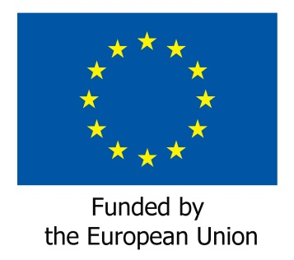

Website on Disability Card in Cyprus http://www.eudisabilitycard.gov.cy/en/page/europaiki-karta-anapirias; retrieved on 30 January 2019

