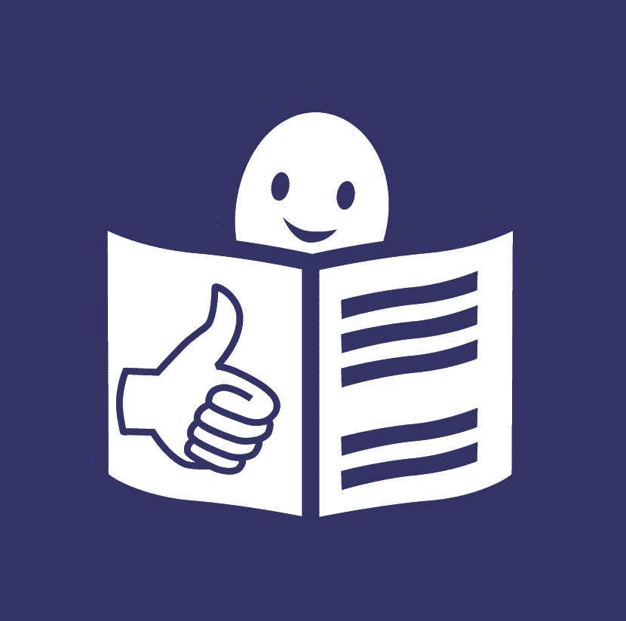

Easy to read

This is a summary of the booklet in easy to read.
Easy to read is a way to make information accessible
so that people with intellectual disabilities and all people
can understand it.

The European Disability Forum

The European Disability Forum is an organisation
of people with disabilities in Europe.
In short, we call it EDF.
EDF works to protect the rights
of people with disabilities in Europe.
We believe that people with disabilities
should decide about their lives.
Nothing should be decided about us without us.

We believe that all people have the right to:
- Be treated fairly and with respect.
- Make their own choices.
- Take part in the community.
- Be equal and have the same chances in life.
We also believe that women
should have the same chances in life as men
and that the voices of children with disabilities
should be heard too.

The people of EDF

EDF has 100 members all over Europe.
These members are also organisations
of people with disabilities
or organisations that want to help people with disabilities.
Some of these organisations stand up
for people with a certain type of disability.
For example, intellectual disability.
On page 6 of this booklet
there is a list of all the organisations
that are members of EDF.

EDF members come together
and discuss important things for people with disabilities.
They also choose the people
who can make decisions for EDF.
All together they decide how to make things better
for people with disabilities in Europe.
On page 10 of this booklet
you can see the names and photos
of the people who make decisions for EDF.

These people form smaller groups and work on things
that are most important to them.
We call these groups ‘Committees’.
For example, we have a Committee that works
to help women with disabilities.
We also have a Committee that works
to help young people with disabilities.
On page 14 of this booklet
you can see all our Committees.

Also EDF has an office in Brussels.
On page 16 of this booklet
you can see photos of people who work at this office.
You will also find information
about how to contact this office.

The UN Convention

Our work has to do a lot with the
‘UN Convention on the Rights
of Persons with Disabilities’.
This is a law that says
what rights people with disabilities have
and how countries should work to protect these rights.
In short, we call it the ‘UN Convention’.

The European Union is a group
of many countries in Europe
that came together to make things better for people.
The European Union and all its countries
have signed the UN Convention and agreed to protect
the rights of people with disabilities.
So they should work to make the UN Convention happen
and make things better for people with disabilities.

Our work

In 2018, we worked hard to make things better
for people with disabilities.
We are proud that our work brought good results.

For example:

- We pushed for a strong
European Accessibility Act.
Things and services in Europe should be accessible
so that people with disabilities can use them
to take part in the community as all other people.
EDF has been asking the European Union
to make a strong law
that will make things and services accessible
so that all people can use them.
As a result of this work, in 2018,
people who make decisions in the European Union
agreed to make this law happen.
We call this law the ‘European Accessibility Act’.
Thanks to this law,
some things and services in Europe
will become accessible
so that people with disabilities can use them.
For example, cash machines, televisions
and ticket machines.

- We pushed for accessible European elections.
European elections happen every 5 years.
That means that people in Europe vote and choose
who will make decisions and laws in Europe.
It is very important to be able to vote.
It means that your voice counts.
It is also important to be able to stand for elections.
That means that people can vote and choose you
to make decisions and laws in Europe.
Many people with disabilities in Europe
are not allowed to vote or stand for elections
because they have a disability.
Other people with disabilities cannot vote
or stand for elections
because the process is not accessible for them.
For example,
people with intellectual disabilities
may not get information that is easy to read
so they may not understand how to vote.
The last European elections happened in May 2019.
We asked people who make decisions in Europe
to make them accessible
so more people with disabilities can vote
and stand for elections.

- We wrote booklets about the rights
of people with disabilities.
For example, we wrote booklets that talk about:
- The rights people with disabilities have
in the European Union.
- The right of all people to be treated fairly
and to have the same chances in life.

- We fought against discrimination.
People with disabilities are sometimes
treated badly or unfairly because of their disability.
This is called discrimination.
Some people with disabilities have bigger risk
of being treated badly or unfairly.
For example, women with disabilities
may be treated unfairly
both because they are women
and because they have a disability.
We continued pushing the European Union
to make a law that protects people
from all kinds of discrimination.
We also want the European Union
and all its countries
to work hard to make the UN Convention
happen in them.

- We stood up for women with disabilities.
Women with disabilities have a higher risk
of being treated badly or unfairly.
We worked to protect the rights
of women with disabilities
and pushed the European Union to sign a law
that protects women from violence.
We also wrote a booklet about
the right of women with disabilities
to have a sexual life and become mothers.

- We worked for the rights
of young people with disabilities.
The European Union has some programmes
that help young people to travel and work
in different countries in Europe.
Sadly, young people with disabilities
are often left out
because things are not accessible for them.
We pushed the European Union to take into account
the needs of young people with disabilities too.
For example, young people with disabilities
may need to have a support person with them
when they travel, work or study.
The European Union should help
young people with disabilities
to take part in these nice programmes too.

- We pushed for accessible technology.
By technology we mean things like computers, televisions, mobile phones and internet.
We pushed the European Union
to make these things accessible
so that people with disabilities can use them too.
As a result, the European Union
made some important laws saying that
some of these things should be accessible.
For example, it made a law saying that
public websites in Europe should be accessible.
Like the website of your hospital
or the website of the community you live in.
This was a great step.

- We pushed for accessible transport.
Often it is hard for people with disabilities to travel
because transport like planes, boats and trains
are not accessible for them.
Also they may not get the support they need
or information may be difficult for them
to understand.
We asked people who make laws and decisions
in Europe
to make transport accessible
so people with disabilities can use it
like everyone else.
Our work helped people who make decisions
in Europe
to understand why this is important
and work to make transport more accessible
especially when it comes to trains.

- We worked to make the Sustainable Development Goals happen in Europe.
The Sustainable Development Goals are goals
that countries agreed to make happen by 2030
to make the world a better place.
For example,
they agreed to protect people who are poor
and make things better for them.
They also agreed to not leave anyone behind.
These goals can make things better
for people with disabilities too.
We explained this in a booklet we wrote.
We also talked to people
who make decisions in Europe.
We asked them to remember
people with disabilities when they work
to make the Sustainable Development Goals happen in Europe.

- We spread the word about the rights
of people with disabilities.
For example,
we wrote articles on magazines
to talk about important things
for people with disabilities.
Also we shared news and important information
with many people
on our pages on Facebook and Twitter.

Work with other organisations

EDF often works with other organisations
who also want to make the lives of people better.
These organisations can be world organisations
or European organisations.
For example, EDF works closely
with a European organisation
that protects the rights of women.
This organisation is called
the ‘European Women’s Lobby’.

Sometimes we also work with companies
who care to help people with disabilities.
We organise meetings and other things together
to support the rights of people with disabilities.

On page 38 of this booklet, you can see a list
of these organisations and companies.

Our money

EDF needs money to make its work happen.
In 2018, we got most of our money
from the European Union.
We also got money from organisations and companies
that wanted to help our work.
We spent this money:

- to pay the people who work for us
- to travel for important meetings
- on other things that are important for our work.

More information

If you want to find more information
about EDF and our work
you can visit our website at www.edf-feph.org.
You can also send us an email at info@edf-feph.org.

