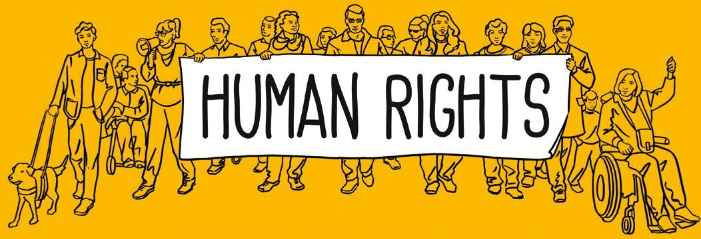
People with disabilities – do they have enough money for a good life and are they included in their communities?

European Human Rights Report
Easy read version 2020
 | The European Disability Forum is an organisation. It makes sure the needs are met of the 100 million people in Europe with disabilities. It stands up for their rights.
Many people with disabilities have said that having enough money, and jobs are still problems that need sorting out.
The European Disability Forum wrote this report to find out more about the problems and tell everyone what should be done.
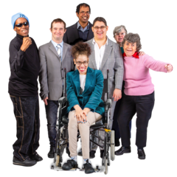 | They got the information from  - the European Union, which is usually called by its short name ‘the EU’  - Disability rights organisations in each country  - Listening to stories about the lives of people with disability.
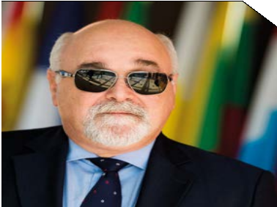 | Ioannis Vardakastanis is the President of the European Disability Forum.  He says it is not fair that if you have a disability you are more likely to be poor. It is important to find out why this is and decide what can be done to change things in the future.
 | This report looks at how people with disabilities are doing. It especially finds out if people have enough money to have a good life and are included in their communities.
This map shows how well people with disabilities in each country are doing. 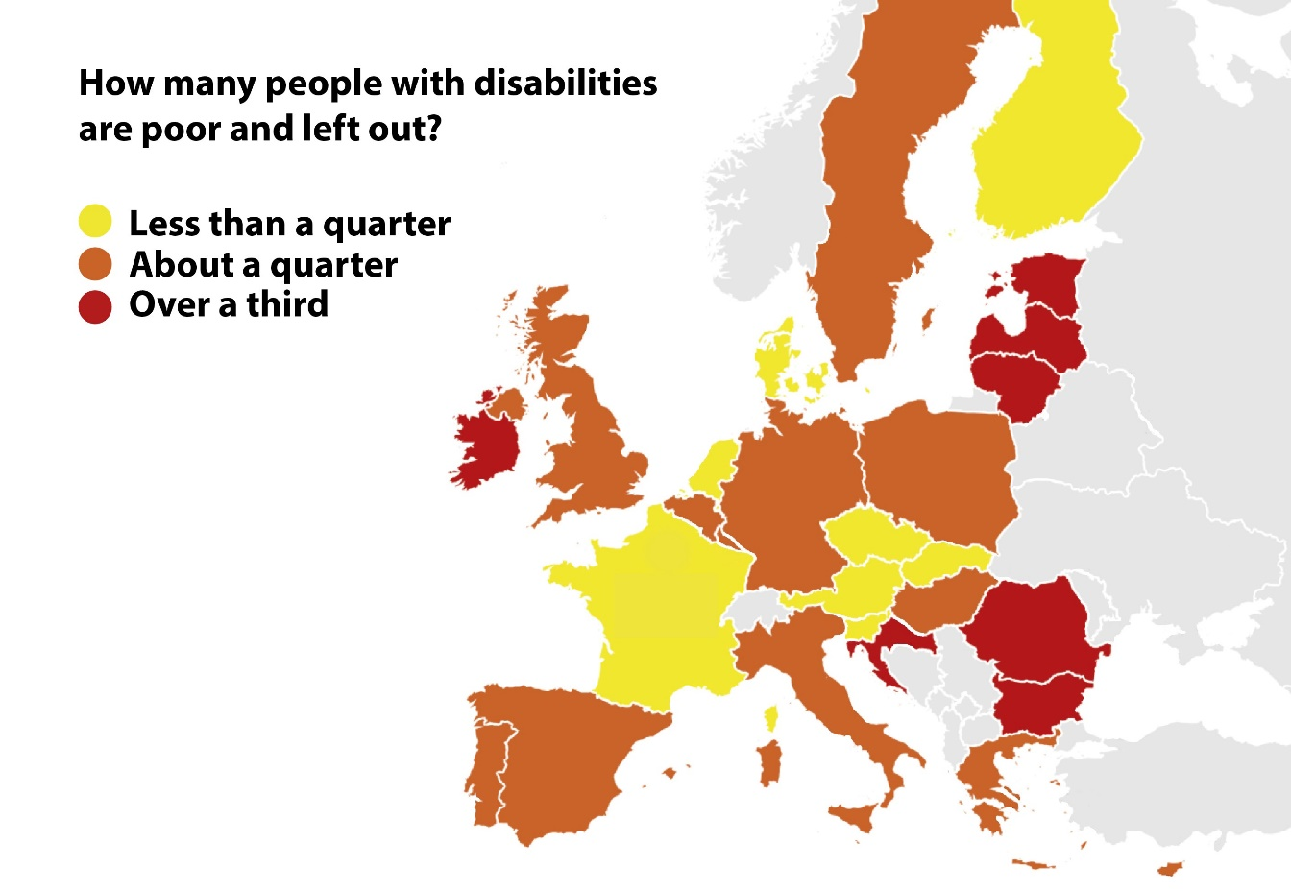
 | About 30 million people in Europe who have disabilities are poor. This is about 1 in every 3 people with disabilities.
More people with disabilities are poor than people without disabilities.
This is not fair as it costs more to live if you have disabilities.
- United Nations Convention on the Rights of People with Disabilities
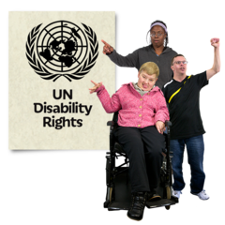 | All the countries in Europe have signed the United Nations Convention on the Rights of People with Disabilities. This means each country must make sure people with disabilities have their rights.
 | But not every country is taking actions to make sure people with disabilities have enough money to live a good life.
- Being poor and left out of community life
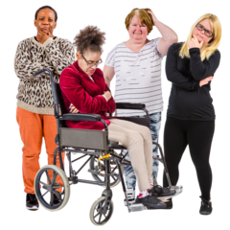 | Women with disabilities are more likely to be poor. These are some of the reasons why:  - It is harder for them to find jobs  - Women are often paid less than men for doing similar jobs  - Women are often treated unfairly  - They do not have enough job skills training  - They don’t have enough computer training
Other groups with disabilities are also more likely to be poor. These are:
- younger people
- people from non-white communities and especially people from the Roma community
- people who live in small towns or the countryside
- people who weren’t born in the EU but live in an EU country, such as refugees
- Disability assessments and what countries spend on welfare benefits and support
 | It costs more to live with a disability. This is because people with disabilities might have to pay for medical treatment, medicine, technical aids and transport.
 | Welfare benefits are the money paid by the government in each country to pay for these extra costs. Welfare benefits are very important to pay for the extra costs of having a disability.
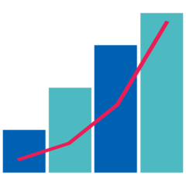 | But each country pays a different amount of welfare benefit money to people with disabilities.
 | To get welfare benefit money people with disabilities have to have an assessment by a specialist. They decide how much money and support the person can have.
 | Each country has a different way of doing the disability assessment. In some countries it is done by medical people, and this does not look at the barriers to living in the community.
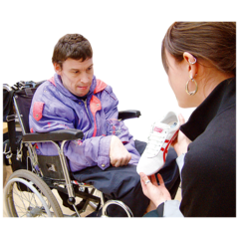 | An assessment should look at all the different ways having a disability makes a difference to people’s lives. This is what the United Nations Convention on the Rights of People with Disabilities says too.
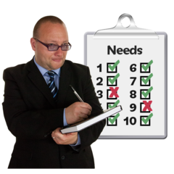 | The assessments and money paid can vary in different countries. This can make it difficult for people with disabilities to travel to live and work in other EU countries. This is not fair for people with disabilities.
- Poverty and homelessness
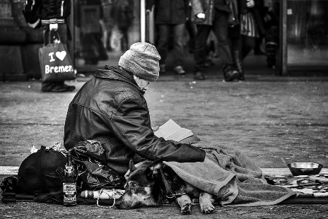 | There are lots of homeless people across Europe. Many of these people have a disability. It could be because they have an intellectual disability, autism or mental health problems. But no one knows, so they do not get the support they need. This is not fair for people with disabilities who are homeless.
- Financial crisis and government spending cuts
 | In 2008 the banks in USA had problems. This spread to all countries in the world, including Europe. So from 2010 some countries cut the money they were spending to support people with disabilities. We call this ‘austerity measures’.
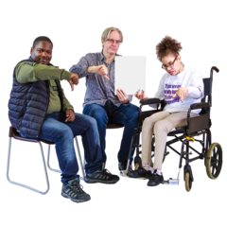 | Since 2010 things have got worse for people with disabilities in 11 EU countries: Estonia, Luxembourg, Germany, Sweden, Ireland, Czechia, Lithuania, Italy, the Netherlands, Malta and Spain.
 | Sweden, Luxembourg and Germany were less affected by the banking crisis than other countries in Europe. But people with disabilities still had less support and money. So some countries are giving less money for other reasons.
 | This means that people with disabilities do not get the support they need. They do not have enough money to live a good life and they cannot take part in community life.
- Jobs and people with disabilities
 | In the EU 75% of people work, but only 50% of people with disabilities do. It is harder for people with intellectual disabilities, people with mental health problems and women with disabilities to get a job.
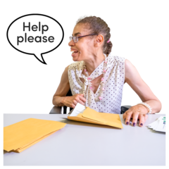 | There are lots of reasons why it is hard for people with disabilities to get a job:  - It can be difficult to earn money and claim benefits  - There isn’t enough support for people to get and keep a job  - Other people in jobs can’t use sign language  - There are not enough opportunities for education and training
There are lots of agreements and plans used in Europe to help people with disabilities to get jobs. These include:
- Companies agreeing to keep some jobs just for people with disabilities
- Giving companies money that goes towards the wages of people with disabilities
- Telling companies they don’t have to pay so much tax if they give jobs to people with disabilities
- Helping with the training costs
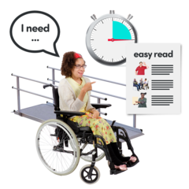 | There should not be disability discrimination where people work. This means people with disabilities are treated unfairly. To stop this there must be positive action. This can be called reasonable accommodation or reasonable adjustments.
 | This means that people with disabilities can have flexible working hours, they can be allowed to work at home, and they can get technology to help them or a job coach.
- How the EU can stop people with disabilities being poor and not being included
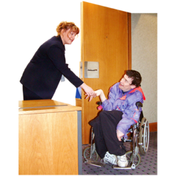 | The EU has said it wants to make sure that people with disabilities can earn enough money from having jobs where they are get better money. This will also help them to be included in the places where they live.
 | This plan fits in with the United Nations Convention on the Rights of People with Disabilities.
How should things change?
- The EU must make an action plan with ideas for the inclusion of people with disabilities.
- It must make plans for 2020–2030 to follow on from the European Disability Strategy 2010–2020. This must include ways to stop poverty and to stop excluding people with disabilities and their families.
- The EU must make laws to protect people with disabilities from discrimination in all areas of their lives, not just employment.
- It must make new jobs by starting a Disability Rights Guarantee. This will offer jobs, apprenticeships, training or life-long learning. It will also make sure people with disabilities get person-centred and flexible support to help them find jobs.
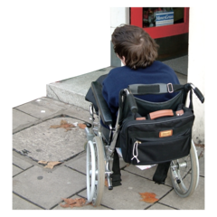 | - Disability assessments must agree with the United Nations Convention on the Rights of People with Disabilities. They must think about all the things that are challenging when someone has a disability. The assessments must look at the disability and where the people live. They must use a person-centred approach.
 | - The EU must give money to make sure all the support and services that are provided to the general public will also help people with disabilities. This will mean there is less need for expensive specialised services that people with disabilities have to pay for.
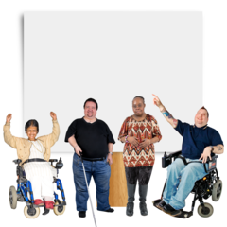 | We need to keep campaigning and working together to make these changes so ‘no-one is left out!’ in Europe.

Original research report commissioned by EDF entitled ‘Poverty and Social Exclusion of Persons with Disabilities’ European Human Rights Report, Issue 4 - 2020
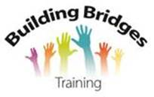
It is available with an accessible PDF version on EDF’s website: www.edf-feph.org

Easy read report produced February 2020 by Building Bridges Training www.building-bridges-training.org

