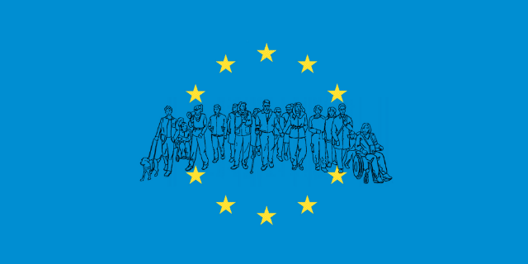  Image description: Illustration of persons with disabilities encircled by the EU flag stars | It's time for a European #DisabilityRightsAgenda post-2020 with actions to:  ▶️ End segregation (including residential institutions)  ▶️ Guarantee the freedom to live travel, study in any EU country.  ▶️ Promote full equality  Our demands: https://bit.ly/DisabilityRightsAgenda
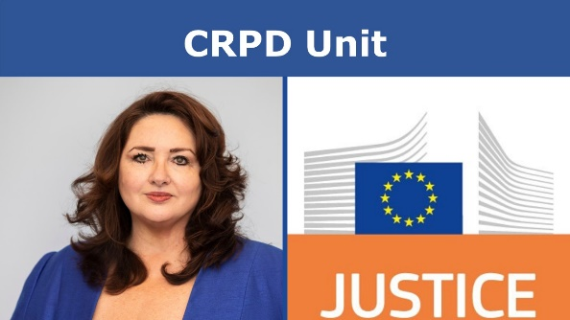  Image description: Word CRPD Unit over photos of Helena Dalli and logo of DG Justice | #DisabilityRightsAgenda is about equality!  @EU_Commission must create "#CRPD Unit":  🇪🇺 tasked with implementation of UN Convention on the Rights of Persons with Disabilities across EU Institutions  🏦at @EU_Justice with equality services  ▶️supervised by Commissioner @helenadalli
Image description: Illustration of persons with disabilities encircled by EU stars | #DisabilityRightsAgenda should guarantee:  💶No investment of EU funds in institutional care settings nor inaccessible structures  🏢A EU Access Board to enforce legislation  🇪🇺 @EU_Eurostat collects disaggregated data on persons with disabilities  📄 https://bit.ly/DisabilityRightsAgenda
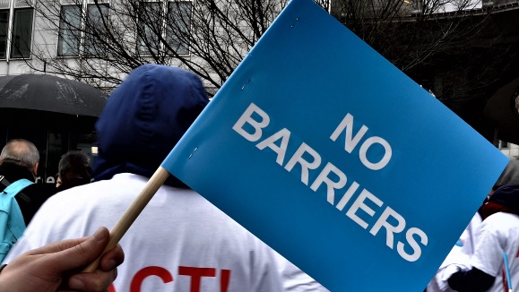  Image description: Flag saying no barriers during a protest | We call for 6 new laws in the #DisabilityRightsAgenda:  🗳️ Ensure persons with disabilities can vote and stand for office  💶 minimum standards for social protection  ✅automatic recognition of disability assessment (status) when moving from one Member State to another 1/2  ⚙️Assistive Technology: Accessible and Affordable”: equal access to affordable assistive technologies  🌇“Accessible spaces” Directive: minimum accessibility requirements for buildings, transport.  🇪🇺EU Disability Parking Card 2.0  2/2  @helenadalli  bit.ly/DisabilityRightsAgenda
Image description : person in wheelchair with t-shirt saying Act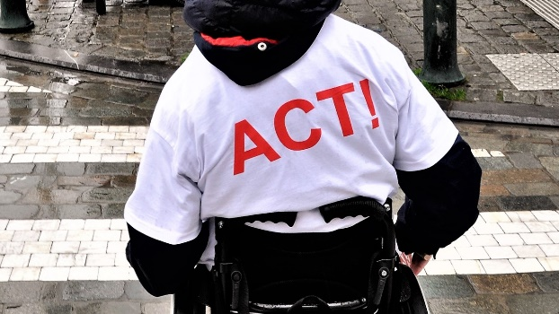 | 🇪🇺 🇪🇺Commissioner @helenadalli: #DisabilityRightsAgenda needs to ensure independent living for all persons with disabilities.  It must end segregation in residential institutions and care settings.  📄: https://bit.ly/DisabilityRightsAgenda
Image description: Banner saying freedom of movement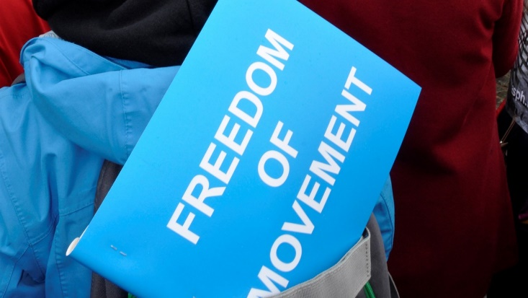 | 🇪🇺 @helenadalli: EU freedom of movement is not a reality for persons with disabilities.  Demand for next #DisabilityRightsAgenda: We need to be free to live, work, travel, study in EU countries without losing rights and entitlement to financial support  https://bit.ly/DisabilityRightsAgenda
Image description : banner sayinh nothing about us without us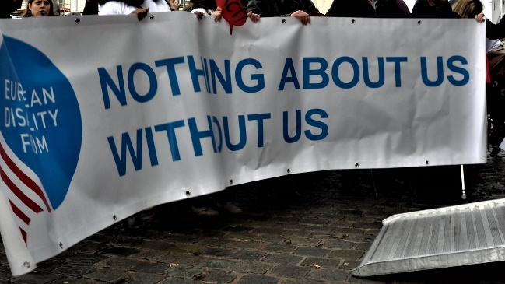 | Next #DisabilityRightsAgenda needs to promote equality for all persons with disabilities.  EU needs to adopt equal treatment legislation protecting all persons with disabilities in all areas.  @helenadalli  📄: https://bit.ly/DisabilityRightsAgenda
🇪🇺Next #DisabilityRightsAgenda needs to see global leadership from the EU.

It means EU should champion disability inclusion in @UN, @coe and all international relations.

@helenadalli

📄: https://bit.ly/DisabilityRightsAgenda

Image description: Illustration of persons with disabilities encircled by the EU flag stars | 🇪🇺@EU_Commission needs to set an example in disability inclusion.  ▶️ disability inclusion at all levels,  ▶️ accessible information  ▶️ better recruitment process  ▶️ rights of staff with disabilities.  @helenadalli @JHahnEU  #DisabilityRightsAgenda: bit.ly/DisabilityRightsAgenda
Image description: Illustration of persons with disabilities encircled by the EU flag stars | Next #DisabilityRightsAgenda must assert #DisabilityRights in all EU Institutions.  It must:  🇪🇺 Have a central service at @EU_Justice to implement #CRPD (🇺🇳#DisabilityRights Convention)  🇪🇺 #DisabilityRights services in all departments  @helenadalli  bit.ly/DisabilityRightsAgenda
A simple demand for #DisabilityRightsAgenda:

@EU_Commission must create the European Access Board. The board should monitor how EU accessibility laws are being implemented throughout the Union.

@helenadalli
bit.ly/DisabilityRightsAgenda

Image description: woman holding a scarf saying Right to vote for all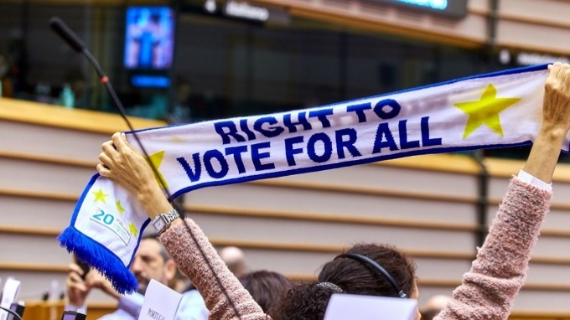 | Next #DisabilityRightsAgenda must ensure participation:  🌐 Involvement of organisations of persons with disabilities in policies (and funding for it)  📊 Data collection disaggregated by disability (@EU_Eurostat)  🗳️ Laws on right to vote  @helenadalli  bit.ly/DisabilityRightsAgenda
Image description : person in wheelchair with t-shirt saying Act | Next #DisabilityRightsAgenda must ensure better social protection:  ▶️ No funding for residential institutions or inaccessible places  📊 law on minimum standards for social protection  🗳️ law on automatic recognition of disability assessment  @helenadalli  bit.ly/DisabilityRightsAgenda
🇪🇺is an important partner of the @coe

This is why it should:
▶️ accede to #IstanbulConvention (preventing violence against women)
▶️ oppose draft protocol to #OviedoConvention that allows for forced treatment.

@helenadalli

Image description: Flag saying no barriers during a protest | #DisabilityRightsAgenda: bit.ly/DisabilityRightsAgenda  #DisabilityRightsAgenda must deliver on accessibility:  ▶️ Create European Access Board  ▶️ propose law on affordable, assistive technologies  ▶️ propose law on accessible buildings and transport  @helenadalli  https://bit.ly/DisabilityRightsAgenda

