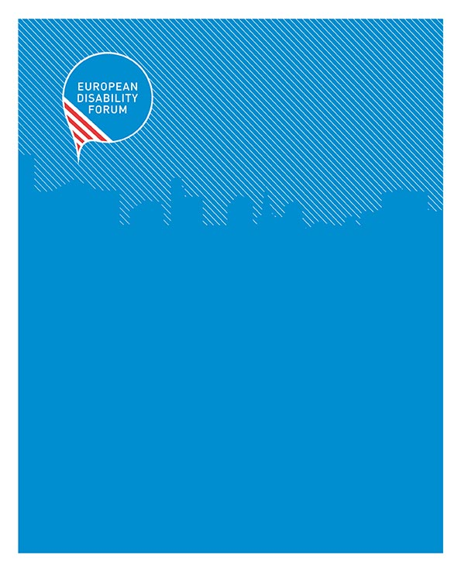

The European Disability Card – State of play

European Disability Card: State of play
  - EDF | August 2016
35 square de Meeûs tel +32 2 282 46 00 info@edf-feph.og
1000 Brussels - Belgium fax +32 2 282 46 09 www.edf-feph.org

...................................................................................................................
The European Disability Forum is an independent NGO that represents the interests of 80 million Europeans with disabilities. EDF is a unique platform which brings together representative organisations of persons with disabilities from across Europe. EDF is run by persons with disabilities and their families. We are a strong, united voice of persons with disabilities in Europe.

Contents
The European Disability Card – State of play 1
Status in the different participating Member States 4
Belgium 5
Cyprus 5
Estonia 5
Finland 5
Italy 7
Malta 7
Romania 8
Slovenia 8
Looking ahead: EDF recommendations 8
Related documents 9
Acknowledgments 9
Contact person at the EDF secretariat: 9

Introduction
EDF started first campaigning for the introduction of a European Disability Card (then known as “European Mobility Card”) in 2011 as part of the Freedom of Movement campaign, publishing the first position paper on this topic. The campaign was accompanied by a thorough Analysis Report in 2012, comparing the existing types of Disability Cards in different EU Member States as well as possible solutions for the introduction of such a Card on EU level. EDF followed up on the initial paper with an update report in 2014.

The core demand of EDF’s campaign was to establish a Card which is recognized throughout the EU and gives its holders the same disability related rights and discounts as a national of the Member States that the person is visiting. Similar to the already long established European Parking Card, the Disability Card was aimed at bridging the gap for persons who were only temporarily staying in another Member States such as tourists, students studying abroad, or interns, that would not be able to benefit from the advantages that national with disabilities have due to the difference in rules and lack of recognition of their disability status.

Now, in 2016, we have come closer to putting the idea of a European Disability Card into practice and this paper will give an update both on what actions have been taken at EU level and what has happened in the different participating Member States.

Recent developments
In mid-2014 the European Commission established a Project Working Group (PWG) of Member States who were potentially interested in introducing such a Card and had regular meetings throughout 2014 and 2015. The participating Member States were initially Belgium, Bulgaria, Cyprus, Estonia, Finland, France, Germany, Greece, Hungary, Italy, Malta, Portugal, Slovakia, Slovenia and Spain. Poland and Romania joined at a later stage, too. The task of the PWG was to compare the current situation in the Member States and try to reach an agreement on the format of a potential Card and who would be the beneficiaries.

As a result of the discussions in the PWG, it was finally decided that Member States would retain almost all of the decision power and the only common feature would be the format of the Card as well as the principle that all other participating Member States would mutually recognize the Card holders based on the national criteria, since these criteria differed significantly from one Member States to another.

In order to launch the Card, the European Commission published a call for proposals in July 2015 to provide funding to interested Member States so that they could set up their systems and take the necessary preparations. It is important to note, that the call was only open to existing members of the PWG, i.e. the 17 Member States mentioned above. Unfortunately, due to the timing of the publication of the call, out of 17 eligible candidates only eight Member States applied for the funding and decided ultimately to launch the Card in their Member State. The participants are:

- Belgium
- Cyprus
- Estonia
- Finland
- Italy
- Malta
- Romania
- Slovenia

Some of the participating Member States already have an established Card system for persons with disabilities residing in their territory, others such as Finland are starting from a blank canvas without a pre-existing Card. Due to the national differences, each Member States decides independently who will become eligible as a Card holder. They also decide each what kind of advantages will be connected to this Card. The European Commission only indicates that the following areas can be included:

- Culture
- Leisure
- Sport
- Transport

During the year 2016, the eight Member States listed above have been busy, putting in place the necessary equipment and structures to produce the Cards and distribute them to persons with disabilities. The European Day of persons with disabilities on 3 December 2016 is foreseen as the official launch date.

Status in the different participating Member States

As mentioned in the previous paragraphs, the participating Member States are currently still in the implementation phase of the pilot project and the Cards have not been launched yet. In order to find out how much progress has already been made and what can be expected, EDF has done research via its members and put together the following status update.

Belgium

Developing the Disability Card is a priority for the Belgian administration: the specific techniques such as the design, protection of private data, flow of information between the different entities involved on the recognition of the Card, as well as delivering and distributing the Card.

The government has involved Disabled Persons’ Organisations (DPOs) from the start, both on national and on regional level. DPOs have been able to express their views on multiple occasions on the different aspects mentioned above. The remaining challenge is now to involve the different partners and economic actors to participate in the project because persons with disabilities are still neglected as consumers or audience and there is a huge potential that should be invested in.

For the launch, the end of the first semester 2017 is planned but no exact date has been confirmed so far.

Cyprus

Currently no information available.

Estonia

Currently no information available.

Finland

In Finland, the Service Foundation for People with Intellectual Disabilities, an NGO, is the coordinator of the project and responsible for the development of the Card. Co-applicant is the association “Jaatinen” (The Finnish Activity Centre for Disabled Children and Their Families). Associate Organisations are: the Finnish Brain Association, the Finnish Association of the Deaf, the Finnish Federation of Hard of Hearing, the Finnish Association of People with Physical Disabilities, Kehitysvammaisten Uudenmaan Tukipiiri (Organisation for persons with intellectual disabilities) and the Ministry of Social Affairs and Health. They are also working closely with the National Institute for Health and Welfare. They have also contacted several other NGOs working in the field of disability and will have an open discussion with them. They have also contacted the National Council on Disability VANE and the Finnish Disability Forum, which is a member of EDF.

Since the Card will have a “European” and a “national” side, they are now designing the “national” side which each Member State does individually. They are also still creating the criteria and the system of issuing the Card, before designing the final layout of the Card.

The main challenges to be tackled in Finland will be to support the creation of the eligibility criteria for the Card, i.e. who can apply and how; engage the service providers in the areas of transport, tourism, culture and leisure to provide advantages for persons with disabilities; Coordinate awareness-raising events in all the largest cities in Finland; establish and maintain the national package of benefits together with Finnish service providers; create an accessible website with clear information on the service providers and the benefits they offer (first draft already available on www.vammaiskortti.fi ); and organise an information and publicity campaign on the European Disability Card.

At this point of the project there are also challenges with the system of issuing the Card and there has been a lot of discussion about the criteria, how the Card relates to the UN Convention, accessibility legislation, reasonable accommodation, and disability services. Easy-to-read material needs to be prepared and it has to be explained what the Card does and what it cannot do, e.g. that it is not related to the provision of disability related services.

The communication with the public has been very open during the project and there has been active communication with and involvement of other NGOs and persons with disabilities. The applicant and the coordinator have developed an open questionnaire for persons with disabilities and their family members as well as personal assistants and social sector staff about their wishes, needs and thoughts for the Card. These results can be used when developing the criteria and the package of advantages. Many people in Finland are really interested in the project and they would like to have the Card as soon as possible.

The Card will be launched at the earliest in the beginning of the year 2018. At this point it needs to be clarified what the system of issuing will be before announcing the exact timing of the launch.

Italy

The project in Italy is managed by the Italian Federation to Overcome Handicap (FISH) in collaboration with the National Federation of Associations of Disability (FAND), both members of EDF’s national council FID. This consortium is responsible for the issuing and distribution of the Card.

It was launched on 6 July 2016 with a press conference with the Ministry of Labour and Social Policies. The project will have a duration of 18 months and FISH has now made a collection of information about the facilities on transport, cinema, theatre, museum, sports events, different leisure parks, and public activities. The first impression is that the rules and advantages differ a lot but it seems it is possible to arrive to a common, harmonized concept.

A model of an ideal disability card was prepared by the consortium to discuss the possibilities with the different public and private competent authorities. The Ministry of Labour and Social Policies have not yet nominated the competent person on the project to discuss all administrative and procedural matters (an agreement with the competent authorities, legal measures, etc.). So far, only the Ministry of Culture and Transport have nominated a contact person for the project.

Malta

The National Commission Persons with Disabilities in Malta (KNPD) are currently working on the procurement of services required for the implementation of the project activities which include the actual production and printing of the card. KNPD is also in contact with various entities to draw up the list of benefits that EU Disability Card holders (or Special ID Card holders) will be able to access in Malta.

The EDF National Council in Malta, the Malta Federation of Organisations Persons with Disability (MFOPD) is not involved in the project. MFOPD was aware of the European Disability Card as the information was given during one of the KNPD's Board committee meetings (MFOPD is a member on this Board) but was not directly involved.

According to the information given at application stage, the target was to have the application forms for this card available in October 2016. At present, KNPD is working on the necessary requests for quotations and call for tenders. Once these processes have been completed, KNPD would know whether the target is achievable so there is currently no concrete launch date announced yet.

Romania

Currently no information available.

Slovenia

The Slovenian National Disability Council (NSIOS), a member of EDF, together with the Ministry of Social Affairs, is responsible for the development and the issuing of the Card. The project is progressing according to plan and in December 2016, coinciding with the European and International Day of Persons with Disabilities, NSIOS will have prepared the database of entities that will give discounts and benefits. The database will be in the form of an accessible website with the information about the discounts and geolocating mobile applications for iOS and android respectively. The Card as such will be launched in the second half of 2017.

Looking ahead: EDF recommendations

The European Disability Card has already come a long way and the pilot project is advancing well in the participating member states. However, EDF is of the opinion that the Disability Card has not reached its full potential yet. There are several factors that could still make this project more meaningful for persons with disabilities in the EU and EDF is thus making the following recommendations:

- The project should be widened, ideally to all EU Member States. Only covering a fraction of the EU’s 28 Member States, it will be confusing for Card holders as in to where the Card will be valid and what status it has when travelling to other EU Member States.

- In order to achieve this, EDF recommends that the Commission launches a second call for proposals, also opening it to Member States that have not yet participated in the Project Working Group. It would also be beneficial if the call is announced with enough time for Member States to apply and react to make it most efficient.

- The advantages that Card holders are entitled to should be harmonized as much as possible. I.e. there should be certain areas that are covered in all participating Member States to avoid incoherence when traveling. Since public transport is an especially important advantage, this should be included under all the different Card schemes.

- Finally, EDF also recommends that the Commission keeps up the work of the Project Working Group to allow Member States the exchange of information and experience in order to improve the different Card systems and to ensure a maximum of coherence in its development and implementation.

Related documents
- First EDF position paper on the European Disability Card (2011)
- EDF Analysis Report on the European Disability Card (2012)
- Second EDF position paper on the European Disability Card (2014)

Acknowledgments
EDF would like to thank all members and partner organisations that have contributed this position paper.

Contact person at the EDF secretariat:
Marie Denninghaus, Mobility and Transport Officer
Tel: +32 (0) 2 286 51 84, Email: marie.denninghaus@edf-feph.org

Should you have any problems in accessing the documentation, please contact the EDF Secretariat. (Tel: +32 (0) 2 282 46 00, Email: info@edf-feph.org).

