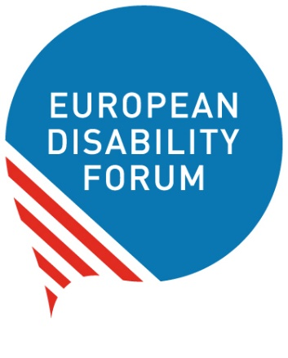

The right of women with disabilities
to have a sexual life and be mothers

Easy to read

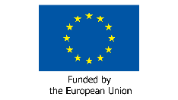
This publication has received financial support from the European Union. The information contained in this publication does not necessarily reflect the official position of the European Commission.

Who are we?
We are the European Disability Forum.
We are an organisation
of people with disabilities in Europe.
In short, we are called ‘EDF’.

At EDF, we work to protect the rights
of people with disabilities in Europe.
We think that people with disabilities
should have the same chances in life
and take part in the community like everyone else.
We also think that people with disabilities should decide about their lives.
Nothing should be decided about us without us!

What is this booklet about?

At EDF, we work a lot on the rights of women with disabilities too.
We have a group of women with disabilities who work hard
to make things better for all women with disabilities in Europe.
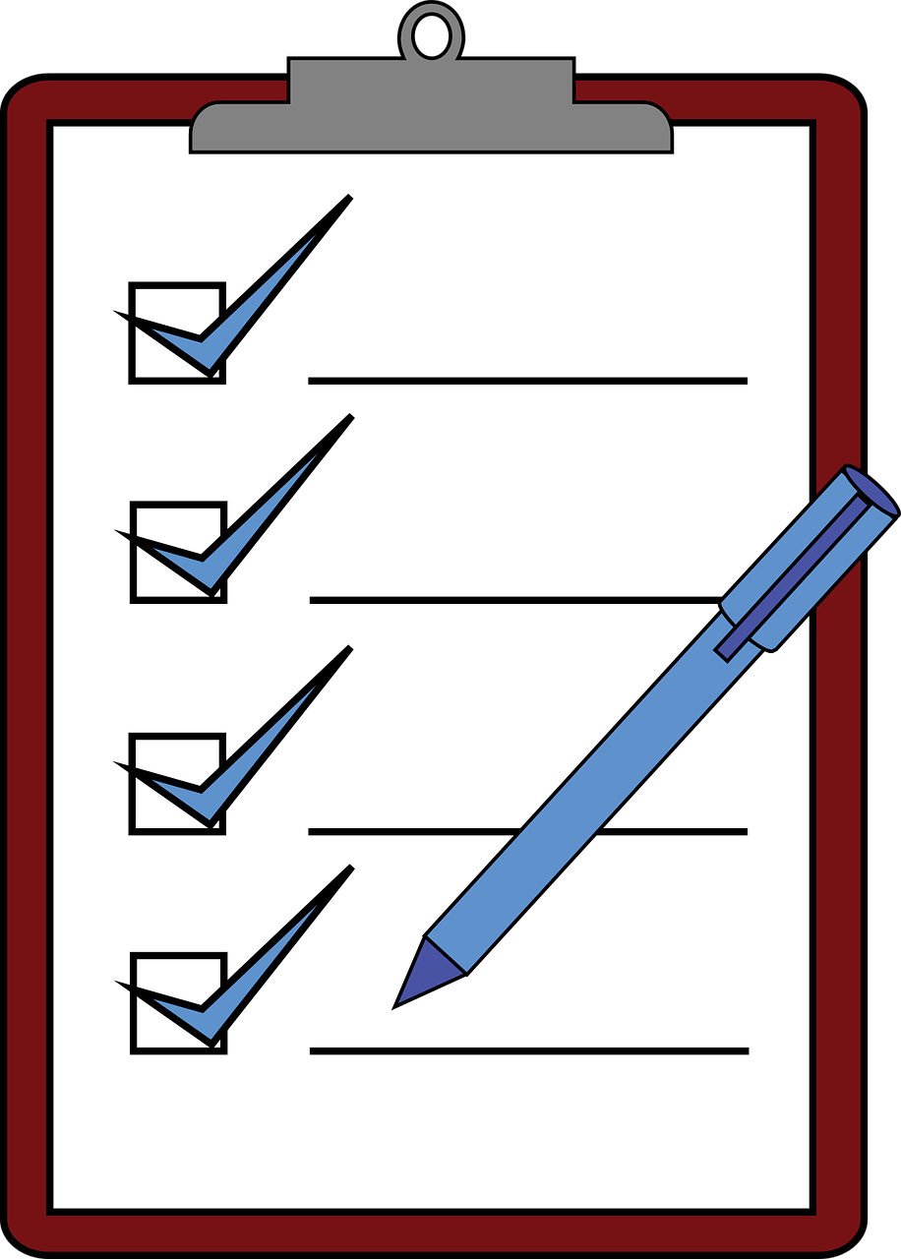
This group is called ‘Women’s Committee’.
Our Women’s Committee wrote this booklet
to talk about the right of women with disabilities
to have a sexual life and to be mothers.
This booklet also says
what countries in Europe should do to make this right happen.

How are things for women with disabilities in Europe?

Some people think that women with disabilities
cannot have a sexual life or become mothers.
Many women with disabilities do not have the chance
to decide about their lives.
Other people decide if they can have a partner
and if they can have children.
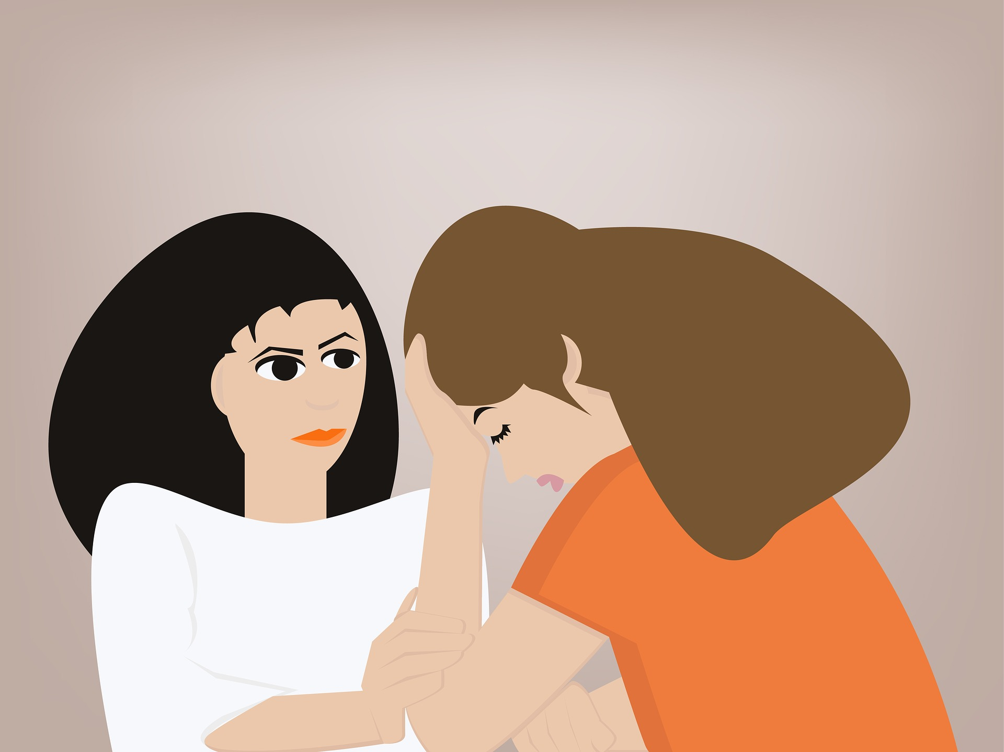

Too often, women with disabilities go through ‘sterilisation’
against their will or without being well informed about it.
‘Sterilisation’ is a medical operation that makes it impossible for women
to become mothers and have children.
This is wrong and unfair.

Things can be even harder for women with intellectual disabilities
or women who live in institutions.
They are at even bigger risk to go through sterilisation against their will.
Often it is their parents or people who run the institution they live in
who decide for them.

Sadly, too often:

- People do not think women with disabilities
can be mothers and take care of a child.

- There is not enough information about the right
of women with disabilities to have a sexual life or become mothers.
Or information is not accessible
and women with disabilities cannot learn about their rights.
For example, information may not be easy to read
so women with intellectual disabilities
cannot read and understand what their rights are.

- Hospitals and other health services are not accessible,
so women with disabilities cannot get the care they need.

- It is hard for women with disabilities to speak out or go to the court
when they feel that their rights are not respected.
They may not know who to ask for help.
Or the court may not take them seriously
just because they have a disability.
Many women with disabilities cannot even go to the court
and talk for themselves like everyone else.
Their parents or other people decide for them.

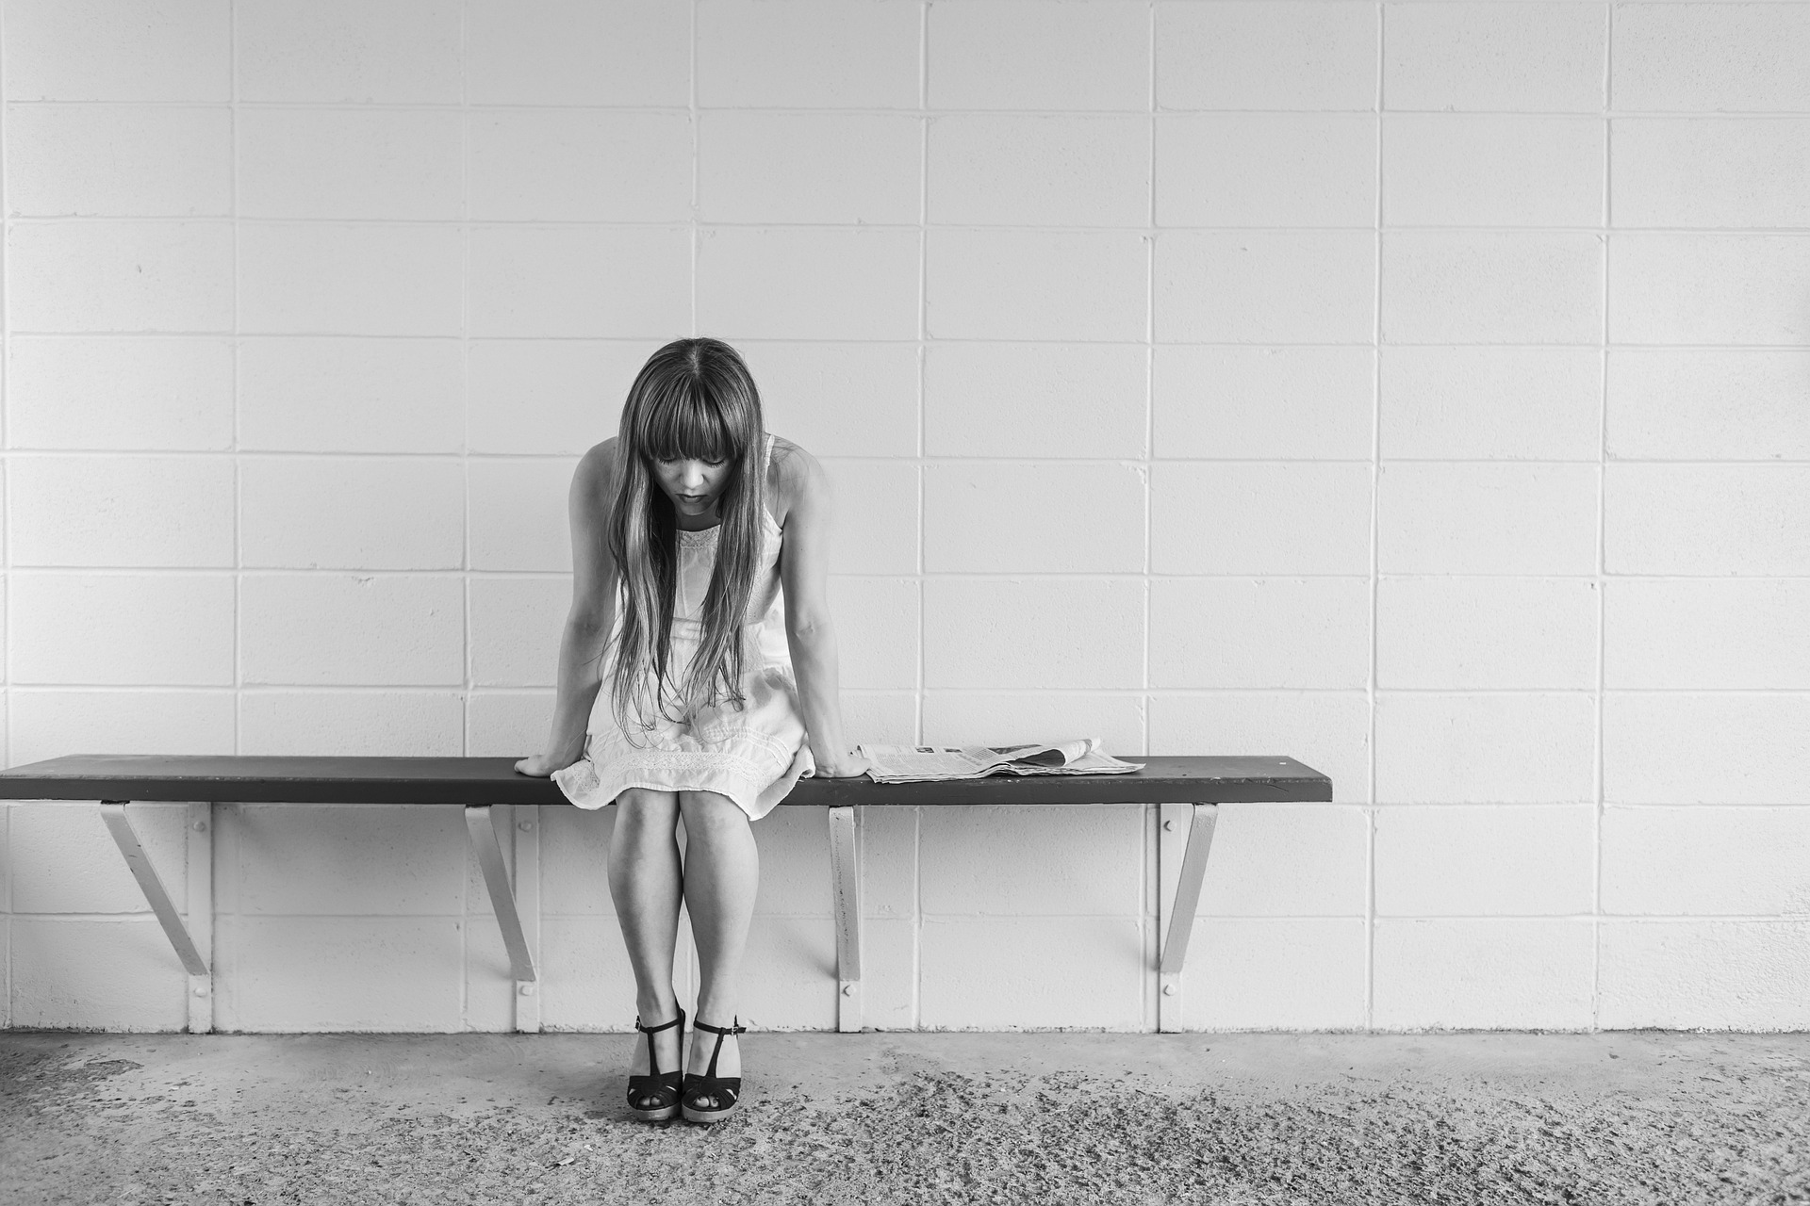

Laws to protect women with disabilities

There are laws that protect the rights of women with disabilities
and all women.

For example:

- the UN Convention on the Rights of Persons with Disabilities,

- the UN Convention to stop discrimination against women,

- the Istanbul Convention to stop violence against women.

Among other things,
these laws talk about the right of women with disabilities to:
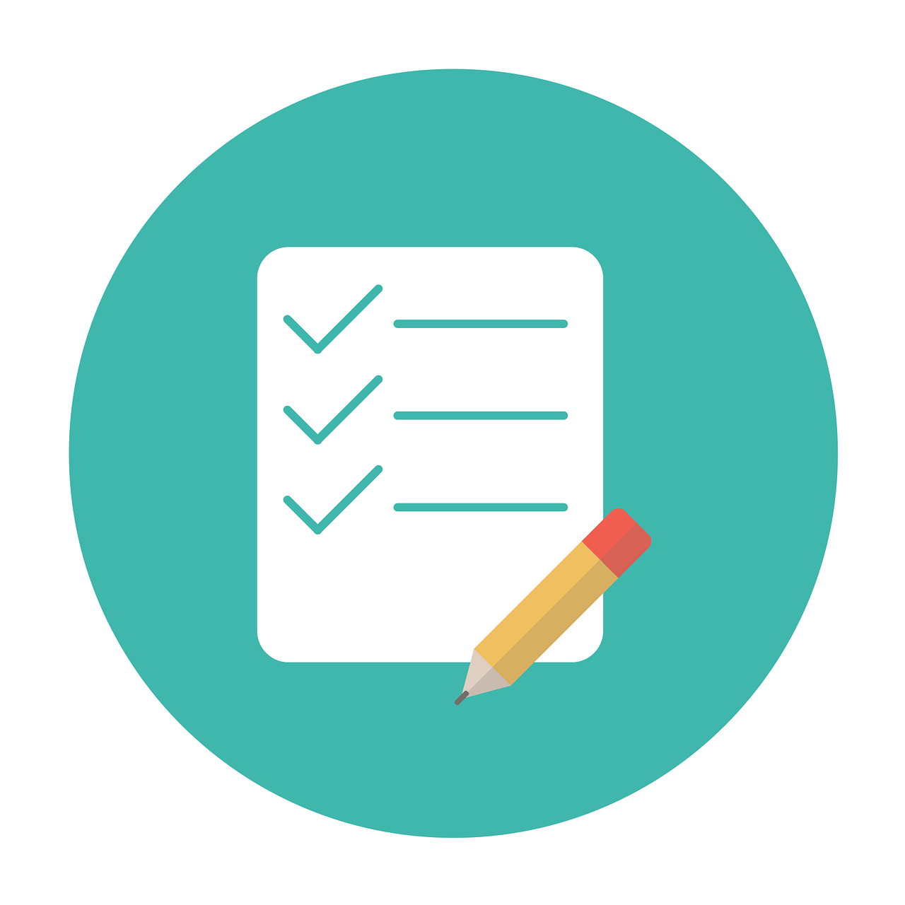
- not be treated badly or unfairly

- have a partner and a family if they want to

- decide about their lives.

Countries in Europe should work hard
to make these laws happen
and protect the rights of all women with disabilities.

The right of women to decide on their body

At EDF, we think that women have the right to decide
about their lives and their bodies.
If a woman wants to be a mother and have children,
she has the right to do it.
Countries should stop sterilisation of women with disabilities
against their will.
On the other hand, if a woman is pregnant
and she does not want to have a baby,
she can decide to have an ‘abortion’.
That is a medical operation that stops the pregnancy.
Women have the right to decide about their body
and make their own choices in life.
Nobody else should decide for them.

How to make things better

At EDF, we think that countries in Europe should work hard
to protect the right of women with disabilities
to have a healthy sexual life and be mothers if they want to.

- Countries should make sure that everyone knows
and respects the rights of women with disabilities.
For example, doctors should be trained
to understand the needs of women with disabilities
and respect their rights.
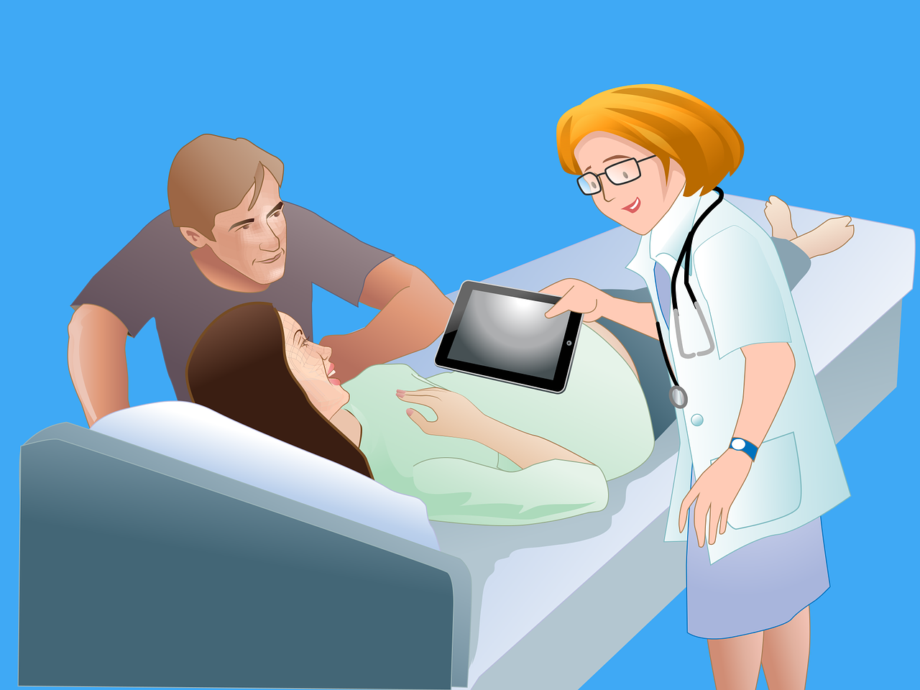

- Countries should try to change the way
people see women with disabilities.
Women with disabilities are just like any other women
and they may have a sexual life, a partner and children.
They should not be treated differently
just because they have a disability.

- Countries should make sure that
women with disabilities get information
about their rights in an accessible way.
For example, they should make information in easy to read
for women with intellectual disabilities
or in braille for blind women.

- Countries should make all things and services
accessible for women with disabilities.
For example, hospitals and health services should be accessible so women with disabilities can get help and care
when they need it.
- Countries should not forget women with disabilities
who are at higher risk of being left out.
For example, women who live in institutions
or women who have left their countries
because their lives were at risk.
The should take care of these women too.

- Countries should gather important information
about women with disabilities.
For example, they should know:
- how many women with disabilities live in institutions,
- how many have gone through sterilisation
against their will,
- how often women with disabilities are treated badly.
This information can help to make programmes and plans
to protect women with disabilities.

- Countries should listen to women with disabilities
when they make laws and decisions that concern their lives.
They should ask women with disabilities what they think
and what is good for them.

More information

If you have questions
or if you need more information
please send us an email at info@edf-feph.org.
Also, you can visit our website at www.edf-feph.org.

