2020 Report on EDF Women’s Committee work and achievements
In January 2020, EDF Women’s Committee adopted its action points for 2020, following its workplan for 2019-2021.
The Committee communicates and works essentially by e-mail. The in-persons meetings were replaced by online meetings due to the COVID-19 pandemic.
This document reviews the activities undertaken by the Committee in 2020 in accordance with its workplan and 2020 action points.

Highlights
- 2 online meetings of the Committee in May and November
- Organisations of 3 webinars in relation to the rights of women and girls with disabilities (Impact of COVID-19 on women and girls with disabilities; Training on reporting to the CEDAW Committee; Ending violence against women and girls with disabilities in the European Union)
- Participation of members in 9 external events
- Recommendations on 4 EU consultations on gender equality and women’s rights
- Publication of a Guide on engaging with the CEDAW Committee and a webpage on the Istanbul Convention
- 11 EDF Women’s Voice newsletters sent to 190 subscribers

Committee meetings
Two meetings of the Committee took place via Zoom on 11th of May and 30th of November. Captioning and Sign language interpretations was provided to the members.
On 30th of November, a representative of the European Women’s Lobby (EWL), Manon Deshayes, attended to give an update on the work of EWL.
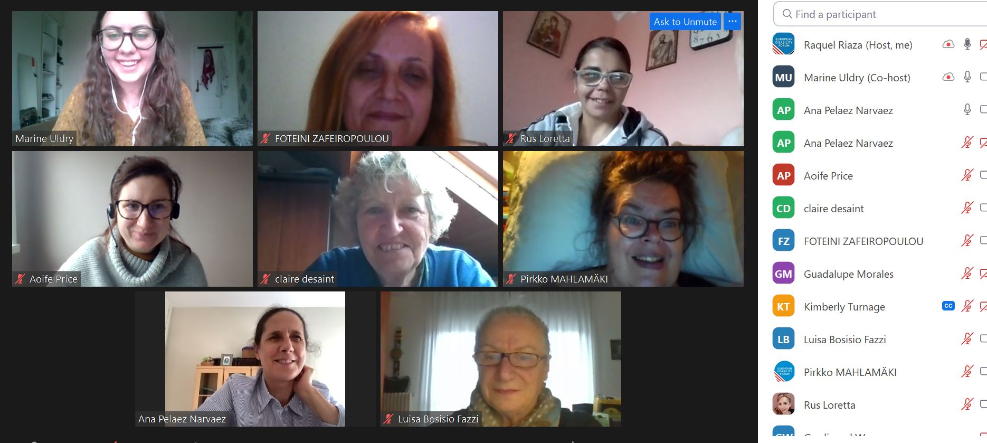

Reporting under 2020 Action Points

Action area 1 - gender mainstreaming in EU disability policies
The Committee provided input to EDF’s recommendations on the European Disability Rights Agenda (2021-2030). The recommendations on women and girls with disabilities were sent to the Gender Equality Unit to influence the inter-institutional consultation on the Strategy
Members of the Committee actively participated in the European Days of Persons with Disabilities that included a session on the Strategy. A question was asked on measures that will be taken by the EU to ensure women’s rights, and to combat violence against women and girls with disabilities.
Because of the COVID-19 pandemic, the Committee’s postponed the proposal of a hearing on women and girls with disabilities by the Disability Intergroup of the European Parliament.

Action area 2 - mainstreaming disability in EU gender equality policies
EC consultations and new policy initiatives
The Committee provided inputs for EDF’s recommendations on various strategies and policy initiatives concerning women’s rights:
- EDF’s recommendations on the Gender Equality Strategy
- EDF’s recommendations on the Gender Action Plan III (GAP III)
- EDF’s input to the consultation on the roadmap on the fitness check on legislation to combat violence against women
- EDF’s input to the consultation on pay transparency to close the gender pay gap
For the first time, the new strategies and initiatives included mentioned of the CRPD and women and girls with disabilities. Members of the Committee contributed to an online article reacting to the publication of the Gender Equality Strategy.
EDF invited representatives of the European Commission to speak and participate in webinars on the rights of women and girls with disabilities. A representative of the Gender Equality Unit spoke at EDF’s webinar on the impact of COVID-19 on women and girls with disabilities; the focal point on gender in the cabinet of Commissioner Dalli spoke at EDF’s webinar on ending violence against women and girls with disabilities in the European Union.
Advisory committee on equal opportunities for women and men
At the initiative of the Women’s Committee, EDF requested participation in the Advisory committee on equal opportunities for women and men of the European Commission. By end of 2020, EDF was not invited to participate in the work of this Committee.
EU Presidencies
Members of the Women’s Committee, Sanja Tarczay and Luisa Bosisio, participated in a conference on gender equality organised by the Croatian presidency in Zagreb.
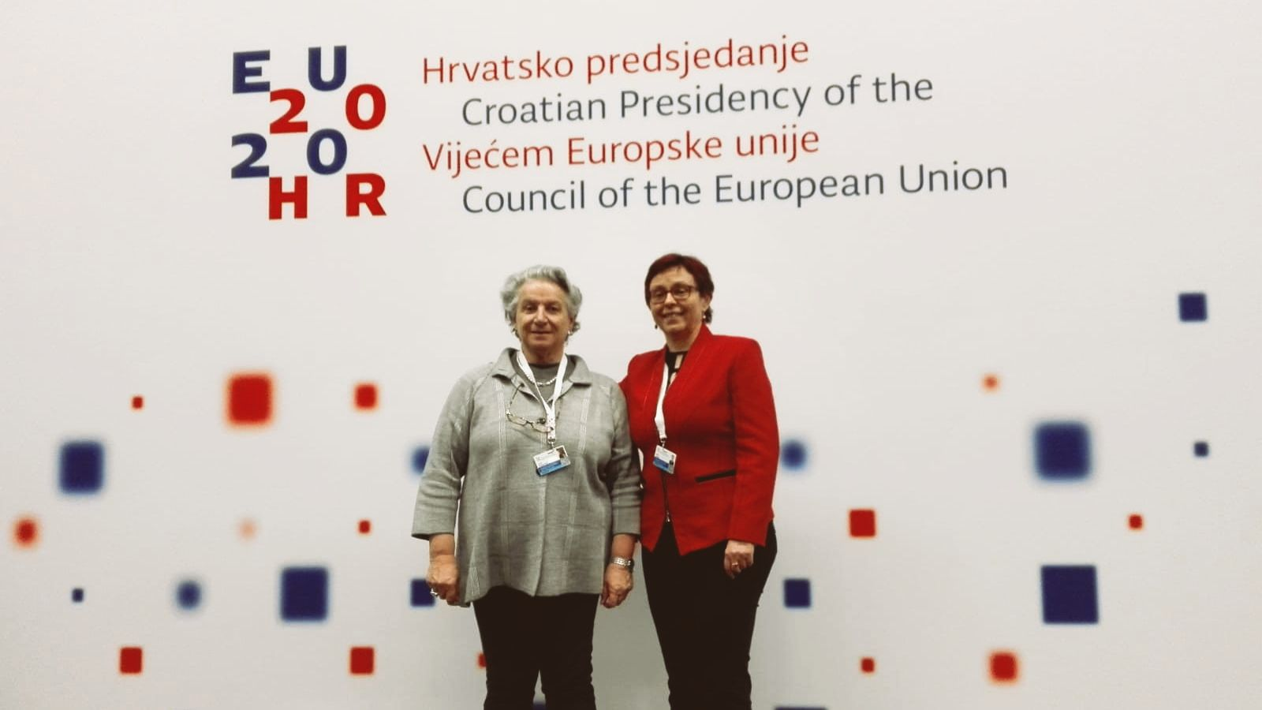
The German Presidency was not responsive to EDF’s request for active participation on events on gender equality. EDF Secretariat attended the event “Women in Focus: Coronavirus and Gender Equality in Europe” on 19 November and raise issues during the Q&A.

Action area 3 - combating violence against women and girls with disabilities
On 28th of January 2020, Ana Pelaez Narvaez and Claire Desaint participated in a Hearing on violence against women with disabilities in the Council of Europe.
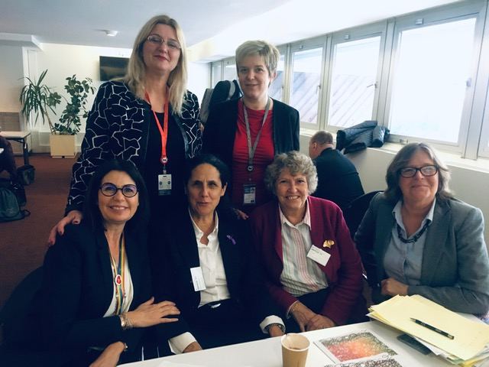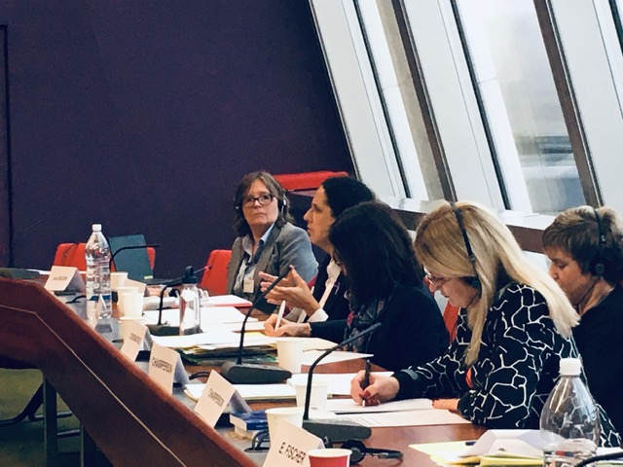
On 24th of November, EDF organised a Webinar on Ending violence against women and girls with disabilities. Members of the Committee actively participated in the event.
Istanbul Convention
With the support of the Committee, EDF conducted an online Workshop on the Istanbul Convention. The Istanbul Convention was made available in Easy to Read thanks to Autism Europe, and with the support of EDF. It is now available in 5 languages: English, French, German, Lithuanian and Spanish.
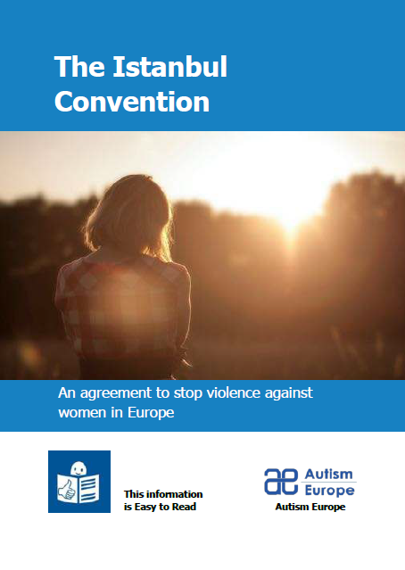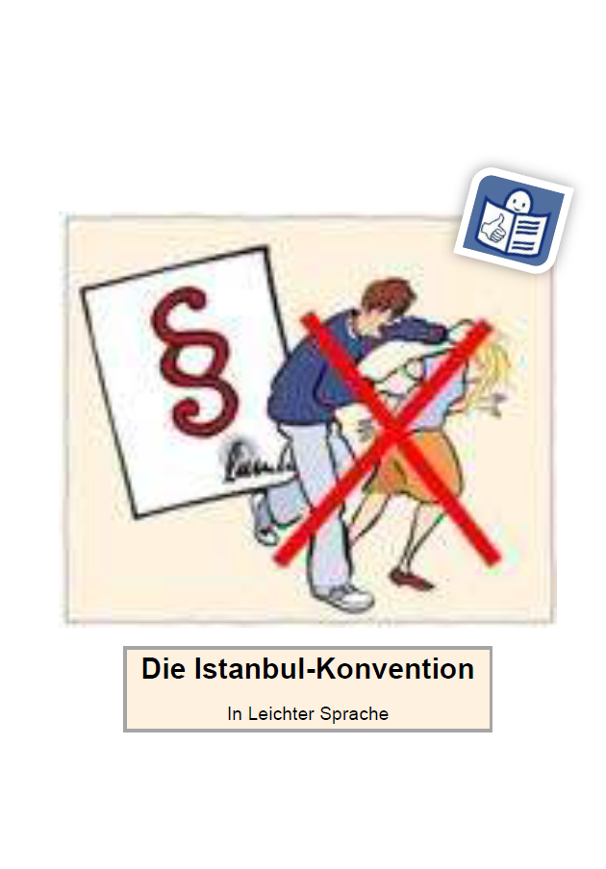
An EDF’s webpage on the Istanbul Convention was created and published in November. It provides additional resources to inform organisations of persons with disabilities and of women with disabilities on how to report on the implementation of the Convention.
EU Victims’ Rights Strategy
The Committee provided input to EDF’s recommendations on the Victims’ Rights Strategy. The Strategy includes some of EDF’s recommendations, including references to gender-based violence and services for victims with disabilities.

Action area 4 - advancing the human rights of women and girls with disabilities
COVID-19 – NEW ACTIVITY
The Committee provided input to EDF’s Human Rights Report on COVID-19.
The Committee actively participated in a Webinar on the impact of COVID-19 on women and girls with disabilities on 19th of June 2020. Members of the Committee highlighted issues faced by women and girls with disabilities during the pandemic at other webinars organised by EDF and by other actors.
Beijing +25
On 8th of April, Pirkko Mahlamäki participated in a virtual event on women and girls with disabilities organised by EDF and IDA to replace CSW side event that was cancelled. Beijing+25 conferences were postponed to 2021 due to COVID-19.
EU CRPD review
The Committee had planned to contribute to the preparation of EDF alternative report on the implementation of the CRPD by the EU. This activity did not take place because the drafting of the report was postponed because of the delay of the second review of the EU by the CRPD Committee.

Action area 5 - Women’s Committee position papers, statements and other documents
EDF published a guide on engagement of organisations of persons with disabilities in the work of the CEDAW Committee.
The Committee published a statement on the occasion of the International Day for the Elimination of Violence against Women on 25th of November (NEW ACTIVITY).

Action area 6 - monitoring international human rights treaties relevant to women and girls with disabilities
EDF organised an online training on reporting to the CEDAW Committee on 25th of September 2020.
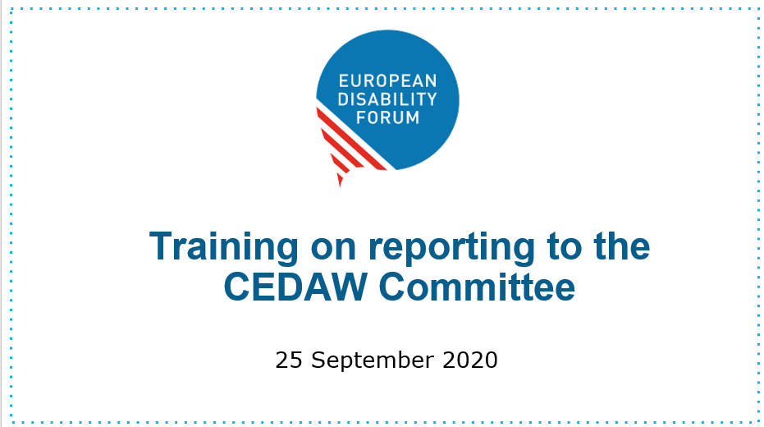
EDF Secretariat supported the submission of an alternative report on Greece, for list of issues prior to reporting on CEDAW.

Action area 7 – networking
A Turkish organisation of women with disabilities, Engelli Kadın Derneği, made a visit to Brussels in January and met with EDF and the European Women’s Lobby.
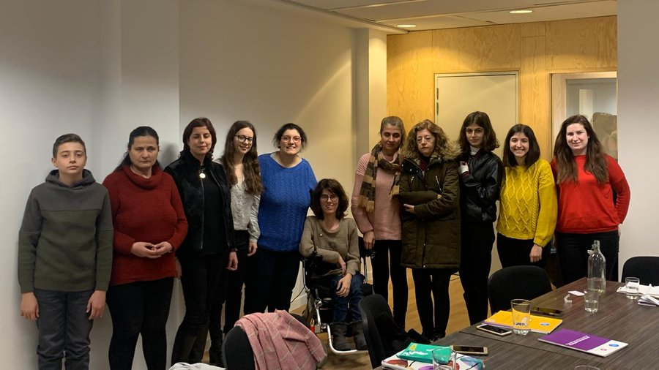
The Committee has been in contact with one new collective of women with disabilities in Poland called Article 6. Two representatives were invited to speak at EDF’s webinar on ending violence against women and girls with disabilities.

Action area 8 - external representation
European Women’s Lobby
Pirkko Mahlamäki continued to represent EDF in the European Women’s Lobby Executive Committee.
Luisa Bosisio continued to represent EDF in EWL’s Feminist Economics Working Group.
New elections and nomination in EWL’s working groups was postponed to 2021 because of COVID-19.
External events and meetings
Members of the Committee’s participate in 9 external events on disability, gender and other relevant issues to include the perspective of women and girls with disabilities at European and international levels. The full list of events is available in annex.

Action area 9 – communication
Newsletters
The Committee contributed to the newsletter EDF Women’s Voice and EDF Disability Voice annual issue on gender and ensured a gender dimension to all our newsletter.
Women’s rights issues were included in the Disability Voice and EDF board mailing. There was a specific issue of on women in the Disability Voice of March.
EDF sent 11 EDF Women’s Voice newsletters. Thematic articles were introduced in some of the newsletters on the following topics: LBTI+; death by institutional violence and neglect; police brutality; coercion in psychiatry; violence against women.
International Days
- International Women’s Day: EDF published a specific issue of the Disability Voice on women and girls with disabilities and dedicated tweets on women and girls with disabilities.
- International Day for the Elimination of Violence Against women: series of tweets was published along with a statement on the occasion of the International Day for the Elimination of Violence against Women.
Website
EDF updated the webpage of the Women’s Committee (for instance with the work programme and report on 2019 activities) and the page on women and gender equality (with information on the Gender Equality Strategy, and recent publication and recommendations)

Annex: participation in external events and meetings

EVENT | PLACE | DATE | WHO IS INVOLVED
Hearing on violence against women with disabilities | Council of Europe (Strasbourg) | 28th January | Ana Peláez (EDF Vice-president) and Claire Desaint (member of EDF Women’s Committee)
Conference on Gender Equality | Zagreb | 30th -31st January | Luisa Bosisio, Sanja Tarczay
IDA EDF virtual event on women and girls with disabilities | Virtual (in replacement of the CSW side event that was cancelled) | 8th April | Pirkko Mahlamäki
Council of Europe Workshop on “Advancing Gender Equality: The role and situation for gender equality mechanisms in the context of COVID-19” | Online | 21st October | Ana Peláez Narváez
EDbU 4th Conference “DeSIGNed Europe for Deafblind Women” | Online | 22nd October | Ana Peláez Narváez
Equinet roundtable Women in Poverty | Online | 22nd October | Pirkko Mahlamäki
Launch of the EDF/Sightsavers paper on women with disabilities and international cooperation | Online | 29th October | Jenny Nilsson
Bridging the Gap - online workshop “Achieving inclusion of women with disabilities: the experience of Bridging the Gap” | Online | 12th November | Ana Peláez Narváez
High-level launch event for Gender Action Plan III | Online- European Commission (in cooperation with European External Action Service and the German Presidency) | 25th November | Ana Peláez Narváez

