AFCO Committee & the Rights of Persons with Disabilities

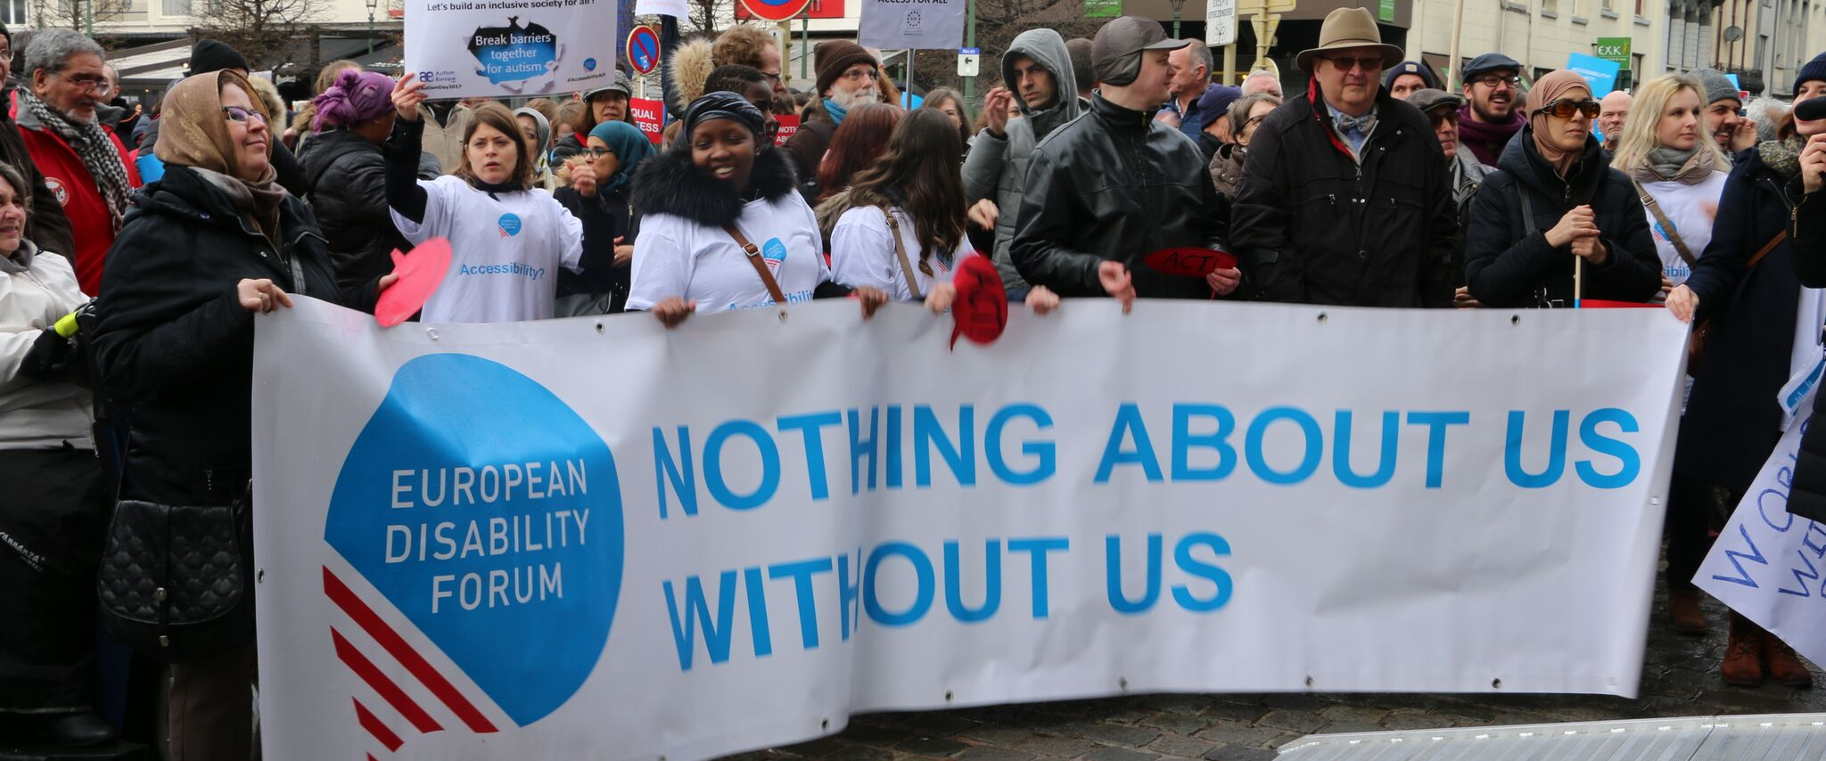
The aim of this document is to give general information concerning why and how the Parliament, and particularly the Constitutional Affairs Committee, can improve the lives of persons with disabilities in the European Union and beyond.
There are 100 million persons with disabilities (this number includes 99 million persons according to the EU-SILC survey of 2016 and 1 million persons estimated to be segregated in residential institutions and therefore not counted on the survey). Persons with disabilities experience legal, physical and attitudinal barriers that hinder their independent living and full participation in all aspects of life on an equal basis with others.

European Disability Forum
The European Disability Forum (EDF) is an umbrella organisation of persons with disabilities that defends the interests of Europeans with disabilities. We are a strong, united voice of persons with disabilities in Europe that collaborates closely with the European Parliament in ensuring that the interests and needs of persons with disabilities are taken into account.

Disability Intergroup
The Disability Intergroup of the European Parliament is an informal grouping of MEPs interested in promoting the right policies for persons with disabilities within their work at Parliament and national level. It was established in 1980 and is an efficient network through which to communicate and coordinate work on disability policies. If you are interested in joining the Disability Intergroup, please contact alejandro.moledo@edf-feph.org.

UNCRPD
The United Nations Convention on the Rights of Persons with Disabilities (UNCRPD) is an international human rights treaty ratified by the EU and all its Member States. It commits all who ratify it to implement and promote the full realisation of all human rights for all persons with disabilities through the adoption of new political tools and review of existing policies. In 2015 the CRPD Committee adopted specific recommendations to be followed by the EU in its Concluding observations on the initial report of the EU.
The European Parliament is bound to take the UNCRPD into account in all its legislative work and processes. As a public entity, it is also obliged to ensure that citizens and personnel with disabilities have equal rights to their peers.

European Charter of Fundamental Rights
The European Charter of Fundamental Rights addresses EU institutions and national authorities when implementing EU law. Article 26 states that “the EU recognises and respects the right of persons with disabilities to benefit from measures designed to ensure their independence, social and occupational integration, and participation in the life of the community”. Article 21 prohibits any discrimination on the basis of disability. As such, the European Parliament has a double responsibility to ensure non-discrimination and promote the full participation of persons with disabilities in all aspect of life. Read the EU Charter of Fundamental Rights.

Constitutional Affairs – AFCO Committee

In the last EU elections, 800,000 persons with disabilities from 16 Member States, particularly persons with intellectual and psychosocial disabilities, could not exercise their right to vote. Besides, many more cannot vote because of lack of accessibility. In this regard, t0here are many accessibility barriers that prevent persons with disabilities from voting and standing as candidates on an equal basis with others. For example, in 8 Member States it is not possible to change the polling station if this is not accessible, and blind and partially sighted voters cannot exercise their right to vote independently in 18 Member States.
The AFCO Committee has responsibilities on the EU electoral law and must remedy this undemocratic situation before the next EU elections in 2024.

Political Priorities
- Adopt a resolution amending the European electoral act from 1976, ensuring that all persons with disabilities can fully enjoy their right to vote.
- Promote the necessary changes to ensure accessibility for persons with disabilities as voters and candidates, as well as in any mechanism put in place to facilitate the participation of citizens in public affairs.
- Ensure an interinstitutional approach to the implementation of the UN Convention on the Rights of Persons with Disabilities.

Useful resources
- European Economic and Social Committee report “The real right of persons with disabilities to vote in EP elections” available in all EU languages.
- Fundamental Rights Agency report: “Who will (not) get to vote in the 2019 European Parliament elections?”
- Mental Health Europe “Manifesto for better mental health in Europe for the European Elections 2019”
- Election-Watch.EU “Election Assessment Mission”
- Inclusion Europe maps on the Right to Vote in Europe, and recommendations for accessible elections.
- OSCE guideline on promoting the political participation of persons with disabilities

Contac
Milan Šveřepa: Inclusion Europe - Director
Alejandro Moledo: EDF Policy Coordinator

