BUDG Committee & the Rights of Persons with Disabilities

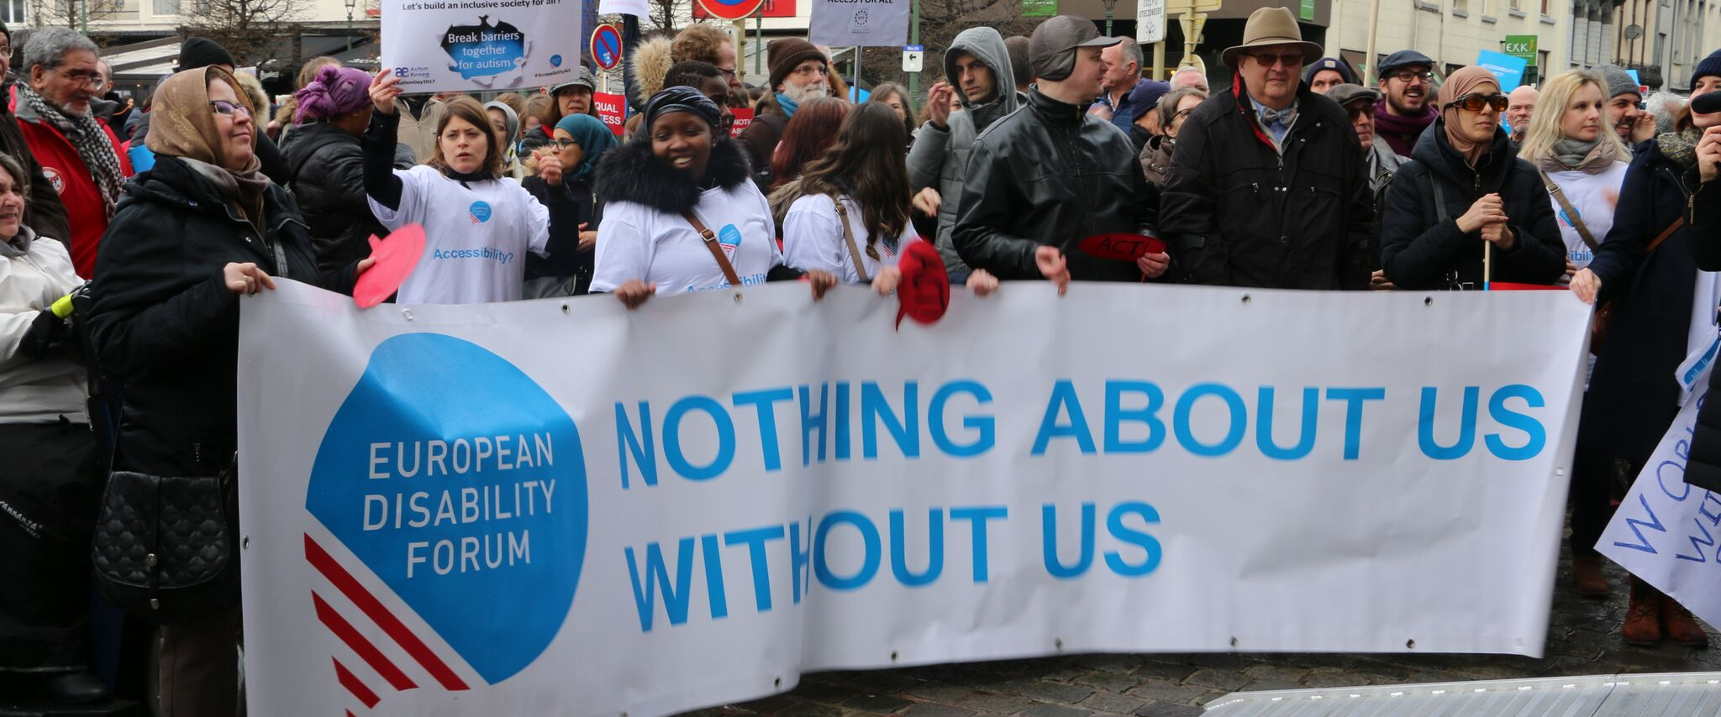
The aim of this document is to give general information concerning why and how the Parliament, and particularly the Budgets Committee, can improve the lives of persons with disabilities in the European Union and beyond.
There are 100 million persons with disabilities (this number includes 99 million persons according to the EU-SILC survey of 2016 and 1 million persons estimated to be segregated in residential institutions and therefore not counted on the survey). Persons with disabilities experience legal, physical and attitudinal barriers that hinder their independent living and full participation in all aspects of life on an equal basis with others.

European Disability Forum
The European Disability Forum (EDF) is an umbrella organisation of persons with disabilities that defends the interests of Europeans with disabilities. We are a strong, united voice of persons with disabilities in Europe that collaborates closely with the European Parliament in ensuring that the interests and needs of persons with disabilities are taken into account.

Disability Intergroup
The Disability Intergroup of the European Parliament is an informal grouping of MEPs interested in promoting the right policies for persons with disabilities within their work at Parliament and national level. It was established in 1980 and is an efficient network through which to communicate and coordinate work on disability policies. If you are interested in joining the Disability Intergroup, please contact alejandro.moledo@edf-feph.org.

UNCRPD
The United Nations Convention on the Rights of Persons with Disabilities (UNCRPD) is an international human rights treaty ratified by the EU and all its Member States. It commits all who ratify it to implement and promote the full realisation of all human rights for all persons with disabilities through the adoption of new political tools and review of existing policies. In 2015 the CRPD Committee adopted specific recommendations to be followed by the EU in its Concluding observations on the initial report of the EU.
The European Parliament is bound to take the UNCRPD into account in all its legislative work and processes. As a public entity, it is also obliged to ensure that citizens and personnel with disabilities have equal rights to their peers.

European Charter of Fundamental Rights
The European Charter of Fundamental Rights addresses EU institutions and national authorities when implementing EU law. Article 26 states that “the EU recognises and respects the right of persons with disabilities to benefit from measures designed to ensure their independence, social and occupational integration, and participation in the life of the community”. Article 21 prohibits any discrimination on the basis of disability. As such, the European Parliament has a double responsibility to ensure non-discrimination and promote the full participation of persons with disabilities in all aspect of life. Read the EU Charter of Fundamental Rights.

Budgets – BUDG Committee

Effective policy is not only about ideas. It is about ensuring that these ideas are followed up on. The distribution of the EU budget is key in determining whether or not certain policies and initiatives will achieve their goals. This is why the European Disability Forum sees the BUDG Committee as crucial in delivering the rights of persons with disabilities.

Political Priorities
- European Disability Strategy 2020-2030: Adopt a new, more ambitious Strategy in line with CRPD obligations. Over the past decade the Commission has been implementing its European Disability Strategy in order to mainstream disability issues into its policy making.
- Funding for the Disability Strategy: Monitor and develop effective monitoring mechanisms during the conception of legislative proposals and initiatives by allocating a sufficient budget for this means. The BUDG Committee can be hugely influential in ensuring the budget is in place to ensure the future Disability Strategy produces outcomes in areas where the current Strategy fell short.
- An ambitious budget for Cohesion and Values, and external action: Ensure that funding is not reduced in the areas of Cohesion and Values and external action. It is particularly important to protect the amounts foreseen for funds that have a significant impact on furthering social inclusion, equal opportunities and accessibility for persons with disabilities, such as the Social Funds Plus, Erasmus+ and the Solidarity Corps, the Regional Development Fund, then Rights and Values programme and the NDICI.

Useful resources
- Your Rights in the EU

Contact
Haydn Hammersley: EDF Social Policy officer

