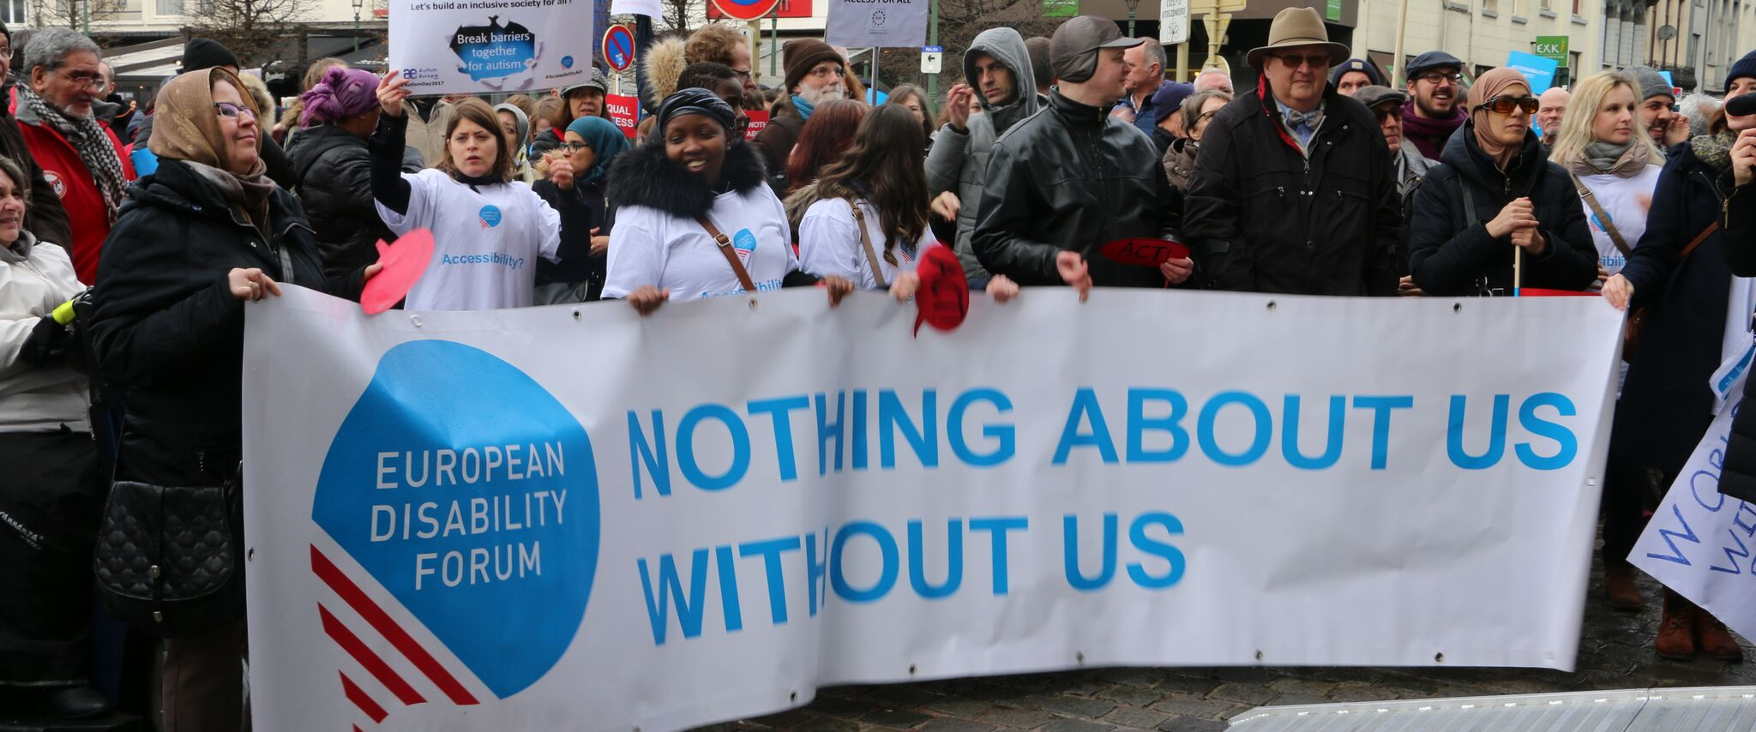
CULT Committee & the Rights of Persons with Disabilities

The aim of this document is to give general information concerning why and how the Parliament, and particularly the Culture and Education Committee, can improve the lives of persons with disabilities in the European Union and beyond.
There are 100 million persons with disabilities (this number includes 99 million persons according to the EU-SILC survey of 2016 and 1 million persons estimated to be segregated in residential institutions and therefore not counted on the survey). Persons with disabilities experience legal, physical and attitudinal barriers that hinder their independent living and full participation in all aspects of life on an equal basis with others.

European Disability Forum
The European Disability Forum (EDF) is an umbrella organisation of persons with disabilities that defends the interests of Europeans with disabilities. We are a strong, united voice of persons with disabilities in Europe that collaborates closely with the European Parliament in ensuring that the interests and needs of persons with disabilities are taken into account.

Disability Intergroup
The Disability Intergroup of the European Parliament is an informal grouping of MEPs interested in promoting the right policies for persons with disabilities within their work at Parliament and national level. It was established in 1980 and is an efficient network through which to communicate and coordinate work on disability policies. If you are interested in joining the Disability Intergroup, please contact alejandro.moledo@edf-feph.org.

UNCRPD
The United Nations Convention on the Rights of Persons with Disabilities (UNCRPD) is an international human rights treaty ratified by the EU and all its Member States. It commits all who ratify it to implement and promote the full realisation of all human rights for all persons with disabilities through the adoption of new political tools and review of existing policies. In 2015 the CRPD Committee adopted specific recommendations to be followed by the EU in its Concluding observations on the initial report of the EU.
The European Parliament is bound to take the UNCRPD into account in all its legislative work and processes. As a public entity, it is also obliged to ensure that citizens and personnel with disabilities have equal rights to their peers.

European Charter of Fundamental Rights
The European Charter of Fundamental Rights addresses EU institutions and national authorities when implementing EU law. Article 26 states that “the EU recognises and respects the right of persons with disabilities to benefit from measures designed to ensure their independence, social and occupational integration, and participation in the life of the community”. Article 21 prohibits any discrimination on the basis of disability. As such, the European Parliament has a double responsibility to ensure non-discrimination and promote the full participation of persons with disabilities in all aspect of life. Read the EU Charter of Fundamental Rights

Culture and Education – CULT Committee

The CULT committee is responsible for education and mobility programmes such as Erasmus+ or Solidarity Corps. It is essential that young persons with disabilities can access these programmes on an equal basis with others, for which accessibility and reasonable accommodation must always be ensured. The lack of these caused that in the last Erasmus program, only 0.17% of the beneficiaries were persons with disabilities.
The CULT committee also leads in dossiers related to culture and media, such as the Creative Europe programme or the recently adopted Audiovisual Media Services Directive, in which accessibility should be incorporated (e.g. by ensuring that audiovisual content always includes subtitles and audio description).
The CULT committee is responsible for the cultural aspects of the European Union, and in particular the protection and promotion of cultural and linguistic diversity. It is essential that the Committee also considers different cultures in the disability community, e.g. deaf culture and linguistic diversity of national sign languages in the EU, by recognising and protecting the 31 sign languages and promoting their legal recognition and use in the EU Member States.
Similarly, the Committee can also support the learning, promotion and use of Braille by blind and partially sighted people.
Last but not least, we expect the CULT Committee to stand strong in the promotion of inclusive education of persons with disabilities. It is paramount to ensure that children and adults with disabilities are not placed in segregated education systems. Currently, many learners with disabilities across Europe cannot find a school which would accept them, they are segregated and not included in mainstream education or allowed to attend but at reduced hours. Sometimes, they do not receive any kind of education at all. The CULT committee must therefore support policies ensuring inclusive education for all with the necessary individualised support when needed.

Political Priorities
- Erasmus+ and European Solidarity Corps: Provide reasonable accommodation (the necessary adaptations or services such as sign language interpretation and personal assistants) for persons with disabilities to access the programs on an equal basis with others, and provide all the necessary information in accessible formats.
- Creative Europe: Ensure that all EU funded within this budget line will respect and promote accessibility for persons with disabilities.
- Audiovisual Media Services Directive and other files related to media: Ensure that European audiovisual media becomes fully accessible for persons with disabilities, through provision of necessary access services including subtitles, audio description, sign language interpretation and spoken subtitles.

Useful resources
- Your Rights in the EU
- EDF’s Priorities for an Inclusive Erasmus+
- Recommendations on Making the Erasmus+ Programme 2021-2027 more inclusive
- Media Accessibility (technical document)
- European Union of the Deaf: Sign Language Legislation in the European Union (2nd edition)
- Inclusion Europe ‘We are desperate’: Students with disabilities left without solution as pupils return to school

Contacts
Martyna Balciunaite: European Union of the Deaf Policy Officer
Antoine Fobe: European Blind Union Head of Campaigning
Loredana Dicsi: Youth Policies
Mher Hakobyan: EDF accessibility officer

