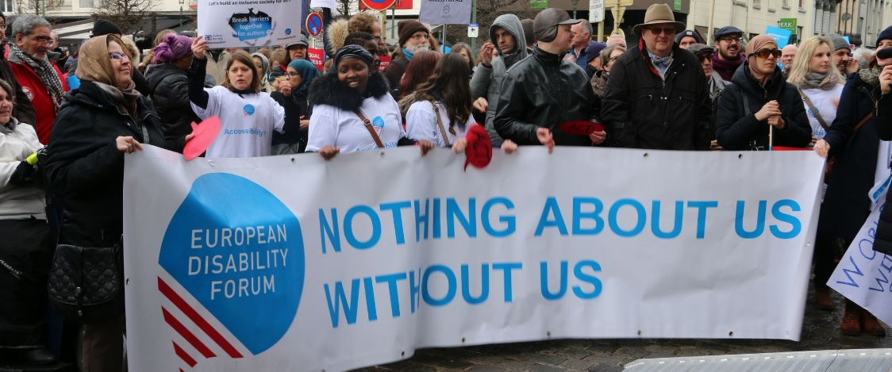
DEVE Committee & the Rights of Persons with Disabilities

The aim of this document is to give general information concerning why and how the Parliament, and particularly the Development Committee, can improve the lives of persons with disabilities in the European Union and beyond.
There are 100 million persons with disabilities (this number includes 99 million persons according to the EU-SILC survey of 2016 and 1 million persons estimated to be segregated in residential institutions and therefore not counted on the survey). Persons with disabilities experience legal, physical and attitudinal barriers that hinder their independent living and full participation in all aspects of life on an equal basis with others.

European Disability Forum
The European Disability Forum (EDF) is an umbrella organisation of persons with disabilities that defends the interests of Europeans with disabilities. We are a strong, united voice of persons with disabilities in Europe that collaborates closely with the European Parliament in advocating for the rights of persons with disabilities.

International Disability and Development Consortium
The International Disability and Development Consortium (IDDC) and its members aim to promote inclusive development. Inclusive development means respecting the full human rights of every person, acknowledging diversity, eradicating poverty and ensuring that all people are fully included and can actively participate in development processes and activities regardless of age, gender, disability, state of health, ethnic origin or any other characteristic.

Disability Intergroup
The Disability Intergroup of the European Parliament is an informal grouping of MEPs interested in promoting the right policies for persons with disabilities within their work at Parliament and national level. It was established in 1980 and is an efficient network through which to communicate and coordinate work on disability policies. If you are interested in joining the Disability Intergroup, please contact alejandro.moledo@edf-feph.org.

UNCRPD
The United Nations Convention on the Rights of Persons with Disabilities (UNCRPD) is an international human rights treaty ratified by the EU and all its Member States. It commits all who ratify it to implement and promote the full realisation of all human rights for all persons with disabilities through the adoption of new political tools and review of existing policies. In 2015 the CRPD Committee adopted specific recommendations to be followed by the EU in its Concluding observations on the initial report of the EU. The European Parliament is bound to take the UNCRPD into account in all its legislative work and processes. As a public entity, it is also obliged to ensure that citizens and personnel with disabilities have equal rights to their peers.

European Charter of Fundamental Rights
The European Charter of Fundamental Rights addresses EU institutions and national authorities when implementing EU law. Article 26 states that “the EU recognises and respects the right of persons with disabilities to benefit from measures designed to ensure their independence, social and occupational integration, and participation in the life of the community”. Article 21 prohibits any discrimination on the basis of disability. As such, the European Parliament has a double responsibility to ensure non-discrimination and promote the full participation of persons with disabilities in all aspect of life. Read the EU Charter of Fundamental Rights.

Development – DEVE Committee

The European Union (EU) plays an important role on the international scene, when it comes to development cooperation, humanitarian action and human rights. For instance, the EU and its 28 Member States are the largest development donor in the world (according to OECD's Development Assistance Committee, 2018) and its upcoming draft budget devotes €89.2 billion to external actions over seven years.
Both EU institutions and all EU Member States having ratified the Convention on the rights of Persons with disabilities (CRPD), they are committed to implement its articles 11 (situation of risk and humanitarian emergencies) and 32 (international cooperation). This commitment to the CRPD is also clearly reflected in the European Consensus on Development adopted in 2017.
It is necessary to actively include persons with disabilities in the work of the EU in international cooperation and humanitarian action. There are about one billion people, or 15% of the world’s population, who experience some form of disabilities. 80% of them live in developing countries, where the EU is striving to eradicate poverty. The EU must work with persons with disabilities and their representative organisations (DPOs) to build the capacity of the disability movement and ensure no one is left behind.
EDF and IDDC (International Disability and Development Consortium) jointly advocates for the European Union to become a global leader in disability inclusive development – adopting disability inclusive development policies, programmes, budget and global cooperation agreements while overall promoting the rights of persons with disabilities.

Political Priorities
- Adopt a new European Disability Strategy 2020-2030 is adopted and it has stronger references to EU external relations, international cooperation and humanitarian action;
- Include persons with disability and promote accessibility in the new Neighbourhood, Development and International Cooperation Instrument (NDICI) budget
- Meet the CRPD obligations – including the ones in its external action – and actively monitor progress;
- Support partner countries in their implementation and monitoring of the CRPD;
- Actively engage persons with disabilities and organisations of persons with disabilities in international cooperation – not just as beneficiaries but also as experts;
- Actively implement and monitor the new 2019 ECHO “Operational Guidance on the Inclusion of Persons with Disabilities in EU-funded Humanitarian Aid Operations”
- Facilitate access to data on disability, including new-borns with disabilities, who are often not registered at birth.

Useful resources
- IDDC “The European Union, Disability, and International Development: a guide for MEPs” (2019)
- ECHO Operational Guidance on the Inclusion of Persons with Disabilities in EU-funded Humanitarian Aid Operations (2019)
- EDF Human Rights report on Disability-inclusive Sustainable Development Goals in Europe and in international cooperation (2017)
- EDF international cooperation strategy “EDF in the world” (2019)
- EU Action Plan on Human Rights and Democracy (2015)
- European Consensus for Development (2017)

Contacts
Marion Steff: EDF International Cooperation Manager
Francois Carbonez: IDDC EU Task Group Coordinator

