DROI Subcommittee & the Rights of Persons with Disabilities

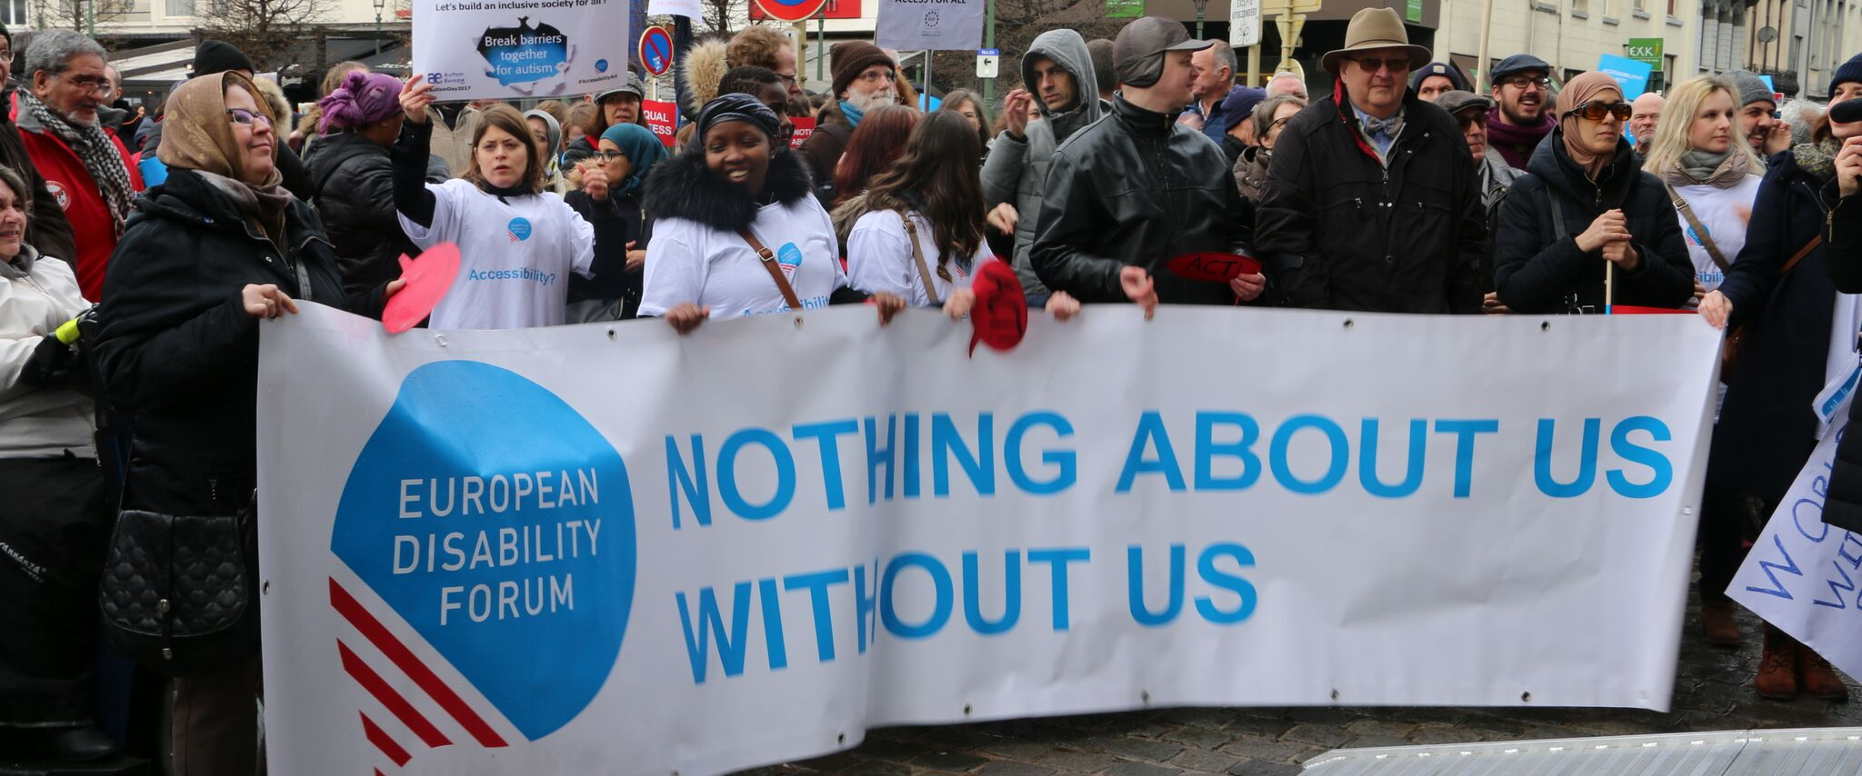
The aim of this document is to give general information concerning why and how the Parliament, and particularly the Human Rights Committee, can improve the lives of persons with disabilities in the European Union and beyond.
There are 100 million persons with disabilities (this number includes 99 million persons according to the EU-SILC survey of 2016 and 1 million persons estimated to be segregated in residential institutions and therefore not counted on the survey). Persons with disabilities experience legal, physical and attitudinal barriers that hinder their independent living and full participation in all aspects of life on an equal basis with others.

European Disability Forum
The European Disability Forum (EDF) is an umbrella organisation of persons with disabilities that defends the interests of Europeans with disabilities. We are a strong, united voice of persons with disabilities in Europe that collaborates closely with the European Parliament in ensuring that the interests and needs of persons with disabilities are taken into account.

International Disability and Development Consortium
The International Disability and Development Consortium (IDDC) and its members aim to promote inclusive development. Inclusive development means respecting the full human rights of every person, acknowledging diversity, eradicating poverty and ensuring that all people are fully included and can actively participate in development processes and activities regardless of age, gender, disability, state of health, ethnic origin or any other characteristic.

Disability Intergroup
The Disability Intergroup of the European Parliament is an informal grouping of MEPs interested in promoting the right policies for persons with disabilities within their work at Parliament and national level. It was established in 1980 and is an efficient network through which to communicate and coordinate work on disability policies. If you are interested in joining the Disability Intergroup, please contact alejandro.moledo@edf-feph.org.

UNCRPD
The United Nations Convention on the Rights of Persons with Disabilities (UNCRPD) is an international human rights treaty ratified by the EU and all its Member States. It commits all who ratify it to implement and promote the full realisation of all human rights for all persons with disabilities through the adoption of new political tools and review of existing policies. In 2015 the CRPD Committee adopted specific recommendations to be followed by the EU in its Concluding observations on the initial report of the EU. The European Parliament is bound to take the UNCRPD into account in all its legislative work and processes. As a public entity, it is also obliged to ensure that citizens and personnel with disabilities have equal rights to their peers.

European Charter of Fundamental Rights
The European Charter of Fundamental Rights addresses EU institutions and national authorities when implementing EU law. Article 26 states that “the EU recognises and respects the right of persons with disabilities to benefit from measures designed to ensure their independence, social and occupational integration, and participation in the life of the community”. Article 21 prohibits any discrimination on the basis of disability. As such, the European Parliament has a double responsibility to ensure non-discrimination and promote the full participation of persons with disabilities in all aspect of life. Read the EU Charter of Fundamental Rights.

Human Rights – DROI Subcommittee

One billion people (15% of the world’s population) experience some form of disabilities. Despite the ratification of the UNCRPD by 180 countries and by the EU, persons with disabilities are at an increased risk of discrimination, violence and violation of their fundamental rights. Among them, persons with disabilities from other marginalised groups, such as women and girls with disabilities, LGBTI people with disabilities, older people disabilities, persons with disabilities from racial, ethnic or religious minorities, as well as migrants, refugees and asylum-seekers with disabilities, are even more at risk of human rights violation.
The Subcommittee on Human Rights should ensure that the implementation of EU instruments in the field of human rights and democracy, and its own resolution, complies with the CRPD and the 2030 Agenda for Sustainable Development, and includes the perspective of persons with disabilities.

Political Priorities
- Implement and monitor of the CRPD worldwide;
- Adopt a new European Disability Strategy 2020-2030 based on the CRPD and cover EU external relations, international cooperation and humanitarian action;
- Disability-inclusive EU external relations and instruments in the field of human rights and democracy;
- Mainstream the CRPD into all the EU's activities and policies with increased coherence and synergies between EU internal and external policies;
- Consult and actively engage persons with disabilities and worldwide organisations of persons with disabilities in the development and implementation of legislation and policies to implement the CRPD, and in other decision-making processes concerning issues relating to persons with disabilities.

Useful resources
- EDF Human Rights Report on Disability-inclusive Sustainable Development Goals in Europe and in international cooperation (2017)
- IDDC “The European Union, Disability, and International Development: a guide for MEPs” (2019)
- EDF Report on ending forced sterilisation of women and girls with disabilities (2017)
- EDF Human Rights Report on Equality and Non-Discrimination (2019)
- EDF Position paper on sexual and reproductive health and rights of women and girls with disabilities (2019)
- EU Action Plan on Human Rights and Democracy (2015)

Contacts
An-Sofie Leenknecht: EDF Human Rights Coordinator
Francois Carbonez: IDDC EU Task Group Coordinator
Marine Uldry: EDF Human Rights Officer
Marion Steff: EDF International Cooperation Manager

