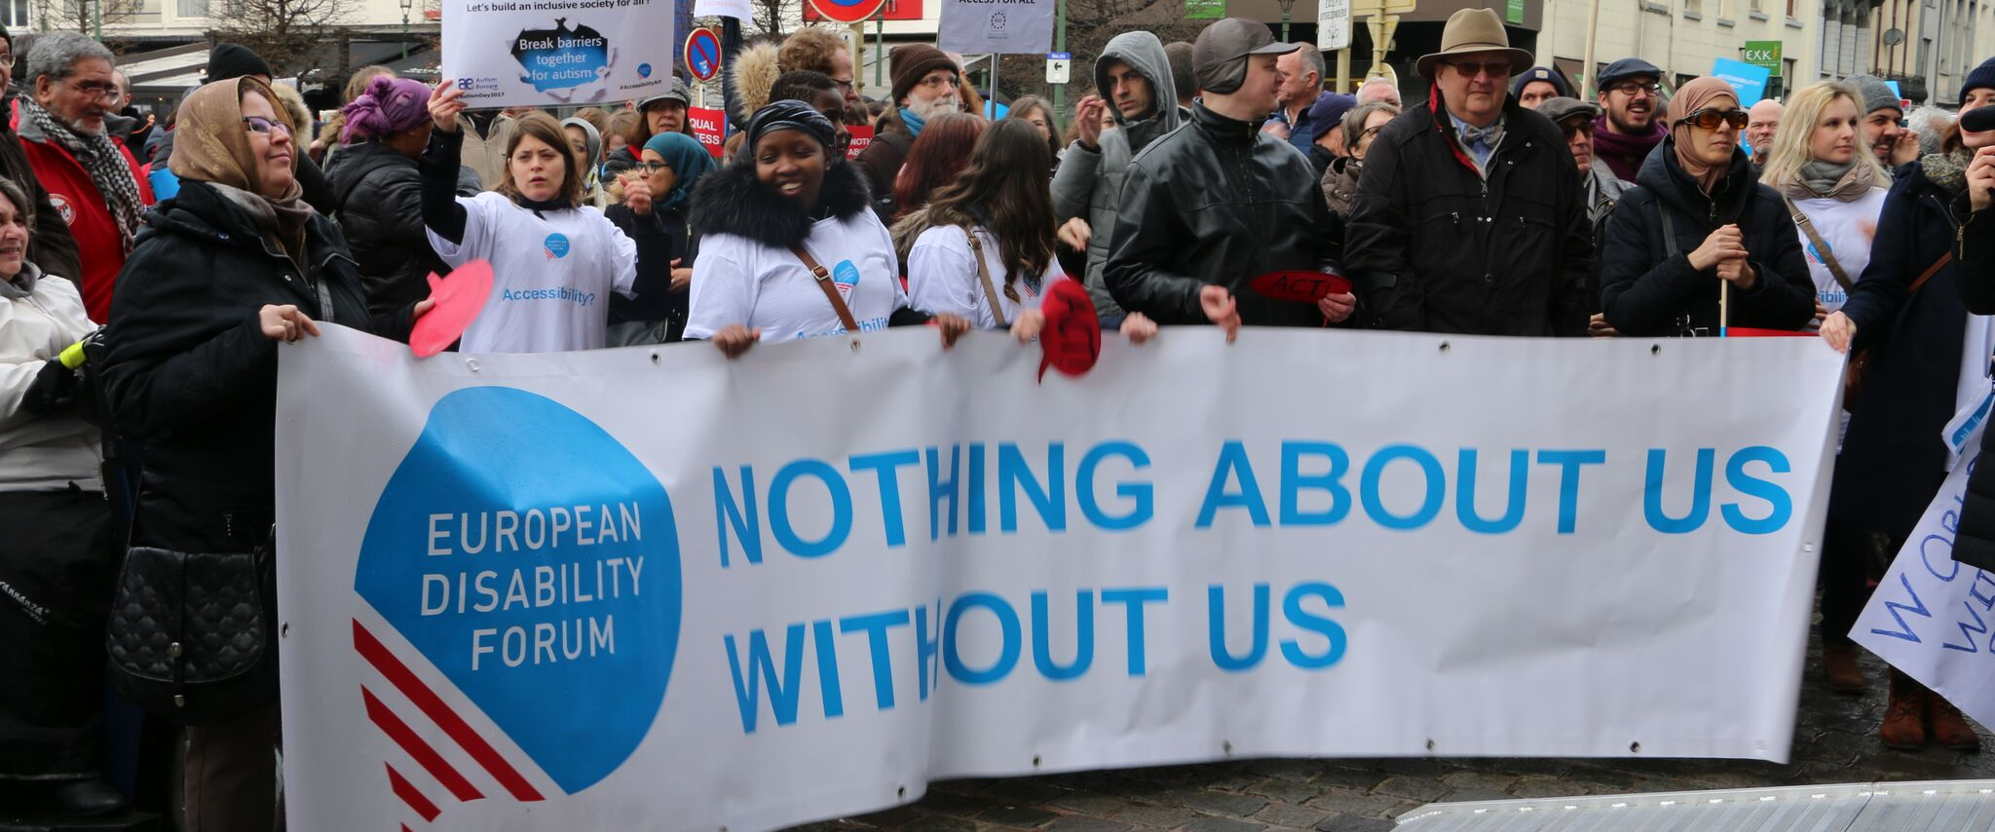
ENVI Committee & the Rights of Persons with Disabilities

The aim of this document is to give general information concerning why and how the Parliament, and particularly the Environment, Public Health and Food Safety Committee, can improve the lives of persons with disabilities in the European Union and beyond.
There are 100 million persons with disabilities (this number includes 99 million persons according to the EU-SILC survey of 2016 and 1 million persons estimated to be segregated in residential institutions and therefore not counted on the survey). Persons with disabilities experience legal, physical and attitudinal barriers that hinder their independent living and full participation in all aspects of life on an equal basis with others.

European Disability Forum
The European Disability Forum (EDF) is an umbrella organisation of persons with disabilities that defends the interests of Europeans with disabilities. We are a strong, united voice of persons with disabilities in Europe that collaborates closely with the European Parliament in ensuring that the interests and needs of persons with disabilities are taken into account.

Disability Intergroup
The Disability Intergroup of the European Parliament is an informal grouping of MEPs interested in promoting the right policies for persons with disabilities within their work at Parliament and national level. It was established in 1980 and is an efficient network through which to communicate and coordinate work on disability policies. If you are interested in joining the Disability Intergroup, please contact alejandro.moledo@edf-feph.org.

UNCRPD
The United Nations Convention on the Rights of Persons with Disabilities (UNCRPD) is an international human rights treaty ratified by the EU and all its Member States. It commits all who ratify it to implement and promote the full realisation of all human rights for all persons with disabilities through the adoption of new political tools and review of existing policies. In 2015 the CRPD Committee adopted specific recommendations to be followed by the EU in its Concluding observations on the initial report of the EU.
The European Parliament is bound to take the UNCRPD into account in all its legislative work and processes. As a public entity, it is also obliged to ensure that citizens and personnel with disabilities have equal rights to their peers.

European Charter of Fundamental Rights
The European Charter of Fundamental Rights addresses EU institutions and national authorities when implementing EU law. Article 26 states that “the EU recognises and respects the right of persons with disabilities to benefit from measures designed to ensure their independence, social and occupational integration, and participation in the life of the community”. Article 21 prohibits any discrimination on the basis of disability. As such, the European Parliament has a double responsibility to ensure non-discrimination and promote the full participation of persons with disabilities in all aspect of life. Read the EU Charter of Fundamental Rights.

Environment, Public Health and Food Safety – ENVI Committee

As we move away from the medical model of disability (focused on diagnosis and cure of disabilities as an “illness”) towards the social model (focused on improving accessibility for all), the question of quality healthcare, diagnosis, and disability assessment remain crucial in upholding the rights of persons with disabilities and ensuring better quality of life.
Going forward it is essential to focus on the necessary link between ensuring that the EU develops in a sustainable way that protects our environment and doing so in an inclusive way with accessible results. This is an area where EDF sees true potential of the ENVI Committee for persons with disabilities.

Political Priorities
- Sustainability and accessibility: Explore and strengthen the link between sustainable development/environmental protection and accessibility for persons with disabilities.
- Access to healthcare on an equal basis with others: Push for the removal of barriers (physical, attitudinal, intellectual, psychological, and financial) preventing persons with disabilities from accessing quality healthcare in line with their needs in Member States and provide information in accessible formats.
- Harmonisation of disability assessment: Harmonise the disability assessment and recognition to allow persons with disabilities to enjoy freedom of movement and work abroad on an equal footing with others. Eliminate the need for re-assessment by medical staff when moving to another Member State and speed up entitlement to necessary support services and rights.
- Call for a Mental Health Strategy for Europe: Create a cooperation framework between Member States and coherence of actions between different policy sectors.
- Transparent and multidisciplinary healthcare system: Ensure increased transparency in healthcare and access to unbiased information in relation to different health services (e.g. support services in mental health, side effects, conflict of interest etc.). Additionally, an integrated and multidisciplinary approach throughout their lifespan, which focuses not only on their physical health but also their mental and social wellbeing, is of utmost importance.
- Promote investments in research on prevention, recovery, solutions to coercion and investment in non-coercive mental health services.
- Raising awareness: Provide training for medical professionals on disabilities in order to tackle persisting stigma and misconceptions on intellectual and physical disabilities. Up-to date information and international guidelines are needed for the treatment and care of persons with disabilities.

Useful resources
- Your Rights in the EU
- Mental Health Europe reaction to the Draft Council Conclusions on the Economy of Well-being
- Shedding Light on transparent cooperation in healthcare

Contact
Marcin Rodzinka: MHE Advocacy & Policy Officer
Athina Giannoutsou: IF European Policy Officer
Haydn Hammersley: EDF Social Policy officer
Marie Denninghaus: EDF Policy Coordinator

