FEMM Committee & the Rights of Persons with Disabilities

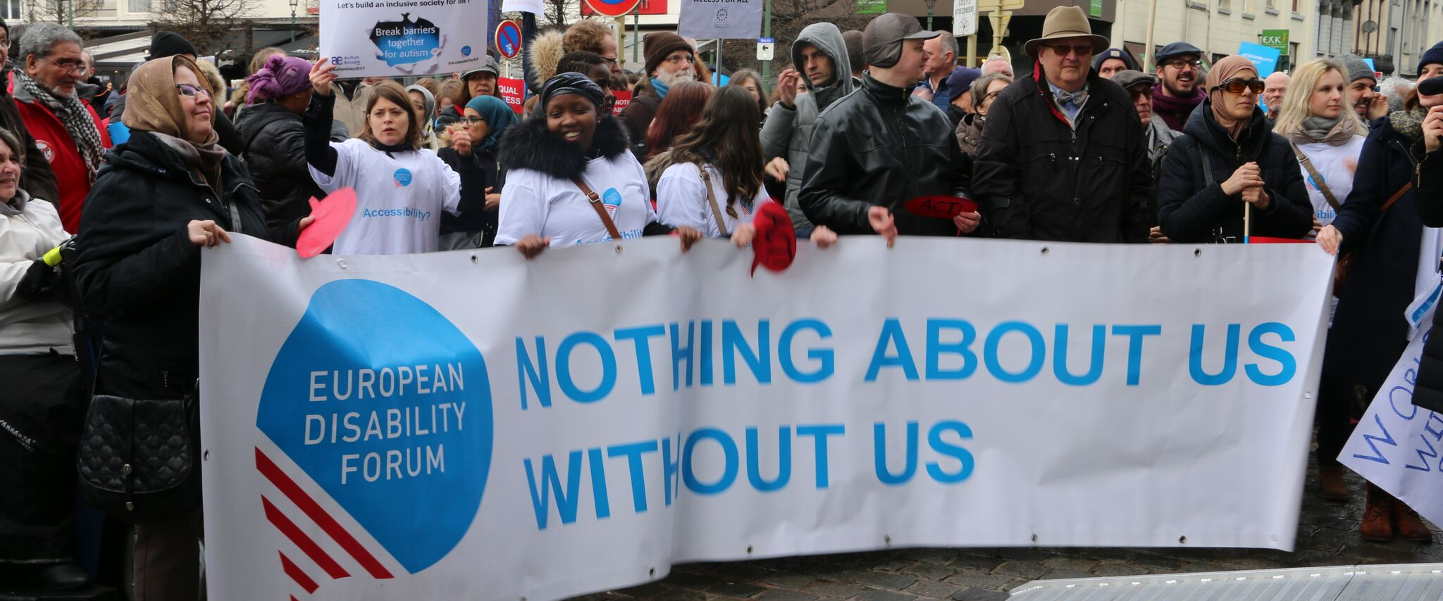
The aim of this document is to give general information concerning why and how the Parliament, and particularly the Women’s Rights and Gender Equality Committee, can improve the lives of persons with disabilities in the European Union and beyond.
There are 100 million persons with disabilities (this number includes 99 million persons according to the EU-SILC survey of 2016 and 1 million persons estimated to be segregated in residential institutions and therefore not counted on the survey). Persons with disabilities experience legal, physical and attitudinal barriers that hinder their independent living and full participation in all aspects of life on an equal basis with others.

European Disability Forum
The European Disability Forum (EDF) is an umbrella organisation of persons with disabilities that defends the interests of Europeans with disabilities. We are a strong, united voice of persons with disabilities in Europe that collaborates closely with the European Parliament in ensuring that the interests and needs of persons with disabilities are taken into account.

Disability Intergroup
The Disability Intergroup of the European Parliament is an informal grouping of MEPs interested in promoting the right policies for persons with disabilities within their work at Parliament and national level. It was established in 1980 and is an efficient network through which to communicate and coordinate work on disability policies. If you are interested in joining the Disability Intergroup, please contact alejandro.moledo@edf-feph.org.

UNCRPD
The United Nations Convention on the Rights of Persons with Disabilities (UNCRPD) is an international human rights treaty ratified by the EU and all its Member States. It commits all who ratify it to implement and promote the full realisation of all human rights for all persons with disabilities through the adoption of new political tools and review of existing policies. In 2015 the CRPD Committee adopted specific recommendations to be followed by the EU in its Concluding observations on the initial report of the EU.
The European Parliament is bound to take the UNCRPD into account in all its legislative work and processes. As a public entity, it is also obliged to ensure that citizens and personnel with disabilities have equal rights to their peers.

European Charter of Fundamental Rights
The European Charter of Fundamental Rights addressed to EU institutions and national authorities when implementing EU law states that “the EU recognises and respects the right of persons with disabilities to benefit from measures designed to ensure their independence, social and occupational integration, and participation in the life of the community” (article 26). It also prohibits any discrimination on the basis of disability (article 21). As such, the European Parliament has a double responsibility to ensure non-discrimination and promote the full participation of persons with disabilities in all aspect of life. Read the EU Charter of Fundamental Rights.

Women’s Rights and Gender Equality – FEMM Committee

Women with disabilities constitute 16% of the total population of women in Europe, and 60% of the overall population of persons with disabilities.
Women with disabilities face multiple and intersectional discrimination in all areas of life, including, socio-economic disadvantages, social isolation, violence against women, forced sterilisation and abortion, lack of access to community services, low-quality housing, institutionalisation, inadequate healthcare and denial of the opportunity to contribute and engage actively in society. Women with disabilities are also exposed to violence at a higher rate: 6 out of 10 women with intellectual disabilities report being sexually abused.
The status of women with disabilities is not only worse than that of women without disabilities, but also worse than that of their male peers. This is especially so in rural areas with fewer services and opportunities for this group than in urban environments.
The FEMM Committee has an important role to play to ensure the rights and perspectives of women and girls with disabilities are included and mainstreamed in the work of the European Parliament.

Political Priorities
- European Disability Strategy 2020-2030: Adopt a European Disability Strategy for 2020-2030 promoting gender equality and including the perspective of women and girls with disabilities
- Istanbul Convention: Accede to the Council of Europe Convention on preventing and combating violence against women and domestic violence (Istanbul Convention) as a step to combating violence against women and girls with disabilities
- A new EU Strategy on Gender Equality post-2019: Adopt an ambitious EU Strategy on Gender for 2019-2024 inclusive of women and girls with disabilities, in line with article 6 of the CRPD and General Comment No. 3 on women with disabilities adopted by the UN Committee on the Rights of Persons with Disabilities.
- Urgently address the well-documented knowledge gap about sexual and reproductive health of women and girls, on preconception and prenatal health (include prevention of birth defects through balanced diet and healthy life choices), and accessible sexual and reproductive healthcare services for women and girls with various disabilities (with a special attention to women from migrant or low socio-economic background).
- Raising awareness: Provide training for medical professionals on health rights of girls and women with disabilities; improve the accessibility of medical facilities, devices (such as gynaecological chairs) and health information; public campaigns to change perceptions about girls and women with disabilities as weak, dependent and sexless beings.

Useful resources
- CRPD General Comment No. 3 on women with disabilities
- European Parliament resolution on the situation of women with disabilities
- EDF 2nd Manifesto on the Rights of Women & Girls with Disabilities in the EU
- EDF Report on ending forced sterilisation of women and girls with disabilities
- EDF Position paper on sexual and reproductive health and rights of women and girls with disabilities
- Life after violence. A study on how women with intellectual disabilities cope with violence experienced in institutions.
- EDF Women’s Voice newsletter

Contact
Milan Sverepa: Inclusion Europe director
Athina Giannoutsou: IF European Policy Officer
Marine Uldry: EDF Human Rights Officer
An-Sofie Leenknecht: EDF Human Rights Coordinator

