IMCO Committee & the Rights of Persons with Disabilities

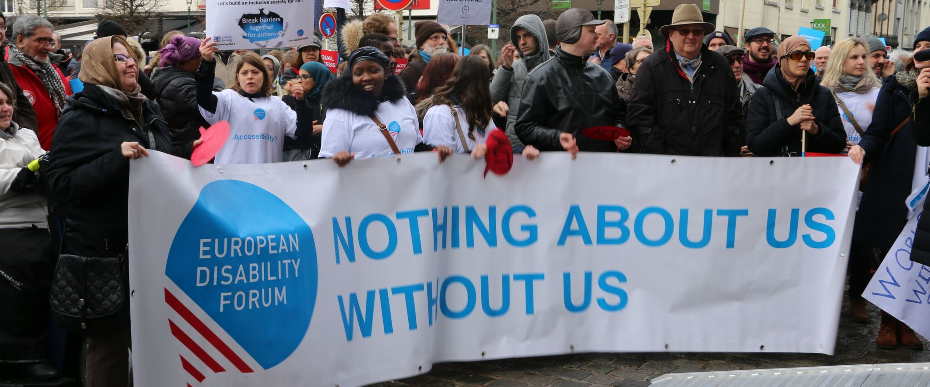
The aim of this document is to give general information concerning why and how the Parliament, and particularly the Internal Market and Consumer Protection Committee, can improve the lives of persons with disabilities in the European Union and beyond.
There are 100 million persons with disabilities (this number includes 99 million persons according to the EU-SILC survey of 2016 and 1 million persons estimated to be segregated in residential institutions and therefore not counted on the survey). Persons with disabilities experience legal, physical and attitudinal barriers that hinder their independent living and full participation in all aspects of life on an equal basis with others.

European Disability Forum
The European Disability Forum (EDF) is an umbrella organisation of persons with disabilities that defends the interests of Europeans with disabilities. We are a strong, united voice of persons with disabilities in Europe that collaborates closely with the European Parliament in ensuring that the interests and needs of persons with disabilities are taken into account.

Disability Intergroup
The Disability Intergroup of the European Parliament is an informal grouping of MEPs interested in promoting the right policies for persons with disabilities within their work at Parliament and national level. It was established in 1980 and is an efficient network through which to communicate and coordinate work on disability policies. If you are interested in joining the Disability Intergroup, please contact alejandro.moledo@edf-feph.org.

UNCRPD
The United Nations Convention on the Rights of Persons with Disabilities (UNCRPD) is an international human rights treaty ratified by the EU and all its Member States. It commits all who ratify it to implement and promote the full realisation of all human rights for all persons with disabilities through the adoption of new political tools and review of existing policies. In 2015 the CRPD Committee adopted specific recommendations to be followed by the EU in its Concluding observations on the initial report of the EU.
The European Parliament is bound to take the UNCRPD into account in all its legislative work and processes. As a public entity, it is also obliged to ensure that citizens and personnel with disabilities have equal rights to their peers.

European Charter of Fundamental Rights
The European Charter of Fundamental Rights addressed to EU institutions and national authorities when implementing EU law states that “the EU recognises and respects the right of persons with disabilities to benefit from measures designed to ensure their independence, social and occupational integration, and participation in the life of the community” (article 26). It also prohibits any discrimination on the basis of disability (article 21). As such, the European Parliament has a double responsibility to ensure non-discrimination and promote the full participation of persons with disabilities in all aspect of life. Read the EU Charter of Fundamental Rights.

Internal Market and Consumer Protection - IMCO Committee

We appreciate the crucial role that IMCO Committee has in relation to the Single Market, including the Digital Single Market, consumers protection and freedom of movement. IMCO members must be the frontrunners in setting accessibility for persons with disabilities as a pre-requisite for any initiative concerning the products and services in the Internal Market, as well as understanding the specific needs of persons with disabilities as consumers.

Political Priorities
- Beyond the European Accessibility Act: Directive (EU) 2019/882 is a major step forward to further integrate the EU internal market and advance accessibility of goods and services for persons with disabilities. However, the limited scope of the Act will need to be complemented by further action on other key products and services for which a harmonised approach to accessibility will be beneficial for consumers and the EU single market as a whole (e.g. built environment, household appliances, tourism services, medical devices, etc.)
- Call for an EU action on assistive technologies: assistive technologies are crucial for enabling many persons with disabilities to live independently. EU should play a leading role on setting a regulatory framework for these technologies to contribute to further integration of the Single Market, as many persons with disabilities cannot access the most suitable piece of assistive technology due to different national delivery provision systems.
- Upcoming Digital Services Act: we call for ensuring that digital service platform respect the same accessibility requirements set out in the European Accessibility Act and in the 2016 Web Accessibility Directive.
- Accessible digitalisation: any new proposal boosting digitalisation in the EU, regardless if meant for citizens or public or private entities, should live up to the same accessibility standards as the Web Accessibility Directive and the European Accessibility Act.
- Emerging technologies, including Artificial Intelligence have great enabling potential for persons with disabilities. At the same time, it is important to foresee and mitigate possible risks in relation to further discrimination and segregation, as well as user privacy concerns.
- Monitoring the effective implementation of the four Directives tackling accessibility in the EU Single Market: the European Accessibility Act (Directive 2019/882), the European Electronic Communications Code (Directive 2018/1972), the Audiovisual Media Services Directive (Directive 2018/1808), and the Web Accessibility Directive (Directive 2016/2102).
- Protection of consumers with disabilities: persons with disabilities face additional barriers when it comes to exercising their consumer rights because of different factors such as lack of accessible information and alternative means of communication and redress.

Useful resources
- EDF webpage and analysis of the European Accessibility Act
- Economic benefits of accessibility - facts and figures
- Your Rights in the EU
- EDF resource on web accessibility.
- EDF work on ICT accessibility.
- Plug and Pray report: a disability perspective on artificial intelligence, automated decision making and emerging technologies.

Contacts
Mher Hakobyan: EDF Accessibility Officer
Alejandro Moledo: EDF Policy Coordinator

