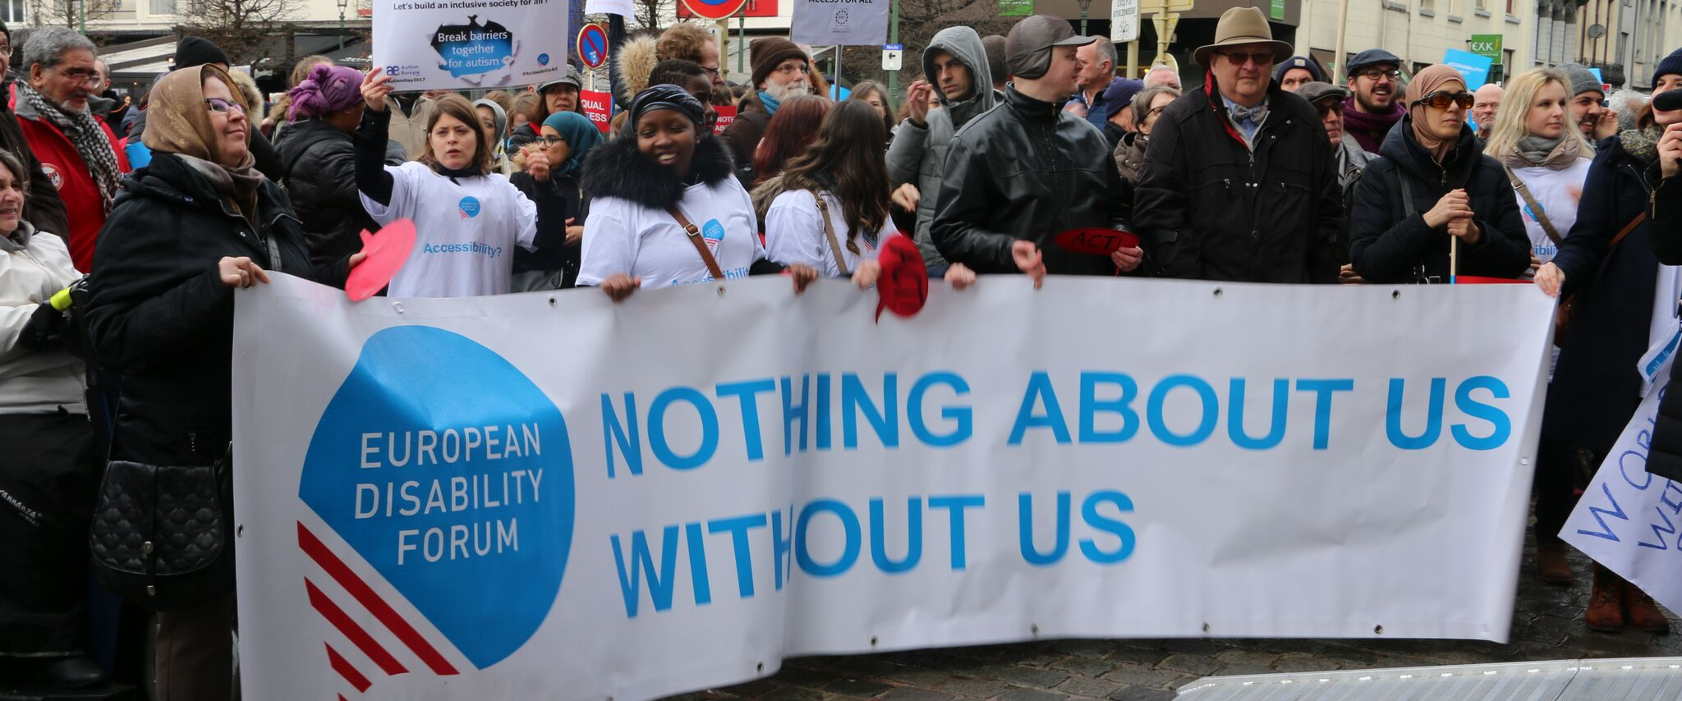
ITRE Committee & the Rights of Persons with Disabilities

The aim of this document is to give general information concerning why and how the Parliament, and particularly your Committee, can improve the lives of persons with disabilities in the European Union and beyond.
There are 100 million persons with disabilities (this number includes 99 million persons according to the EU-SILC survey of 2016 and 1 million persons estimated to be segregated in residential institutions and therefore not counted on the survey). Persons with disabilities experience legal, physical and attitudinal barriers that hinder their independent living and full participation in all aspects of life on an equal basis with others.

European Disability Forum
The European Disability Forum (EDF) is an umbrella organisation of persons with disabilities that defends the interests of Europeans with disabilities. We are a strong, united voice of persons with disabilities in Europe that collaborates closely with the European Parliament in ensuring that the interests and needs of persons with disabilities are taken into account.

Disability Intergroup
The Disability Intergroup of the European Parliament is an informal grouping of MEPs interested in promoting the right policies for persons with disabilities within their work at Parliament and national level. It was established in 1980 and is an efficient network through which to communicate and coordinate work on disability policies. If you are interested in joining the Disability Intergroup, please contact alejandro.moledo@edf-feph.org.

UNCRPD
The United Nations Convention on the Rights of Persons with Disabilities (UNCRPD) is an international human rights treaty ratified by the EU and all its Member States. It commits all who ratify it to implement and promote the full realisation of all human rights for all persons with disabilities through the adoption of new political tools and review of existing policies. In 2015 the CRPD Committee adopted specific recommendations to be followed by the EU in its Concluding observations on the initial report of the EU.
The European Parliament is bound to take the UNCRPD into account in all its legislative work and processes. As a public entity, it is also obliged to ensure that citizens and personnel with disabilities have equal rights to their peers.

European Charter of Fundamental Rights
The European Charter of Fundamental Rights addresses EU institutions and national authorities when implementing EU law. Article 26 states that “the EU recognises and respects the right of persons with disabilities to benefit from measures designed to ensure their independence, social and occupational integration, and participation in the life of the community”. Article 21 prohibits any discrimination on the basis of disability. As such, the European Parliament has a double responsibility to ensure non-discrimination and promote the full participation of persons with disabilities in all aspect of life. Read the EU Charter of Fundamental Rights..

Industry, Research and Energy – ITRE Committee
The European Union and all Member States have ratified the United Nations Convention on the Rights of Persons with Disabilities (UN CRPD). We look forward to supporting you as members of this Committee and MEPs representing your constituents at European level in ensuring that EU and your Member States fully comply with their human rights obligations under the UN CRPD. We appreciate the crucial role that this Committee has in relation to funding programs such as Horizon Europe, on Research and Development, or Digital Europe, as well as the European standardisation system.

Political Priorities
- European Electronic Communications Code (Directive (EU) 2018/1972) is important for promoting fair competition in the provision of electronic communication networks and services and contributing to the connectivity of the European market. It also aims to provide stronger protection to European consumers when accessing and using communication networks and services, including ensuring accessibility for end-users with disabilities. It is therefore important that the committee members follow its implementation and ensure the interoperability of these services with assistive technologies and accessible mainstream technologies.
- Horizon Europe 2021-2027, with a proposed budget of €100 billion, is the largest European research and innovation framework programme. It has great potential to fill existing gaps through promoting innovation that progresses human rights and inclusion of persons with disabilities, and needs to ensure that benefits of innovation are reaped equally by all members of society, do not create further barriers and enhance accessibility for diverse societies.
- Digital Europe 2021-2027 focuses on building the strategic digital capacities of the EU and on facilitating the wide deployment of digital technologies, to be used by Europe's citizens and businesses. With a planned overall budget of €9.2 billion, it will shape and support the digital transformation of Europe’s society and economy. We need to ensure that benefits of digital advancement are available, accessible and affordable to all members of society equally, and that persons with disabilities are not left behind.
- Call for a reform of the European Standardisation System: the current Regulation 1025/2012 does not ensure the participation of representative organisations of persons with disabilities on equal basis with other stakeholders, particularly industry representatives. Furthermore, this system does not require to take into account accessibility as a pre-condition, resulting in new standards that reinforce existing barriers for persons with disabilities.
- Emerging technologies, including Artificial Intelligence have great enabling potential for persons with disabilities. At the same time, it is important to foresee and mitigate possible risks in relation to further discrimination and segregation, as well as user privacy concerns.

Useful resources
- Your Rights in the EU
- EDF work on ICT accessibility
- Economic benefits of accessibility - facts and figures
- Plug and Pray report: a disability perspective on artificial intelligence, automated decision making and emerging technologies.

Contacts
Mher Hakobyan: EDF Accessibility Officer
Alejandro Moledo: EDF Policy Coordinator

