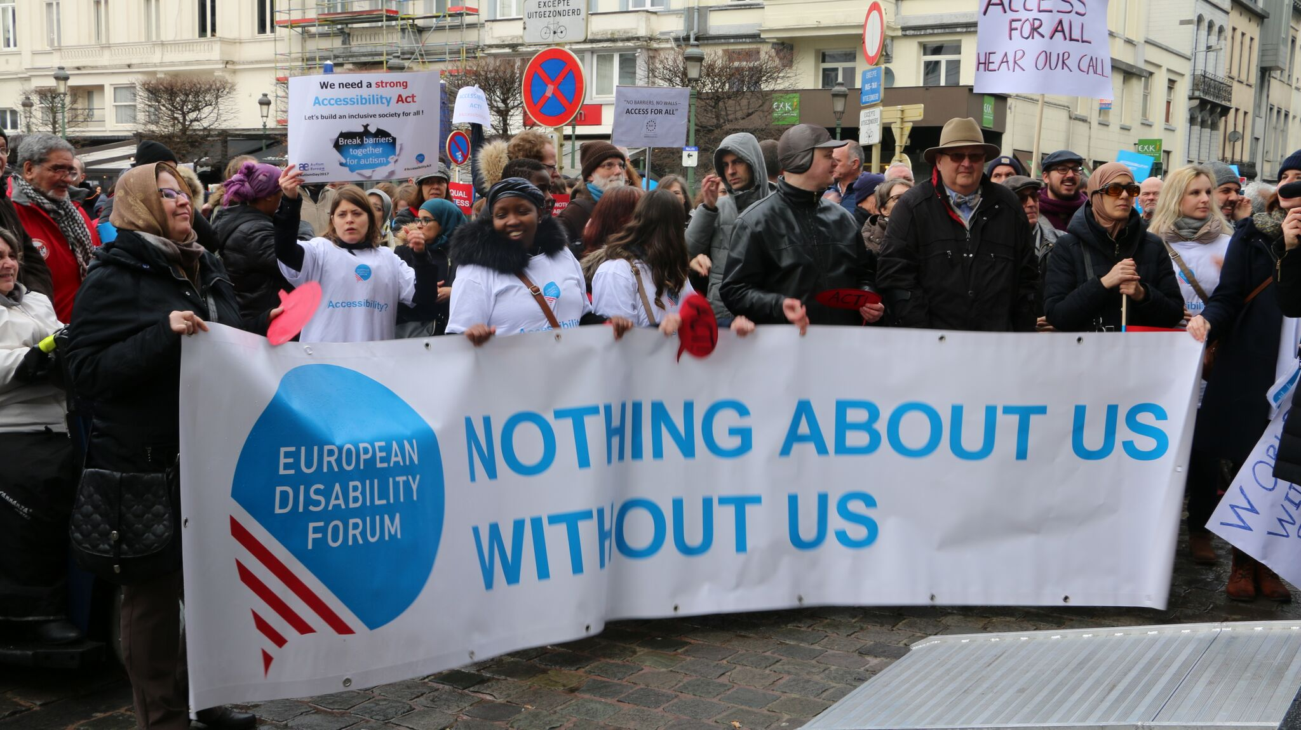
JURI Committee & the Rights of Persons with Disabilities

The aim of this document is to give general information concerning why and how the Parliament, and particularly your Committee, can improve the lives of persons with disabilities in the European Union and beyond.
There are 100 million persons with disabilities (this number includes 99 million persons according to the EU-SILC survey of 2016 and 1 million persons estimated to be segregated in residential institutions and therefore not counted on the survey). Persons with disabilities experience legal, physical and attitudinal barriers that hinder their independent living and full participation in all aspects of life on an equal basis with others.

European Disability Forum
The European Disability Forum (EDF) is an umbrella organisation of persons with disabilities that defends the interests of Europeans with disabilities. We are a strong, united voice of persons with disabilities in Europe that collaborates closely with the European Parliament in ensuring that the interests and needs of persons with disabilities are taken into account.

Disability Intergroup
The Disability Intergroup of the European Parliament is an informal grouping of MEPs interested in promoting the right policies for persons with disabilities within their work at Parliament and national level. It was established in 1980 and is an efficient network through which to communicate and coordinate work on disability policies. If you are interested in joining the Disability Intergroup, please contact alejandro.moledo@edf-feph.org.

UNCRPD
The United Nations Convention on the Rights of Persons with Disabilities (UNCRPD) is an international human rights treaty ratified by the EU and all its Member States. It commits all who ratify it to implement and promote the full realisation of all human rights for all persons with disabilities through the adoption of new political tools and review of existing policies. In 2015 the CRPD Committee adopted specific recommendations to be followed by the EU in its Concluding observations on the initial report of the EU.
The European Parliament is bound to take the UNCRPD into account in all its legislative work and processes. As a public entity, it is also obliged to ensure that citizens and personnel with disabilities have equal rights to their peers.

European Charter of Fundamental Rights
The European Charter of Fundamental Rights addresses EU institutions and national authorities when implementing EU law. Article 26 states that “the EU recognises and respects the right of persons with disabilities to benefit from measures designed to ensure their independence, social and occupational integration, and participation in the life of the community”. Article 21 prohibits any discrimination on the basis of disability. As such, the European Parliament has a double responsibility to ensure non-discrimination and promote the full participation of persons with disabilities in all aspect of life. Read the EU Charter of Fundamental Rights.

Legal Affairs – JURI Committee

The EU and all the EU Member States are state parties to the UN Convention on the Rights of Persons with Disabilities (the CRPD). in this regard, all EU laws, policies and programmes need to take into account the rights of persons with disabilities and ensure compliance with this international human rights treaty.

Political Priorities
- Full implementation of the CRPD in Europe: EDF advocate for full implementation of the CRPD at EU and Member States level, including in the work of the JURI Committee in its role of interpreting and applying international law.
- Follow the implementation of the Marrakech Treaty for the benefit of persons who are blind, visually impaired or otherwise print disabled.
- Take action concerning the impact of emerging technologies (i.e. Artificial Intelligence and Machine Learning) for persons with disabilities, preventing further discrimination and exclusion.

Useful resources
- Information about the Marrakech Treaty by the European Blind Union
- EDF Human Rights Report on Equality and Non-Discrimination
- EDF Human Rights Report on the 10th year of the CRPD
- Plug and Pray: a disability perspective into artificial intelligence, automated decision making and emerging technologies

Contact
Antoine Fobe: European Blind Union Head of Campaigning
An-Sofie Leenknecht: EDF Human Rights Coordinator
Marine Uldry: EDF Human Rights Officer
Alejandro Moledo: EDF Policy Coordinator

