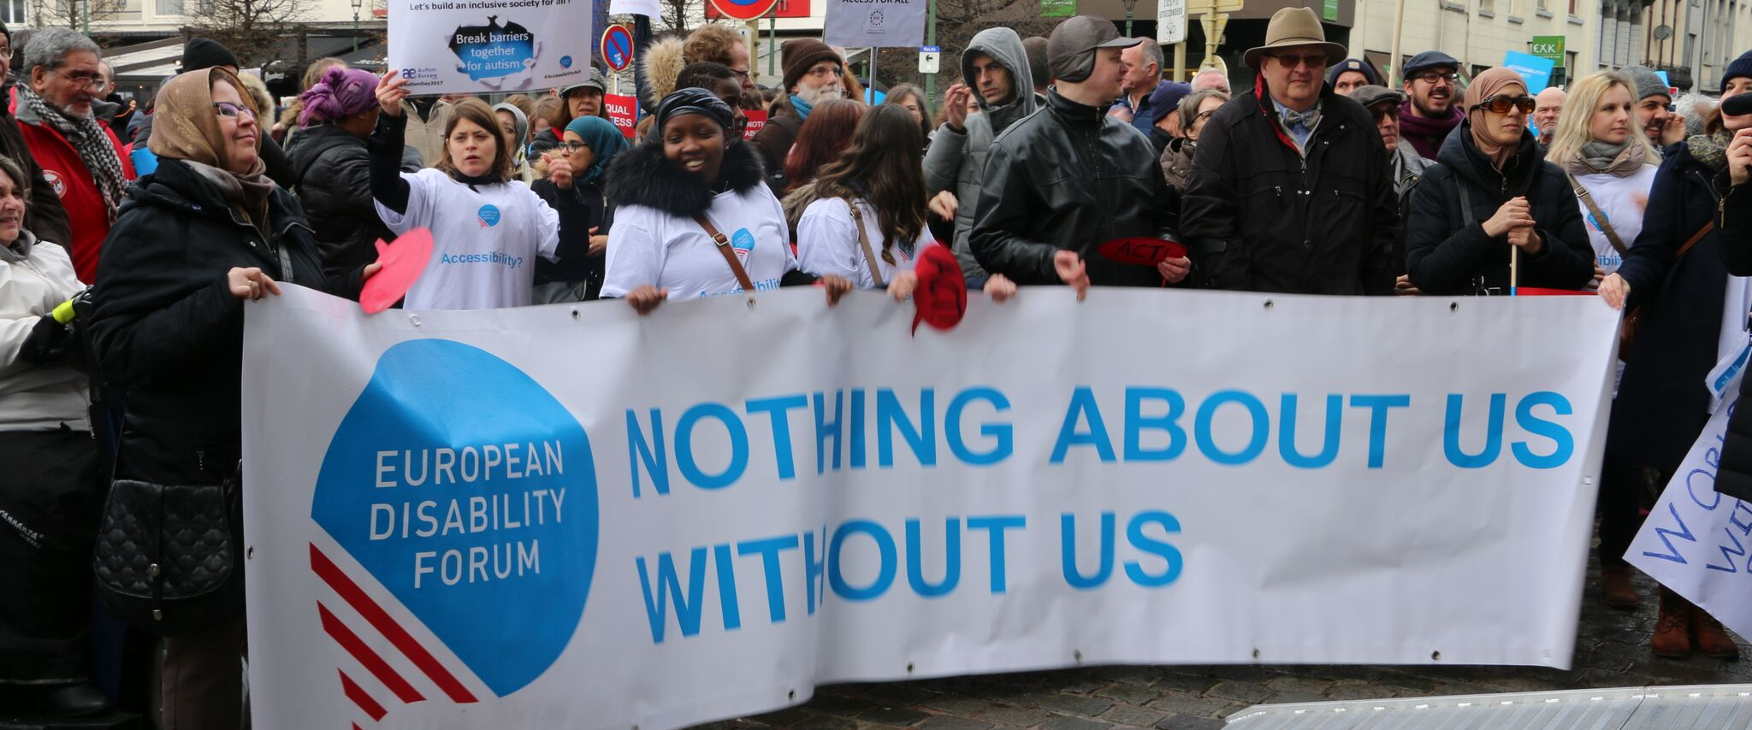
LIBE Committee & the Rights of Persons with Disabilities

This document gives an overview of why and how the Parliament, and particularly the Civil Liberties, Justice and Home Affairs Committee, can improve the lives of persons with disabilities in the EU and beyond.
There are 100 million persons with disabilities (this number includes 99 million persons according to the EU-SILC survey of 2016 and 1 million persons estimated to be segregated in residential institutions and therefore not counted on the survey). Persons with disabilities experience legal, physical and attitudinal barriers that hinder their independent living and full participation in all aspects of life on an equal basis with others.

European Disability Forum
The European Disability Forum (EDF) is an umbrella organisation of persons with disabilities that defends the interests of Europeans with disabilities. We are a strong, united voice of persons with disabilities in Europe that collaborates closely with the European Parliament in ensuring that the interests and needs of persons with disabilities are taken into account.

Disability Intergroup
The Disability Intergroup of the European Parliament is an informal grouping of MEPs interested in promoting the right policies for persons with disabilities within their work at Parliament and national level. It was established in 1980 and is an efficient network through which to communicate and coordinate work on disability policies. If you are interested in joining the Disability Intergroup, please contact alejandro.moledo@edf-feph.org.

UNCRPD
The United Nations Convention on the Rights of Persons with Disabilities (UNCRPD) is an international human rights treaty ratified by the EU and all its Member States. It commits all who ratify it to implement and promote the full realisation of all human rights for all persons with disabilities through the adoption of new political tools and review of existing policies. In 2015 the CRPD Committee adopted specific recommendations to be followed by the EU in its Concluding observations on the initial report of the EU.
The European Parliament is bound to take the UNCRPD into account in all its legislative work and processes. As a public entity, it is also obliged to ensure that citizens and personnel with disabilities have equal rights to their peers.

European Charter of Fundamental Rights
The European Charter of Fundamental Rights addressed to EU institutions and national authorities when implementing EU law states that “the EU recognises and respects the right of persons with disabilities to benefit from measures designed to ensure their independence, social and occupational integration, and participation in the life of the community” (article 26). It also prohibits any discrimination on the basis of disability (article 21). As such, the European Parliament has a double responsibility to ensure non-discrimination and promote the full participation of persons with disabilities in all aspect of life. Read the EU Charter of Fundamental Rights.

Civil Liberties, Justice and Home Affairs - LIBE Committee

Europeans with disabilities amount to over 15% of the European population and 1 in 6 people across the EU have experienced mental ill health.. Yet, they continue to face unequal treatment, discrimination and violation of their fundamental rights, ranging from the most visible forms (such as segregated education and denial of employment opportunities) to more subtle forms (such as imposition of legal, physical, psychological and social barriers), resulting in their exclusion from society. Among them, persons with disabilities from other marginalised groups, such as women and girls with disabilities, LGBTI people with disabilities, older people with disabilities, persons with disabilities from racial, ethnic or religious minorities, as well as migrants, refugees and asylum-seekers with disabilities, are even more at risks of violation of their fundamental rights.
When violation arise, persons with disabilities struggle to seek and obtain justice, especially due to barriers in accessing the justice system, such as inaccessibility of infrastructure, deprivation of legal capacity and lack of reasonable accommodation to judicial proceedings, among others.
There are still considerable gaps in protection against discrimination on the grounds of disability in the EU. Progress began almost two decades ago with the adoption of the 2000 Employment Equality Directive prohibiting discrimination at the workplace and in vocational training. The 2008 Commission proposal of a horizontal equal treatment directive regrettably did not lead to harmonisation in all countries of the EU in relation to protection against discrimination in all fields of life, because Member States of the EU are still blocking the adoption of the Commission’s proposal.
LIBE Committee’s work on issues related to fundamental rights, equal treatment and access to justice is crucial to fully ensure the rights of all European with disabilities.

Political Priorities
- Horizontal equal treatment directive: EDF advocates for the prompt adoption of an EU horizontal equal treatment directive to protect persons with disabilities against discrimination in all areas of life, including the denial of reasonable accommodation as a form of discrimination, discrimination by association and intersectional or multiple forms of discrimination. Such legislation should also increase equality bodies’ and ombudspersons’ competences to cover complaints of disability-based discrimination.
- Full legal capacity and assisted decision-making: EDF advocates for all persons with disabilities who have been deprived of their legal capacity to be able to exercise all the rights enshrined in European Union treaties and legislation, in line with the UNCRPD, including through supported decision-making when needed.
- European Disability Strategy 2020-2030: EDF calls for the adoption of an ambitious European Disability Strategy for 2020-2030 by the EU.
- Asylum-seekers and refugees with disabilities: EU institutions need to ensure the equal protection of migrants, asylum-seekers and refugees with disabilities.
- EU institutions should launch a wide campaign to raise awareness on mental health stigma and the rights of persons with psychosocial disabilities as suggested by the CRPD Committee in collaboration with civil society organisations

Useful resources
- EDF booklet on Your Rights in the EU
- EDF Human Rights Report on Equality and Non-Discrimination
- EDF Human Rights Report on the 10th year of the CRPD
- MHE Promising practices in prevention, reduction and elimination of coercion across Europe

- MHE Position Paper on the need for mental health and psychosocial support for migrants and refugees in Europe
- MHE Position Paper on Article 12 UN CRPD on legal capacity

Contact
Marcin Rodzinka: MHE Advocacy & Policy Officer
Marine Uldry: EDF Human Rights Officer
An-Sofie Leenknecht: EDF Human Rights Coordinator

