PETI Committee & the Rights of Persons with Disabilities

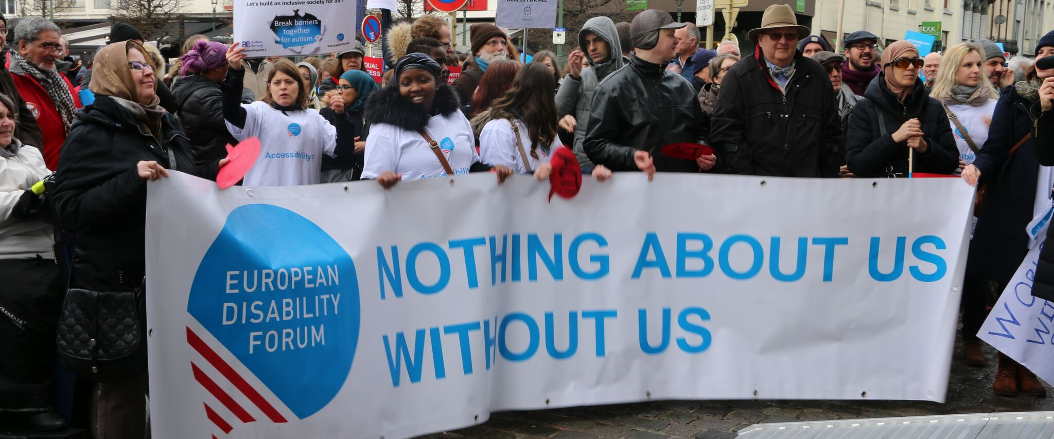
The aim of this document is to give general information concerning why and how the Parliament, and particularly the Petitions Committee, can improve the lives of persons with disabilities in the European Union and beyond.
There are 100 million persons with disabilities (this number includes 99 million persons according to the EU-SILC survey of 2016 and 1 million persons estimated to be segregated in residential institutions and therefore not counted on the survey). Persons with disabilities experience legal, physical and attitudinal barriers that hinder their independent living and full participation in all aspects of life on an equal basis with others.

European Disability Forum
The European Disability Forum (EDF) is an umbrella organisation of persons with disabilities that defends the interests of Europeans with disabilities. We are a strong, united voice of persons with disabilities in Europe that collaborates closely with the European Parliament in ensuring that the interests and needs of persons with disabilities are taken into account.

Disability Intergroup
The Disability Intergroup of the European Parliament is an informal grouping of MEPs interested in promoting the right policies for persons with disabilities within their work at Parliament and national level. It was established in 1980 and is an efficient network through which to communicate and coordinate work on disability policies. If you are interested in joining the Disability Intergroup, please contact alejandro.moledo@edf-feph.org.

UNCRPD
The United Nations Convention on the Rights of Persons with Disabilities (UNCRPD) is an international human rights treaty ratified by the EU and all its Member States. It commits all who ratify it to implement and promote the full realisation of all human rights for all persons with disabilities through the adoption of new political tools and review of existing policies. In 2015 the CRPD Committee adopted specific recommendations to be followed by the EU in its Concluding observations on the initial report of the EU.
The European Parliament is bound to take the UNCRPD into account in all its legislative work and processes. As a public entity, it is also obliged to ensure that citizens and personnel with disabilities have equal rights to their peers.

European Charter of Fundamental Rights
The European Charter of Fundamental Rights addressed to EU institutions and national authorities when implementing EU law states that “the EU recognises and respects the right of persons with disabilities to benefit from measures designed to ensure their independence, social and occupational integration, and participation in the life of the community” (article 26). It also prohibits any discrimination on the basis of disability (article 21). As such, the European Parliament has a double responsibility to ensure non-discrimination and promote the full participation of persons with disabilities in all aspect of life. Read the EU Charter of Fundamental Rights.

Petitions – PETI Committee

Persons with disabilities in Europe continue to face daily discrimination and violation of their rights enshrined in the UN Convention on the Rights of Persons with Disabilities (UNCRPD) and EU law. These violations range from the most visible forms (such as segregated education and denial of employment opportunities) to more subtle forms (such as imposition of legal, physical, psychological and social barriers), resulting in their exclusion from society.
The PETI Committee has played and continues to play an important role in considering petitions from its citizens with disabilities and ensuring their fundamental rights are respected in the EU.
However, we would also like to highlight that the electronic means to submit a petition through the Parliament dedicated webpage is not accessible for persons with disabilities and we therefore urge the PETI Committee to ensure that the petitions platform complies with the web accessibility standard W3C – Web Content Accessibility Guidelines 2.1 level A and AA.

Political Priorities
- Monitoring the implementation of the UNCRPD in Europe: we call on the PETI Committee to study thoroughly the petitions of persons with disabilities when their rights are undermined and coordinate with the EU CRPD monitoring framework members and the Parliament Disability Intergroup for follow up.
- Call for the PETI Committee to ensure that its website, publications and particularly the platform to submit and support a petition fully complies with the relevant web accessibility standard.
- In addition to this, and given the importance of this committee for citizens, further accessibility for persons with disabilities, such as easy-to-read format or information in official sign languages would ensure more participation from persons with disabilities across the EU.
- European Parliament should also allow deaf sign language users in Europe to submit petitions in all European national and regional sign languages (Petition number 1056/2016).

Useful resources
- UN Convention on the Rights of Persons with Disabilities
- EDF booklet on Your Rights in the EU
- EDF Human Rights Report on Equality and Non-Discrimination
- EDF Human Rights Report on the 10th year of the CRPD
- EDF Report on ending forced sterilisation of women and girls with disabilities
- EDF Position paper on sexual and reproductive health and rights of women and girls with disabilities
- Inclusion Europe platform on supported decision-making
- Inclusion Europe toolkit on easy to read

Contact
- Milan Šveřepa: Inclusion Europe Director
- Martyna Balciunaite: European Union of the Deaf, Policy Officer
- Marine Uldry: EDF Human Rights Officer
- An-Sofie Leenknecht: EDF Human Rights Coordinator
- Alejandro Moledo: Secretariat of the Disability Intergroup

