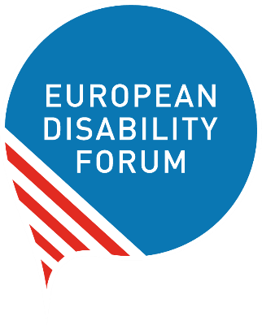
The United Nations Committee on the Rights of Persons with Disabilities
A Guide for Organisations of Persons with Disabilities
October 2019

This document offers guidance to organisations of persons with disabilities on how to engage with the United Nations Committee on the Rights of Persons with Disabilities. It gives practical information related to:

- Participation in the review of their country;
- Submission of complaints;
- Submission of information for Days of General Discussion/General Comments.

For any questions or comments, please send contact info@edf-feph.org.

Author: Marine Uldry
Executive editors: Catherine Naughton, An-Sofie Leenknecht

Partially funded by the European Union

Contents
The United Nations Committee on the Rights of Persons with Disabilities 5
Why is the Committee important for persons with disabilities? 6
Useful definitions 6
Country review and alternative reporting 8
How are countries reviewed by the Committee? 8
Review process in more detail: 8
Useful information: 10
How and when can you engage in the review process? 10
How to best prepare your alternative report 12
Purpose 12
What and when? 12
What to include? 13
Other useful information 13
Tips and tricks 14
How to best prepare your presentation in Geneva 15
Purpose 15
When? 15
How? 15
Structure of the private meeting 16
Useful information 16
Tips and tricks 17
What happens after? 18
Complaints: communication and inquiry 18
What are individual communications and inquiries? 18
In short 20
How to contribute to the work on complaints and inquiries? 20
By informing members/persons with disabilities on the process 20
By submitting individual communication or information for inquiry to the Committee 20
General Comment 21
What are General Comments? 21
How to contribute to General Comments 21
Conclusion 22

The United Nations Committee on the Rights of Persons with Disabilities

The United Nations Committee on the Rights of Persons with Disabilities (the Committee) is the expert Committee in charge of monitoring the implementation of the UN Convention on the Rights of Persons with Disabilities (the Convention) by the countries that ratified it.

The Convention is an international human rights treaty that reaffirms that all persons with disabilities must enjoy all human rights and fundamental freedoms. It clarifies that all persons with disabilities have the right to participate in civil, political, economic, social and cultural life of the community just as anyone else. The Convention clearly stipulates what public and private authorities must do to ensure and promote the full enjoyment of these rights by all people with disabilities.

The Committee is composed of 18 independent experts elected by States (countries and other state parties that ratified the Convention). The members of the Committee serve in their individual capacity, not as government representatives. They are elected from a list of persons nominated by the States for a four-year term, with a possibility of being re-elected once

The Committee meets in Geneva, Switzerland, and holds two sessions per year. At these sessions, the Committee has the role to:

- Review the implementation of the Convention by the countries who ratified the Convention and adopt concluding observations
- Examine individual complaints and conduct an inquiry concerning the violation of disability rights
- Discuss the interpretation of articles of the Convention and adopt General Comments to guide countries in ensuring the rights of persons with disabilities

Organisations of persons with disabilities/Disabled people’s organisations (DPOs) can engage in each of these activities. DPOs’ knowledge of the situation in their country is extremely valuable and important for the work of the Committee. It allows the Committee to have a better picture of how the Convention is implemented and what the main issues and priorities are.

Why is the Committee important for persons with disabilities?
Some examples on how the Committee is important for persons with disabilities helped improved disability rights include:
- Recommendations adopted by the Committee put pressure on the government to change their laws and policies, support putting the Convention in practice and bring media attention on the subject. For instance in Spain, following the recommendations of the Committee and strong advocacy by organisations of disabilities, laws were amended so that all persons with disabilities may vote and serve as juries.
- Individual communications and inquiries are ways to expose violation of disability rights and to recall States’ obligations under the Convention. For instance, after a complaint against Austria, the government made its railway system more accessible.
- General Comments explain in more details obligations of countries and can be used by organisations to explain to policy-makers the meaning of rights in the Convention. For instance, General Comment No. 1 on equal recognition before the law explains the concept of supported decision making and that “person’s decision-making ability cannot be a justification for any exclusion of persons with disabilities from exercising their political rights.” Recently, we saw several reforms in European countries to allow the right to vote of people with disabilities, for instance in France, Germany and Spain.
However, to be able to do its work, the Committee need your help to know more about the lived experiences of persons with disabilities in your country, and, in particular, what the main barriers are for persons with disabilities to fully enjoy their human rights. It is important for DPOs to take ownership of the review process as to ensure the national advocacy afterwards.

This short guide explains how you can efficiently engage with the Committee.

Useful definitions
Alternative/shadow report: report prepared by organisations of persons with disabilities or civil society organisations on the implementation of the Convention in their country. It is important because it gives to the Committee more information on what is happening on the ground. The official report is submitted by the State being reviewed.

Concluding observations (COs): document in which the CRPD Committee assesses whether a country respected or violatedthe rights of persons with disabilities as written in the Convention. It includes specific recommendations on actions the country should take to ensure the implementation of the Convention.

General Comment: document explaining the content of one or several articles in the Convention, for instance legal capacity (General Comment No 1) or the rights of women and girls with disabilities (General Comment No 3).

Individual communication: a formal complaint, from an individual who claims that her or his rights under the Convention has been violated by a State party.

Inquiry: investigation by the Committee to examine whether a country violate the rights of persons with disabilities. Usually it starts by the Committee receiving complaint(s) from individuals or organisations of grave or systematic violation of the rights of persons with disabilities in a specific country. The Committee looks into the complaint(s), may visit the country, and will say whether the country is breaking the rights written in the Convention.

List of Issues (LOI): list of questions prepared by the Committee and sent to a State in advance to the session in which the Committee will examine the State’s report. The State has to send its reply to the Committee before the start of the session.

(Periodic) review: process of the Committee to examine how the States that ratified the Convention implemented it in their country. Each review ends with the adoption of concluding observations (see definition above).

Pre-session/pre-sessional working group: smaller formation of the Committee composed of at least 5 members in charge of preparing the list of issues for the review of countries twice a year.

Simplified reporting procedure: new optional reporting that consists in the preparation of lists of issues, called “List of Issues Prior to Reporting” (LOIPR) sent to States before the submission of their periodic report to facilitate the reporting process. The State’s response to this list of issues prior to reporting constitutes its report. It’s only possible when the State has already been reviewed at least once by the Committee.

Find a full glossary of technical terms on the UN website: https://www.ohchr.org/EN/HRBodies/Pages/TBGlossary.aspx.

Country review and alternative reporting

How are countries reviewed by the Committee?
All States that ratified the Convention are obliged to submit regular reports to the Committee on how the rights in the Convention are being realised in the country. States must report initially within two years of accepting the Convention, and then every four years. The Committee examines each report and make recommendations on the report in a document called “Concluding observations”. This document is sent to the country, which should implement the recommendations of the Committee.

Review process in more detail:

- Within two years after ratification of the Convention, the State submits a report to the Committee on how it implemented the rights of persons with disabilities. The report must cover all the articles of the Convention.

- The Committee will examine the report. During a “pre-session” it will adopt a list of questions for additional information that will be send to the State. The government must usually reply within six months.

- At the following session, an “interactive dialogue” is organised between the Committee and representatives from the States. The Committee asks specific questions on implementation of articles of the Convention and the government must reply orally. The dialogue is organised in two meetings lasting three hours each.

- Based on the State’s report, the reply to the list of questions, the interactive dialogue, and information provided by organisations of persons with disabilities and monitoring bodies, the Committee adopts the Concluding observations. They are sent to the States and available on the website of the Committee.

- The State must implement the recommendations. After four years, it will have to submit its new report to the Committee. If the State accepted the simplified reporting procedure (see definition above), it will be the Committee that starts the second cycle of review by the adoption of list of issues prior to reporting.

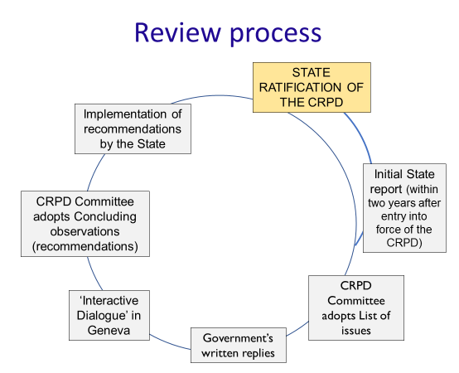

Useful information:
- The European Union and all European countries (except Liechtenstein) have ratified the CRPD. The full list of the States parties is available on the UN website.
- The sessions of the CRPD Committee are usually organised in March/April and August/September each year. To see if your country will be reviewed soon, or find the concluding observations that were adopted, go on the session page of the website of the CRPD Committee.
- You can watch the interactive dialogue online on UN WebTV. Follow @myEDF on Twitter for announcement.
- You can find examples of List of Issues and Concluding Observations adopted by the CRPD Committee on its website.

How and when can you engage in the review process?
Your organisation can participate in each step of the review.
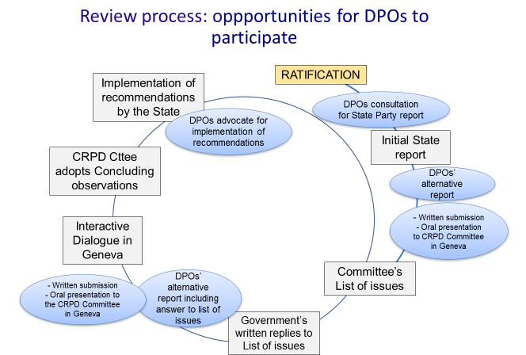

- Before the review: You should be consulted by your government in the preparation of the country report. In parallel, you should prepare your own alternative report on the implementation of the Convention. Usually, it is the umbrella organisation / national council representing the diversity of organisations of persons with disabilities of the country who coordinates the work on the alternative report. However, individual organisations may also prepare their own alternative report. Preparing an alternative report takes a lot of effort and time, therefore we suggest you coordinate with other organisations. The report should be submitted before the pre-session, which constitutes the first step of the review. More information under: How to best prepare your alternative report

- During the pre-session in Geneva: You can take part in a private meeting with the Committee to provide detailed information on the situation of persons with disabilities in your country. This meeting lasts 1 hour to 1 hour 30 minutes and takes place before the adoption of the list of issues. In this meeting, no government representatives are present. You must prepare a statement on the main issues and will be asked clarifications/additional information by the Committee members. During the pre-session, a smaller number of Committee members are present (usually 6 to 9). More information under: How to best prepare your presentation in Geneva

- Between the pre-session and the interactive dialogue: You can revise your alternative report and add more information or decide to submit a report only at this stage. A this point you can give your own (parallel) reply to the list of issues adopted by the Committee.

- During the session in Geneva: You can attend the session during which the interactive dialogue take place. Another private meeting, similar to the one taking place at the pre-session, is organised where you can raise your priorities with the Committee. You can also attend the interactive dialogue but cannot speak as it is a meeting between the Committee and the State.

Useful information:
- Most of the umbrella organisations / national council of European countries are EDF members. You can find the list on our website.

How to best prepare your alternative report

Purpose
To provide additional information to the Committee on the implementation of the Convention and situation of persons with disabilities in your country. It can also correct information provided in the State’s report,. It should focus on how the government complies (or does not) with its obligations –not on what has been achieved by your organisation.

What and when?
Alternative reports must be submitted to the Secretariat of the Committee at the latest one month before the start of the session during which the country is considered for List of Issues or Concluding Observations. It is thus important to start drafting it well in advance.
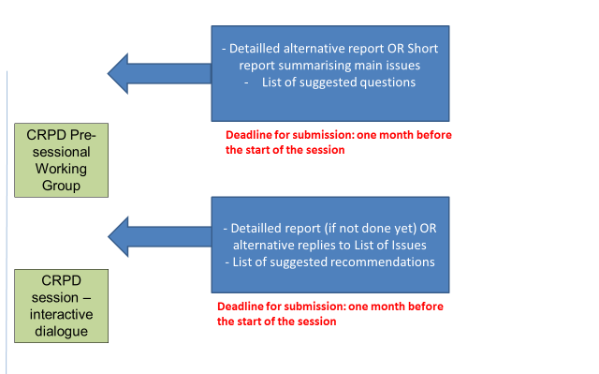
For the pre-sessional working group, you can either submit a detailed alternative report covering all articles of the Convention, or a shorter report summarising the main issues. It should include list of suggested questions for the List of Issues.
For the session, you should submit a detailed alternative report, covering all articles of the Convention and including suggested recommendations for the concluding observations.

What to include?
In order to facilitate the work of the Committee, the report should be specific and concise. The Committee imposes a word limit for all submissions – currently of 10.700 words for alternative report and 5.300 words for other submissions.
We recommend alternative reports to use the following structure:
- A self-introduction of your organisation/coalition: short paragraphs introducing your organisation – its history and who it represents. The aim is to establish your credibility to the Committee. It is also important for the Committee to know that you are if you are an organisation of persons with disabilities, or another organisation. The Committee particularly welcomes reports drafted by organisations that include diversity of groups of persons with disabilities.
- An executive summary of the most relevant issues: it should reflect what you think requires particular attention of the Committee when reviewing the report of the State.

- (If relevant) An updated of basic relevant information about your country: short paragraphs with basic information on your type of government, population, recent political changes, etc.

- A critical analysis of the situation of the country in light of the Convention: This is the most important part of the report and should constitute an article by article review of the implementation of the Convention and critical analysis of the State’s report. You can also suggest questions to be included in the List of Issues or recommendations to be included in the Concluding Observations.
You can find examples of alternative reports submitted for pre-session and session of the Committee on its website, for instance:
- For adoption of the list of issues: Example of alternative report from the Greek National Confederation of Disabled People
- For adoption of concluding observations: Example of alternative report from the Civil Society Coalition from Norway

Other useful information
Language: The Committee works in the five UN languages (English, French, Chinese, Russian, and Spanish) but does not translate alternative reports. It this thus highly recommended that you submit your reports in English.
Format: The report should be sent in accessible electronic format (Word or text), not PDF.
Contact: You should send your submission to crpd@ohchr.org before the deadline. In the subject of the e-mail you should indicate “submission” and the “name of the country” (e.g. “Submission Spain.”)

Tips and tricks
- Do not expect the Committee to know anything about the issues in your country – you report must be self-explanatory.
- Provide sources to the information you give and include cross- references to the State’s report (for instance saying “para. X of the State report”)
- Be careful to use the correct terminology when referring to persons with disabilities and use quotation marks when referring to the language used by the State – for example if the State uses negative words, such as “mental retardation”, “dumb”, etc.
- Avoid abbreviation (for instance “PWD” for persons with disabilities) and acronyms
- Each suggested questions or recommendations must be linked to information provided earlier in your report. Avoid suggestions that can be answered by yes/no. Be concrete and specific, taking into consideration the kind of actions you aim to inspire from the questions or recommendations.

How to best prepare your presentation in Geneva

Purpose
You have the opportunity to privately meet the members of the Committee to inform them on the situation of persons with disabilities in your country before they adopt their list of issues and concluding observations. It is an opportunity to explain to the Committee your priorities and concerns, and for them to ask you specific questions on the situation in your country.

When?
- During the pre-sessional working group (to inform the adoption of the List of Issues)
- During the Committee session (to inform the constructive dialogue with the State and adoption of concluding observations)

How?
To participate in this private meeting with the Committee, you must send a request to the Secretariat (usually at the same time that you send your alternative report) before the deadline set for each session (in general one month before the start of the session). To know the exact deadline, check the announcement on the Committee website and do not hesitate to contact EDF for information.
You can participate either in person in Geneva or via video-conference that must be scheduled in advance with the Secretariat of the Committee (see the requirements in the “informative note for participation” published before each session). The UN does not provide funding for participation.
You will be asked to prepare an oral statement and to submit it in written by e-mail to the Secretariat of the Committee a few days before your meeting. Your statement should be concise and inform the Committee on the major issues in your country in the implementation of the Convention. You can also take this opportunity to stress which questions or recommendations should be included in the list of issues and/or concluding observations.

Structure of the private meeting
- Presentation: organisations of persons with disabilities, independent monitoring framework, equality body, national human rights institution and other civil society organisations that registered to the meeting are invited to deliver their oral statement
- Questions: Committee members asked a list of questions to the representatives
- Replies: representatives reply to the questions (no break is provided, you must be prepared to reply immediately)
(If there is still time after the replies, the Committee members are invited to ask follow-up questions, and the representatives are given the floor to answer once again.)
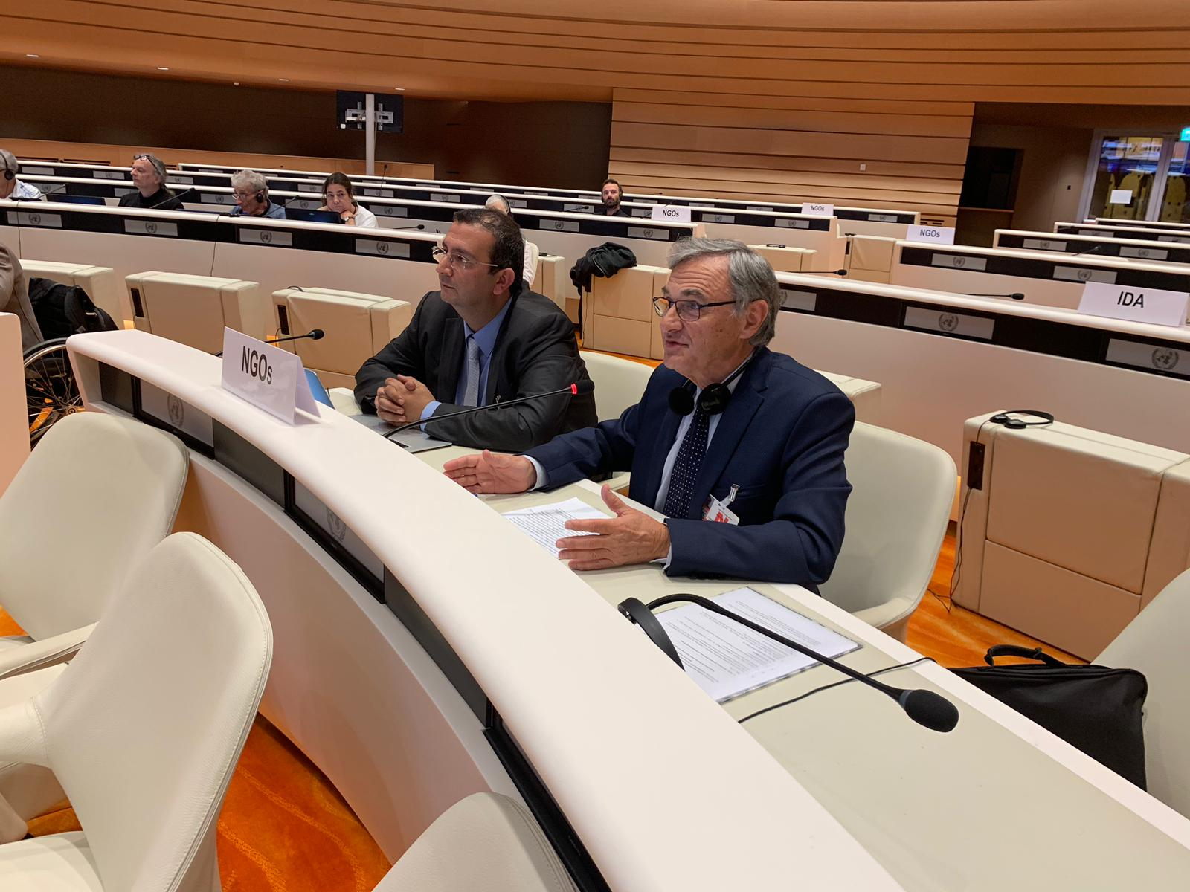
Picture: Delegation from the French Council of Disabled People for European Affairs speaking at a private meeting with the CRPD Committee

Useful information
Duration: the private meeting lasts between 1 hour and 1 hour 30 minutes; this will be indicated by the Secretariat of the Committee. Coalition of organisations of persons with disabilities have in average 7 minutes and single organisations 5 minutes to deliver their oral statement.
Language: interpretation is provided in English, Spanish, French, Russian and International Sign. To deliver your statement in other language, you must bring your own interpreter (at your own cost).
Confidentiality: the meeting is confidential- this means that nothing that is discussed can be shared outside of the room.
Contact: You should send your request to participate in the private meeting and your statement to crpd@ohchr.org before the deadlines. In the subject of the e-mail you should indicate “private meeting/oral statement” and the “name of the country” (e.g. “Private meeting/Oral statement Romania.”)
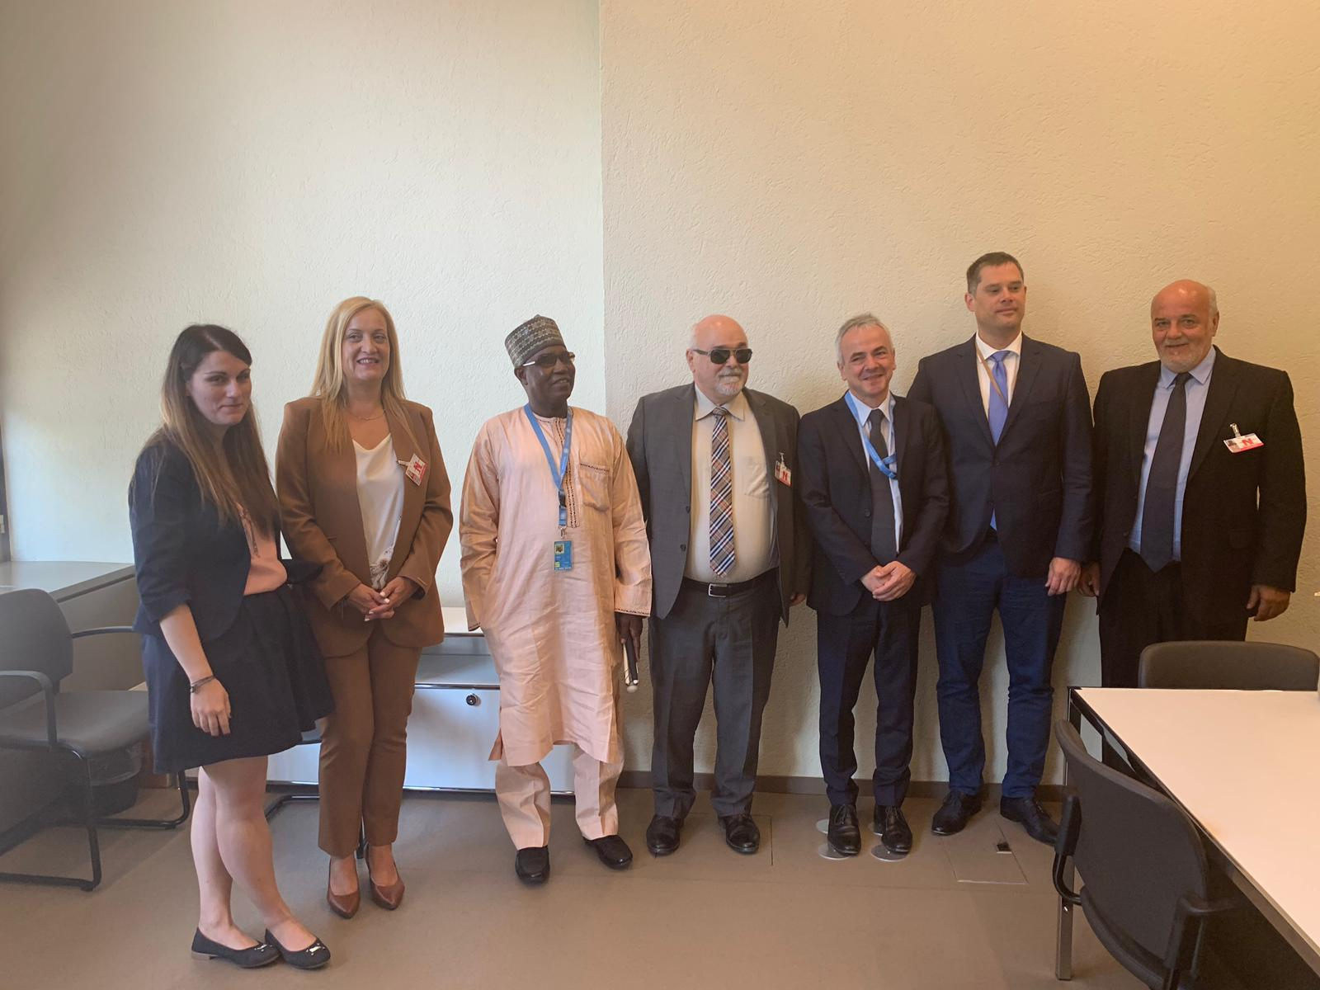
Picture: Delegation of the Greek National Council of Disabled People with Chair of the Committee and the co-rapporteurs on Greece

Tips and tricks
- Prepare in advance and coordinate: it is important to prepare in advance your statement and coordinate with the other organisations who may be present during the meeting. Do not hesitate to contact in advance your national equality body, human rights institution and your national monitoring framework of the Convention to know if they will participate.
- Focus on your priorities (what you want to see in the list of issues and recommendations) and on providing additional information not given already in your alternative report. It is important to give enough time to Committee members to ask questions and for you to respond.
- Reach out to EDF and the International Disability Alliance: let us know that you will be attending the private meeting of the Committee, so we can support you and organise a preparatory meeting beforehand.

What happens after?
The list of issues and concluding observations are published on the Committee’s website a few weeks after the end of the session. It is for you to translate them in your national language and use them in your advocacy. For instance, some organisations organise a press conference to present the recommendations, together with the national body monitoring the Convention, or follow-up meetings with their government to discuss implementation of the recommendations.
If your country accepted the simplified reporting procedure (see definition page 3), the next review of the country will be started by the Committee itself by the adoption of a “list of issues prior to reporting”. The replies to this list of issues will be considered as the State report. It is thus important to keep an eye on the agenda of the Committee and future countries for review to make sure you are involved.

Complaints: communication and inquiry

What are individual communications and inquiries?
The Committee can examine violations of the rights of persons with disabilities. They can do it only in countries that ratified the Convention and its Optional Protocol. The list of countries that ratified the Optional Protocol is available on the UN website.
Depending on the information received the Committee will:
- Adopt views on individual complaints (called by the United Nations “views on individual communications”), when the rights of a person with disabilities was violated in a country. It is possible only after the complaint was brought unsuccessfully to the national courts with no further possibility for appeal. This is a written procedure, there is no hearing or lawyer. The International Disability Alliance published on its website summaries of views adopted by the Committee. They concern issues of discrimination, accessibility, access to justice, right to vote, employment, and others.

- Launch an investigation (called “inquiry”) to examine grave or systematic violations of the rights of persons with disabilities in the country. It may include a country visit. So far, the Committee examined two inquiry procedures concerning the United Kingdom (on the negative impact of welfare reform on independent living, social protection and work and employment of persons with disabilities) and Spain (on the structural exclusion and segregation of persons with disabilities from the mainstream education system). The reports of the inquiries are available on the Committee’s website.
Although these decisions are not legally binding, they send a strong message to countries that violated the rights of persons with disabilities.

In short
Individual communication:
- Ratification of Convention and its Optional Protocol by the State
- Complaint concerning one or several persons with disabilities
- After exhaustion of domestic remedies
- Identification of the victim(s) (cannot be anonymous)
Inquiry
- Ratification of the Convention and its Optional Protocol by the State
- Complaint concerning grave or systematic violation affecting a big number/group of persons with disabilities
- No need to have brought a complaint to court
- Complainant(s) can remain confidential

How to contribute to the work on complaints and inquiries?

By informing members/persons with disabilities on the process
You can inform your members and persons with disabilities in your country on the communication and inquiry mechanisms and support them in the process. Because most of the information are provided only in English, it is difficult for many people to understand the process. You could for instance translate the guidelines for submission of communication (below) in your national language.

By submitting individual communication or information for inquiry to the Committee
As an organisation of persons with disabilities you can also directly submit a communication or information for inquiry to the Committee. If you submit a communication on behalf of an individual, you must possess an authorisation to act on their behalf (written consent).
On the website of the Office of the High Commissioner for Human Rights you can find:
- Guidelines for submission of communications to the Committee
- Information on the inquiry procedure
You may always contact EDF for more information.

General Comment

What are General Comments?
General Comments are documents explaining in more details the content of one or several rights in the Convention and how they should be implemented by governments. So far, the Committee has adopted seven General Comments on various articles of the Convention:
- General Comment No 1 on Article 12: Equal recognition before the law (Adopted 11 April 2014)
- General Comment No 2 on Article 9: Accessibility (Adopted 11 April 2014)
- General Comment No 3 on Article 6: Women and girls with disabilities (Adopted 26 August 2016)
- General Comment No 4 on Article 24: Right to inclusive education (Adopted 26 August 2016)
- General Comment No 5 on Article 19: Right to independent living (Adopted 31 August 2017)
- General Comment No 6 on Article 5: Equality and non-discrimination (Adopted 9 March 2018)
- General Comment No 7 on Article 4.3 and 33.3: Participation with persons with disabilities in the implementation and monitoring of the Convention (Adopted 21 September 2018)
Announcements of the work on new general comments are posted on the website of the Committee.

How to contribute to General Comments
Organisations of persons with disabilities are invited to make written submissions and participate in Days of General Discussion on the topic of the general comments. This helps members of the Committee to be better informed about issues of implementation in various countries/regions or affecting different groups of persons with disabilities.
For instance, before the adoption of General Comment No 6, the Committee organised a Day of General Discussion on the right of persons with disabilities to equality and non-discrimination to which organisations were invited to send written submissions and make oral interventions. To inform the discussion on General Comment No 7, the Committee made a call for written submissions.
The requirements to submit written submissions and interventions vary. It is crucial to regularly consult the Committee website for information on new general comments and instructions on contributions. For questions, you may also contact EDF.

Conclusion
Engaging with the Committee takes time and energy, but it is a real opportunity to bring your priorities and issues to the attention of UN experts. It can play a fundamental role in your advocacy at the national level and help to put pressure on your government. As “nothing about us, without us”, the work of the Committee should not be without you!
If you have any questions, do not hesitate to contact us at: info@edf-feph.org.

The full list of experts and their CV is available at: https://www.ohchr.org/EN/HRBodies/CRPD/Pages/Membership.aspx.

