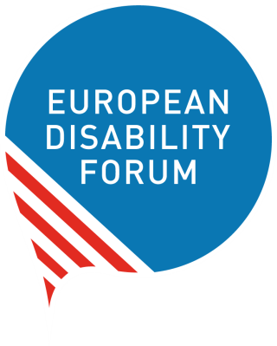

A STRONG SOCIAL EUROPE FOR JUST TRANSITIONS: Implementing the EU Pillar of Social Rights
Position Paper from the European Disability Forum

Haydn Hammersley
April 2020, Brussels, Belgium

Avenue des Arts 7-8 tel ++32 2 329 00 59 info@edf-feph.org
B- 1210 Brussels Belgium www.edf-feph.org

Contents
Introduction 3
Who we are 3
Our response 3
Opportunities to mainstream disability issues 3
Reinforced Youth Guarantee 3
European Gender Equality Strategy, followed by binding pay transparency measures 4
Child Guarantee 5
Updated Skills Agenda for Europe, the European Unemployment Re-insurance Scheme and the Action Plan for the Social Economy 6
European Education area 7
Green paper on ageing 8
Just Transition Fund 9
Digital Services Act 9
Initiative on Roma Equality and Inclusion 9
What is missing? 10
COVID 19 10
Support for refugees and migrants 10
Updating the Social Scoreboard to better include disability 11
A Disability Rights Guarantee for employment of persons with disabilities 11
How could EU Structural Investment Funds be used to implement the EU Pillar of Social Rights? 12

Introduction
This position paper outlines the reaction of the European Disability Forum (EDF), to the Commission’ communication on “A Strong Social Europe for Just Transitions”, released on the 14 January 2020. The communication prepares the way for an Action Plan to implement the European Pillar of Social Rights.
In this paper we will analyse whether the proposed action for 2020 and beyond live up to the Social Pillar’s commitments to the EU’s over 100 million persons with disabilities, and whether the entirety of its actions can ensure nobody is left behind.

Who we are
EDF is an umbrella organisation of persons with disabilities that defends the interests of over 100 million persons with disabilities in Europe.
We are a unique platform which brings together representative organisation of persons with disabilities from across Europe.
We are run by persons with disabilities and their families. We are a strong united voice of persons with disabilities in Europe.

Our response
We welcome the fact that the implementation of Principle 17 - Inclusion of People with Disabilities - is covered to a certain extend by the new Disability Rights Agenda, named in the Commission’s communication as the “Strategy for Disability” planned for 2021.
However, it is crucial that disability-specific measures are not limited solely to this particular strategy. Disability is a transversal issue, and as such needs to be reflected clearly in a number of the other outputs planned for the “Just Transition”.
Below we explore some of the specific action points the Commission plans to initiate in order to implement the EU Pillar of Social Rights. We will explain how and why certain elements specific to persons with disabilities need to be mainstreamed into them.

Opportunities to mainstream disability issues

Reinforced Youth Guarantee
The youth guarantee serves to tackle the issue of youth unemployment and of groups referred to as NEETS (not in employment, education or training). While employment remains an acute challenge for many young people in the EU, for young persons with disabilities it is a double-edged sword. Not only do they face barriers due to their age and the many delays young persons with disabilities face in getting their formal qualifications, but equally due to the overriding barriers of inaccessibility and lack of reasonable accommodation that can prevent even the most qualified candidate from finding a job.
Currently the youth Guarantee does not include young persons with disabilities who receive disability allowance. The cost of living with disability is considerable, meaning that even when in full-time employment 11% of persons with disabilities in the EU are at risk of in-work poverty. The average extra living costs per year for persons with disabilities, in order to make ends meet, are estimated at 23,012€ in Sweden 20,681€ in the Netherlands, 20,555€in Denmark, 16,321€ in Austria, 14,550€ in Belgium and 14,425€ in Finland. Furthermore, taking up paid employment in many Member States signals an inability to receive disability allowance at a later date, should the person lose their job or their condition change and prevent them from working.
The Reinforced Youth Guarantee therefore needs to acknowledge the need for flexibility in making paid work compatible with eligibility for receiving disability allowance, as a way of off-setting the additional costs persons with disabilities face in their daily lives.
Funding that goes toward the Youth Guarantee should also help cover other costs needed to facilitate the employment of certain persons with disabilities. This should entail earmarking expenditure for the provision of personal assistance and/or sign language interpretation, when required, as well as to support employers in providing reasonable accommodation for the young employee with a disability.

European Gender Equality Strategy, followed by binding pay transparency measures
Women with disabilities face even higher levels of poverty and social exclusion than men with disabilities in the EU. Figures indicate that 29.5% of women with disabilities in the EU are at risk of poverty and social exclusion compared to 27.5% of men with disabilities. The same is true of unemployment rates. EU figures show that on average only 48.3% of women with disabilities are in employment in the EU, compared with 53.3% of men.
Women and girls with disabilities face multiple and intersectional discrimination in all areas of life, including, socio-economic disadvantages, social isolation, violence against women, forced sterilisation and abortion, lack of access to community services, low quality housing, institutionalisation, inadequate healthcare and denial of the opportunity to contribute and engage actively in society. Women with disabilities are also two to five times more likely to face violence. The status of women and girls with disabilities is not only worse than that of women without disabilities, but also worse than that of their male peers. We welcome the good example established by the recently published EU Gender Equality Strategy. For the first time, the process to develop the strategy actively involved women with disabilities through their representative organisations and, as a result, it includes important commitments to ensure the rights of women and girls with disabilities. However, we consider that inclusion of women and girls with disabilities in the strategy does not go far enough:
- It fails to ensure full access to justice for women with disabilities, and especially for those who face restrictions in legal capacity, due to obstacles in accessing courts, including a lack of procedural adjustments, and insufficient training of judiciary professionals on gender and disability;
- The strategy does not explicitly recognise that women with disabilities have more difficulty to access work and employment;
- The measures regarding gender pay gap, pension gap and care gap do not explicitly address the needs of parents, and especially mothers of children with disabilities;
- It does not address the situation faced by thousands of women and girls who are confined in institutions because of their disability, and who are at even greater risk of violence, cannot access empowerment initiatives and are segregated from their communities.
EDF is also advocating for the upcoming European Disability Rights Agenda, as a follow up to the current European Disability Strategy 2010-2020, to fully mainstream the rights of women with disabilities in all its actions.

Child Guarantee
Children with disabilities have an increased likelihood of living in poor households, as do children living in households with persons with disabilities. A recent study from the UK found that members of 43% of households, where at least one member has a disability, live in poverty.
When children with disabilities cannot be cared for by their families, they are all too often placed in institutional care. Children with disabilities worldwide are 17 times more likely to live in institutional care that children without disabilities. They are also more likely to stay in institutions on a long-term basis, often indefinitely.
A Child Guarantee aiming to pull children in the EU out of poverty cannot hope to achieve its aim in any way, shape or form if the specific challenges faced by Europe’s children with disabilities are not fully integrated into it.

Updated Skills Agenda for Europe, the European Unemployment Re-insurance Scheme and the Action Plan for the Social Economy
Employment is a crucial issue for persons with disabilities in the EU. The latest EU figures show that only 50.8% of persons with disabilities are in employment, compared to 74.8% for persons without disabilities. In certain Member States the rate of employment is far lower. Even in Member States that aren’t among the worst offenders when it comes to employment of persons with disabilities, the employment gap (the difference in employment rates between persons with and without disabilities) is considerable.

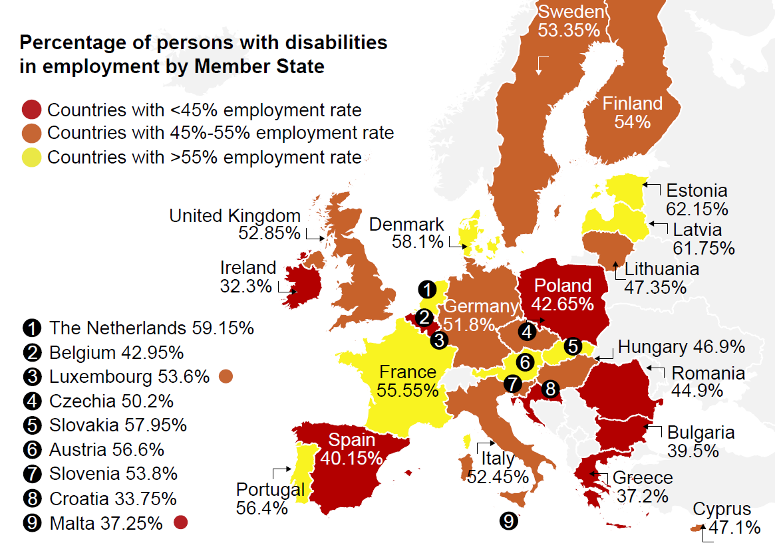

Image alt text: Map of the EU and the UK showing percentage of persons with disabilities in employment by Member State: Ireland 32.3%, Croatia 33.75%, Greece 37.2%, Malta 37.25%, Bulgaria 39.5%, Spain 40.15%, Poland 42.65%, Belgium 42.95%, Romania 44.9%, Hungary 46.9%, Cyprus 47.1%, Lithuania 47.35, Czechia 50.2%, Germany 51.8%, Italy 52.45%, UK 52.85%, Sweden 53.35%, Luxembourg 53.6%, Finland 53%, Slovenia 53.8%, France 55.55%, Portugal 56.4%, Austria 56.6%, Slovakia 57.95%, Denmark 58.1%, Netherlands 59.15%, Latvia 61.75%, Estonia 62.15%

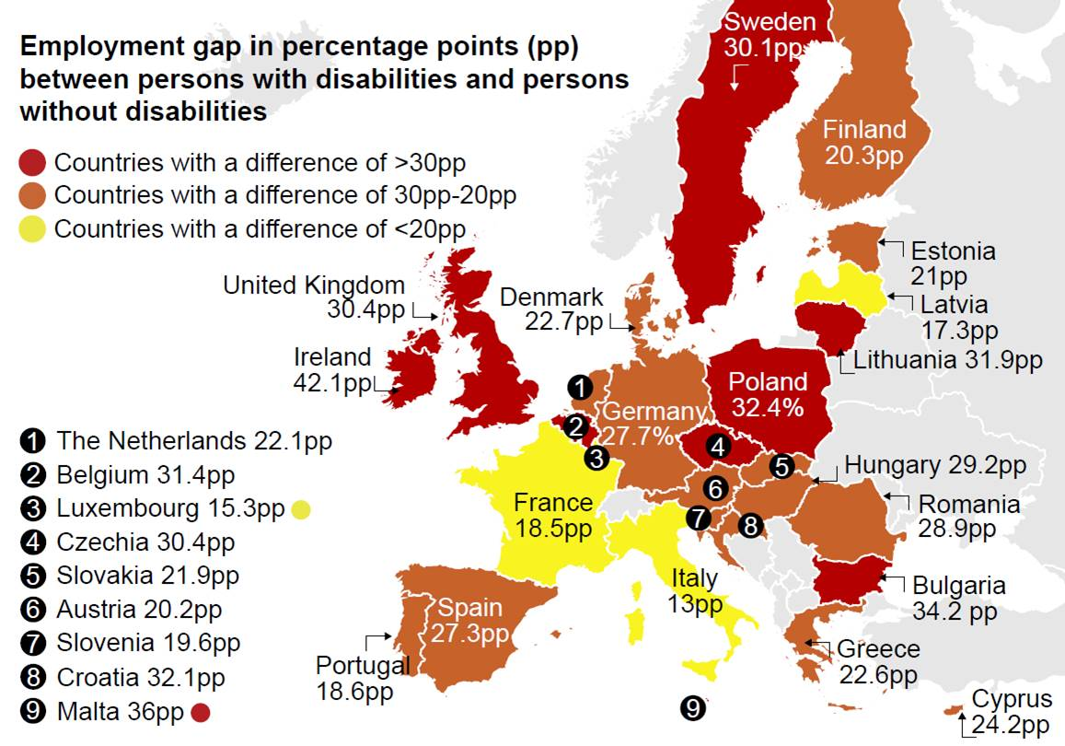
Image alt text: Map of the EU and the UK showing the employment gap in percentage points (pp) between persons with and without disabilities: Ireland 42.1pp, Malta 36pp, Bulgaria 34.2pp, Poland 32.4pp, Croatia 32.1pp, Lithuania 31.9pp, Belgium 31.4pp, Czechia 30.4pp, UK 30.4pp, Sweden 30.1pp, Hungary 29.2pp, Romania 28.9pp, Germany 27.7pp, Spain 27.3pp, Cyprus 24.2pp, Denmark 22.7pp, Greece 22.6pp, Netherlands 22.1pp, Slovakia 21.9pp, Estonia 21pp, Finland 20.3pp, Austria 20.2pp, Slovenia 19.6pp, Portugal 18.6pp, France 18.5pp, Latvia 17.3pp, Luxembourg 15.3pp, Italy 13pp.

Furthermore, these figures obscure the fact that persons with disabilities are often paid at or below minimum wage, work part-time, have precarious work contracts and even work in isolated workshops away from the open labour market.

COVID 19 will have only served to make the situation worse across the EU. It is essential that these initiatives focus on giving persons with disabilities the skills they need to find jobs, and then supports them in being able to access quality employment with a fair salary in the open labour market.

European Education area
Persons with disabilities in the EU are shown to be on average 10.1 percentage points more likely to be early school leavers than the general population, and 10.5 percentage points less likely to complete tertiary education. It can be difficult to access quality education due to the inaccessibility and lack of support for students with disabilities in most mainstream educational settings. Quality education is naturally a prerequisite for entering most labour market sectors, meaning exclusion from mainstream education puts persons with disabilities at a huge disadvantage. It should also be noted that girls and women with disabilities have high rates of illiteracy, school failure, absenteeism and drop-out rates.
According to a 2018 report by the European Parliament Research Service, the loss of tax revenue in the EU linked to lower educational attainment and employment levels, in light of the barriers faced by persons was disabilities, was estimated to be 255€-416€ million per year. Furthermore, the loss of Gross Domestic Product is estimated at 710€ million to 1.2€ billion annually in the EU.
Of course, education is not merely a means to find employment. The European Educational area should therefore focus not only on educational attainment and school completion of persons with disabilities, but also the quality and inclusiveness of the education they receive. Certain countries, such as Belgium and Germany, see soaring figures when it comes to segregated education. The COVID 19 crisis has also exposed the inability of educational systems to offer adequate distance learning.

Green paper on ageing
This green paper is likely to focus largely on accessibility and “active ageing”. It should be clear from the conception of the paper that the learning and investment resulting from this initiative will also benefit the more than 100 million persons with disabilities in the EU, as many older persons also have disabilities. An initiative to encourage the social inclusion and active citizenship of Europe’s ageing population therefore goes logically hand-in hand with doing the same for persons with disabilities.
This fact needs to be acknowledged in the Green Paper to underline the impact measures for positive inclusion can have for such a large number of Europeans, as well as the intelligence of investing in accessibility and inclusivity for persons with disabilities as a way of simultaneously supporting the growing number of older people in our Union.
To remain coherent, the Commission should pay attention to use the general term “accessibility” rather than inventing new terminologies or referring to other aspects such as “age-friendly environments” as those are all part of the wider understanding of accessibility. Established concepts such as Universal Design should also be used rather than re-inventing the wheel when talking about accessibility for older persons.

Just Transition Fund
The Just Transition Fund needs to supports Member States in ensuring this transition is done in a way that promotes security, social inclusion, employment and accessibility for persons with disabilities.
The fund will assist the transition towards a greener and more inclusive economy. Within this aim, the fund should particularly promote employment among groups already largely cut off from the open labour market, such as persons with disabilities.
A balance should however be kept between investing in retraining workers moving to new forms of greener employment, and preparing those in the affected communities who are newly entering the labour market with the skills required by emerging forms of work. Particular emphasis should be placed on supporting the employment of those furthest away from the labour market such as young people and persons with disabilities.
The transformation process towards a carbon-neutral economy is also dependent on investment in accessible and sustainable public transport systems and built environments. Jointly with the European Regional Development Fund, the JTF should be used to promote carbon neutrality through investment in these areas in a way that ensures they can be used by all members of society, and are accessible to persons with disabilities and older people.

Digital Services Act
EDF expects the upcoming Digital Services Act to lay down accessibility requirements (similar to those of the Web Accessibility Directive and the European Accessibility Act) to all online platforms, incluing the necessary tools to facilitate the creation of accessible content by users (e.g. possibility to add alternative text to images, subtitles and audio description to vídeos, etc.). Furthermore, given that persons with disabilities are at great risk of suffering hate speech and be subjects of harmful content and cybercrime, we would like to stress the importance of ensuring that online platforms will set up remedial mechanisms to these situations which are easy to understand and use by the widest range of users, as many times reporting misbehaviours on these online platforms are not sufficiently easy to find and use.
Finally, we also expect that the privacy of persons with disabilities will also be protected on these platforms.

Initiative on Roma Equality and Inclusion
A group that is particularly susceptible to poverty and social exclusion, and that finds it difficult to access support services, is the Roma community. It is estimated that there are at least 1.6 million Roma with disabilities in the EU and in EU enlargement countries. This constitutes a considerable group, and one that faces double discrimination on the basis of both ethnicity and disability.
It is crucial that initiatives for inclusion for the Roma community take into consideration the need for accessibility for persons with disability in education, and reasonable accommodation in employment. Particular attention should be paid to avoiding the placement of persons with disabilities belonging to the Roma community in institutional care settings. Roma with disabilities are particularly overrepresented in such care institutions, denying them of their right to freedom of choice over how, where and with whom they live, as outlined in Article 19 of the United Nations Convention on the Rights of Persons with Disabilities and its General Comment 5. It is therefore imperative that the Initiative on Roma Equality and Inclusion address these particular challenges faced by members of the Roma community who have disabilities.

What is missing?
The Commission’s communication on “A Strong Social Europe for Just Transitions” covers the principles enshrined in the EU Pillar of Social Rights, but fails to address a number of pressing social issues currently facing the EU. Some issues were hard to foresee at the time of the creation of this action plan, whereas others have been obvious for some time.

COVID 19
The solidity of the European social model has been thrown into disarray by the ongoing COVID 19 pandemic, and the economic shock that will result from it. To have credibility in the hope of upholding Europe’s social principles, this will need to be integrated into the action plan for implementing the Social Pillar.

Support for refugees and migrants
The list of action lacks a specific planned output on support for refugees and migrants. EDF is particularly concerned about the wellbeing of persons with disabilities arriving in Europe as refugees and migrants, many of whom face support that nowhere near covers their specific needs.
UNHCR reports that refugees are at heightened risk as the COVID 19 virus spreads quickly in refugee camps, where people are living without access to sanitation, food and water supplies. The International Rescue Committee reports that in overcrowded refugee camps and detention centres, social distancing, washing your hands and isolation is nearly impossible and a public health disaster is real.
Refugees and asylum seekers with disabilities face the same risks as other refugees, however compounded by many other issues: finding themselves at heightened risk of violence, including sexual and domestic abuse, discrimination, inaccessible facilities, inaccessible support services or disruption of these services being disproportionately more likely to put their lives at risk, and in some cases pre-existing health conditions which leave them more at risk of developing serious illness or dying.

Updating the Social Scoreboard to better include disability
Disability remains absent from the Social Scoreboard, the tool used to measure the implementation of the EU Social Pillar. It seems logical, given that one of the Pillar’s 20 Principles focuses on inclusion of persons with disabilities, that there should be a way of measuring if the pillar is having an impact in this particular area. We should therefore see in the action plan, a point to specifically address the shortcomings of the social scoreboard.

A Disability Rights Guarantee for employment of persons with disabilities
The action plan focuses on tackling the unemployment of young people through its renewed Youth Guarantee. However, as established above, the unemployment figures for persons with disabilities are staggering, and will have only worsened as a result of the COVID 19 pandemic.
The new European Commission has established an aim of an “economy that works for all”. This aim needs to take into account the countless persons with disabilities who would like to work but are unable to. This could be for many reasons, including employers being unwilling or unable to offer accessible work places and material, lack of inclusive training opportunities giving persons with disabilities the skills they need for the modern labour market, or the risk of losing disability payments making the risk of in-work poverty too high.
In the same vein as the Youth Guarantee, EDF would like to see a commitment to a Disability Rights Guarantee. This should be a commitment by Member States to ensure that all persons with disabilities who declare themselves able to and/or wanting to enter the labour market, receive a good quality offer of:
• Employment
• A traineeship
• An apprenticeship
• Vocational training
Or support for:
• Entrepreneurship
• Preparing placement exams for the public sector

The offer should be relevant to the person’s level of education, qualifications and, to the greatest extent possible, desired area of work.
To incentivise participation in this scheme, and to avoid the risk of in-work poverty faced by persons with disabilities in the EU, this should be open to persons with disabilities receiving disability allowance and be compatible with the continued eligibility to receive this financial support once a placement has been found.

How could EU Structural Investment Funds be used to implement the EU Pillar of Social Rights?
- Undertake action to invest EU funds in initiatives for the training, employment and job mobility of persons with disabilities, including support for social entrepreneurship and social economy enterprises, transitioning away from sheltered work, and with a particular focus on young people, women, migrants and refugees and older workers with disabilities. Emphasis should be put on supporting persons with disabilities to exercise choice in their area of work and investment should also be made in vocational rehabilitation, job retention, career progression and return-to-work policies, with an emphasis on developing skills for emerging professions.
- Invest EU funds in inclusive learning settings, early childhood intervention, lifelong learning programmes and training programmes to assist the transition from education to employment for persons with disabilities.
- Ensure that the Just Transition Fund not only focuses on retraining workers who are moving towards new forms of greener and more sustainable employment, but also targets bringing in persons currently cut off from the labour market, such as persons with disabilities.
- Invest in supporting national statistics offices in the collection of data on persons with disabilities disaggregated by type of disability, as well as sex and age. Data should also be collected on persons with disabilities living in institutional care, where data at the EU level is absent.
- Ensure EU funds are never used to further the institutionalisation of persons with disabilities and are actively invested in community- and family-based services. It is crucial that young people participating in the EU Solidarity Corps are not allocated placements in institutional care settings that perpetuate segregation. Investment should also go to training workers currently in institutions to offer community-based, CRPD-compliant care, co-produced alongside persons with disabilities.
- Prioritise access to culture and leisure through the use of EU funds, namely by promoting and formalising the use of the EU Disability Card by all MS, supported by EU funding.
- Use EU funds to review good practices and employment legislation on the reintegration and rehabilitation of workers after long sick leaves and who might have acquired a disability.

EU SILC 2018. Available at: https://ec.europa.eu/info/sites/info/files/2020- european-semester-joint-employment-report_en.pdf
Antón, J.I., Braña. F.J. and Muñoz de Bustillo, R. (2014). An analysis of the cost of disability across Europe using the standard of living approach. Available at: https://link.springer.com/content/pdf/10.1007%2Fs13209-016-0146-5.pdf
EU SILC 2018, except for Slovakia, Ireland and the UK for which that data is from 2017.
EU SILC 2017
Tinson, A., Aldridge, H., Born, T, B. and Hughes, C. (2016). Disability and poverty: why disability must be at the centre of poverty reduction. New Policy Institute. Available at: https://www.npi.org.uk/files/3414/7087/2429/Disability_and_ poverty_MAIN_REPORT_FINAL.pdf
EU SILC 2017
EU SILC 2017
EU SILC 2017
Based on respondents aged 18-24. EU SILC 2017
Based on respondents aged 30-39. EU SILC 2017
EPRS (2018). Equality and the fight against racism and xenophobia: the cost of non-Europe. Available at: http://www.europarl.europa.eu/RegData/etudes/ STUD/2018/615660/EPRS_STU(2018)615660_EN.pdf
Szporluk, M. (2016). Not Even in the Margins: Where are Roma with Disabilities? European centre for Minority Issues. Pp 12. Avilable at: https://www. ecmi.de/uploads/tx_lfpubdb/ECMI_Study__8_final.pdf

