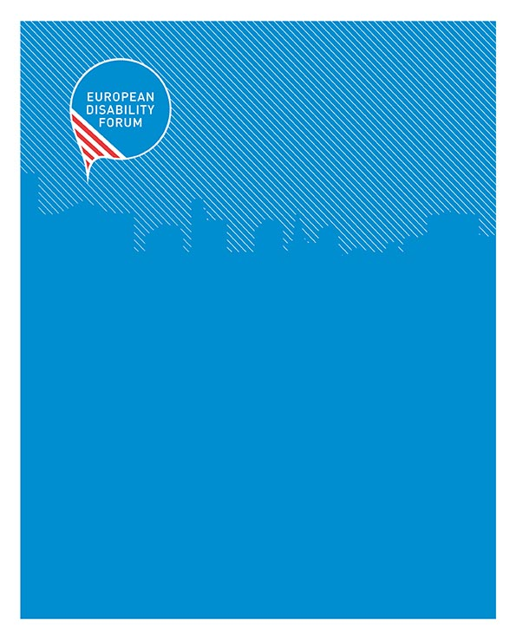

info@edf-feph.org - www.edf-feph.org

  - March 2020

An inclusive Green Deal for Europe
Contents
1
About EDF 3
Introduction 3
How are persons with disabilities affected by climate change and its consequences? 3
Disability and the New Green Deal 4
Accessibility 4
Inclusive sustainable mobility 4
Strengthening the social, human rights and gender dimension 5
Going global 6
Research and Innovation 6
Inclusive planning and meaningful involvement 6
Can it be done? Good practice examples 7
Basque Region, Spain 7
Bordeaux, France 7
Gothenburg, Sweden 7
Recommendations 7
Acknowledgements 9
Contact person at the EDF secretariat: 9

About EDF
The European Disability Forum is an independent umbrella organisation of persons with disabilities that represents the interests of more than 100 million Europeans with disabilities. EDF is a unique platform which brings together representative organisations of persons with disabilities from across Europe, run by persons with disabilities and their families. EDF is a member of the Social Platform and works closely to the European institutions, the Council of Europe and the United Nations.

Introduction
The President of the European Commission has committed to taking serious measures to tackle climate change. From her first statement of political priorities to the attribution of responsibilities within the European Commission, to the recent EU Green Deal communication, we see a range of measures laid out. The European Disability Forum welcomes the emphasis on a sustainable Europe and sees the opportunities to enhance the living conditions of all Europeans in this new initiative. This document highlights the measures that should be included to ensure the EU deal is inclusive, building a better society for us all, in Europe and around the world.

How are persons with disabilities affected by climate change and its consequences?
- 100 million Europeans with disabilities are as affected as everyone else by pollution, environmental degradation, and more affected than others by some consequences of climate change, such as climate change driven emergencies: fires and tornadoes, droughts and flooding are all extra risking and dangerous for persons with disabilities.
- People with disabilities who faced multiple and intersectional forms of discrimination are affected at a higher degree by climate change. For instance, situations of crisis exacerbate pre-existing gender inequalities and also compound intersecting forms of discrimination that affect women and girls with disabilities, to a different degree or in different ways than men or other women.
- Energy availability and energy prices affect us all. Persons with disabilities face greater poverty, and in some cases higher energy costs than the general population
- New investment in green jobs can be targeted to reach people most excluded from the labour market, such as persons with disabilities
- Building and renovation of buildings can result in a more, or less accessible environment. Access to schools, universities, hospitals and workplaces can be enhanced or made worse by the upcoming renovation wave expected in the Green Deal.
- Transport, and lack of accessible public and private transport affects the daily lives of children and adults with disabilities.

Disability and the New Green Deal

Accessibility
Accessibility is a right enshrined in Article 9 of the UN Convention on the Rights of Persons with Disabilities (CRPD), signed and ratified by the EU and its Member States. Accessibility is a right in itself but also a precondition for accessing other rights. Where our transport, built environment, virtual environment and communications are inaccessible, 100 million Europeans are excluded. In many cases, separate provision need to be made for persons with disabilities, which are more expensive and less sustainable than accessible solutions.
Accessibility will become even more important in the coming years with demographic change – already now there are cases of persons with disabilities and older persons that are “prisoners in their own homes” because of the lack of accessible housing.
Experience and studies have shown that including accessibility from the beginning in the planning and concept phase reduces costs and leads to a better outcome. While renovation is still relatively more expensive than including accessibility in new buildings, there will still be economies of scale and especially the opportunity cost of doing a “complete” renovation instead of several small renovations addressing different aspects of the building (e.g. energy efficiency, accessibility, comfort, safety, etc.).
In all measures taken for “future-proofing” buildings, it is important to also consider accessibility. In renovation, measures to enhance accessibility should be encouraged and incorporated. The Cohesion Policy, under the present regulations, and in the negotiations for the future regulations, importantly the Common Provision regulation recognises the need to ensure accessibility. It is coherent for the EU to include the same provisions in the new green deal.
Most importantly, no EU funding should be spent on programmes, projects, or actions that create new buildings and infrastructure which are not accessible for persons with disabilities.

Inclusive sustainable mobility
Smart and sustainable mobility will contribute to a better connected and more sustainable Europe: when investing in intelligent transport systems or when focusing on rail travel rather than air travel, measures need to be taken to make rail also accessible for persons with disabilities.
These measures include for example the construction and renovation of transport infrastructure and vehicles, the development of multi-modal transport terminals, the development of strategies such as the Sustainable Urban Mobility Plans (SUMPs), investment in connected mobility including Intelligent Transport Systems and real-time passenger information, allocating the necessary EU funding under programmes such as the Connecting Europe Facility or the Structural Funds etc.
To allow passengers with disabilities to make sustainable choices such as switching from using a private car to rail travel, special attention shall be paid to making rail travel accessible and affordable for everyone.
Connectedness, multimodality, and integrated mobility planning are very important to allow everyone to travel independently and spontaneously and in planning of these enhanced initiatives persons with disabilities should be included at all levels of planning and dialogue, and measures put in place to ensure accessibility and inclusiveness so that all of society, and all ages, benefit.

Strengthening the social, human rights and gender dimension
Social sustainability is an important component, already recognised in the Green Deal needs to be strengthened by putting a stronger focus on including persons with disabilities in the labour market through the emerging opportunities that the Green Deal with bring about. Attention should also be paid to leave no-one behind in the transition process of the economy for example by providing trainings and allowing for reasonable accommodation measures and improving accessibility.
A human rights compliant approach must also be adopted in all climate actions. Efforts should be adequate, sufficiently ambitious, non-discriminatory and otherwise compliant with the responsibilities of States and other duty-bearers (including businesses) under international, regional and national human rights obligations. In 2015, the Office of the United Nations High Commissioner for Human Rights highlighted essential obligations in its Key Messages on Human Rights and Climate Change, including:
- To mitigate climate change and to prevent its negative human rights impacts
- To ensure that all persons have the necessary capacity to adapt to climate change
- To ensure accountability and effective remedy for human rights harms caused by climate change
- To mobilize maximum available resources for sustainable, human rights-based development
- International cooperation
- To ensure equity in climate action
- To guarantee that everyone enjoys the benefits of science and its applications
- To protect human rights from business harms
- To guarantee equality and non-discrimination
- To ensure meaningful and informed participation
The EU must pay particular attention to compliance with its Charter of Fundamental Rights and the CRPD.
In addition, as women with disabilities commonly face higher risks and greater burdens from the impacts of climate change, all climate actions should include a gender dimension to prevent negative impact and burden, such as social expectations that women and girls will act as primary care-givers for children, relatives and older people.

Going global
The EU Green Deal travels and will impact far beyond the EUs borders. The EU should therefore keep all of these recommendations in mind in the external dimensions of the Green Deal. This also includes the connection with the 2020 Agenda for Sustainable Development and its Sustainable Development Goals (SDGs) and other relevant international strategies and initiatives.
Furthermore, it has to be ensured that the initiatives resulting from the Green Deal will not adversely affect people outside the EU and that our progress will be paid for at the expense of other regions of the World.

Research and Innovation
The EU is investing already in research and innovation through its extensive “Horizon” Programme and related initiatives. As with other funding programmes, a focus should be on funding projects that contribute to improving inclusion and accessibility for persons with disabilities. The political priorities and award criteria should be adjusted accordingly to ensure harmonisation with the EU Green Deal and the UN CRPD.
EU partnerships on relevant topics should always include representatives of Disabled Persons’ Organisations (DPOs) to ensure that the aspects mentioned above are sufficiently taken into account.

Inclusive planning and meaningful involvement
Include EDF and other DPOs in the platforms of stakeholders on the different programmes to support with their development and implementation. Consultation and decision-making should be done in an accessible manner, including accessible communications, and stakeholder participation has to be inclusive, allowing for reimbursement of all costs and adequate remuneration of experts.

Can it be done? Good practice examples
We hear the repeated mantra that the EU will lead, with be the first carbon neutral continent. We argue in this position paper that inclusion and accessibility need to be part of every measure. This is completely possible and the examples here demonstrate it:

Basque Region, Spain
The Basque Region in Spain has adopted a renovation strategy that focuses on making buildings accessible and more energy efficient, the “Road Map for Sustainable Buildings – Bultzatu 2025”.

In 2012, 76.8% residential buildings were considered to be inaccessible and 18.8% of the Basque population identifies buildings as being the main source of their mobility problems. Related to this figure, despite having worked a lot in installing lifts, is the 29% of residential buildings that did not have lifts.

The target of the strategy is to decrease in the percentage of homes in inaccessible buildings by 53% in 2025.The strategy goes together with a grant scheme to support the improvements in accessibility and energy efficiency and has been followed up by an Urban Agenda 2050 for the Basque Country.

Bordeaux, France
The “Grand Parc Bordeaux » project won the 2019 EU Prize for Contemporary Architecture - Mies van der Rohe Award of DG EAC. It included the renovation of 500 social housing units in Bordeaux - in addition to energy efficiency, the project included improved accessibility (lifts upgraded).
https://www.miesarch.com/work/3889

Gothenburg, Sweden
WHO age-friendly environments projects, “Age in place – Interaction for good living”
Renovation of flats and the urban environment to make them more accessible for older persons to stay longer in their own homes.
https://extranet.who.int/agefriendlyworld/afp/age-in-place-interaction-for-good-living/

Recommendations

The European Disability Forum and its members call on the EU institutions to ensure that:
- all initiatives resulting from the EU Green Deal are disability inclusive, in line with the CRPD and promote non-discrimination and equal opportunities to all.
- all communication, information and services in relation to the measures resulting from the Green Deal are inclusive and accessible to all persons with disabilities, including women and girls with disabilities
- the Green Deal fully includes the UN’s 2030 agenda for sustainable development in alignment with the different goals and that it aspires, across all policy and funding initiatives, to leave no one behind
- all private and public buildings and spaces renovated during the “renovation wave” are fully accessible for persons with disabilities to make them future-proof and avoid waste of resources due to adapting already constructed buildings (“retro-fitting”);
- all new and renovated transport systems meet the needs of persons with disabilities so that every person can travel freely using public transport and contribute to reducing carbon emissions
- accessibility to persons with disabilities is an integral part of the move towards smart and sustainable mobility;
- the transition to a “greener” economy leaves no-one behind and that the “Just Transition Fund” supports Member States in ensuring this transition is done in a way that promotes security, social inclusion, employment and accessibility for persons with disabilities.
- the “EU Green Deal” does not lead to improvements in Europe at the expense of the Global South or groups in society that are already marginalised- the well-being, income, access to goods and services for persons with disabilities should not be negatively impacted
- there is funding for adequate measures to address the specific rights and needs of women and children with disabilities and to ensure participation in all initiatives resulting from the EU Green Deal related to disaster response planning for emergency situations and evacuations, humanitarian emergency response and health-care services
- direct and effective involvement of organisations of persons with disabilities in all relevant initiatives and particularly on the planned cross-sector renovation platform
- No measures are taken that are counter-productive or dangerous for persons with disabilities, without consultation with them and provision of reasonable, affordable alternatives (for example in the banning of single use plastic straws or pre-packaged food)
- the impact of the Green Deal does not make the daily lives of persons with disabilities harder and place an additional burden on those who are already struggling - we need affordable food, housing and transport and these costs should not be increased for ordinary people and for people with disabilities.

Following the recommendations above, the European Disability Forum is ready to cooperate to ensure a sustainable future that leaves no-one behind.

Acknowledgements
We would like to thank all EDF members who provided input during the discussion of the February 2020 Board meeting in Brussels as well as all the external partners who gave feedback, in particular Friends of the Earth and AGE Platform Europe.

Contact person at the EDF secretariat:
Marie Denninghaus, Policy Coordinator
E-mail: marie.denninghaus@edf-feph.org

Should you have any problems in accessing the documentation, please contact the EDF Secretariat. (Tel: +32 2 329 00 59, Email: info@edf-feph.org).

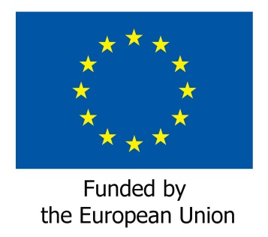

Website of the United Nations High Commissioner for Human Rights; Five UN human rights treaty bodies issue a joint statement on human rights and climate change (retrieved on 27 March 2020) https://www.ohchr.org/en/NewsEvents/Pages/DisplayNews.aspx?NewsID=24998&LangID=E
“Barrierefreies Bauen im Kostenvergleich”, Terragon Wohnbau and the German Network of Municipalities and Cities (Deutscher Städte und Gemeindebund), 2017
Road Map for Sustainable Building in the Basque Country – Bultzatu 2025
Urban Agenda for the Basque Country – Bultzatu 2050

