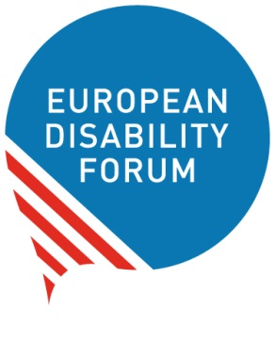

Recommendations on the Web Accessibility Directive Implementing Acts
Table of Contents
Recommendations on the Web Accessibility Directive Implementing Acts 1
Introduction 1
Accessibility Statement 2
Monitoring and reporting 3
Contact 4

Introduction
Within the development of the Directive (EU) 2016/2102 on the accessibility of websites and mobile applications of public sector bodies, known as the Web Accessibility Directive, the European Commission has adopted the so-called implementing acts foreseen in the legislation.
These implementing acts were agreed with Member States and drafted in consultation with experts, including one from EDF. These decisions provide further details regarding three key aspects of the Directive: the accessibility statement, the monitoring methodology, and the reporting obligations from Member States to the Commission on the implementation of the Directive.
The Commission published the drafts of these decisions in an open consultation in May 2018, and EDF provided its feedback. We welcome that several of our recommendations, particularly regarding monitoring, were taken into consideration.
However, given the importance of these three provisions, and the flexibility given by the Commission to Member States to decide some aspects at national level, the aim of this document is to provide recommendations to EDF members on how to implement these decisions at national level. This document should be read along with the EDF toolkit on the transposition of the Web Accessibility Directive.

Accessibility Statement
The decision establishing a model accessibility statement in accordance with the Web Accessibility Directive is available in all EU official languages.

The Directive and this implementing act could allow one accessibility statement to cover any number of websites and mobile application. This will certainly make the statement too generic, potentially long, and not useful for the users.
Action for organisations of persons with disabilities (DPOs): make sure that your government require all public body to prepare an accessibility statement for each website and mobile application under their responsibility.

The Commission does not require that the accessibility statement should be placed equally by all the public sector bodies of a Member State. Nevertheless, it should be easy to find for the user. The Commission provides some examples:
- through a prominent link on the home page, or
- by making it available in every webpage: for example, at the header or the footer of every page.
Member States may also require to use a similar URL to find the accessibility statement, for example: www.examplepublicbody.org/accessibility.
Action for DPOs: ensure that your government decides one of the above options and obliges all public sector bodies to use it on their websites.

The accessibility statement on mobile applications should be placed:
- either on the website of the public body responsible for that app, or
- included in the information provided on the App Store from which people can download the mobile application.
The Commission also suggests the possibility to access that statement within the mobile app itself.
Action for DPOs: make sure that your government requires all public sector bodies to use the same approach to provide the statement about the accessibility of their mobile applications.

It is important that at least inside Member States, all public bodies have the same approach in providing information about their accessibility for two main reasons. Firstly, because it will be easier for the users to find the statement if every public body places them similarly. Secondly, because it will also facilitate the monitoring of this provision.

The Directive requires to update the statement regularly, and the implementing acts recommends updating them annually. However, this is not an obligation.
Action for DPOs: Call your government to establish an annual review by public bodies to check if the content of the statement is still accurate and updated. This review should also take place when the website or mobile application undergo through a substantial update.

As for the contact and feedback mechanism, it does not oblige to provide various means of communication for the user. Users may be able to contact the staff in charge of accessibility by email or phone, but it does not ensure the possibility of contacting them through email and phone.
Action for DPOs: Ask your government to require all public sector bodies to include at least two ways of communication. This should also be possible for the enforcement mechanism referred to in the statement.

For transparency and monitoring reasons, it would be best to make available a link to an evaluation report assessing the accessibility of the website or mobile app. This information will not be used by all users, but it will support monitoring efforts. Public bodies may claim that their websites are fully accessible, so it would be better to attach a technical document to support this statement.
Action to DPOs: Recommend your government to ask the public bodies to make available their accessibility evaluation reports to back up their claims in the accessibility statement.

Monitoring and reporting
The decision establishing the monitoring methodology and the reporting arrangements is also available in all EU languages.

Monitoring

For the in-depth monitoring, the Commission accepts that the monitoring body may accept evaluation results provided by public bodies and made 3 years ago. Given the constant updates and changes on websites and apps, a 3-year-old accessibility assessment will most probably be outdated.
Action for DPOs: advocate for shorter time limit to accept evaluation results.

As for the simplified monitoring, even though the Commission explicitly allows the exclusive use of automatic tools, it also gives the possibility for Member States to use tests other than automatic ones. Promoting the latter option can help to verify aspects of the websites and apps, which are not so easily testable with automatic tools, such as the features related to “usage with limited cognition”.
Action for DPOs: Find suitable tests to check all the relevant user needs referred to in the simplified methodology, and promote them to your monitoring body.

As proposed by EDF, it is an obligation of Member States to consult organisations of persons with disabilities on the composition of the sample of websites and mobile applications that will be monitored.
Action for DPOs: Discuss at national level and come up with a list of websites and apps to be prioritise in the monitoring exercise, and communicate this list to your national monitoring body.

Reporting

In addition to the mandatory aspects to be reported from Member States to the Commission, the more data is publicly available, the better we will be able to assess if the different provisions of the Directive work in practice. Therefore, the content tagged by the Commission as optional should also be included in the Member States reports.
Action for DPOs: require the national monitoring body to include in their report:
- results of monitoring beyond the scope and the requirements of the Directive. For example, if the national legislation covers private website, or if requires higher accessibility requirements (e.g. sign language interpretation);
- how different technologies performed regarding accessibility. There are different ways to design a website or an app, therefore it would be interesting to learn which ones are more accessible than others;
- the outcomes of the consultation with organisations of persons with disabilities and the list of those organisations consulted;
- details on how the exemption based on disproportionate burden is used, and
- any lesson learned at the level of the public sector body, or at national level, with regards to the implementation of web accessibility.

Contact
Alejandro Moledo | EDF Policy Coordinator | alejandro.moledo@edf-feph.org

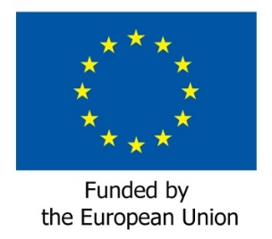
This document only reflects the views of the European Disability Forum.

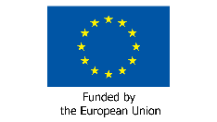
This publication has received financial support from the European Union. The information contained in this publication does not necessarily reflect the official position of the European Commission.

