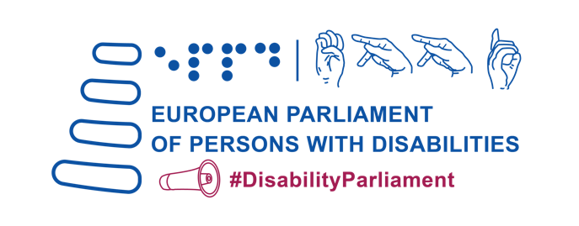
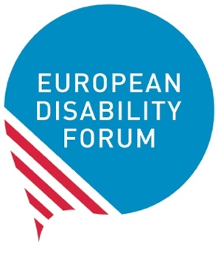

EDF Manifesto on the
European Elections 2024

Adopted by the 5th European Parliament of
Persons with Disabilities
Brussels, 23 May 2023

Content

Introduction 3
Building an inclusive future for persons with disabilities in the EU 4
1. Guarantee the participation of persons with disabilities in the political and public life of the EU 4
2. Realising a Union of Equality for persons with disabilities with the CRPD as its compass 6
3. Becoming a more social Europe 8
4. Embracing accessibility – allowing free movement in Europe 11
5. Protecting persons with disabilities in Europe and beyond 13
Nothing about us without us 14

Introduction

The European Disability Forum (EDF) is an independent organisation with over 25 years of history representing the interests of 100 million persons with disabilities. On May 23rd, EDF organised the 5th European Parliament of Persons with Disabilities in collaboration with its member organisations and the European Parliament.

The 5th European Parliament of Persons with Disabilities brought together over 600 delegates with disabilities from across Europe, representing the diversity of the European disability movement.

In view of the upcoming European elections in 2024, the delegates of the 5th European Parliament of Persons with Disabilities adopted the following Manifesto with the aim of guiding the political programmes of candidates for the European Parliament, the future European Commission appointed after the elections, and all the relevant policies affecting the future of persons with disabilities in Europe and beyond.

This Manifesto outlines the key priorities for persons with disabilities to be fulfilled by the European Union institutions, in full alignment with the United Nations Convention on the Rights of Persons with Disabilities (CRPD) and with the motto of the disability movement: “Nothing about us without us”.
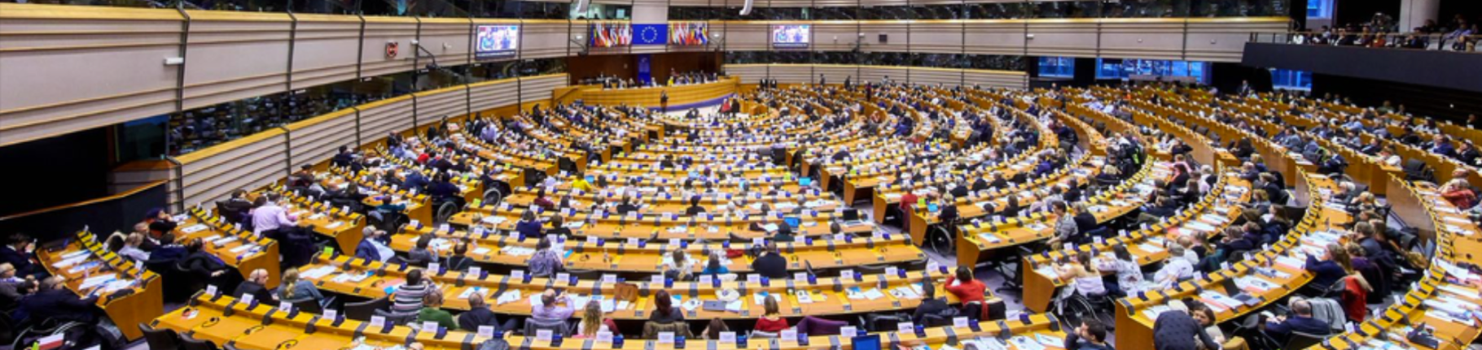

Building an inclusive future for persons with disabilities in the EU

We call on European Union (EU) political leaders to:

Guarantee the participation of persons with disabilities in the political and public life of the EU

- Ensure that all persons with disabilities have the right to vote and the right to stand as candidates in European elections, regardless of legal capacity status, and EU country of residence.
- Adopt measures to maximise the accessibility of the whole electoral process (procedures, facilities, materials, and information), to facilitate the possibility of voting independently and in secret through reasonable accommodation (e.g., providing alternative means of voting, advance voting, tactile stencils, QR codes, or guidance in easy to read, sign language or Braille), and to allow free choice of assistance to cast one’s vote.
- Involve persons with disabilities in the development of political programmes for the European elections, and increase the number of candidates with disabilities, including women and young people with disabilities. European and national political parties must ensure they are inclusive and accessible to persons with disabilities with regards to their campaign materials, political programmes, debates, and events. Election authorities must involve representative organisations of persons with disabilities to identify and foster solutions to persistent accessibility issues.
- Adopt measures to better prevent and protect candidates in the EU elections against cyber-violence and harassment, including hate speech based on disability, gender identity, ethnicity and sexual orientation.
- Collect disaggregated data on the participation of persons with disabilities as voters and candidates in the European elections.

- Support the replacement of substituted decision-making regimes depriving persons with disabilities of their legal capacity with well-resourced supported decision-making schemes.
- Make available resources and tools, including awareness-raising campaigns, for the effective participation of persons with disabilities and their representative organisations in all their diversity, in EU public affairs, including in the preparation and negotiation of EU laws, initiatives and budgets. More precisely, this should include public consultation tools, stakeholders meetings, public debates, events, etc.
- Improve the overall level of accessibility of the EU institutions, including all buildings, digital tools, documents and communications. This must be done in collaboration with organisations of persons with disabilities, accessibility professionals, and by complying with EU harmonised accessibility legislation. Notably, accessibility of communications must include the use of easy-to-read formats, Braille, subtitling, augmentative and alternative communication systems, and ensure the recognition of all the EU’s national sign languages at EU level. As for the latter, the European Parliament must allow citizens to submit petitions in national sign language as requested by petition 1056/2016.
- Establish a Disability Committee in the European Parliament, following the 2024 European elections, that actively involves the European disability movement.

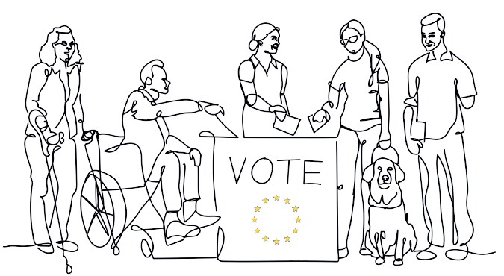

Realising a Union of Equality for persons with disabilities with the CRPD as its compass

- Assess the progress achieved by the European Strategy for the Rights of Persons with Disabilities 2021-2030, and update actions, resources and deadlines for the second half of its implementation, including with further legislative proposals and flagship initiatives.
- Maintain the position of European Commissioner for Equality with the specific mandate to implement the CRPD and mainstream equality in all EU policies, including the next EU budget.
- Establish a new Directorate-General for Equality and Inclusion in the European Commission under the leadership of Commissioner for Equality. Within this new Directorate-General, increase the human and financial resources dedicated to the rights of persons with disabilities to make sure that the CRPD is duly considered by all Commission services.
- Establish an Equality configuration within the Council of the EU, and a Disability Working Party in the Council preparatory bodies.
- Establish focal points concerning the CRPD in all EU institutions and bodies, including in the European Parliament and the European Council.
- Set up a specific budget line in all EU institutions and bodies for the implementation of the CRPD.
- Increase the number of persons with disabilities working in the EU institutions through targeted employment programmes.
- Collect EU-wide disaggregated data by gender, age, and type of disability to assess the impact of EU policies and programmes. Data must also start being collected on persons with disabilities living in institutions.
- Introduce or strengthen enforcement mechanisms of equality policies in the EU, including those related to disability rights.
- Propose further initiatives to guarantee equal and effective access to justice for persons with disabilities.

- Prohibit disability-based discrimination in and by the EU in all areas of life through the adoption of a Horizontal Equal Treatment Directive. Special attention must be paid to intersectional and multiple forms of discrimination, reasonable accommodation, accessibility and the prohibition of hate speech and hate crimes.
- Take into consideration the specific situation of women and girls with disabilities in all relevant policies, especially in the development, implementation and monitoring of EU gender equality policies. Such policies should also consider women who are carers of persons with disabilities.
- Carry out a large-scale, Europe-wide survey on violence against persons with disabilities, which pays attention to the specific situation of women, children, and older people with disabilities. The survey should determine the real situation they face and facilitate the design and adoption of comprehensive legislation and policies to combat it.
- Ratify and swiftly implement the Istanbul Convention on preventing and combating violence against women and domestic violence.
- Criminalise forced sterilisation of persons with disabilities under EU law.
- Put forward specific measures to realise the rights enshrined in the CRPD for those persons with disabilities at higher risk of exclusion, such as persons with disabilities living in segregating institutions, persons with disabilities with high support needs, deafblind people, people with intellectual and psychosocial disabilities, autistic people, persons with disabilities living in rural areas, people with invisible disabilities, people living with rare diseases, people with dementia or persons with disabilities living in poverty.
- Recognise and address the intersectional issues faced by, but not limited to, racialised persons with disabilities, Roma with disabilities, LGBTIQ+ persons with disabilities, older persons with disabilities, children and young persons with disabilities, asylum seekers, refugees and migrants with disabilities, and women and girls with disabilities throughout EU’s equality and inclusion policies and initiatives.
- Provide guidance and support to EU Member States on improving disability assessment methodologies, to ensure alignment with the CRPD and that no one with a disability, visible or invisible, is left behind when accessing social protection, independent living schemes, and other support for persons with disabilities.

Becoming a more social Europe

- Establish a Disability Employment and Skills Guarantee, in line with the successful Youth Guarantee, to provide funding and support to ensure that persons with disabilities have equal access to mainstream education, training and employment opportunities, including self-employment and entrepreneurship. The Guarantee should also offer support in making every training and skills-development programme fully inclusive and accessible.
- Safeguard an adequate budget for Cohesion Policy in the next EU budget (Multiannual Financial Framework) and earmark funds specifically for the social inclusion of persons with disabilities.
- Develop a European Deinstitutionalisation Strategy, and act against the segregation of persons with disabilities, including children with disabilities. Additionally, ensure and guarantee appropriate measures and support for the transition from institutions to independent living and community-based services, allowing for the full and effective participation of persons with disabilities in the community.
- Adopt measures to support the development of a range of person-centred support services in communities for independent living, including personal assistance and a well-trained and adequate workforce. Moreover, ensure preventative measures against institutionalisation targeting children and families by ensuring early identification, early childhood intervention and family support.
- Adopt clear instructions for Member States on how to use EU funds to advance the rights of persons with disabilities. These should apply to all forms of EU funding, spent both in the EU and around the world, and should include a set of indicators to monitor.
- Maintain the general principles of equality between men and women and non-discrimination, including the requirement of accessibility for persons with disabilities in the planning, implementation and monitoring process of all EU-funded programmes. For example, EU investments must not finance inaccessible infrastructures, transport or new technologies that create barriers for persons with disabilities.
- Promote the investment of EU funds in increasing the accessibility of communities, including transport, housing and infrastructure to help make independent living a reality.

- Guarantee the involvement of organisations of persons with disabilities in the partnership and monitoring processes with national managing authorities, to ensure their role in the development and monitoring of EU investment at national level.
- Present a European legislative proposal to guarantee a minimum income in all Member States ensuring an adequate standard of living that takes into consideration the specific situation of persons with disabilities, including disability-related costs, which can reduce the impact of the cost-of-living crisis.
- Adopt further measures, including supported employment services, to increase the employment of persons with disabilities in inclusive and accessible workplaces in the open labour market. Such measures should tackle the specific situation of women, young people with disabilities and people with high support needs who are particularly prone to being excluded from employment.
- Ensure all employment measures including or targeting persons with disabilities guarantee fair wages, respect labour rights, provide reasonable accommodation, and grant access to an effective social protection system.
- Support social economy initiatives, in particular those led by persons with disabilities and their families, which uphold and promote quality employment and social inclusion.
- Take measures to guarantee comprehensive and flexible social security systems in which persons with disabilities can maintain disability-related support when accessing paid-work. Such systems will boost participation of inactive persons with disabilities in the open labour market, should offer sufficient levels of support to persons with disabilities, reduce the risk of poverty and social exclusion, and tackle the dangers faced by the cost-of-living crisis.
- Propose actions aimed at facilitating the transition of workers from sheltered employment towards the open labour market, with adequate and personalised support for each individual making this transition. While people are still working in sheltered settings, action should be taken to improve their working conditions, labour rights and remuneration.

- Fund training programmes for young people with disabilities to facilitate their transition to the open labour market and abolish unpaid or underpaid traineeships and work placements. Focus particularly on vocational training, digital skills training, professional re-qualification, skills accreditation, career guidance and support.
- Support persons with disabilities to maintain a job by funding training through both the “Train and Place” model, preparing persons with disabilities for the expectations of their role before they begin working, as well as the “Place and Train” model, in which training happens on site after the person has started their new role. Promote these among young people with disabilities.
- Support Member States in efforts aiming at ensuring that all learners with disabilities can enjoy their right to quality inclusive education with personalised support in the general education system and through accessible online learning. Life-long learning initiatives supported by the EU should also be accessible to persons with disabilities.
- Establish, at EU and Member State levels, spaces promoting the active participation of children, including children with disabilities, thereby facilitating the successful implementation of the European Child Guarantee and the EU strategy on the rights of the child. These initiatives should also underpin the development of preventative measures towards families and children, including family-centred Early Childhood Intervention services.
- Adopt health-related initiatives that ensure access to the highest standards of health for persons with disabilities across all Member States. Health policies should take a human rights approach towards persons with disabilities, including in the area of cancer prevention and treatment, mental health and sexual and reproductive health.
- Support the good mental health and wellbeing of persons with disabilities and their family members within the EU's comprehensive approach to mental health.
- Introduce measures to support families of persons with disabilities, notably those who act as informal carers, to support and empower them to manage their caring responsibilities, to remain active in employment, to maintain good health, and to have a life of their own outside of caring. These measures should also seek to prevent situations where family members with caring responsibilities are disadvantaged or discriminated against.

- Support the right of persons with disabilities to form a family, as well as their equal rights related to marriage, parenthood and relationships.
- Develop a European strategy to combat loneliness that takes into consideration the situation of older persons with disabilities.

Embracing accessibility – allowing free movement in Europe

- Adopt an EU-wide Disability Card which ensures the mutual recognition of disability status across Member States, covering not only leisure, culture and sport facilities, but all specific services for persons with disabilities, including in transport and other commercial services.
- Grant, with the European Disability Card, the necessary support for persons with disabilities during the transition period of moving to another country to study or to work, and until their disability has been certified by their new country of residence.
- Create a new European agency for accessibility, based on the work of the AccessibleEU centre, to support the implementation of all EU harmonised accessibility legislation.
- Make sure the Digital and the Green Transition consider accessibility and non-discrimination for persons with disabilities as a core pre-condition to reduce (digital) exclusion and address the climate crisis. This is especially relevant in the context of legislation concerning new technologies, such as Artificial Intelligence, digitalisation of justice and healthcare, and other legislation under the EU Green Deal, such as the renovation of buildings and infrastructure.
- Introduce legal requirements to ensure that, when providing digital means to access a right or a service of general interest, there will always be non-digital alternative (through human interaction).
- Promote consumers’ rights for persons with disabilities and protection for persons with disabilities as potentially vulnerable consumers, including by introducing legislation on accessible labelling and inclusive financial services.
- Update Passengers’ Rights Regulations so persons with disabilities can move as freely as any other person in the EU.

- Adopt legislative measures for air travel to avoid situations such as denial of boarding, obligation to travel with an assistant without the air carrier paying for the extra ticket, lack of quality assistance in airports, and insufficient compensation for loss or damage of assistive and mobility equipment.
- Step up efforts to harmonise and expand accessibility requirements in transport infrastructure, including train stations and rolling stock, so all transport becomes more accessible to passengers with disabilities and a wider range of passengers.
- Strengthen enforcement mechanisms of EU legislation concerning accessibility and passengers’ rights.
- Ensure that the Marrakesh Treaty is fully implemented within the EU and in cooperation with partner countries around the world so that blind and partly sighted people and otherwise print-disabled people have access to the same books, magazines and reading materials as all other people.
- Expand EU-wide copyright exemptions to other cultural works to facilitate accessible adaptations and availability of these for all persons with disabilities.
- Ensure equal access for persons with disabilities to individual transportation means (e.g., to obtain driving licenses and adapted cars).
- Introduce legislation to guarantee the availability and affordability of assistive technologies for persons with disabilities in the EU single market.
- Invest EU resources in increasing the knowledge and availability of national sign languages, easy-to-read formats, Braille, speech to text, hearing assistive devices, and any other accessible means of information and communication for persons with disabilities.
- Invest EU funds in culture and sporting activities that are inclusive of persons with disabilities, requiring accessibility as a pre-condition and encouraging the participation of persons with disabilities.
- Ensure that EU funds invested in research and innovation, including in new technologies, respect and support the rights of persons with disabilities.

- Promote an ambitious transposition and proper implementation and monitoring of EU accessibility legislation on products and services, on the public sector, on audio-visual media services, and on electronic communications, with a focus on setting EU-wide quality criteria for accessibility.
- Introduce accessibility obligations and a universal design approach in the development of all public policies shaping the EU single and digital markets. These should guarantee the free movement of people, goods, products and services without discrimination. Include penalties for non-compliance of accessibility requirements.

Protecting persons with disabilities in Europe and beyond

- Develop and fund support services for asylum-seekers and refugees with disabilities in the EU.
- Launch targeted awareness raising campaigns in and outside Europe to combat stereotypes and discrimination against persons with disabilities and to promote the human rights approach to disability.
- Ensure the CRPD is promoted in the EU’s work around the globe, in cooperation with persons with disabilities and their representative organisations. This should be the case regarding funding for international cooperation, humanitarian action, disaster risk reduction and armed conflicts. Scrutinise the disbursement of EU funds in global work to prevent violations of the rights of persons with disabilities, with the EU supporting deinstitutionalisation processes in third partner countries.
- Support Ukrainians with disabilities inside and outside Ukraine, and make sure the EU’s contribution to the reconstruction of Ukraine builds a more inclusive country for persons with disabilities. EU-supported reconstruction should include accessible housing, transport and public infrastructure, and community-based support services instead of institutionalised care. Developments towards rebuilding Ukraine should support EU accession and be done in cooperation with Ukrainian organisations of persons with disabilities.
- Take into consideration the situation of persons with disabilities as well as the implementation of the CRPD in the accession process of EU-candidate countries.

- Prepare for future crises by effectively implementing existing guidelines at UN and EU levels, which already take into consideration the rights and requirements of persons with disabilities.
- Ensure that essential everyday services – such as health, education, building infrastructure, transport and communications – are developed in a way that ensures they continue to function equally for persons with disabilities during emergency situations, including conflict, pandemics, and other natural events such as flooding and earthquakes.
- Meaningfully consult organisations of persons with disabilities on the design of civil protection systems and preparedness strategies, as well as on the actions taking by emergency services when responding to crisis situations.
- Play a leading role in the global move towards disability inclusion in climate action, ensuring that the 'just transition' benefits and does not negatively impact persons with disabilities.

Nothing about us without us

