
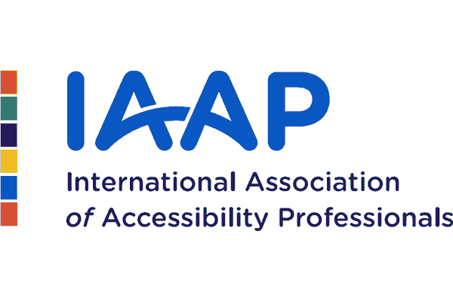

May 2023

European Disability Forum (EDF) and International Association of Accessibility Professionals (IAAP) joint statement on accessibility overlays

Note: We use some technical terms in this statement.
These are explained in a glossary at the end.

Digital accessibility is a fundamental part of an inclusive society. Accessible websites and online services ensure that people’s individual preferences and needs can be met, using mainstream devices, operating systems features or the user’s chosen assistive technology and browser plugins.

Artificial intelligence and other emerging technologies have great potential to improve accessibility and assistive technology. However, to date none of these technologies can instantly fix an inaccessible website.

There are several technology products on the market claiming to improve website accessibility. Some of these products are called ‘accessibility overlays’.

It can be difficult for people who are not digital accessibility specialists, including users, developers, designers and website owners who purchase technology, to understand what accessibility overlays can and can’t deliver, and the limitations and potential risks of any new technology.

An accessibility overlay is a type of technology that enables users to make changes to the way content appears on a website. Accessibility overlays add extra functionalities to individual websites, such as text-to-speech, contrast, magnification, or the ability to control colour to improve readability.

While some of these functionalities can help some users, most are redundant as they are already available in browsers or provided by users’ chosen assistive technology.

Other types of accessibility overlays try to automatically ‘repair’ accessibility problems directly on the website when it is used. However, this is not always reliable and can interfere with assistive technology.

It is not acceptable for overlays, plugins or widgets to impede access to users’ assistive technology, choice of browsers and/or operating system features.

Accessibility overlays can cause significant problems:

- Users of assistive technology already have their devices and browsers configured to their preferred settings. The overlay technology can interfere with the user’s assistive technology and override user settings, forcing people to use the overlay instead. This makes the website less accessible to some user groups and may prevent access to content.
- Most of the functionalities offered by accessibility overlays are copying built-in mainstream features that already exist in today’s browsers and operating systems. There is no point replicating these features with an overlay. Making users aware of mainstream features would be a far more efficient way of providing support where needed.
- Some overlays automatically detect when an assistive technology is running on a user’s device. This can be an issue if there is no ability to opt out of such tracking as assistive technology is often associated with a disability and information about disability is sensitive personal data.
- Website owners who are not digital accessibility specialists may be led to believe that overlays can ‘fix’ the accessibility of a website, which is not the case. Overlays do not make the website accessible or compliant with European accessibility legislation. They do not constitute an acceptable alternative or a substitute for fixing the website itself.

EDF and IAAP agree that innovation should be encouraged - but it should always be carefully deployed.

Digital content accessibility is not the responsibility of the user, it is the responsibility of the website owner. User needs should be met by ensuring that code on the website is compliant with existing laws and digital accessibility standards.

We therefore strongly advise public and private sector buyers of technology to actively engage with digital accessibility experts, persons with disabilities and their representative organisations to understand user needs and how these can be met.

Only this will ensure that content is accessible on all devices and compatible with any assistive technology. No technology should be added to a website if it is likely to prevent access for some users.

Glossary

- Assistive technology: Accessible technology is any item, piece of equipment, service or product system, including software, that is used to increase, maintain, substitute or improve functional capabilities of persons with disabilities. Examples of assistive technologies include hardware such as Braille display keyboard, sip-and-puff mouse or eye tracking devices and software such as screen readers, magnifiers, virtual keyboards or speech input programmes.
- Browser: A web browser is an application software used to fetch content from the internet and display it on a user's device. Examples of browsers include Google Chrome, Firefox and Safari.
- Browser plugin: A Browser plugin is software to manage Internet content that a browser is not designed to process. An example of browser plugin is Adobe Reader, which enables people to view PDF files in their browser.
- Operating system: An operating system is system software that manages computer hardware and software resources. It also provides common services for computer programmes. Examples of operating systems are Microsoft Windows, MAC OS, Apple iOS and Android.
- Widget: A widget is a feature that displays information or provides a specific way for a user to interact with the operating system or an application. Examples of widgets include buttons and toolbars.

