EDF Human Rights Report about
the Sustainable Development Goals

Why are they important
for people with disabilities in Europe?

Easy to read version

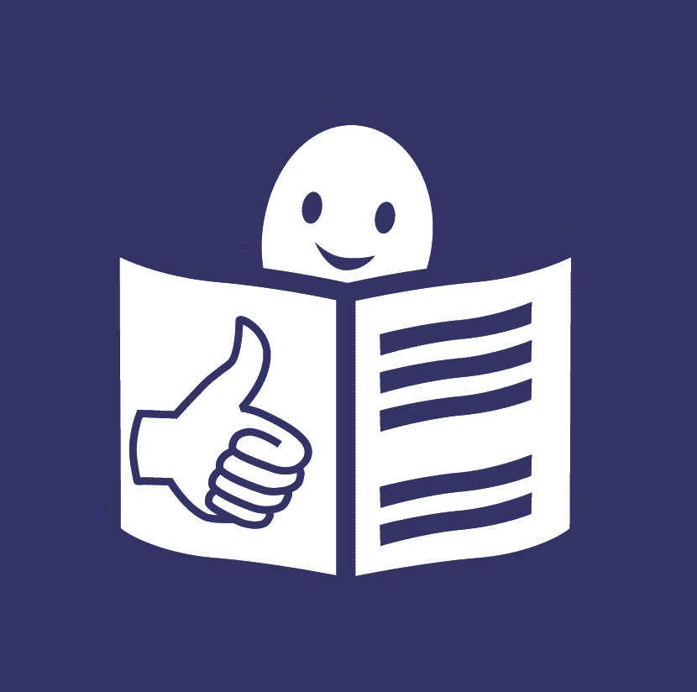

The European Disability Forum

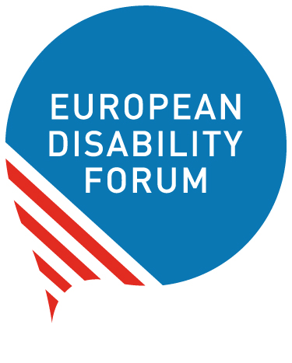
The European Disability Forum is an organisation of people with disabilities in Europe.
In short, we call it ‘EDF’.

EDF works to protect the rights
of people with disabilities in Europe.
We think that people with disabilities
should have same chances in life
and take part in the community like everyone else.

We also think that people with disabilities should decide about their lives.
Nothing should be decided about us without us.

The human rights report

Every year, EDF makes a document
that talks about the rights of people with disabilities.
It talks about things that are important for them.

For example, last year we made a document that talks about
the ‘UN Convention on the Rights of Persons with Disabilities’.

The UN Convention

The UN is a big organisation
that works for peace and a better world.
The UN made a document that says
what rights people with disabilities have.
It also says how countries should protect these rights.
This document is called
‘the UN Convention on the Rights
of Persons with Disabilities’.
In short, we call it ‘the UN Convention’.

Many countries have signed the UN Convention.
That means that they agreed to do what the UN Convention says.
They agreed to make things better for people with disabilities.

The Sustainable Development Goals

This year, EDF made a document
that talks about another important thing for people with disabilities:
‘the Sustainable Development Goals’.

Some time ago, countries came together and agreed to work
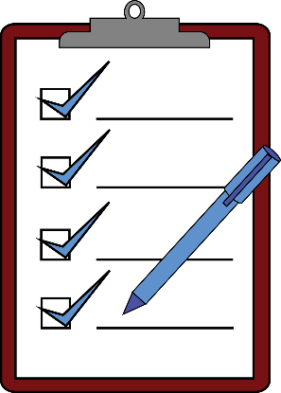
to make the world better.
For example, they agreed to protect people
who are very poor or left out
and make things better for them.
They also agreed to try to make peace in the world
and to protect the planet.
They made a plan to make this happen by 2030.

To make this plan happen, they set some goals.
We call these goals ‘the Sustainable Development Goals’.
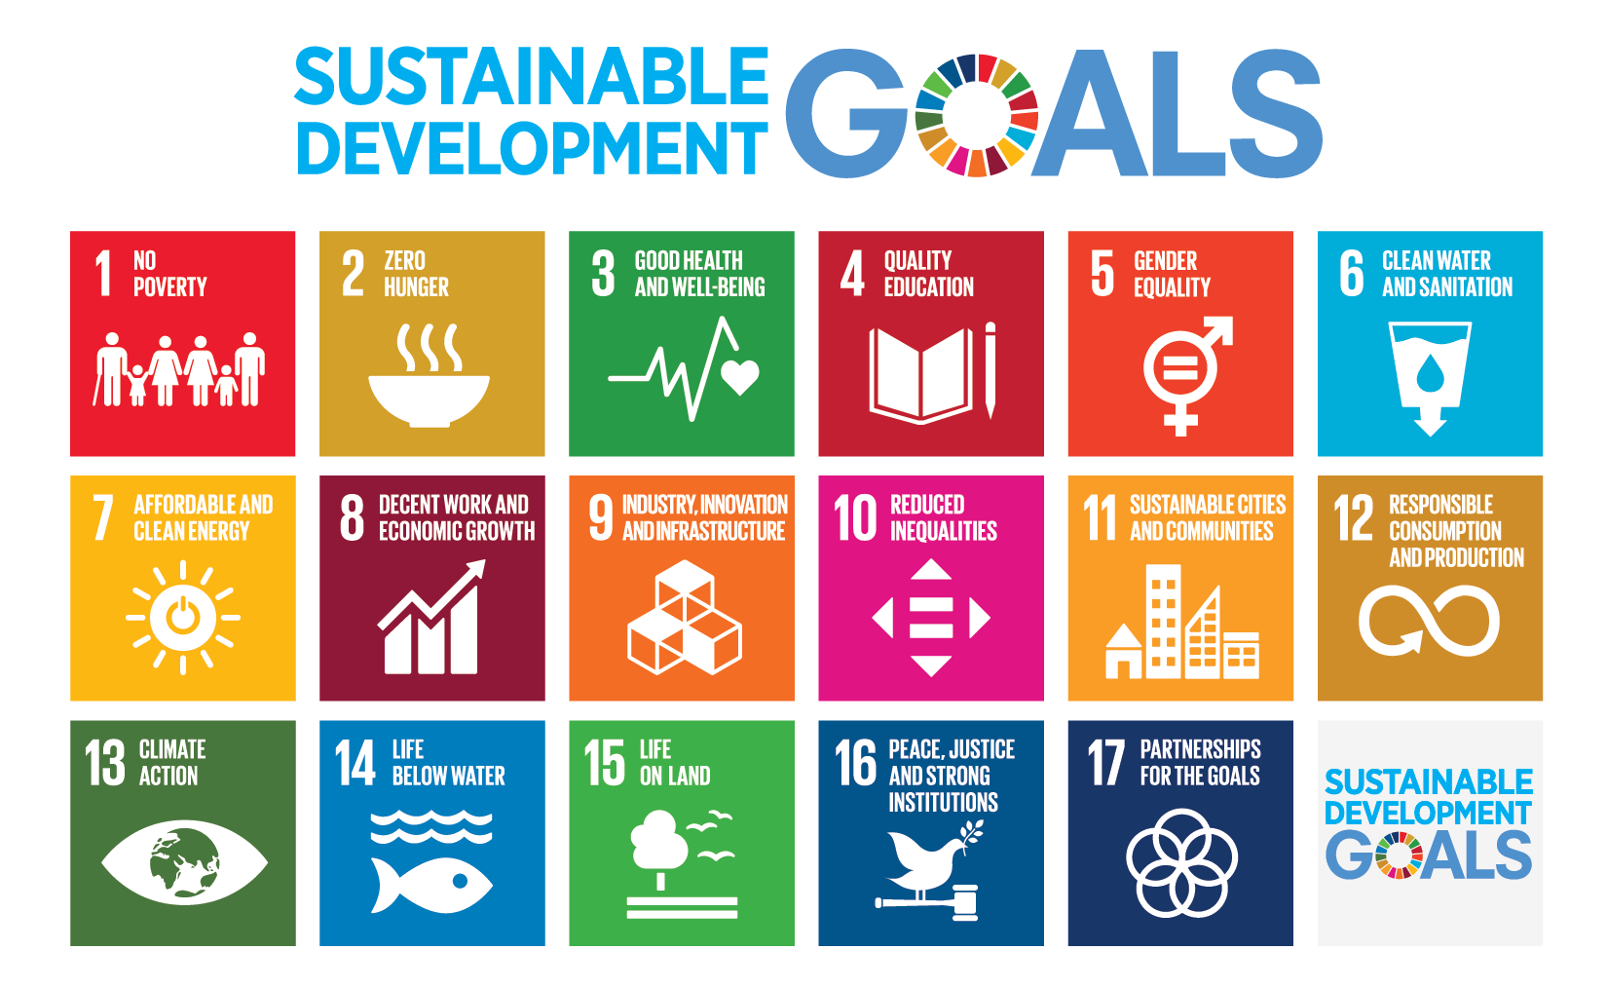
If countries make these goals,
the world will be a better place for everyone
and no one will be left behind.

For example:

- Less people will be poor, hungry or left out.
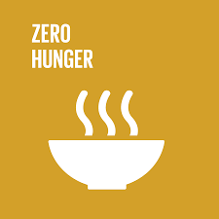
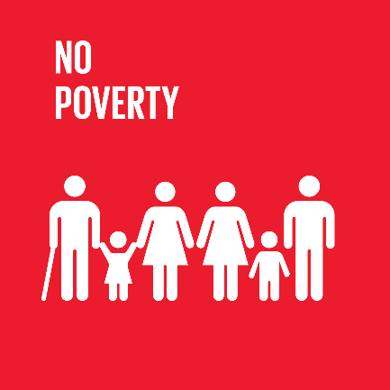

- All people will have the chance to go to school and study.
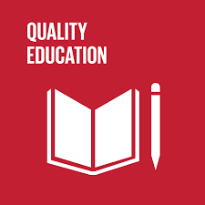

- All people will have the chance to work
and make their own money.
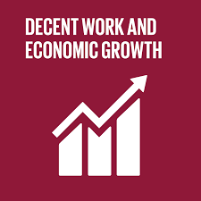

- Women will have same chances in life as men.
They won’t be treated unfairly or badly.
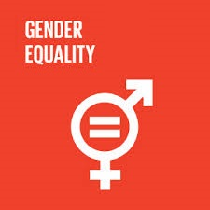
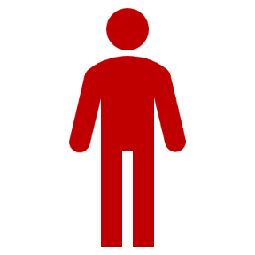
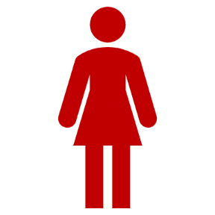

- All people will take part in the community
and live together as equals.
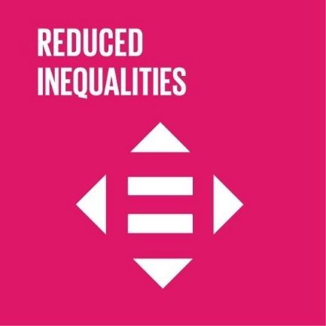

Countries who have agreed to make these goals happen,
meet every year to talk about how it is going.
They talk about what they did to make these goals happen.
They also talk about problems that make it harder for them
to make these goals happen.
They share their experiences, learn from each other
and try to solve these problems.
For example, every year in July,
there is a big meeting in New York.
This meeting is called ‘High Level Political Forum’.

All people should have a say

Countries should hear what people think about their work
to make the Sustainable Development Goals happen.
They should listen to all people and make sure
that no one is left behind.
The Sustainable Development Goals
concern people with disabilities too.
They can make their lives better.
So countries should listen to people with disabilities too.
That is why people with disabilities and their organisations
made a group.
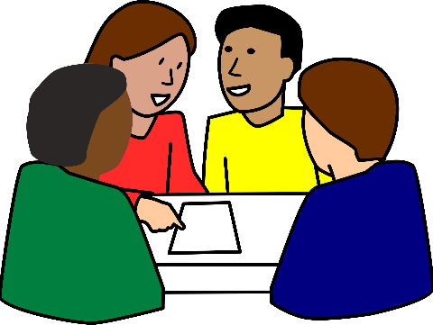
All people with disabilities and their organisations
can join this group, if they want to.
This group wants to make sure
that people with disabilities can take part
in the work that countries do
to make the Sustainable Development Goals happen.
The group reminds the countries that
the Sustainable Development Goals
concern people with disabilities too.
So the countries should listen to them and respect their rights.

How things are in Europe

The European Union is a group of 28 countries in Europe.
These countries came together to make the lives of people better.

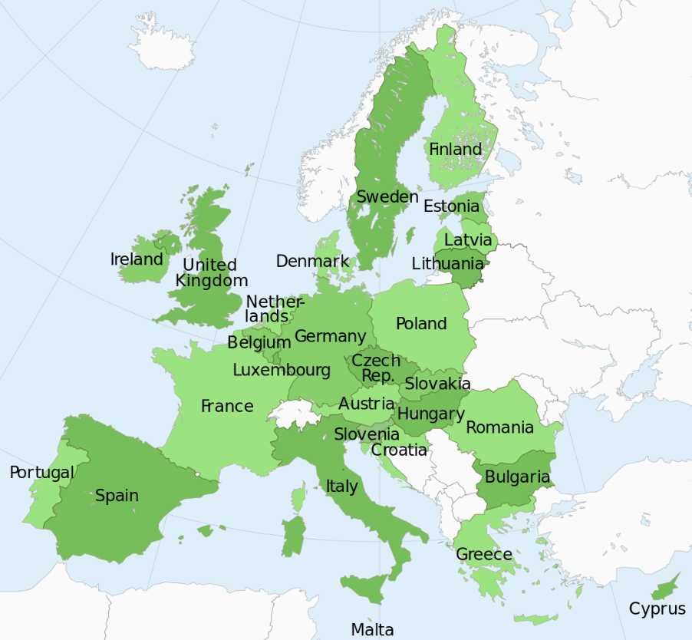
The European Union signed the UN Convention
and agreed to protect the rights of people with disabilities.
They agreed to make things better for people with disabilities in Europe.

The European Union agreed
to make the Sustainable Development Goals happen too.

Both the UN Convention and the Sustainable Development Goals
are very important for people with disabilities.
The UN Convention talks about the rights of people with disabilities.
The Sustainable Development Goals talk about the good of all people.
Also people with disabilities.

What the European Union should do

The European Union and its countries should work together
to make the UN Convention and the Sustainable Development Goals happen.
Some work should be done by the European Union
and some work should be done by each country that is part of it.

EDF thinks that the European Union should do more work
to make the Sustainable Development Goals happen.
We think that the European Union should make a plan that says
how they will work to make the Sustainable Development Goals
happen.
The European Union should also help its countries
to make the Sustainable Development Goals happen in each of them.

EDF also thinks that the European Union should make a plan
that says how they will work in the next years
to make the UN Convention happen.

If the European Union makes the Sustainable Development Goals
and the UN Convention happen in Europe,
things will be better for people with disabilities and all people.

For example:

- Both the Sustainable Development Goals and the UN Convention
say that women are equal to men.
They should not be treated unfairly or badly
just because they are women.
Often women with disabilities are treated badly or unfairly.
They have a bigger risk to be left out than women without disabilities. This is unfair and should stop.
EDF thinks that the European Union
should protect women with disabilities and make sure
they have same chances in life like everyone else.
They should not be left out or treated badly
just because they are women or because they have a disability.

- Both the Sustainable Development Goals
and the UN Convention
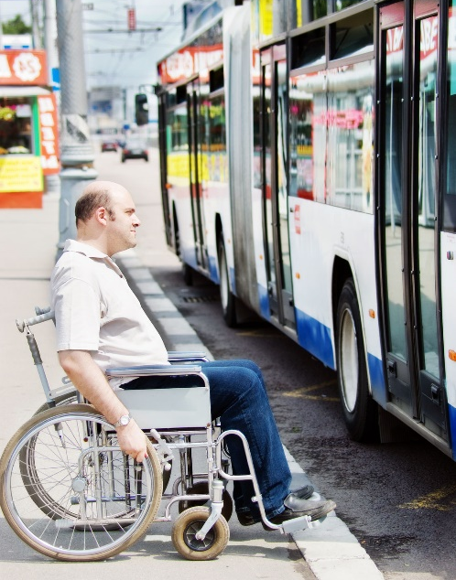
say that things should be accessible
so that all people can use them.
This is very important
for people with disabilities.
Too many things in Europe
are still not accessible for them.
For example, often buses and trains
are not accessible.
So people with disabilities
cannot use them to go to work
or go meet their family and friends.

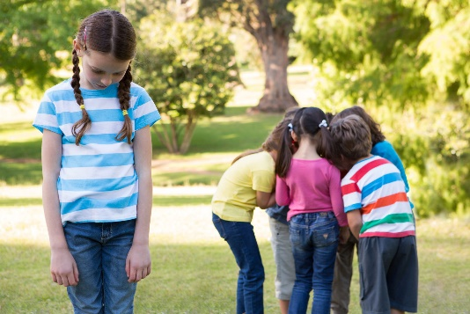
Or schools are not accessible.
and children with disabilities
cannot go to school with other children.

So people with disabilities
cannot take part in the community
like other people
because things are not accessible for them.
They are left out and this is unfair.

EDF thinks that the European Union should make sure
that things are accessible for all people.
We think that the European Union should make a strong law
to make more things accessible for people with disabilities.
This law is called ‘the European Accessibility Act’.

Now the European Union is talking about this law and will decide
if they will make this law happen in Europe.
If this law happens, some things will be better
for people with disabilities.

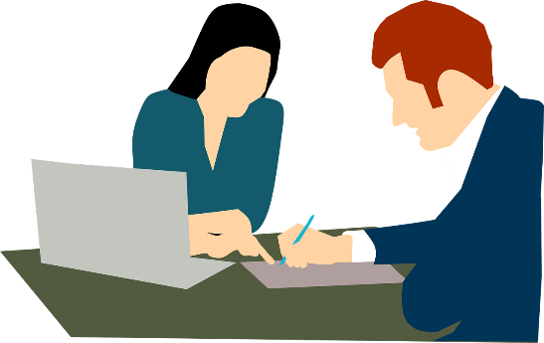
- Both the Sustainable Development Goals
and the UN Convention
say that all people
should have the chance to get a job.
If they have a job,
they can make their own money,
be independent and make their life
as they want.

But too many people with disabilities in Europe
do not have the chance to get a job.
This is because things are not accessible for them.
For example, if the bus is not accessible,
many people with disabilities cannot take it to go to work.
It can also be because other people do not want to work with them.

Without a job, people with disabilities do not have money
to buy the things they need to have a good life.
They may be very poor or left out of the community.

EDF thinks that the European Union should make sure
people with disabilities have same chances to get a job
like other people.

To make things better for people with disabilities,
it is very important that the European Union knows
how many people with disabilities there are in Europe.

For example, they should know:

- How many are women with disabilities?
- How many are children with disabilities?
- How many people with disabilities live in care homes?

If they know how many people with disabilities there are,
they will be able to help people with disabilities in a better way.

Leave no one behind

It is also very important that the European Union listens
to people with disabilities and their organisations.
When countries agreed to make the Sustainable Development Goals happen,
they promised to leave no one behind.
So people with disabilities should not be left behind either.

The European Union and all countries should remember this
when they work to make the Sustainable Development Goals
happen.

They should listen to people with disabilities and all people
and try to do things better for them.
They should keep their promise to leave no one behind.

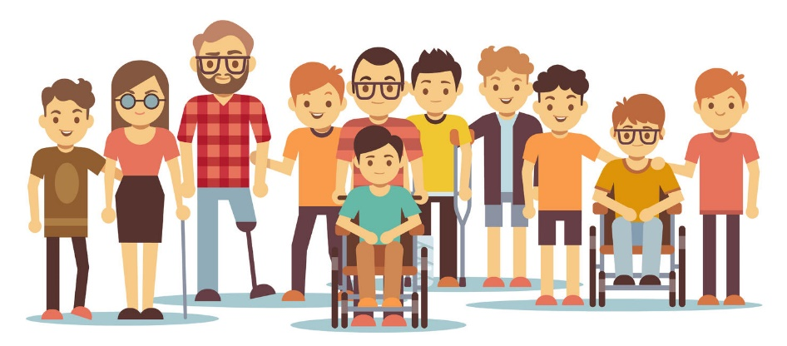

How people with disabilities can help

People with disabilities and their organisations can help
to make the Sustainable Development Goals
happen in their countries.

For example:

- They can learn more about the Sustainable Development Goals
and understand why they are important for them.

- They can share information and learn from each other.
- They can talk to people who make decisions in their country
about how important the Sustainable Development Goals are
for people with disabilities
and ask them to make them happen.

More information

If you have questions
or if you need more information
please send us an email at info@edf-feph.org.

Also, you can visit our website at www.edf-feph.org.

