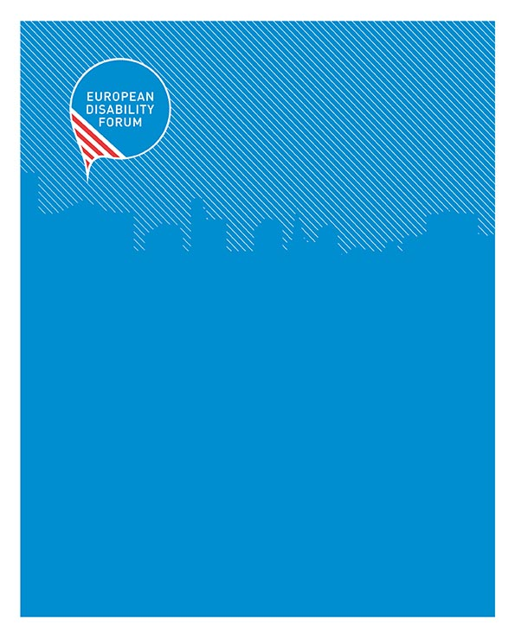

EDF Guide on engaging with Council Presidencies
7-8 Avenue des Arts tel +32 2 329 00 59 info@edf-feph.og
1210 Brussels - Belgium fax +32 2 282 46 09 www.edf-feph.org

EDF Guide on engaging with Council Presidencies
  - EDF | June 2021
...................................................................................................................
The European Disability Forum is an independent NGO that represents the interests of 100 million Europeans with disabilities. EDF is a unique platform which brings together representative organisations of persons with disabilities from across Europe. EDF is run by persons with disabilities and their families. We are a strong, united voice of persons with disabilities in Europe.

Contents
EDF Guide on engaging with Council Presidencies 1
Glossary 3
Background 4
What are Council Presidencies? 5
Good practice example: The Latvian Council Presidency 2015 6
The preparations Error! Bookmark not defined.
The results Error! Bookmark not defined.
Challenges Error! Bookmark not defined.
The benefits Error! Bookmark not defined.
Summary of recommendations 9
Related documents and links 9
Acknowledgments 10
Contact person at the EDF secretariat: 10

Glossary

- Council of the EU: The institution representing the member states' governments. Also known informally as the EU Council, it is where national ministers from each EU country meet to adopt laws and coordinate policies.

- European Council: The EU institution that defines the general political direction and priorities of the European Union. It consists of the heads of state or government of the member states, together with its President and the President of the Commission.

- Council of Europe: An international organization representing 47 Member States working on democracy and human rights, based in Strasbourg.

- Council conclusions: The Council of the EU negotiates and adopts not only legal acts but also documents such as conclusions, resolutions and statements, which do not intend to have legal effects. The Council uses these documents to express a political position on a topic related to the EU's areas of activity. These types of documents only set up political commitments or positions - they are not foreseen in the treaties.

- Council Presidency: The presidency of the Council rotates among the EU member states every 6 months. During this 6-month period, the presidency chairs meetings at every level in the Council, helping to ensure the continuity of the EU's work in the Council.

- Council Preparatory Bodies: The Council is supported by the Committee of Permanent Representatives of the Governments of the Member States to the European Union (Coreper) and more than 150 highly specialised working parties and committees, known as the 'Council preparatory bodies'. The preparatory bodies can be divided into two main categories: Committees set up by the treaties, intergovernmental decisions or by Council act - they are mostly permanent and often have an appointed or elected chairperson, and Committees and working parties set up by Coreper - these deal with very specific subjects and are chaired by the delegate of the country holding the rotating 6-month presidency of the Council. In addition, ad hoc committees can be created for a specific purpose and cease to exist when their task is fulfilled.

- COREPER I and II: Coreper stands for the 'Committee of the Permanent Representatives of the Governments of the Member States to the European Union'. It is the Council's main preparatory body. All items to be included into the Council's agenda (except for some agricultural matters) must first be examined by Coreper, unless the Council decides otherwise. It is not an EU decision-making body, and any agreement it reaches can be called into question by the Council, which alone has the power to make decisions. Its main tasks are to coordinate and prepare the work of the different Council configurations, to ensures consistency of the EU's policies, and to work out agreements and compromises which are then submitted for adoption by the Council. Coreper I is composed of the permanent representatives from each member state, who, in effect, are their country's ambassadors to the EU. Coreper II are the deputy permanent representatives from each Member States. They express the position of their government. The two configurations of Coreper (Coreper I and II) meet every week.

- Presidency Programme: List of political priorities that each Presidency publishes at the beginning of their 6-months-term (usually in January and July).

- Presidency Agenda: List of official events, meetings, and conferences during each Presidency.

- Disabled Persons’ Organisation (DPO): Organisations comprising a majority of persons with disabilities and their families which represent the interests and defend the human rights of persons with disabilities through self-representation and advocacy.

Background

Since we started strengthening our work on the Council in 2018, it became clear during the first year that this is not an easy task. Especially engaging with the Council’s General Secretariat and the Preparatory Bodies (Council of Permanent Representatives – COREPER, and the Working Parties) proved to be challenging because access to information is highly restricted and their work is not transparent.

Therefore, we decided to concentrate more on the Council Presidencies which we can influence better via our members. In fact, during 2019 we started working closer with our members to prepare the upcoming Presidencies and to influence their programmes, trying to better reflect disability issues throughout all policy fields,events and meetings of the Presidency.

This work is still in its infancy and will be developed further. One step to raise awareness among our members and Disabled Persons’ Organisations (DPOs) in general is to share the experiences and the expertise that our own members have collected over the years by engaging with different Presidencies. This Guide is therefore a snapshot of the possibilities but it is of course not limiting us in testing new strategies and actions that can make our work even more efficient in the future!

This Guide is based on a webinar we held on 20 February 2020 in which we shared general information about the EU’s Council Presidencies as well as the good practice example of the Latvian Presidency in 2015, which successfully involved Latvian DPOs.

What is the “Council”?

First of all, it should be clarified that when talking about the “Council” in the context of Presidencies, we usually mean the Council of the EU. This is an EU institution, formerly known as „Council of Ministers“, which regularly meets in different policy-related configurations. For example, to discuss transport files, the national Ministers of Transport meet in the Transport and Telecommunications Council. If social issues are being discussed, these fall often under the remit of the Employment, Social Affairs, and Consumer Affairs Council which consist of the relevant ministers from each Member States. The Council of the EU has a rotating Presidency, chaired by a different Member State every six months.

Not to be confused with the Council of the EU is the European Council. While it is also an EU institution, it is a high-level meeting of the Member states’ Heads of State and Governments which takes important political decisions. These are summits that discuss urgent political issues such as the “Migration crisis”, Brexit, or the EU Budget. The European Council has a permanent President, which is currently Charles Michel from Belgium. Finally, another “Council” not to be confused with is the Council of Europe. This is not an EU institution, it is an international human rights organisation based in Strasbourg. When discussing the “Council” in the rest of this document we therefore refer only to the “Council of the EU” unless clearly otherwise stated.

The Council can be considered as the most powerful institution in the decision-making procedure. While the Commission has the power to propose new laws, and the European Parliament has veto power, the Council has the last word and can indefinitely block a legislative procedure if no compromise can be reached. An example is the proposed Horizontal Equal Treatment Directive which has already been in discussion for over 10 years but is still blocked by some Member States, thus freezing the complete procedure and the adoption of this important piece of legislation.

The Council also has a “special” position among the main EU institutions because it is at the same time an EU-level body but it consists of representatives of the 27 EU Member-States. It has thus a “double hat”, both representing national interests and EU-level interests. Another defining feature is the notorious lack of transparency of the Council. While the Commission and especially the European Parliament have become more transparent to citizens and interest representations over the years, the Council is still far from achieving this. It seems, indeed, like there is not really an interest to change this feature either. Meetings of the different Council working structures have no public minutes or records, they happen behind closed doors. Even if documents are published afterwards, it takes weeks to become public and documents have to be requested individually, often in formats that are not accessible.

But there is nevertheless also an opportunity in trying to influence the agenda of the Council, since it has significant powers as mentioned above and can push for change very effectively.

What are Council Presidencies?

The Presidency of the Council rotates every six months. In order to ensure a long-term political vision, three consecutive Presidencies are grouped together in a “Trio” in which these three Member States work closely together and align their Presidency programmes. This has been in force since the Lisbon Treaty in 2009 as six months are a very short time in the context of EU decision-making, where a legislative file can remain under discussion for several years.

The Member State that holds the Presidency chairs all the meetings of the Council and its preparatory bodies, which can be around 1500 meetings per Presidency where about 200 – 300 legislative files are discussed. This means that the Presidency holds the position of a neutral broker who should strive to seek compromise among the other Member States and with the other EU institutions. The Presidency also represents the Council in relations with other EU institutions and it closely coordinates its work with the President of the European Council and the High Representative of the Union for Foreign Affairs and Security Policy (the EU equivalent of a Foreign Affairs minister).

The current Presidency is held by Croatia. The upcoming Presidencies are:

- Germany (July-December 2020)
- Portugal (January-June 2021)
- Slovenia (July-December 2021)
- France (January-June 2022)
- Czechia (July-December 2022)

Since the Presidency also sets the agenda for the work that will be done in the next six months, it is important for Disabled Persons’ Organisations (DPOs) to also try and influence the content and the priorities of each Presidency. This is best done by preparing already input on national level and influencing the national Ministries, as those determine later the Programme of the Presidency.

Good practice example: The Latvian Council Presidency 2015

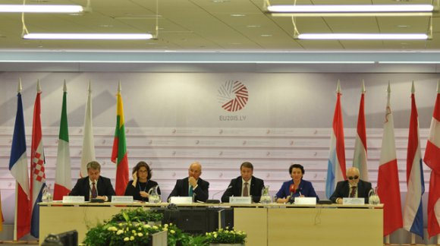
1High-level meeting on disability in Riga, Latvia, on 11 May 2015 (copyright:www.eu2015.lv)

The Latvian Umbrella Body for Disability Organisations (Sustento) is a full member of EDF. Currently, Sustento brings together 54 different organisations whose members include more than 50 000 people with disabilities or chronic illnesses in Latvia. Sustento works to ensure that the government develops policies that ensure the human rights and non-discrimination of persons with disabilities and chronic illnesses by promoting full inclusion.

In 2015, Sustento was successful in including disability issues on the programme of the Latvian Presidency. During the 6 months between January and June, three major disability-related events were organised in collaboration with Sustento: a high-level meeting on disability, an event on disaster preparedness and persons with disabilities, and an event on de-institutionalisation. For comparison, in some Presidencies there is not even a single event dedicated specifically to disability issues.

Besides these three major events, Sustento also put a lot of effort into mainstreaming disability in other events of the Presidency. Those events included for example events on employment, on gender, or on patients’ rights in healthcare. They managed to bring in the disability perspective pro-actively.

But all of this was not achieved easily. Sustento put a lot of effort into the preparations and the advocacy before the Presidency even started. Already in 2013, two years before the start of the Presidency, they had with meetings with government officials and decision-makers to prepare the ground and raise awareness. Their main contact point was the Secretariat of the Council Presidency but they also went separately to different Ministries.

With some the contact was easier, as it was already established (e.g. the Ministry of Social Affairs), with others new links had to be made. They also approached for example the Ministry of Economic Affairs to discuss employment issues, and the Ministry of Transport to talk about passengers’ rights for persons with disabilities. Sustento pointed out that it is important to talk to all of them to find supporters in a wide range of policy areas.

Besides the preparatory policy work, Sustento also looked at the practical aspects of organizing an accessible Presidency: they trained the staff of the Presidency Secretariat on disability awareness to make sure that meetings and events would be accessible to all persons with disabilities. They also highlighted the need for accessible meeting venues and accommodation for guests with disabilities, and the need for accessible transport.

Since all of this work is very time-consuming and Susteno was, like most DPOs, faced with limited resources, they decided to rely a lot on volunteers. These volunteers were recruited and trained specifically for the Presidency and its preparations. They helped for example with finding accessible restaurants or accompanied persons with disabilities to meetings and helped out at events.

Following the work of Sustento described above, there were some concrete results achieved :

- Three major Presidency events on disability
- Mainstreaming of disability issues in several other events on different policy topics
- Council conclusions on disability
- EDF Board conference on accessible Information- and Communication Technologies (ICT) was part of the official Presidency programme
- Funding received for both the main events as well as the EDF Board conference and meeting

However, Sustento of course also faced several challenges. As mentioned above, the preparations had to start early and involved a lot of planning which also requires a certain capacity of the organisation. The same is true for establishing the relationship with the Presidency Secretariat, which required prior investment of time and staff resources. The engaging and training of new volunteers had to be organised and followed up throughout the Presidency.

But all in all, the benefits definitely prevail:

- disability issues were included on the official Presidency Programme and strengthened therefore the policy agenda of Sustento
- lasting policy impact through official Council Conclusions
- raised awareness among government officials of disability issues and accessibility which lasted beyond the Presidency
- high visibility of disability issues in the media
- practical improvements in terms of accessibility
- funding through the Presidency for the three major events that were mentioned above as well as funding to organize the EDF Board meeting in Spring 2015 in Latvia.

How can EDF support you?
The EDF secretariat can provide you with guidance such as this document, or the webinar recording and transcript so that you build your member organisations’ capacity to better influence the Council via your national decision-makers.

We also help you define the priorities for each Presidency, which is usually a combination of EU-level items combined with important priorities that you see on national level. For example the Multiannual Financial Framework or the “EU Budget” is of course an important EU-level item, but if a new national law on disability assessment is being discussed, this is of course also a priority that should be included. EDF can provide you with a draft document for you to complete.

Furthermore, we can help you arrange meetings with the Permanent Representation of your Member State here in Brussels. Their staff, both the Ambassador as well as the Policy Advisors, will be the ones who will chair all the actual Working Group meetings and other preparatory bodies so it is important to establish a good contact with them prior to the Presidency, in addition to the staff from national ministries.

Finally, we also arrange informal meetings at each EDF Board meetings for EDF members to exchange their views and experiences and support upcoming Presidency countries. At the moment, these meetings cover usually the current Presidency and the next three or four upcoming ones.

If you would like further information or practical support please get in touch, the contact details are at the end of this document.

Summary of recommendations
- Start early, at least two years in advance
- Establish good contacts with the Presidency Secretariat and the relevant Ministries on national level
- Be pro-active and propose topics for the Presidency programme and events during the Presidency
- Be specific and ask for a clear outcome, such as Council Conclusions

Related documents and links
- Link to recording of Webinar (youtube – with subtitles)
- Transcript of Webinar
- Presentation for the Webinar
- Website of the Council – general information about the institutions, decision-makering, policy areas, etc.
- Document register of the Council – request documents that are not published (yet)
- EU Legislative Observatory (OEIL) – status of decision-making procedures, names of Rapporteurs, etc.
- Full list of Council Preparatory Bodies (September 2019) - PDF

Acknowledgments

EDF would like to thank all members that have contributed this Guide, especially EDF Secretary General Gunta Anca.

Contact person at the EDF secretariat:
Marie Denninghaus, Policy Coordinator
Tel: +32 (0) 2 329 00 61, E-mail: marie.denninghaus@edf-feph.org

Should you have any problems in accessing the documentation, please contact the EDF Secretariat. (Tel: +32 2 329 00 59, Email: info@edf-feph.org).

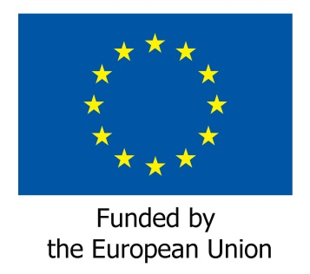

Website of the Council of the EU, https://www.consilium.europa.eu/en/council-eu/, retrieved on 3 March 2020
Website of the Latvian Council Presidency 2015, https://eu2015.lv/ ; retrieved on 27 February 2020

