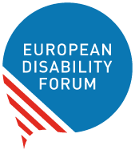
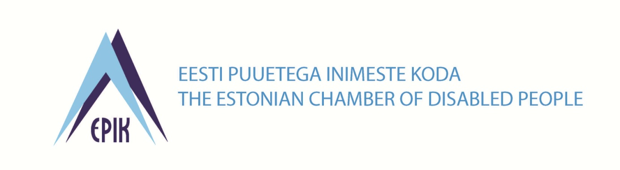
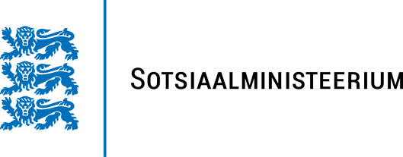
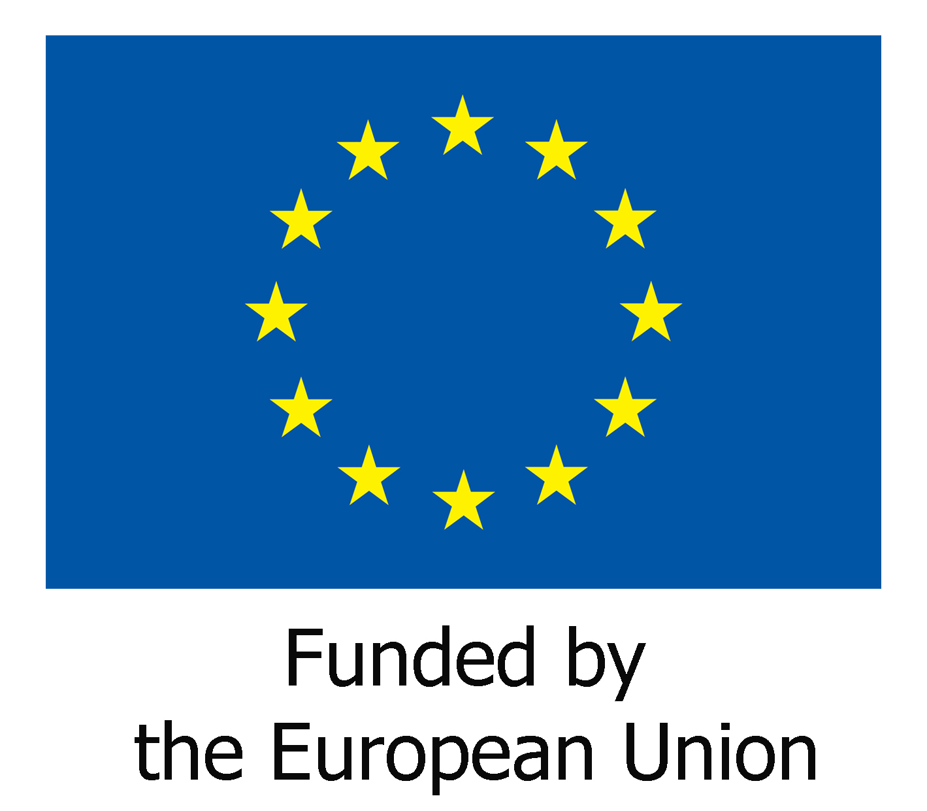
Minutes of the Executive Committee Meeting in Tallinn, June 2017
Presents : Pat Clarke, Rodolfo Cattani, Yannis Vardakastanis, Pirkko Mahlamaki, Gunta Anca, Humberto Insolera, Albert Prévos, Klaus Laschwitz
In attendance : Catherine Naughton, Muriel Da Via, Romy O'Callaghan, Gerdinand Wagenaar, Tonia Nassoula
Apologized : Nadia Hadad, Maureen Piggot, Ana Pelaez

- Welcome by the President and adoption of the agenda
The President welcomed all the participants and mentioned the apologized members. He also thanked the Estonian members for hosting the event. He insisted on the commitment requested by the members of the Executive to the EDF policies and work. He requested that the full expertise of all Executive members be mobilized to the implementation of the work.
The agenda was accepted with an addition in the AOB on internship
- Review the decisions from the last executive:
The Director explained that the working process requested the minutes and list of decisions to be approved by the Secretary General before being sent to the other Executive Members.
The Director went through the decisions from last meeting and gave an update on each. She underlined that :
- a meeting took place with the Bulgarian member about the upcoming presidency and that it was unlikely that a board be organised there. Our member was not in a position to organise or co-financing, and the Bulgarian presidency also said it was not possible. Other options should be looked into including co-financing from the SDG project, with a Board in Brussels.
- the follow-up on the Board meeting in Austria was on track
- the conference of State Parties took place on June 13-15 with the organisation of side events between EDF (including the EDF President, a few Executive members and the EDF Director), EC and ECOSOC and that an article was available on-line
- The Strategy Framework adopted by the AGA would be the basis of the four year planning
- the EDF would not be part of the Chairing trio of the European Expert Group on Deinstitutionalisation directly but that Inclusion Europe is co-chair so a DPO is involved
- A meeting with DG Regio took place about Structural Funds and that another meeting was planned on July 6 as well a meeting with Comissioner Cretu on July 18 to discuss the current use of the Structural Funds (considering the non favorable political environment, a strong mobilization at European and National level would be needed.
The Director mentioned that other items would be dealt with on a separate basis included in the agenda and that the list of decisions would be updated after the meeting.

- Introduction and discussion on methods of work (DOC-EXEC-17-06-01)
The President said that the document presented a guide for the use of members of the EDFs executive committee and that it included the relevant guiding principles expected from Executive members as outlined in the EDF Statutes and Internal Rules.
He gave the floor to the Director who explained that this document had been drafted for this new executive Committee and that it highlighted the main responsibilities of the Executive Committee members.
She also mentioned that the document would be completed by a section on the responsibilities and work of the Secretariat.
The President said that the Executive Committee members should be informed thoroughly about all policies and their development in order to be ready to substitute each of the member on any subject and in order to gain expertise in all levels and in any aspects of the European Union. Therefore, the President suggested to create an email group including all Executive Members and the Director in order to keep a global view of the EU political level.
Pirkko Mahlamaki expressed the importance not to be stuck in the disability field but to remain open to the overall EU policies. She suggested to prioritize and flag actions requested to the Executive Members in order to avoid overloaded agenda and not to miss important issues.
Gunta Anca suggested to provide Executive Members with business cards. The president agreed that the Secretariat look into this matter.
Albert Prévos insisted on the need to consider a global EU approach and not only oriented to disability issues.
Klaus Lachwitz mentioned that the Brexit process was changing the negotiation process towards the EU and that there might be an opportunity to reach new developments in the disability field and in others. He also expressed the difficulty to identify who were active in all committees and thus what were the priorities in general. He also expressed the difficulty of conflict of interest that might arise from the fact of being members of the EDF Executive but also members of national or other associations. He suggested to hold open discussions in case such conflicts arise. The President ensured that historically, no such case happened.
Pat Clarke reported that the Irish government committed to the ratification of the UN Convention. The President suggested to present the issue of BREXIT and the Irish border issues at the next Board meeting.
About methods of work, Rodolfo Cattani insisted on the access of the working documents one week in advance and requested to received the documents by email not only to be uploaded from the website. He also insisted that Executive Committee members represent themselves individually and not as an organisation.
The Director summarized the actions to follow-up : add a section to the document on EDF Secretariat, include an item on Brexit at next Board, provide business cards for Executive members, better highlight of emails requesting actions, send email when docs are available on the website members area and also send documents by email, create an Executive Committee email group and all members to use this to provide updates on their activities on behalf of EDF

- EDF strategic Framework (DOC-EXEC-17-06-02) and presentation of work priorities 2017
The President gave the floor to the Director who explained that the document was the strategic framework developed and adopted, with some small changes at the EDF AGA. She explained that it provided a basis for the 4 year planning exercise we needed to undertake in relation with the EC partnership framework contract. She explained that the EC would issue their call by the end of July but that no information was available at this stage about funding or priorities.
She mentioned that the upcoming priorities would be linked to Influencing the EU, strengthening the movement and communication. From a practical point of view she explained the need to develop co-financing for the organisation of Board meetings and other governing bodies or committee meetings.
The President highlighted the importance to reflect on the working priorities for the next four years in order to be well prepared.
The Director mentioned that the set up of new Committees and working groups would be finalized and discussed at next Committee meeting.
She listed other priorities detailed in the document about Brexit, Social Pillar, Structural Funds, SDG's Project, Access City Award, Passenger's rights, European Parliament of Persons with disabilities, work with Disability Intergroup, European Accessibility Act, Political participation (right to vote), capacity building on CRPD review, external evaluation and finances.
The president mentioned the meeting on October 3 at ECOSOC about the EC Alternative Report.
Gunta Anca mentioned a meeting on CRPD in Russia in collaboration with IDA. Humberto Insolera requested information about external evaluation.
The President requested a plan of action to be ready for the European elections.
The Director summarized the actions to be undertaken : discuss agenda on political participation with Pat, discuss DPOs situation in Russia and Ukraine with Gunta after her participation to the meeting, send last year's External evaluation to the Executive Committee members.
- Update on developments with EU institutions(DOC-EXEC-17-06-03)
The President gave the floor to the Director who gave an update on Developments with EU Institutions as listed in the document. She mentioned Loredana's maternity leave in November that would need to organise a replacement.
- European Accessibility Act (DOC-EXEC-17-06-04)
The President gave the floor to the Director who reported on the last discussions that took place at the EP. She insisted on the importance to report on actions taken at national level on this issue.
She gave the floor to Marie Denninghaus who explained the next steps that would take place in preparation of the debate at the plenary in September in Strasbourg. She advised to have clear and few priorities that we could put forward in order to have a chance that they be accepted. She explained that the main priorities were linked to the built environment, public procurements, and persons with functional limitations (concerning not only persons with disabilities), micro-enterprises (that are totally excluded from the scope of the act). Marie Denninghaus also mentioned some secondary priorities whose scope should be enlarged: audio visual media services, ticketing machine, banking, transport services. She explained how political support from groups and MEPs was needed in order to achieve these amendments.
The President insisted on defending the priorities towards EU high level decision makers. He explained that the Commissioner was supporting some of the amendments but not all of them. Marie Denninghaus insisted on the need to negotiate more and highlighted the difficulty to support the Act in its current state.
Rodolfo Cattani expressed the need to include amendments in the built environment as he considered it essential. He called for accepting limited compromises and not support an Act that would not correspond to real needs of persons with disabilities. Pat Clarke also called for insisting on including all the amendments required. Klaus Lachwitz reminded the opinion of the delegates of the AGA insisting on the need to obtain all the amendments needed. Albert Prévos questioned about the need to continue to lobby on a political level in the current difficult context. He reminded how important the Act would be on an economical point of view, especially in creating jobs. Humberto Insolera wanted to know more about the current oppositions from some countries such as Finland. Gunta Anca highlighted the opportunity that could arise from the upcoming EP elections to try to influence the political support from a national basis. Pirkko Mahlamäki confirmed that the EDF's credibility is in balance with the support of the Act in its current state.
The President recalled the long way through getting the current draft of the Accessibility Act. He suggested to try to make the best of negotiations in order to get the maximum amendments we could.
The Director summarized the follow-up : remain strong in our position and stay ambitious, try to ensure there are amendments tabled on the main priorities (public procurement, microenterprises/SMEs, the Annex, the Built environment and transport), work on all levels and also encourage members to work on local and regional level with their decision-makers.
The President reminded that while our official position should be strong, we also have to stay flexible and try to get the most out of the Act and that Built environment was a difficult topic that might have to be tackled in another fight.
The Executive agreed that Marie Denninghaus and Alejandro Moledo revise the amendments accordingly and that it is sent to EDF membership and relevant MEPS by end of June.
EDF to participate in Strasbourg with involvement of Rodolfo Cattani to continue advocacy on the Act.

- CRPD and human rights issues, and collective complaint in France (DOC-EXEC-17-06-05)
The President gave the floor to the Director who explained that the document was providing an update of the on-going work of EDF on the promotion of the implementation of the CRPD. She explained that It was focussing on the reviews by the CRPD Committee and the planned General Comments, the European Disability Strategy, important CRPD events that took place, the EDF report on ending forced sterilisation and finally EDF’s involvement in the collective complaint in France.
She recalled the training seminar with OHCHR that would take place on 17-18 October on CRPD.
The Director mentioned a meeting to take place on 12 July on the EP report on the European Disability Strategy.
The Executive Committee decided to continue to support Collective complaint in France with Albert Prévos as focal point. Albert Prévos highlighted some difficulties linked to the management of this complaint, and he will stay in touch with the EDF secretariat on this issue.

- Discussion and decisions on task allocation and external representation among Executive Committee members (DOC-EXEC-17-06-06)

The president gave the floor to the Director who explained that the document had been put together on the basis of the previous tasks sharing for the executive, and discussions with the EDF president and individual executive members. She added that not all tasks had been filled in and that this should be decided.
The Executive Committee agreed to nominate:
Yannis Vardakastanis responsible for the Youth Committee with Humberto Insolera as substitute;
Maureen Piggot, Pat Clarke, Yannis Vardakastanis, Catherine Naughton and Muriel Da Via responsible for finances as a whole;
Yannis Vardakastanis responsible for Structural Funds
Albert Prévos responsible for Disability Intergroup (whether in Strasbourg or Brussels)
Gunta Anca responsible jointly with Klaus Lachwitz on issues related to European pre accession and former soviet countries;
Rodolfo Cattani responsible for the Social Policy and Inclusion Committee, Disability Assessment, Standardisation and work with ANEC;
Klaus Lachwitz is Chair of the human rights committee and focal point for human rights issues, and Donata Vivanti would be requested to remain involved in collective complaints.
Giampiero Griffo would be the board member responsible for Humanitarian Actions and Thorkild Olesen on SDGs.
The Executive Committee agreed on other responsibilities as stated in the document.
The President also explained that this distribution of tasks would be completed in the future should any item needed to be added.
The President also stated that other areas of work would be considered on an ad hoc basis.

- EDF secretariat (DOC-EXEC-17-06-07)
The President gave the floor to the Director who explained that the document presented the structure of the EDF secretariat, the individual staff and their roles, and the functions of the secretariat according to the statutes of EDF. She specified that this document was presented for information.

- Youth Committee and Women’s Committee (DOC-EXEC-17-06-08)
The President gave the floor to the Director who explained the process related to the renewal of those committees. She reminded the Executive Committee members that an application process for new candidates took place and that a lot of applications had been received. She added that, at this stage, it had not been possible to proceed with the selection. She reminded that the selection process would put the accent on the geographical, and gender repartition, to ensure a balanced representation of disabilities and of ENGOs and National Councils.
The Executive members discussed about the maximum age to apply for the youth Committee. It was agreed that 35 would be the maximum age to be considered as young people and that applying for a mandate of 4 years was possible up to 34 years old. It was also decided to encourage younger people to apply and to give priority in general to younger people.
There was also a large number of diverse women nominated to the Women’s Committee and priority would be given to women with disabilities and mothers in the selection process which would be led by Ana with the secretariat.
The Executive Committee agreed to finalize the selection during the month of September and to officialise the result in October.
- EDF email expert groups and new board committees (DOC-EXEC-17-06-09)
The Director explained that the first meeting of the committees (Human rights and Non-Discrimination and Social Policy and Inclusion) would take place in October during the Board meeting that would be held in Estonia. The Executive Committee decided to address the Board asking them to send their expression of interest in participating in those committees.
The Director listed the expert groups and focal points in the EDF secretariat and in the Executive Committee:

- Transport- Marie Denninghaus and Gunta Anca
- Built environment-Marie Denninghaus and Gunta Anca
- ICT-Alejandro Moledo and Humberto Insolera
- Standardisation- Alejandro Moledo and Rodolfo Cattani
- European Structural and Investment Funds (ESIF)- Simona Giarratano and Yannis Vardakastanis
- International Cooperation to become International Cooperation and SDGs – Marion Steff and Ana Pelaez
- Refugees with disabilities - An Sofie Leenknecht and Yannis Vardakastanis
- Task Force on the Accessibility Act (temporary)- Marie Denninghaus and Rodolfo Cattani
- Council of Europe (new)- Etienne Cuche and Pat Clarke
- A small e-mail expert group from EDF members with specific expertise on persons with disabilities requiring more intensive support, with the specific aim and restricted scope to follow up the EDF policy and documents in the perspective of persons with disabilities requiring more intensive support – Donata Vivanti, Albert Prévos and Pat Clarke.

- Financial issues (DOC-EXEC-17-06-10)
The Director explained that the document provided a brief update on the financial situation of the year 2017 and further.
The Director explained that:
- EDF had been able to conclude its 2016 financial year with a positive result allowing to the association to recuperate totally the losses accumulated from previous years.
- The budget 2017 had been agreed by the European Commission and had allowed for the payment of 80 % of the EC Grant.
- The European Commission had also approved the accounts 2016 and the last installment had just been received
- These two payments would allow the Secretariat to make all pending payments including the reimbursements related to the AGA 2017.
- Other income (contribution from Malta for the Board, from CERMI and ONCE for the AGA in Spain, Income related to projects) had also been received according to plans. Membership fees have also been paid diligently by members and the missing fees will be followed up during the summer.
- A more in-depth meeting on finance was being prepared before the summer including the EDF president to allow for a more long term financial planning.
- This was also on the agenda of every EDF executive as the full responsibilities for ensuring our financial health, which helps us to thrive as a movement is at stake
The President said that two years ago EDF finances had been discussed thoroughly within the Executive Committee and that it was decided that the finances, the income and fund raising was and should be a top priority for the Executive Committee in order to insure safe finances for the future. The President suggested to write a document on sustainable finances for the future. The President suggested that the Director could do this tasks provided that she would benefit from the help of a Deputy Director freeing her from the day to day tasks.

- Participation of EDF in projects (DOC-EXEC-17-06-11)
The President gave the floor to the Director who explained that the EDF executive in its last term made decisions on how to approach involvement in projects and that as a matter of routine the executive was provided at each meeting with an update on projects.

She explained that the document outlined the EDF’s current projects (ERA CRPD Project, OSI New Executive Fund, UNICEF IPA in Western Balkans and Turkey, Disability and the SDGs, Bridging the Gap DEVCO Project, DFID Advancing inclusive Development and Human Rights for all Persons with Disabilities, TeSLA Adaptive trust-based e-assessment system for learning) some new projects in the inception period and some project applications (Sightsavers India and Web Accessibility Tool) and rejected projects.

- Preparation of next Board meeting of October: draft programme and agenda (DOC-EXEC-17-06-12)
The President gave the floor to the Director who explained that the Board meeting in Estonia had been decided in replacement of the meeting foreseen in Scotland.
She went through the programme of meetings related to the Board in October. She mentioned that the Executive Committee would take place on Thursday 5th October, that the Executive Committee members would attend a conference on Accessibility in Narva, that the Board meeting will start on Saturday with a conference followed by the EDF Business Agenda in the afternoon and on Sunday morning.
The Executive Committee decided to send invitations and to open registration on July 3.
The Director went through the main items of the agenda. The President suggested some of the items to be discussed: European Accessibility Act, Structural Funds, SDGs, European Elections, Brexit, working plans of the Committees. He invited the members of the Executive Committee to forward their suggestions after receipt of the first draft.

- Meetings and events till end of December 2017 (DOC-EXEC-17-06-13)
The Director went through the document outlining key meetings until the end of the year.
She underlined the need to ensure the effective representation of EDF executive, Board and members effectively in all these meetings.
The table of meetings was agreed by the members with following adding :
- Gunta Anca would participate on meeting ECAC on September 5
- The President would participate to the ENIL March on Freedom Drive on 27 September
- Meeting of the Executive Committee and the European Parliament on 23 and 24 January.
The Director also informed the Executive Committee that the Board in Austria would take place in November (dates to be confirmed) and that place, dates and co-financing for Board meeting in February and AGA in March would need to be confirmed.
- Any other business
Google Fellowship: The Director explained that following various discussions with Google, we had been offered a six month fellowship within EDF financed by the Google. The Executive Committee agreed on this project.

Conference on EU Disability Card Project : Launching the Estonian Webpage
30 June 2017, Museum of Occupations, Toompea 8, Tallinn

Mr. Meelis Joost moderated the conference opened by Monika Haukanõmm, Chair of Estonian Chamber of Disabled People who explained the process leading to the launch of the Card.
The EDF President explained that :
- EDF has been campaigning for a common European Disability Card, or “Mobility Card” as it was previously called, for many years
- It started as part of our “Freedom of Movement” campaign in 2010 to make it easier for persons with disabilities to travel and move to other European countries and to make full use of their fundamental EU right to move, work, and reside freely in other EU member states
- As you probably know, currently many persons with disabilities that are abroad temporarily face problems with their social security coordination, e.g. it is not guaranteed that you can keep your personal assistant when you do an Erasmus university exchange or an internship.
- It became clear that the Disability Card could maybe not directly solve the problem of the social security coordination, but there are many other aspects linked to it: transport, culture, leisure, sport, and other aspects of life that enable persons with disabilities to participate fully in society according to 30 of the UNCRPD
- The project has evolved over the years and now we finally have the first prototypes of the Disability Card that we can hold in our hands, which is a great achievement.
- Persons with disabilities from Estonia will be able to travel to Italy, Malta, or Romania and receive the same discounts as local persons with disabilities by showing their Disability Card.
- We also hope, that the Card will make it easier for local persons with disabilities to participate in the community and enjoy a good film in the cinema, take a swim at the local swimming pool, or travel around by bus because the information will now be readily available on the Disability Card website.
- As a side effect, we hope of course also that this will encourage more and better accessibility of those venues and motivate others to also participate.
- However, now we have to make sure that the Card will be widely used and recognized, to make it a meaningful initiative.
- It is also essential, that ALL EU member states participate in this scheme – how can it be called “EU Disability Card” if only 8 member states are part of it? We want the scheme to be widened and allow others to join as soon as possible to create a strong, well-known network that all citizens can benefit from.
- Finally, EDF advocates for covering as many areas of life under the Card as possible: it is not enough to focus on leisure activities, transport for example has to be included and should not be optional. Further services could also be added at a later stage.
- Today we are here to celebrate the progress that has been made so far over the past seven years and I would like to congratulate the organizers to the launch of the website, which is an important step towards achieving a truly European Disability Card!

Marie Denninghaus, the Transport and Mobilitiy Officer of the EDF explained the background from the European Disability Movement for the EU Disability card.

Mrs Kaia Iva, Estonian Minister of Social Protection, gave the point of view of the policy makers and Ms Merlin Murumets, Estonian Social Protection Boardgave the view of the issuing body.

Mrs Merilin Piipuu from the Museum of Occupations, MrTom Rüütel from User view, explained the challenges and opportunities for users and service providers.

Ms Kirke-Anneli Kuld presented and launched the webpage.

Mrs Monika Tomingas, project leader at Museum of Estonian Dance Festivals presented the project «I see» / «Mina näen» facilitating the visually impaired to follow the Dance festival by providing accessibility solutions.

Decisions taken at Executive Committee meeting held in Tallinn, June 2017

Executive : Methods of Work
- add a section on EDF Secretariat in the Executive Committee document,
- include an item on Brexit at next Board,
- provide business cards for Executive members,
- better highlight of emails requesting actions,
- send email when docs are available on the website members area, and also send the documents by email
- create an Executive Committee email group and all members use this email list to update the members on their activities for EDF

Strategy towards the EU Institutions

- Follow-up on next 4 years presidencies
- Follow-up on a political statement on the Social Pillar, the Structural Funds the European Semester to adopt at the next board. Every member could send it to their ministries in view of the Social Summit in Sweden on 17 November
- Follow-up meeting with Commissioner Oettinger on Policy for staff with disabilities and parents of children with disabilities : November 2017
- Follow-up on meeting with Commissioner Cretu on Structural Funds : July 2017
- Hearing in the EP on forced sterilization : December 5

Review of Upcoming meetings

- Follow-up on Board in Estonia on October 7th and 8th with conference on Accessibility Act (with Marie as focal point) and the following business agenda items : European Accessibility Act, Structural Funds, SDGs, European Elections, Brexit, working plans of the Committees including Executive Committee members suggestions
- Follow-up on Board meeting to be organized in Austria :
- Follow-up on possible AGA venues in 2018- there was no response to the mail sent to members
- Follow-up on finding place for Board in February 2018

Follow-up on Projects

- Follow-up DFID/IDA project on the SDGs
- BREXIT workshop with ENIL and ECAS: follow-up with Commission on EU responsibilities
- Follow-up on Bridging the Gap Project (by Ana Pelaez, Catherine Naughton and Marion Steff)
- Follow-up on UNICEF Project
- SDGs Disability Inclusion: follow-up on activities (High level political forum in July including side events, second funding,…)
- Follow-up on Bridging the Gap inception workshop (Ana Pelaez, Marion Steff, Giampiero Griffo)

Restructuring Committees in EDF
- Follow-up on constituting Youth and Women Committees: Finalize the selection during the month of September and officialize the result in October.

- Follow-up on constituting EDF email expert groups and new board committees: Finalize the selection during the Board in October with the candidates participating to the Board who expressed their interests.

European Elections
- Follow-up on 4th European Parliament of persons with disabilities (on progress review, revision on Guidelines to form delegations, contacts with members, decision on the programme, etc.) on 6 December

- Follow-up on work and meetings with Disability Intergroup

- Right to vote : include item at Board meeting in Tallinn

20th Anniversary

- Picture exhibition: to be organized at the EESC with an opening session on 3rd October
- Dissemination of the Picture Exhibition on a wide basis between September and December
European Accessibility Act

- Follow-up on a strong position and revise amendments with regards to public procurement, microenterprises/SMEs, the Annex, Built environment and transport
- Send revise amendments to membership and to relevant MEPs

Financial Issues
- Meeting on Finance with EDF President, Treasurer, Vice-President, Director and Finance Officer to be organised in July
- Include Financial Item at each Executive Committee meeting
- Follow-up on co-funding 2017 (membership fees and membership contributions)
- Set up quadrennial plan linked to the EC Grant 2018-2021 based on EDF strategic framework
- Explore sponsorship possibilities and other financing
- Draft a financial strategy for the coming years (with the help of the auditor)

Human Rights issues
- CRPD training seminar on 17-18 October
- Attend meeting on 12 July on the EP report on the European Disability Strategy
- Continue to support Collective complaint in France with Albert Prévos as focal point. Albert Prévos highlighted some difficulties linked to the management of this complaint.

Any Other Business
- Google fellowship- proceed to recruitment
- Include an EEG work item for further discussion at Executive Committee in the future
- Proposal from the Advisory working group on Independent living on award commemorating Peter Lambreghts to be discussed further at Executive Committee in October
- Strong follow-up on Structural Funds (meeting on July 6 and on July 18 with Commissioner Cretu, send documents on SF to the Executive Committee, participation to EC working group on partnership)
- Discuss agenda on political participation with Pat,
- Discuss DPOs situation in Russia and Ukraine with Gunta after her participation to the meeting,
- Send last year's External evaluation to the Executive Committee members.

