Meeting of EDF Executive Committee Online

September 4th 10:00 am- 13:30 pm

Zoom Meeting platform with international Sign Interpretation through this link:
https://zoom.us/j/94319970656?pwd=azhkeUFsbVRlSDA3cHZYbjZvbFFxdz09
Present : Yannis Vardakastanis, Pat Clarke, Ana Pelaez, Gunta Anca, Pirkko Mahlamäki, Nadia Hadad, Klaus Lachwitz, Albert Prévos, Humberto Insolera, Rodolfo Cattani
In attendance : Catherine Naughton, Muriel Da Via, Loredana Dicsi, Haydn Hammersley

- Opening of the meeting and approval of the agenda
The President welcomed the participants. The agenda was adopted with no changes. One AOB item on 3th party intervention to the European Court has been added and the Director added an update on Human Resources and an information point on the UNICEF white paper on small scale residential care.
- Follow-up of actions since the last meeting (DOC-EXEC-20-09-01)
The President gave the floor to the Director who went through the main follow-up actions from the last meeting. She reported that
- European Disability Strategy: all actions decided at the last meeting under implementation and to be discussed under the relevant agenda item;
- EU budget: all actions decided at the last meeting under implementation and to be discussed under the relevant agenda item
- COVID 19- human rights report: all actions decided at the last meeting under implementation and to be discussed under the relevant agenda item
- Security policy for EDF: The focal persons in the Executive Committee (reviewing draft policy) Pat Clarke and Nadia Hadad nominated at the last meeting. Drafting security policy ongoing. Some other policy changes required by the VIVID T project in the field of human resources. EDF need to ensure volunteers are affectively covered in EDF. The simplest way to do this would be small revisions to existing HR policies: safeguarding, recruitment and data protection. The executive agreed to allow these policies to be revised and presented by written procedure for review and update.
- Child rights consultation: EDF gave written input as planned and co-signed a statement with other organisations with approval of the Executive Committee.
- WHO EURO region cooperation continues with proposed project and letter sent to the Regional Representative of WHO.

- European Disability Rights Agenda (DOC-EXEC-20-09-02)
The President gave the floor to the Director to update the Executive on the developments relating to the next European Disability Rights Agenda 2021-30.
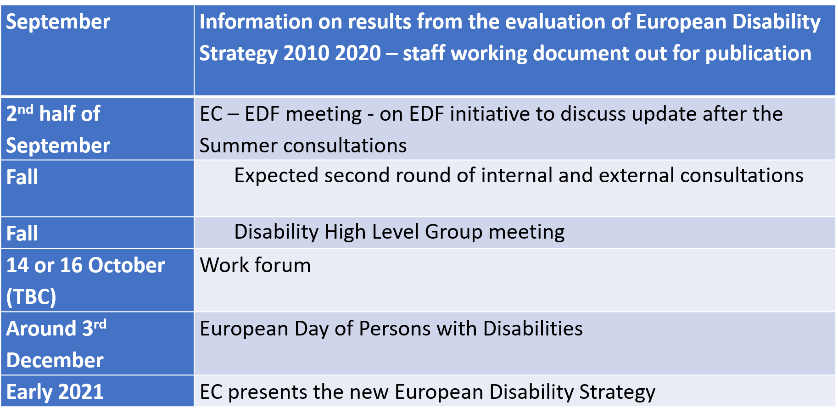
She also explained that the Parliament had been very active and focused on the Strategy. Suggestions from the executive:
- contact Human Rights or Social Affairs Committee of the Parliament to suggest a hearing on the EDRA
- Send an email to EDF members to ask them to lobby their member state focal points in advance of the Disability High Level Group
- Put the EDRA on the agenda of the Board with the EC asked to present it

- Impact of the EU’s recovery package agreed by the European Council on the Multiannual Financial Framework 2021-2027 (DOC- EXEC-20-09-03)
The President gave the floor to Haydn Hammersley who gave an overview of the final agreement by the Council on the next EU long-term budget (the Multiannual Financial Framework) and the COVID-19 recovery package (Next Generation EU), taken in July. He explained how the final agreement will have an impact on investment in furthering the rights of persons with disabilities and the need to decide on what future advocacy needs to be done.
The Committee commented on the ESF reduction, the need to enhance work with Parliament, Council and work at national level, and the possibility to highlight EDF’s position in a paper. The need to touch the national, regional and local level was acknowledged.
Catherine mentioned that, regarding the Justice, Rights, and Values Programme, we are trying to keep pressure on the Commission alongside allies. We got recovery of equality funding, but we signed a letter asking to increase it.
Maureen and Nadia asked if we have details on ESF reduction, and whether it is taking money from specific actions or if it is general. Haydn explained that it is a general reduction but that the thematic concentration has increased the percentages to make up for the loss of the health strand. We had our own demands on this thematic concentration that we now need to re-evaluate regarding this change in budget.
Albert asked about the Erasmus programme and how students with benefits can benefit. He asked about the position of the Parliament and who we can contact there for support. Loredana explained that the Parliament has been very supporting of ensuring extra funds for support costs for participants with disabilities.
Ana suggested trying to fix a position paper on the EU budget and COVID-19 recovery package from our side. In Spain they are doing the same. We need to highlight exactly what we expect on disability in all policies.
Yannis explained that in Greece they have already started working on operational programmes. He pointed out that there is a difference between a provision in a Regulation, and that provision delivering real benefits to citizen at regional level. He proposed that EDF go ahead with an alert letter giving general guidance, with a very quick mapping exercise to find out what is happening at national level for cohesion and recovery package, to get in touch with national desk officers at EU level to find out what is happening with partnership agreement and how expect operational programmes to be submitted to them, and deadlines. Then we should draft a guide for our members at national level to capitalise on the successes we have had at the European level, because the successes we have had at EU level remain very abstract and included into projects and funding in general or specific terms for persons with disabilities.
Maureen suggested it might be useful to have a webinar on the topic of how to apply for funds.

- Finance
The President gave the floor to the treasurer who explained that projections presented during last meetings remained valid until to date and will be updated at the end of September, that current costs incurred remained in line with the global budget with some variations in headings linked to travels and services and that membership fees were being paid. She added that the European Commission had confirmed flexibility due to the Covid-19 situation and allowed EDF to proceed with consultancy work on the Covid-19 publication.
It was confirmed that the Finance Committee would take place in October and will examine the updated projections.
- Update on EDFs role in projects (DOC-EXEC-20-09-04)
The President gave the floor to the Director who explained that the document outlined EDF’s current projects, some new projects in the inception period, some project applications and rejected projects. The Director went through the main projects with an emphasis on new projects and projects where decisions should be taken.

The Director highlighted some new Projects: European Disability Expertise (dealing the study of the impact of Covid-19 on persons with disabilities with the involvement of Nadia Hadad and Haydn Hammersley). The WHO project on inclusive accessible public health messages will have Gunta Anca as a focal point. The Web accessibility initiative (Communities of Practice) project will have the involvement of Maureen Piggot.

She also gave an update on I2I project explaining the merge of DFID and the Foreign Commonwealth Office (FCO), severe economic downturn as a result of the COVID-19 pandemic - £2.9 billion package of reductions in the Government’s planned ODA spend and reduction for our budget of £32,464.

- COVID 19 and human rights report update (DOC-EXEC-20-09-05)
The President gave the floor to the Director who went through the document giving some update to the Executive Committee on the COVID 19 human rights report. She summarised the key decisions taken till now, progress on the report, and provided sections for feedback and decision.
She invited the Executive Committee Members to send to the Secretariat all the information they would have.
The Executive Committee highlighted the difficulty of desegregated and completed data at national level although the difficulty to get full and accurate details on this report was also acknowledged taking into account the continuous development of the virus and the measures taken. The President thanked the members for their comments and invited them to send their suggestions in writing to the Secretariat.
- Membership review- update (DOC-EXEC-20-09-06)
The President gave the floor to the Director for an update on the membership review.
She presented the progress of the Review process and mentioned a number of cases where the criteria for EDF membership was not fully reached by the member in that category for which the decision of the Executive Committee was requested.
The Director gave the floor to the chair of the Membership and credentials Committee, Gunta Anca. She explained that the review of all EDF members had started as decided by the General Assembly on the 1 and 2nd of June 2019 and that the document was giving a list members reviewed. She explained that the situation of some members was kept on hold in view of getting more information or clarifications. She also mentioned that some members had some issues in fulfilling the statutory obligations of EDF.
The Executive Committee decided to try to ensure the review is complete this year. The missing information from members should be received as soon as possible so that members could still have time to adapt and make changes to allow them to remain fully involved in the membership.
The Executive Committee decided to finalize the reviewing process and to examine the outcome at a next meeting.

- Planning for our Board meeting in Berlin (DOC-EXEC-20-20-09-07)
The President gave the floor to the director who explained the situation. It is not possible right now to have a face to face meeting with the Quorum of the Board due to travel and meeting restrictions.
It was agreed to propose to the Board to have an online meeting on October 23rd, with committee meetings in advance. It was also proposed to have a conference with the German partners on COVID 19 and disability.
It was also foreseen to have a small delegation of the executive or Board who would go to Berlin to meet with high level German representatives. Klaus Lachwitz informed the members that the German President of the German National Council was very interested to meet with EDF representatives. He said he was also in discussion to organise a meeting with the Minister of Social Affairs. Any meetings which will be done will be done following the COVID 19 regulations.
Klaus Lachwitz also explained that some costs (such as interpretation) could be paid by the German Ministry.
Therefore, the Executive Committee agreed to organise the conference, Board meeting and other meetings online and for a small delegation to travel to German as circumstances allow.
- EDF upcoming meetings 2020 +2021 (DOC-EXEC-20-20-09-08)
The President gave the floor to the Director who explained that the document was presented for information and she invited the members of the Executive Committee to send their information on additional meetings if any to the Secretariat.
In view of discussing Board agenda, next AGA and other issues, The Executive Committee decided to organise a next Executive Committee meeting on October 1st.
- Any other business:
  - The Committee agreed to submit a EDF third party intervention European Court of Human Rights – on Oviedo Convention and forced treatment.
  - The Executive Committee agreed to recruit a Communication Officer while André Félix is on long-term sick leave (paid by the social security)
  - The Director will send information on the white paper of UNICEF on small scale institutions for the executive for their advice.

