Human Rights Report

What does discrimination mean
and how can the European Union
protect people with disabilities?

Easy to read version

The European Disability Forum

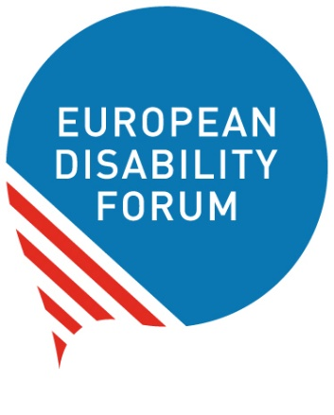
The European Disability Forum is an organisation
of people with disabilities in Europe.
In short, we call it ‘EDF’.

EDF works to protect the rights
of people with disabilities in Europe.
We think that people with disabilities
should have the same chances in life
and take part in the community like everyone else.

We also think that people with disabilities should decide about their lives.
Nothing should be decided about us without us!

Our Human Rights Reports
Every year, EDF makes a document
that talks about the rights of people with disabilities.
It talks about things that are important for them.

For example, in 2017 we made a document that talked about
‘the UN Convention on the Rights
of Persons with Disabilities’.
And in 2018, we made a document that talked about
the ‘Sustainable Development Goals’
and how important they are for people with disabilities.
We call these documents ‘Human Rights Reports’
and you can find them in easy to read on our website here:
www.edf-feph.org/other-publications.

This year we made a document that talks about what it means
to be equal and to be treated fairly.
This document can help you to understand:

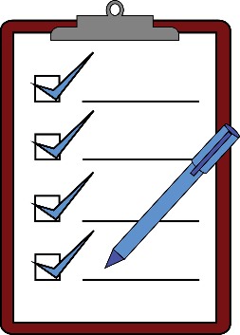
- What discrimination is.
- How things are now for people with disabilities
in Europe.
- What laws the European Union has
to protect people with disabilities.
- How the European Union can make sure
that all people with disabilities are treated fairly.

The European Union
The European Union is a group of 28 countries in Europe.
These countries came together
to make things better, easier and safer for people.
They agreed to work together and help each other.
These countries are:

- Austria
- Belgium
- Bulgaria
- Croatia
- Cyprus
- Czech Republic
- Denmark
- Estonia
- Finland
- France
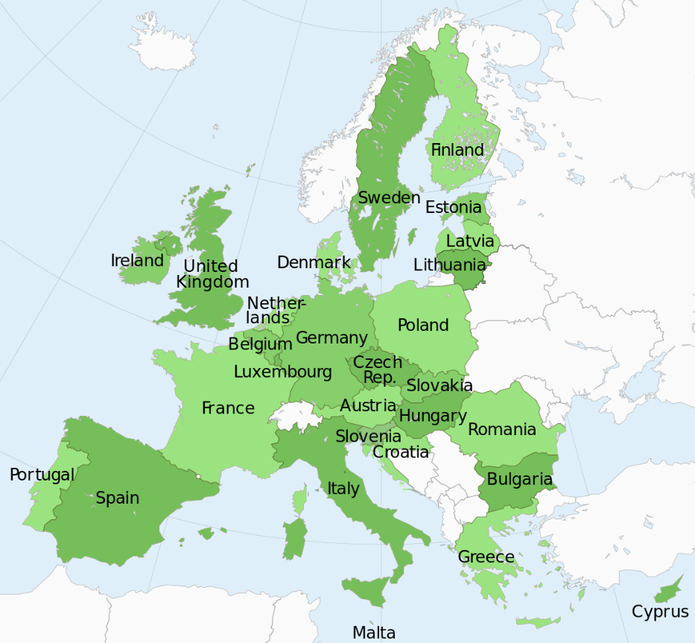
- Germany
- Greece
- Hungary
- Ireland
- Italy
- Latvia
- Lithuania
- Luxembourg
- Malta
- Netherlands
- Poland
- Portugal
- Romania
- Slovakia
- Slovenia
- Spain
- Sweden
- United Kingdom
Recently, the United Kingdom decided
to stop being part of the European Union.
So from March 2019, the United Kingdom
will not be part of the European Union anymore.

The UN Convention

The European Union has signed a very important law
for the rights of people with disabilities.
This law is called ‘the UN Convention on the Rights
of Persons with Disabilities’.
In short, we call it ‘the UN Convention’.
The UN Convention says what rights people with disabilities have
and how countries should work to protect these rights.
By signing the UN Convention, the European Union
agreed to do what it says to make things better
for people with disabilities in Europe.
For example, the European Union agreed to make sure that:

- People with disabilities have the same chances in life
like all other people.
- People with disabilities can take part in the community
like everyone else.
- Things and services are accessible
and all people with disabilities can use them.
- People with disabilities are treated in a fair way
and as equals.

The UN Convention made things better
for people with disabilities in Europe.
Since the European Union signed the UN Convention,
many things have changed for the best.
This is a very important step.
But things are still not as good as they should be
for people with disabilities.

People with disabilities in Europe still face discrimination every day.
Discrimination means to be treated unfairly and to be left out.
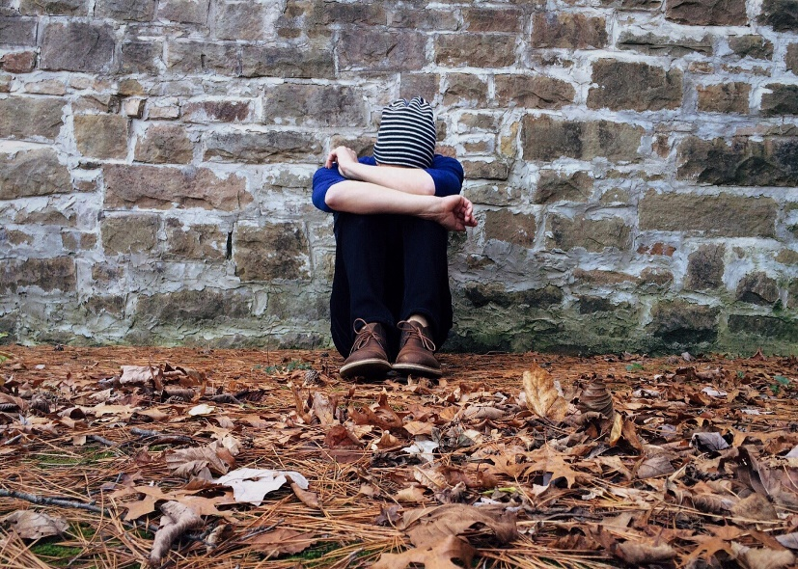

For example, discrimination is when:

- A person with disability cannot get a job
because they have a disability.
- A child with intellectual disability cannot go to school
together with other children because the school
does not have books in easy to read.

- A mother of a child with disability cannot get a job
because she has a child with disability.
- A blind person cannot work in an office like other people
because the office does not want to get the technology
this person needs to do their work.

- A person with disability is treated badly or unfairly by others
because they have a disability.

All these things are discrimination
and they make a person be left out of the community.

Discrimination at work happens too often to people with disabilities.
It is too hard for them to get a job.
That is because:
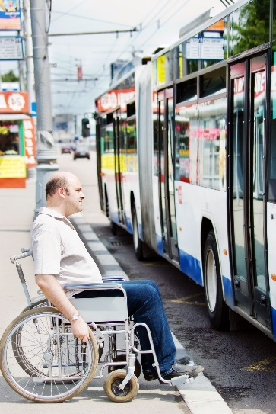
- Other people may think that they cannot do the job
because they have a disability.
- Buses, streets, offices and other things
are not accessible and people with disabilities cannot use them to go to work.

Too many people with disabilities in Europe
do not have a job
or they cannot choose a job that they like.
But even those who have a job, they may be paid less
than people without disabilities.
This is unfair.

Women with disabilities

Things are often harder or more unfair for women with disabilities.
They may be treated unfairly both because they are women
and because they have a disability.
This is two kinds of discrimination in one.

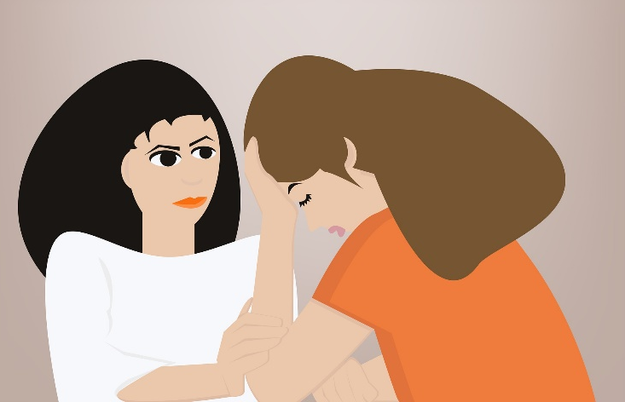

Often women with disabilities are left out of the community.
They do not have the same chances in life like other people.
For example, too often women and girls with disabilities
do not have the chance to:

- Go to school and study.
- Get a job and be independent.
- Get the care they need in hospitals.
- Get informed about their rights in an easy way for them.
- Speak out or go to the court if they are treated badly.
- Have a family and kids like other women.

This is totally unfair and has to stop!
The UN Convention says that countries should work hard
to make things better for women with disabilities.

Children with disabilities

The UN Convention says that children with disabilities
should have the same chances in life as other children.
Children should know their rights and express their opinion
when it comes to things that have to do with them.

In reality, children with disabilities do not have the chance
to enjoy their rights like other children.
They are often left out and their opinion does not matter.
For example, they are often:
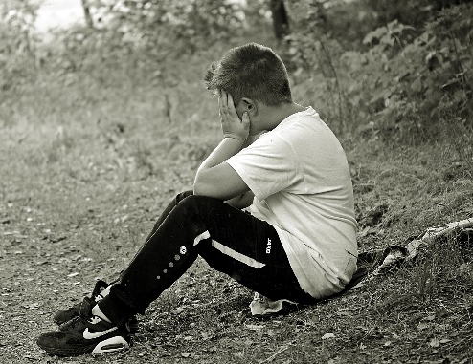
- Closed in institutions
away from their families.
- Not able to go to school together
with other children.
- Treated badly or unfairly.
- Not informed about their rights
and do not know how to protect themselves
if they are treated badly.

Young people with disabilities
Young people with disabilities face discrimination too
in many things in life.

For example, it may be hard for them
to study at a university or find a job.
This is because jobs usually ask for people with experience.
But most young people do not yet have any experience
so they cannot apply for the job.
Things are even harder for young people with disabilities
because universities and offices are usually not accessible for them
so they cannot go there to study or work.

Older people with disabilities
Older people with disabilities face discrimination too.
For example, older people may often:

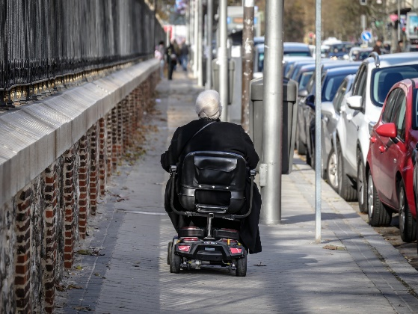
- Have to live in institutions
away from their families and friends.
- Not get the support they need
to have a good life.
- Get little or no money so they cannot buy
the things and services they need
to be independent.

LGBTI people with disabilities
‘LGBTI’ stands for people who may be
Lesbian, Gay, Bisexual, Transgender or Intersex.
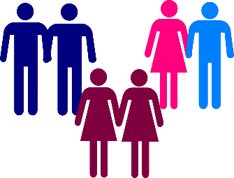
The word ‘Gay’ means a person
who has sexual or romantic relationships
with people of the same gender.
For example, a man who is having a relationship
with another man.

The word ‘Lesbian’ means a woman
who has sexual or romantic relationships with other women.

The word ‘Bisexual’ means a person
who may be attracted to both women and men.

The word ‘Transgender’ means a person who was born a woman
but feels more like being a man.
Or a person who was born a man but feels more like being a woman.

The word ‘Intersex’ means a person
who was born with some characteristics
that make it hard to say if they are a man or a woman.

LGTBI people are like all other people
and they should have the same chances in life
and be free to make choices like everyone else.

But often they face discrimination and they cannot enjoy life
like all other people.
Other people may see them as different,
look down at them or treat them badly.
Things are even harder for LGBTI people with disabilities.
Other people may look down at them or treat them badly
both for being LGBTI and for having a disability.
This is unfair.
We are all equal.
It doesn’t matter what gender we are
and if we like to have relationships with men or women.
We all have the same rights in life
and we should be treated with respect.

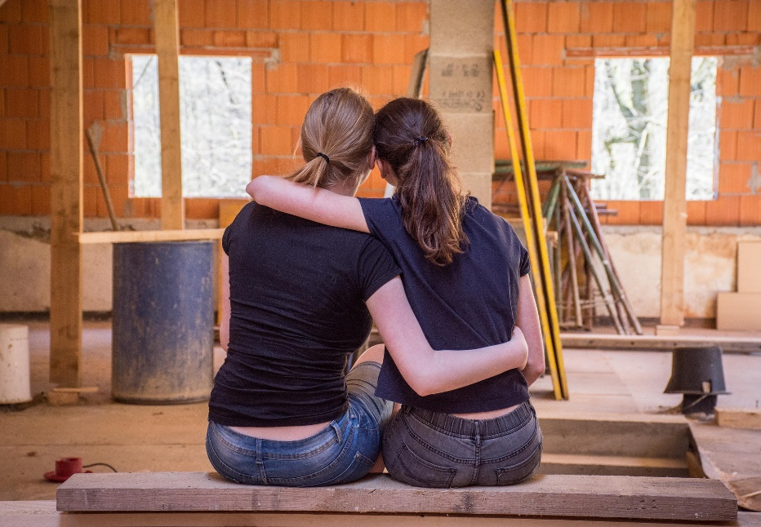

People with disabilities of different skin colours
People from different countries may have different colours of skin.
For example, there are people who have dark or black skin.
People of different skin colours often face discrimination.
Other people may look down at them or treat them badly
because their skin colour is not white
or because they come from another country.
Things are even harder
for people with disabilities of different skin colours.
Other people may look down at them
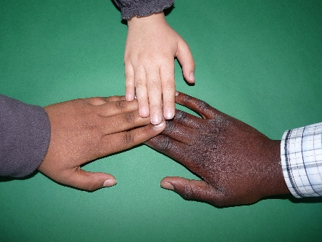
and treat them badly or unfairly
both because they are not white
and because they have a disability.
This is unfair.
It does not matter what colour our skin is
and where we come from.
We are all equal and we should be treated fairly.

Migrants with disabilities

‘Migrants’ are people who move from their country to another country
to live there.
They may do that because they like to live in another country
or because things in their country are hard for them.
For example, their countries may be very poor
or they may even be at war.

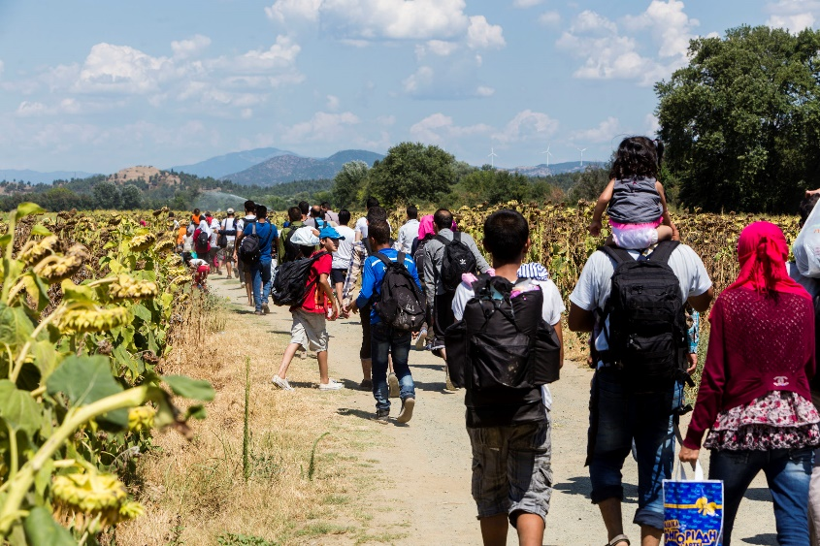

Very often, migrants and especially migrants with disabilities
face discrimination.
When they move to another county,
they may not be treated in the same way as the people of this country.
They may not get the support they need to have a good life.
They may be left out.

How things are in Europe
The European Union and all its countries
have signed the UN Convention.
That means that they agreed to do
what the UN Convention says for people with disabilities.
That was a great first step!

But countries should not just agree with the UN Convention on paper.
They should work hard to make the UN Convention really happen
in Europe and make things better for all people with disabilities.
Each country should work hard to make the UN Convention happen in it.

Some countries are doing better than others in some things.
But in general, there are still many things that could be better
for people with disabilities in Europe.
People with disabilities in Europe still face discrimination
and their rights are not respected.

For example, in many countries in Europe:

- People with disabilities are not protected from discrimination.
They are treated badly or unfairly
and they do not have the same chances like other people.
Often they cannot even speak out or go to the court
to report that they are treated badly or unfairly.

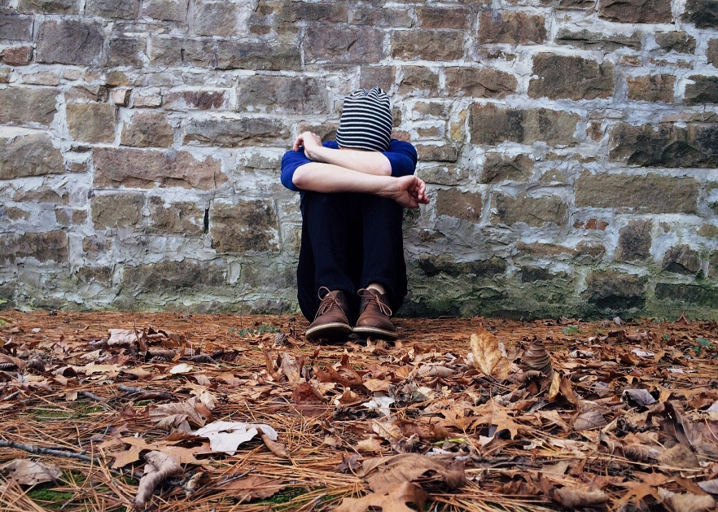

- People with disabilities who move
to another country in the European Union
may find things hard for them.
They may get little or no support in their new home.

- It is often very hard for people with disabilities to get a job.
Offices are usually not accessible for people with disabilities
and people who offer the job don’t want to spend money
to make them accessible.
They prefer to not hire a person with disability
to not have to make any changes.
So even if a person with disability is suitable for the job,
they may be rejected because of their disability.
This is very unfair.

- But even if offices are accessible,
too many other things are not accessible
for people with disabilities.
For example, metros, buses, roads, hospitals and schools.
If things like these are not accessible,
people with disabilities cannot use them
and they cannot take part in the community like all other people.
They are left out.

- There is not enough information about people with disabilities
and in which things they face discrimination.
Without this information, countries cannot work well
to make things better.

- There is not enough money
to make things accessible for all people.
Some countries in Europe are poorer than others
and they may have less money to spend
to make things better for their people.

- Many people with disabilities live in institutions
away from their families and friends.
So they cannot live independently or be part of the community
like other people.

How to get help

It is important
that the voice of people with disabilities is heard!
If you face discrimination
and you are treated unfairly or badly,
there are offices you can contact
to talk about your problem and get help.
Each country in the European Union has an office for this.

- If you live in Austria,
you can find more information here: www.behindertenanwalt.gv.at.
Or you can send an email at: office@behindertenanwalt.gv.at.

- If you live in Belgium,
you can find more information here: www.unia.be.
Or you can send an email at: info@unia.be

- If you live in Bulgaria,
you can find more information here:
www.kzd-nondiscrimination.com.
Or you can send an email at: kzd@kzd.bg

- If you live in Croatia,
you can find more information here: www.posi.hr.
Or you can send an email at: ured@posi.hr.

- If you live in Cyprus,
you can find more information here: www.ombudsman.gov.cy.
Or you can send an email at: ombudsman@ombudsman.gov.cy.

- If you live in Czech Republic,
you can find more information here: www.ochrance.cz.
Or you can send an email at: ombudsman@ombudsman.gov.cy.

- If you live in Denmark,
you can find more information here: www.humanrights.dk.
Or you can send an email at: info@humanrights.dk.

- If you live in Estonia,
you can find more information here: www.volinik.ee.
Or you can send an email at: info@volinik.ee.

- If you live in Finland,
you can find more information here: www.syrjinta.fi.
Or you can send an email at: yvv@oikeus.fi.

- If you live in France,
you can find more information here: www.defenseurdesdroits.fr.
Or you can send an email at: communication@defenseurdesdroits.fr.

- If you live in Germany,
you can find more information here: www.antidiskriminierungsstelle.de.
Or you can send an email at: beratung@ads.bund.de.

- If you live in Greece,
you can find more information here: www.synigoros.gr.
Or you can send an email at: press@synigoros.gr.

- If you live in Hungary,
you can find more information here: www.egyenlobanasmod.hu.
Or you can send an email at: ebh@egyenlobanasmod.hu.

- If you live in Ireland,
you can find more information here: www.ihrec.ie.
Or you can send an email at: info@ihrec.ie.

- If you live in Italy,
you can find more information here: www.unar.it.
Or you can send an email at: unar@unar.it.

- If you live in Latvia,
you can find more information here: www.tiesibsargs.lv.
Or you can send an email at: tiesibsargs@tiesibsargs.lv.

- If you live in Lithuania,
you can find more information here: www.lygybe.lt.
Or you can send an email at: lygybe@lygybe.lt.

- If you live in Luxembourg,
you can find more information here: www.cet.lu.
Or you can send an email at: info@cet.lu.

- If you live in Malta,
you can find more information here: www.crpd.org.mt.
Or you can send an email at: helpdesk@crpd.org.mt.

- If you live in Netherlands,
you can find more information here: www.mensenrechten.nl.
Or you can send an email at: info@mensenrechten.nl.

- If you live in Poland,
you can find more information here: www.rpo.gov.pl.
Or you can send an email at: biurorzecznika@brpo.gov.pl.

- If you live in Portugal,
you can find more information here: www.provedor-jus.pt.
Or you can send an email at: provedor@provedor-jus.pt.

- If you live in Romania,
you can find more information here: www.cncd.org.ro.
Or you can send an email at: support@cncd.org.ro.

- If you live in Slovakia,
you can find more information here:
www.komisarprezdravotnepostihnutych.sk.
Or you can send an email at: sekretariat@komisar.sk.

- If you live in Slovenia,
you can find more information here: www.zagovornik.si.
Or you can send an email at: gp@zagovornik-rs.si.

- If you live in Spain,
you can find more information here: www.oadis.mscbs.gob.es.
Or you can send an email at: oadis@mscbs.es.

- If you live in Sweden,
you can find more information here: www.do.se.
Or you can send an email at: do@do.se.

- If you live in the United Kingdom,
you can find more information here: www.equalityhumanrights.com.
Or you can send an email at: international@equalityhumanrights.com.

European laws to stop discrimination

The European Union can make laws
to protect people with disabilities and all people from discrimination.
For example, it has made a law called
‘Employment Equality Directive’.
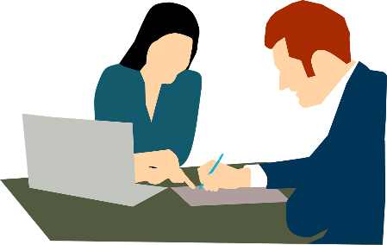
This law says that all people
should have the same chances to work.
So people with disabilities
should also have the chance to work
like all other people.
They should not be rejected from work
only because they have a disability.

This law is very important.
But sadly it only talks about discrimination at work.
In reality, people with disabilities face discrimination
and are treated unfairly not only at work,
but in other things too.
For example, children with disabilities
may not have the chance to go to school
together with other children.
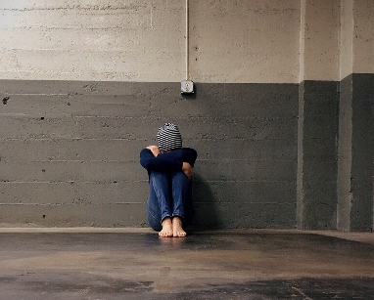
Or many people with disabilities
may not have the chance to live independently
and be part of the community.
They are often left out.
We need a law to stop discrimination in all things in life!

Over 10 years ago, the European Union
suggested a law like this.
It was called ‘Horizontal Equal Treatment Directive’.
This law aimed to stop discrimination in all things.
This was a great step!
This law could help people with disabilities in Europe
and all people to have same the chances in life.
Sadly, this law has not happened
because countries in Europe could not agree about it.

How things can be better in Europe

To stop discrimination for people with disabilities
and make sure all people have the same chances in life,
the European Union should make the UN Convention happen!
It should work to make things better and fairer
for people with disabilities in Europe.

For example:

- The European Union should make a law
to stop discrimination in all things in life.
No person should be treated unfairly or badly.
This law should not only exist on paper.
It should come true in all countries in Europe
and make things better for all people with disabilities.

- The European Union should make sure
that all people with disabilities
have the same chances in life like other people.
For example, people with disabilities should have the chance
to take part in the community, and not live in institutions.
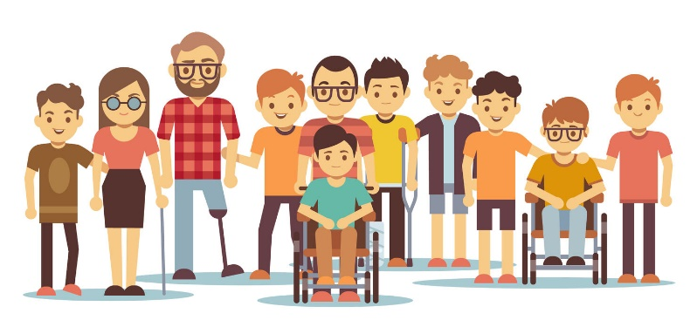

- The European Union should make sure
that the money it gives to its countries is spent in the right way.
Countries should not spend this money to make things
that are not accessible to people with disabilities.
They should spend this money on things that help
all people be part of the community.
For example, they should spend this money
on making accessible schools so that all children with disabilities can go to school with other children.

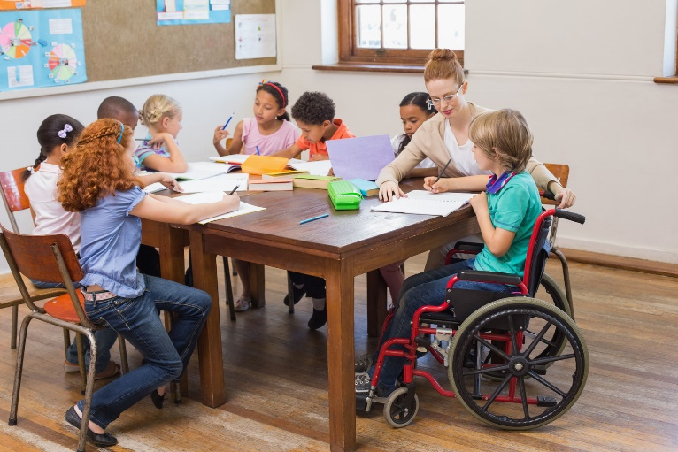

- The European Union should collect important information
about people with disabilities and how they are treated unfairly.
If the European Union knows this information,
it can better plan how to protect people from discrimination
in the future.

- The European Union should spread the word
about the rights of people with disabilities and how important it is that all people have the same chances in life.

- The European Union should make sure
that all people who are treated badly or unfairly
can speak out and get the right help to stop that.

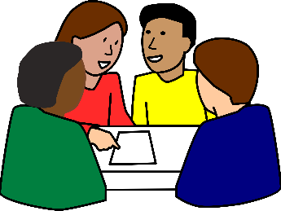
- The European Union should always ask
people with disabilities and their organisations
for their opinion when it makes laws and decisions
that concern their lives.

Nothing should be decided about us without us!

More information

If you have questions
or if you need more information
please send us an email at info@edf-feph.org.
Also, you can visit our website at www.edf-feph.org.

