DOC-AGA-21-04-01

2020 annual report
Document for information for AGA Delegates

Chapter 1 Our year in spotlight

I am proud to present to you EDFs Annual Report of 2020.
I would like to dedicate it to all the persons with disabilities who lost their lives, who became ill, or who spent long weeks and months isolated due to COVID 19. We will not forget you.
We will also never forget 2020. Even as we publish our 2020 Annual report, halfway through 2021, persons with disabilities in Europe and around the world are fighting for their lives, their safety and their livelihoods as COVID 19 still ravages our communities, our cities and towns, our health services, our economies.
Our Annual Report tells you who we are, and what was achieved in 2020. I encourage you to also consult our website, where all of our work is reported in more detail. You can also download there our new Human Rights Report on COVID 19 and persons with disabilities.
I would like to thank all of our members for their tireless work in 2020. I would also like to thank our partners and supporters for their collaboration during this time. No one was prepared for a pandemic. However, the disability movement reacted bravely and strongly.
In spite of the challenges 2020 threw at us, in 2020 in EDF we continued our work, our collaboration and our advocacy. As we look to the future, the disability movement needs to be strong, diverse and united to ensure the COVID 19 recovery is inclusive.
Let’s make “Nothing about us without us” a reality for all of us. Together we will work, to build back a more diverse, thriving, and inclusive Europe.

Chapter 2 Who we are

Nothing about us without us
The European Disability Forum advocates for the rights of over 100 million persons with disabilities living in Europe. EDF is a unique platform. We are an umbrella organisation of persons with disabilities, created in 1996 to ensure that decisions at a European level concerning persons with disabilities are taken with and by persons with disabilities. We are run by persons with disabilities and their families and we serve as a strong united voice of persons with disabilities in Europe.

Our values
EDF’s values are built on the principles of the United Nations’ Convention on the Rights of Persons with Disabilities (CRPD)
- Respect for inherent dignity
- Individual autonomy including the freedom to make one's own choices
- Non-discrimination
- Full and effective participation and inclusion in society
- Respect for difference and acceptance of persons with disabilities as part of human diversity and humanity
- Equality of opportunity
- Accessibility
- Equality between men and women
- Respect for the evolving capacities of children
- with disabilities and respect for the right of children with disabilities to preserve their identities

Executive Committee members

Yannis Vardakastanis
EDF President
National Confederation of Disabled People (NCDP)
Ana Peláez
EDF Vice-President
Comité Español de Representantes de Personas con Discapacidad (CERMI)
John Patrick Clarke
EDF Vice-President
Maureen Piggot
EDF Treasurer
Inclusion Europe
Gunta Anca
EDF General Secretary
The Latvian Umbrella Body for Disability Organisations (SUSTENTO)
Albert Prevos
French Council of Disabled People for European Affairs (CFHE)
Dovilé Joutdkaité
Lithuanian Disability Forum (LDF)
Humberto Insolera
European Union of the Deaf
Klaus Lachwitz
Deutscher Behindertenrat (DBR)

Nadia Hadad
European Network on Independent Living (ENIL)
Pirkko Mahlamäki
Finnish Disability Forum
Rodolfo Cattani
European Blind Union

Board Members

Athena Frangouli
Social Firms Europe
Branislav Mamojka
Slovak Disability Council (NROZP)
Cato Lie
International Federation of Spina Bifida and Hydrocephalus (IF)
Christina Wurzinger
Austrian Disability Council (Der Österreichische Behindertenrat)
Dovilé Juodkaité
Lithuanian Disability Forum (LNF)
Francisco Vano
International Federation of Persons with Physical Disability (FIMITIC)
Gabor Petri
Mental Health Europe
Giampiero Griffo
Disability International People Europe (DPI-Europe)

Gisèle Marlière
Belgian Disability Forum (BDF)
Goran Kustura
Slovenian National Disability Council
John Dolan
Disability Federation Ireland (DFI)
Jolijn Santegoeds
European Network of (ex) Users and Survivors of Psychiatry (ENUSP)
Luisa Bosisio Fazzi
Italian Disability Forum
Marcel Bobeldijk
European Federation of Hard of Hearing (EFHOH)
Marica Miric
Croatian Union of Associations of Persons with Disabilities (SOIH)
Pierre Gyselinck
Action Européen des Handicapées (EAH)
Thorkild Olesen
Disabled Peoples Organisation Denmark
Thurídur Sigurdardottir
The Organisation of Disabled in Iceland
Vera Bonvalot
Brain Injured and Families – European Confederation

Committees and Expert groups
In order to have a full involvement of members and a balanced representation of all categories of disabilities, EDF set up different structures to support its work. We have 4 committees that are established for 4 years and include a mid-term review.
- Human Rights and Non-Discrimination Committee
It ensures that national and European leaders are closely involved in, and are fully informed about our work on human rights, equality, non-discrimination and especially on the United Nations Convention on the Rights of Persons with Disabilities (UN CRPD).
- Social Policy and Inclusion Committee
It contributes to EDF’s work on social and employment policy and supports its members by providing expertise on social rights, including the right to work and employment, social protection and full inclusion in society.
- Women’s Committee
It mainstreams gender in all EDF policies and documents, to raise awareness on the situation of women and girls with disabilities and to work towards the inclusion of women and girls with disabilities in society.
- Youth Committee
Its role is to ensure that EDF’s work takes into account the perspective of young people with disabilities but also to represent young people with disabilities in both EDF and external events.

Chapter 3 Our members: Stronger together
In 2020 EDF has 101 members. EDF has four categories of membership:

Full Members
In 2020 we have 56 full members: 29 national councils of persons with disabilities and 25 European non-profit organisations representing persons with disabilities.
Austria
The Austrian Disability Council (Der Österreichische Behindertenrat)
Belgium
Belgian Disability Forum (BDF)
Bulgaria
National Council of People with Disabilities in Bulgaria (NCDPB)
Croatia
Croatian Union of Associations of Persons with Disabilities (SOIH)
Cyprus
Cyprus Confederation of Organisations of the Disabled (KYSOA)
Czech Republic
Czech National Disability Council (CNDC)
Denmark
Disabled People’s Organisation Denmark (DPOD)
Estonia
Estonian Chamber of Disabled People (EPIK)

Finland
Finnish Disability Forum (FDF)
France
French Council of Disabled People for European Affairs (CFHE)
Germany
German Disability Council (DBR)
Greece
Greek National Confederation of Disabled People (NCDP)
Hungary
Hungarian Council of Federations of People with Disabilities (FESZT)
Iceland
Organisation of Disabled in Iceland (ÖBI)
Ireland
Disability Federation Ireland (DFI)
Italy
Italian Disability Forum (FID)
Latvia
Latvian Umbrella Body for Disability Organisations (SUSTENTO)
Lithuania
Lithuanian Disability Forum (LNF)
Luxembourg
National Disability Council of Luxembourg (Info Handicap)

Malta
Malta Federation of Organisations of Persons with Disability (MFOPD)
Norway
Norwegian Federation of Organisations of Disabled People (FFO)
Poland
Polish Disability Forum (PDF)
Portugal
National Confederation of Organisations of Disabled People in Portugal (CNOD)
Romania
Romanian National Disability Council (CNDR)
Slovakia
Slovak Disability Council (NROZP)
Slovenia
Slovenian National Disability Council (NSIOS)
Spain
Spanish Committee of Representatives of Persons with Disabilities (CERMI)
Sweden
The Swedish Disability Rights Federation (Funktionsrätt Sverige)
The Netherlands
Dutch Network for People with Disabilities or Chronic Illness (Ieder-in).

25 European non-profit organisations representing persons with disabilities:
- Action Européenne des Handicapés (AEH)
- Autism-Europe
- Brain Injured & Families - European Confederation (BIF-EC)
- Cerebral Palsy – European Communities Association (CP-ECA)
- DEBRA-International
- Disabled Peoples' International Europe (DPI-Europe)
- European Alliance of Muscular Dystrophy Association (EAMDA)
- European Association of Cochlear Implant Users (EURO-CIU)
- European Blind Union (EBU/Union européenne des Aveugles (UEA)
- European Cooperation in Anthroposophical Curative Education and Social Therapy (ECCE)
- European Deafblind Network (EDbN)
- European Deafblind Union (EDBU)
- European Down Syndrome Association (EDSA)
- European Dyslexia Association (EDA)
- European Federation of Hard of Hearing (EFHOH)
- European Federation of Parents of Hearing Impaired Children (FEPEDA)
- European League of Stuttering Associations (ELSA)
- European Network of (ex-) Users and Survivors of Psychiatry (ENUSP)
- European Network on Independent Living (ENIL)
- European Union of the Deaf (EUD)
- Inclusion Europe
- International Federation for Spina Bifida and Hydrocephalus (IF)
- International Federation of Persons with Physical Disability (FIMITIC)
- Rare Diseases Europe (EURORDIS)
- Retina Europe

Ordinary Members
In 2020 we have 10 Ordinary Members. European organisations for persons with disabilities that are consistent with EDF’s aims and objectives.
- Alzheimer Europe
- Association de Recherche et de Formation sur l’Insertion en Europe (ARFIE)
- Association Internationale Aphasie (AIA).
- Design for All Europe (EIDD)
- European Association of Service Providers for Persons with Disabilities (EASPD)
- European Guide Dog Federation (EGDF).
- European Multiple Sclerosis Platform (EMSP).
- European Union of Supported Employment (EUSE)
- Mental Health Europe (MHE)
- Social Firms Europe (CEFEC)

Associated Members
In 2020, EDF have 34 Associate Members.
The associate members of EDF are non-profit organisations or companies that are committed to promoting EDF’s aims.
- Association Numérydis
- Associazione Nazionale Mutilati ed Invalidi Civili (ANMIC)
- CBM- Global Disability Inclusion
- Coalition for Independent Living (CIL)
- Commission for the Rights of Persons with Disability (CRPD)
- Confederation of Family Organisations in the European Union (COFACE)
- Ente Nazionale per la protezione e l’assistenza dei Sordi (ENS)
- Euro PSY Rehabilitation (EPR)
- European Council of Autistic People (EUCAP)
- European Dysmelia Reference Information Centre (EDRIC)
- European Federation of Hereditary Ataxias (EURO- ATAXIA)
- European Ostomy Association (EOA)
- European Polio Union (EPU)
- European Union of the Deaf Youth (EUDY)
- Fundación ONCE (FONCE)
- Gelijke Rechten voor iedere Persoon met een handicap (GRIP)
- Hilfsgemeinschaft der Blinden und Sehschwachen Österreichs (HBSO)
- Housing Options Scotland (HOS)
- International Federation of Hard of Hearing Young People (IFHOHYP)
- Kosovo Disability Forum (KDF)
- Leonard Cheshire Disability
- Light for the World
- Remploy
- San Marino Paralympic Committee (SMPC)
- Sightsavers
- SO Euroasia Europe (Special Olimpics Europe)
- The European and Ibero-American Academy of Yuste Foundation (FAEY)
- The European Myalgic Encephalomyelitis Alliance (EMEA)
- The Norwegian Association of Youth with Disabilities
- The Saint Lazarus Foundation
- The Swiss national organisation of persons with disabilities (AGILE)
- Union of Disabled People in Bulgaria (UDPB)
- Union of Disabled People Organizations (UDPO) of the Republic of Azerbaijan
- Vittime Italiane Talidomide (VITA)

Observer Members
Observer members of EDF are national organisations of persons with disabilities from countries in Europe who are outside of the European Union. In 2020 EDF counted with:
- Confederation of the Disabled of Turkey.
- National Council of Disability Organisations of North Macedonia (NSIOM).
- National organisation of persons with disabilities of Serbia (NOOIS).

Chapter 4 2020 achievements by areas of work

Accessibility

European Accessibility Act

- EDF published a toolkit on transposition of the European Accessibility Act to help members advocacy at national level and presented it in a successful webinar
- We also highlighted the importance of effective transposition at European and national high-level discussions.
- EDF held webinars to support members for national advocacy during transposition of the European Electronic Communications Code (EECC) and the European Audiovisual Media Services Directive (AVMSD). During both webinars the text of the Directives was introduced, and we gave our main recommendations from earlier-published toolkits. Both EECC and AVMSD highlight accessibility and rights of persons with disabilities.
- EDF continued to campaign for the effective implementation of the Web Accessibility Directive. We had a successful online event to highlight the deadline for accessibility of public websites in September 2020.
- We also engaged in emerging policy topics, such as the Digital Services and Markets Act, and regulatory framework of Artificial Intelligence.
- In September 2020 we met with the Cabinet of Commissioner for Internal Market, Thierry Breton and highlighted concerns of persons with disabilities, including in relation to accessibility and digital rights.
- We had another successful year of awarding a scholarship with a student with disability aiming to improve e-accessibility, in partnership with Oracle.

Transport and Built environment

- We held a successful campaign on the Rail Passengers Rights Regulation, including a petition in partnership with WeMove, which gathered almost 60, 000 signatures. As a result of our campaign the revised Regulation reduced pre-notification time for assistance from 48 to 24 hours.

- Together with our national members and European partners, we successfully campaigned for the adoption of the 1st European Standard on accessibility and usability of the built environment (EN17210).
- The new EU Sustainable and Smart Mobility Strategy highlighted accessibility and rights of passengers with disabilities as a result of our advocacy.
- We met with European Commissioner for Transport Adina Vălean and presented the concerns of passengers with disabilities.
- We also met with the Cabinet of Commissioner Timmermans to highlight inclusion of persons with disabilities in the EU Green Deal.
- We actively engaged in transport policy-making at European-level, contributing to public consultations, studies and thematic workshops for the evaluation of passengers’ rights laws (air, bus & coach, waterway transport), transport infrastructure (TEN-T; TSI-PRM) and for proposal of Year of Rail 2021 initiative.
- We supported the European Commission with the Access City Award campaign, and promoted accessibility of airports through the Accessible Airport Awards in cooperation with ACI-Europe.

Children and Youth with disabilities

- EDF published detailed recommendations to influence the EU Strategy on the Rights of the Child and the Child Right Guarantee. EDF members used the recommendations to take part in the online consultation.
- The EDF Youth Committee published in December a report that illustrates the result of the survey the Youth Committee run between July and October 2020 about the situation of young people with Disabilities in times of COVID-19.
- Three webinars were organised about EU mobility programmes with the presence of the European Commission. The events covered the Erasmus+ and the European Solidarity Corps Programme and the DiscoverEU initiative.
- The Youth Committee representing for the first time EDF as full partner of the European Youth Event (EYE), with the support of MEP Stelios Kympuropoulos organised an event on the situation of Young People with disabilities in times of COVID as part of the online EYE2020.
- The Youth Committee gave workshops to our Croatian members on Independent living and personal assistance, to EURO Desk on the accessibility of events online or physical for young people with disabilities, and on inclusion during a Study Visit session organised by OBESU a youth organization.
- The Youth Committee participated and took the floor during several events: such as The Work Convention on Youth an event attended by thousand young people.
- The Youth Committee is part of several advisory boards of projects linked to young people and inclusion. One of them is preparing the online courses for the European Solidarity Corps volunteers where we strongly advocate for the accessibility of the platform and material created.
- EDF has chaired the Inclusive Mobility Alliance the first half of 2020.
- We have advocated for more inclusiveness in the Reinforcement of the Youth Guarantee, the European Commission took several of our recommendations into account and we are part of the publication of Standards for quality job offers within the Youth Guarantee, published by the European Youth For
- With the Erasmus+ coalition we published a guide for reimbursement of online activity costs and other costs resulting from the pandemic where Captioning Sign Interpretation have been included.

COVID-19 and its impact on persons with disabilities

EDF responded to the COVID-19 pandemic by organisations meetings and events with members, monitoring the impact of the response on persons with disabilities and reaching out to policymakers at EU and national level.
From the beginning of the COVID-19 pandemic, we engaged with policy makers at the EU level towards an inclusive COVID-19 response. As a consequence:
- The Fundamental Rights Agency (FRA) increased the amount of information in its COVID-19 Bulletin. The EU CRPD Monitoring Framework published an overview of the COVID-19 related work of each member of the Framework.
- Speakers from the Disability Unit of DG Employment, the European Parliament, the Fundamental Rights Agency (FRA), along with Equinet and ENNHRI took part in a webinar on the human rights violations of persons with disabilities in the COVID-19 pandemic.
- EDF, as secretariat of the European Parliament Disability Intergroup, organised the first high-level discussion on the impact of COVID-19 to persons with disabilities. Commissioner Dalli participated in this event, along with several EDF members. The event reached an audience of over 500 participants from all over Europe.
- We published open letters to the European Commission, the European Parliament and Council and sent specific letters to Commissioner and EU bodies such as the European Centre on Disease Prevention and Control (ECDC) and the Joint Research Centre. In July, the ECDC published a ‘Guidance on the provision of support for medically and socially vulnerable populations in EU/EEA countries and the United Kingdom during the COVID-19 pandemic’ that includes persons with disabilities.
- We published strong recommendations on the testing and vaccine roll-out.
- We researched and collected information for the publication of a Human Rights Report on COVID-19.

Human Rights and non-discrimination

- The European Commission adopted several equality strategies that include references to the CRPD and persons with disabilities, including the Gender Equality Strategy, a LGBT Strategy, a new Roma strategic framework and the Action plan on integration and inclusion of migrants.
- We were successful in including disability in the new Victims’ Rights Strategy and have become a member of the Victim Support Platform.
- We launched a toolkit on inclusion of refugees with disabilities in DPOs work, collection of good practices on what DPOs and EDF members have done to include the voices and perspectives of refugees and migrants with disabilities in their work and updated of “Your rights in the EU” toolkit.
- We supported our members for the review of their country by the CRPD Committee, including through the organisation of a webinar in preparation of the review of France. The reviews were however rescheduled due to the COVID-19 pandemic.
- We sent an information note to the CRPD Committee experts highlighting European wide issues and encouraging them to issue questions and adopts recommendations on those, including on the implementation of EU legislation such as the web accessibility directive, and the European Accessibility Act.
- We continue to advocate against the draft additional protocol to the Oviedo Convention of the Council of Europe and mobilised partners to submit a joint third-party intervention on the interpretation of the Oviedo Convention by the European Court of Human Rights.
- We launched an email expert group on human rights and CRPD with an online platform where members can find information on the CRPD, reports of special rapporteurs, human rights report, COVID-19 response, and share information from their countries.

International Cooperation and Humanitarian Action

- We were invited to meet Commissioner Lenarčič, the new Commissioner for Crisis Management in February, while we met Commissioner Urpilainen, the new Commissioner for International Partnerships in March. We were able to provide detailed proofing on the priorities of the disability movement for the EU’s role in international cooperation and humanitarian action.
- We actively were involved in the consultation relating to the new EU Strategy for the Rights of Persons with Disabilities: We sent a joint global and regional DPOs letter focusing on international cooperation to EU leaders, encouraged our members to take part in EC consultations and we secured a panel on international cooperation at the EESC conference “Shaping the EU agenda for disability rights 2020-2030”.
- We published a guidance note on the Organisation for Economic Co-operation and Development (OECD) Development Assistance Committee (DAC) disability inclusion marker to continue advocating for its use in EU global work.
- We were invited to give a training in inclusive international cooperation at the internal Fundamental Rights Network Seminar organised by DG NEAR, in collaboration with DG DEVCO.
- We organised a series of events on international cooperation including a reception, a conference and different meetings between high level EC policymakers and EDF, the International Disability Alliance and the African Disability Forum whom we welcomed in Brussels.
- We successfully advocated for the inclusion of persons with disabilities in the next EU Action Plan on Human Rights and Democracy 2020-2024.
- We successfully suggested concrete initiatives for the inclusion of persons with disabilities in the new EU-African Action plan, together with the African Disability Forum.
- We were invited to participate in the targeted consultation on the EU Action Plan of Gender equality and women’s empowerment in external relations.
- We were invited to provide feedback on DG ECHO single form and the inclusion of disability. The single form is Directorate General European Civil Protection and Humanitarian Aid Operations (ECHO)’s main instrument of Framework Partnership Agreement. Our feedback was done in collaboration with IDDC and concretely resulted in Washington Group questions being recommended for ECHO partners in data gathering, and promotion of meaningful engagement with DPOs. This will improve disability mainstreaming in the EU’s 11 billion humanitarian action budget.
- We readjusting our global work in projects to provide an inclusive response to COVID-19, with guidance, resources as well as on-going advocacy with letters to all EU leaders.
- We met with four Directorates working outside the EU to improve the collaboration between the European Commission and the European disability movement.
- We actively contributed to our various international projects including Bridging the Gap, Innovation 2 Inclusion (i2i), VIVID-T on volunteering, disability and humanitarian action as well as our project in India on DPOs and the Sustainable Development Goals.
- We expanded our work on humanitarian action, disaster risk reduction (DRR) as well as climate change.
- We contributed to the consultations by the UN Partnership on the Rights of Persons with Disabilities on its upcoming new strategy as well as Special Rapporteur on the rights of persons with disabilities on disability-inclusive international cooperation.
- We contributed to the on-going preparation of the Global Disability Summit 2022.

Social Policy
- The negotiations around the new Structural Investment funding Regulations drew to an end. We advocated intensively on the negotiations between the Parliament and the Council regarding the European Regional Development Fund (ERDF), the European Social Fund Plus (ESF+) and the Common Provisions Regulation (CPR). We were successful in having nearly all EDF’s priorities included in the final wording of the text, particularly regarding accessibility requirements for persons with disabilities, ensuring significant investment towards social inclusion, and clarifying the need to invest in community-based services and independent living as opposed to institutional care. This was a very positive outcome after years of work by the EDF secretariat.
- We published our Human Rights Report on Poverty and Social Exclusion of Persons with Disabilities. This publication explored the situation of poverty, unemployment and homelessness faced by persons with disabilities prior to the onset of the COVID-19 pandemic.
- We gave input to the European Semester process and managed, for another consecutive year, to increase the number of references to persons with disabilities in the Country Reports and the Country Specific Recommendations delivered to the Member States. These references to persons with disabilities also took into account the impact of COVID-19 and the issues EDF had been raising in its advocacy work around the pandemic.
- We built the capacity of our members on the subject of Disability Assessment. We ran a webinar on how disability assessment can be aligned with the CRPD, and how we can ensure the freedom of movement of persons with disabilities in the EU through mutual recognition of disability assessment.
- We stepped up our involvement in the European Expert Group on the Transition from Institutional to Community-based Care (EEG). We co-organised the EEG’s external meeting to promote its new checklist, a document supporting Commission desk officers in spotting and flagging possible EU investments in institutional care. We also supported the creation of a report on the situation of institutions and deinstitutionalization in the 27 EU Member States over that past decade. We were also voted to act as Co-Chairs of the EEG from the end of 2020.

Women and girls with disabilities
- For the first time, women and girls with disabilities were mainstreamed in the new Gender Equality Strategy and Gender Action Plan III.
- We sent recommendations on 4 EU consultations on gender equality and women’s Rights.
- We organised 4 webinars on the topic of women and girls with disabilities on topics such as COVID-19, ending violence against women and girls with disabilities, and a training on the UN Convention on Elimination of All Forms of Discrimination Against Women and its Committee, and on the Istanbul Convention.
- We were successful in reaching mainstream women’s organisations and policy makers. For example, our webinar on the impact of COVID-19 on women and girls with disabilities included speakers from the European Women’s Lobby, the European Institute on Gender Equality, the Gender Equality Unit of the European Commission and UN Women, and our webinar on ending violence against women and girls with disabilities, speakers from the European Women’s Lobby and the cabinet of Commissioner Dalli.
- Members of EDF Women’s Committee took part in 9 external events, including an event on gender equality organised by the Croatian Presidency.
- We supported Autism Europe to develop an Easy to Read version of the Istanbul Convention, now available in English, French, German, Lithuanian.
- We published a guide on engaging with the CEDAW Committee. We supported our Greek member in the preparation of a shadow report to the CEDAW Committee.
- EDF Women Voice newsletters reached 200 subscribers and launched thematic articles in some newsletters, including on LBT women, institutional and structural violence, coercion in psychiatry.

Chapter 6 Our voice

Communication impact
In 2020, we reached around 80,000 people through our website, social media, newsletters, and press statements.

New website

At the end of 2020, early 2021 we launch our new website. We have changed our online look, but more importantly we have implemented a more accessible website for everyone.
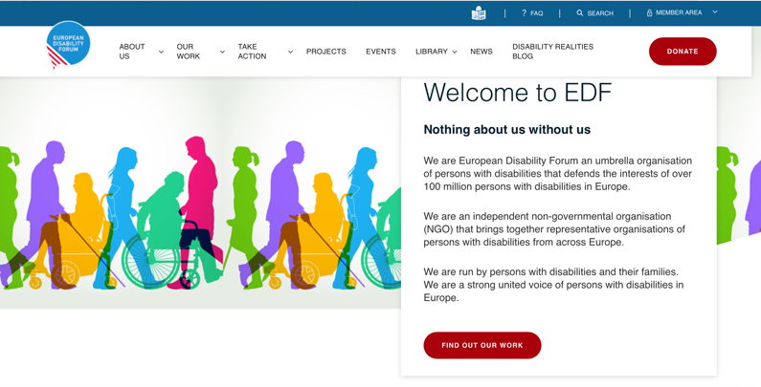
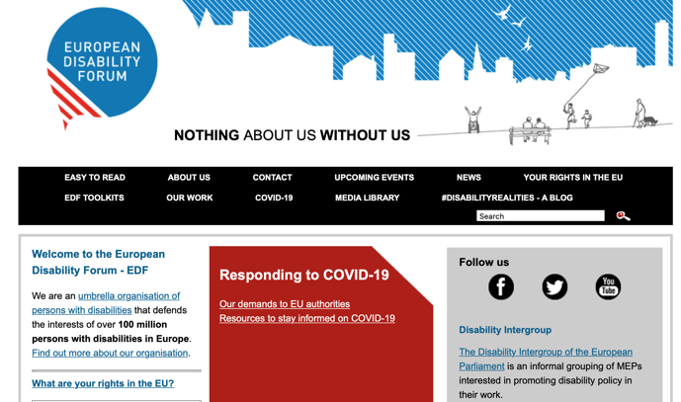

Creating engagement on social media

Through social media, we reached…
EDF Facebook page
15,700 fans
@MyEDF Twitter page
18,000 followers on

Our top campaigns
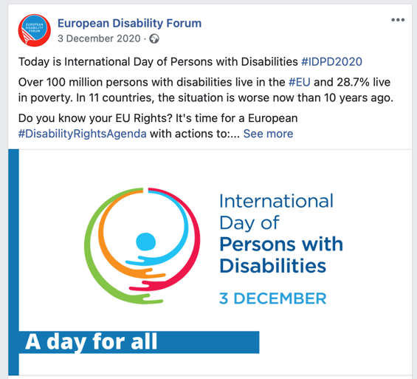
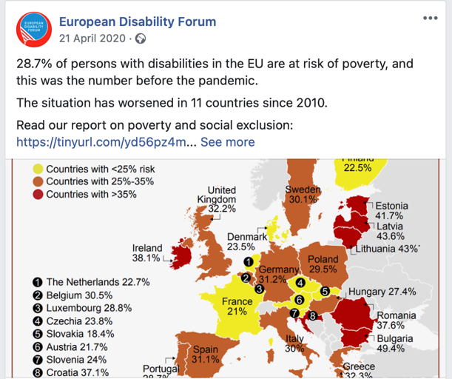
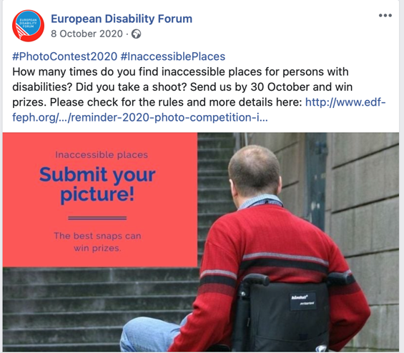

EDF in news

Media coverage included coverage of:
- Sign the petition for Train travel for all campaign
- The impact of COVID 19 in residential institutions
- 45 MEPs Coronavirus Response
- 60.000 people demand from the EU to make train travel work for persons with disabilities.

Events

During 2020 we held 43 webinars with 5,900 registrations in total and 4,000 attendees. We also organised Governing Body meetings:
- 1 AGA
- 4 Board Meetings
- 10 Executive Meetings

