Draft: 19 April 2021

European Year of Rail 2021 - Towards independent and spontaneous rail travel for all

Online Conference
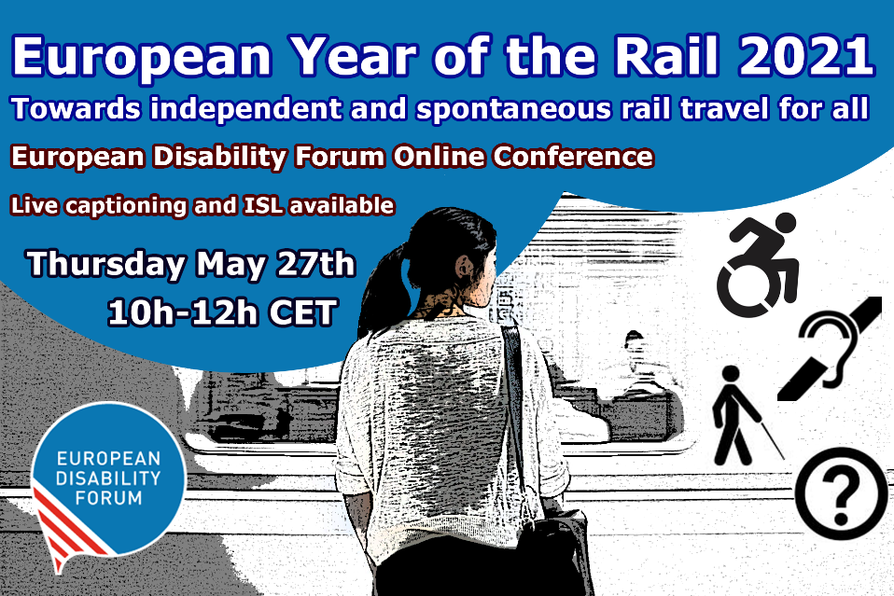
This year, we celebrate the “European Year of Rail”. In recent years, the European Union has adopted several important laws that have strengthened the rights of rail passengers with disabilities and improved accessibility. While we celebrate achieved success, we highlight that equal and independent access to rail travel for persons with disabilities remains a goal rather than a reality. Ensuring equal access to rail is paramount not only because the EU has obligations to do so under the UN Convention on Rights of Persons with Disabilities (UN CRPD), but also because it cannot achieve set goals under the EU Green Deal if it does not ensure that more than 100 million of its citizens with disabilities can fully and equally participate in supporting rail as a sustainable way of travelling.
We need accessible rail leading to an accessible and green future!

Objectives:

The conference will aim to:
- Give overview of EU legislation that already exists in the field of rail accessibility
- Create awareness of the current shortcomings to ensuring equal access and needs of persons with disabilities in order to travel independently
- Start the discussion on how we can achieve accessibility

Draft: 19 April 2021

Thursday, 27th May 2021
10:00 – 12:00 CET
Moderator: Catherine Naughton, EDF Director

Opening remarks:
- Adina Ioana Vălean, EU Commissioner for Transport
- Yannis Vardakastanis, EDF President

Panel 1: Accessibility of railway infrastructure
- Eddy Liegeois, Head of Unit, B.1 DG MOVE, European Commission (tbc): The role of the TEN-T Regulation in improving accessibility of stations
- Dovilė Juodkaitė, President, Lithuanian Disability Forum: From EU policy to national implementation

Q&A

Short break

Panel 2: Accessibility of rolling stock
- Community of European Railway and Infrastructure Companies (tbc): Good practice example of accessible rolling stock
- Nadia Hadad, European Network for Independent Living (tbc): Towards independent and spontaneous rail travel for everyone

Q&A

Closing remarks: the way ahead
- Gunta Anca, EDF Secretary-General

