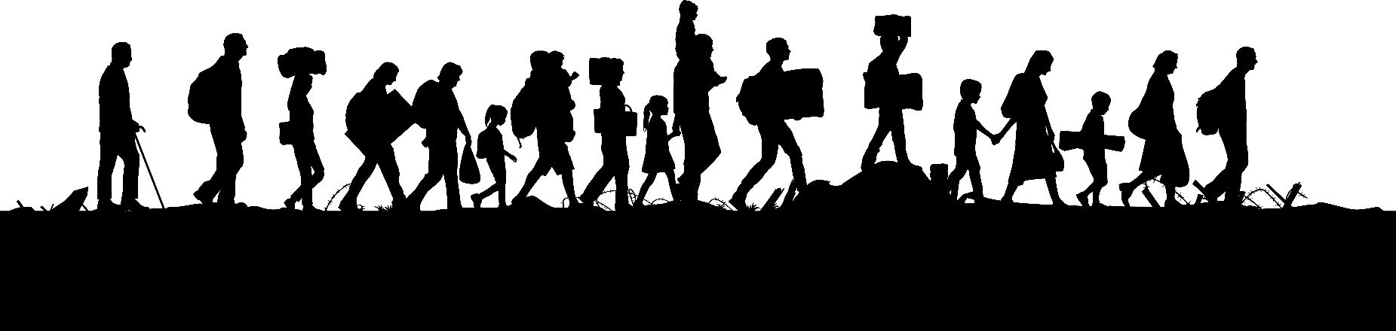
EDF’s booklet on refugees with disabilities

Easy to read version

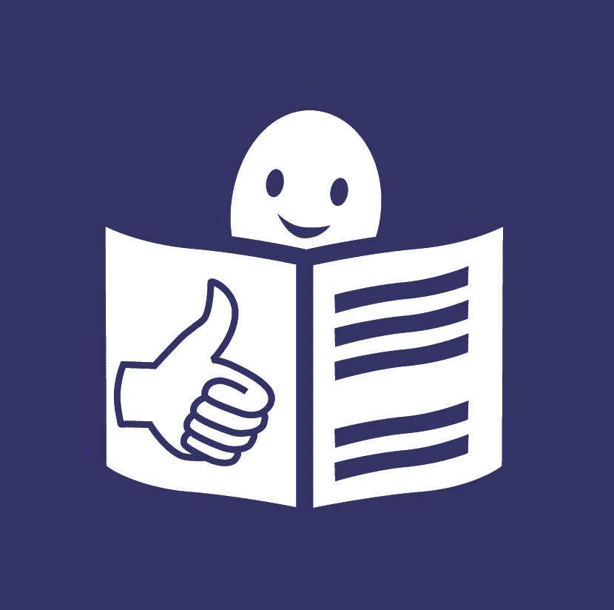
Easy to read is a way
to make information simpler and clearer
so people with intellectual disabilities
and all people can understand it.
This text is written by Lila Sylviti
and checked by Soufiane El Amrani.
You can find more information
about easy to read at www.easy-to-read.eu

Explanation of difficult words
Here you can read an explanation of the difficult words
you may find in this booklet.
You can always come back to this page
to remember the explanation of these words.

European Union
The European Union is a group of 27 countries in Europe.
These countries came together
to make things better, easier and safer for people.
In this map, you can see all the countries
that are part of the European Union:

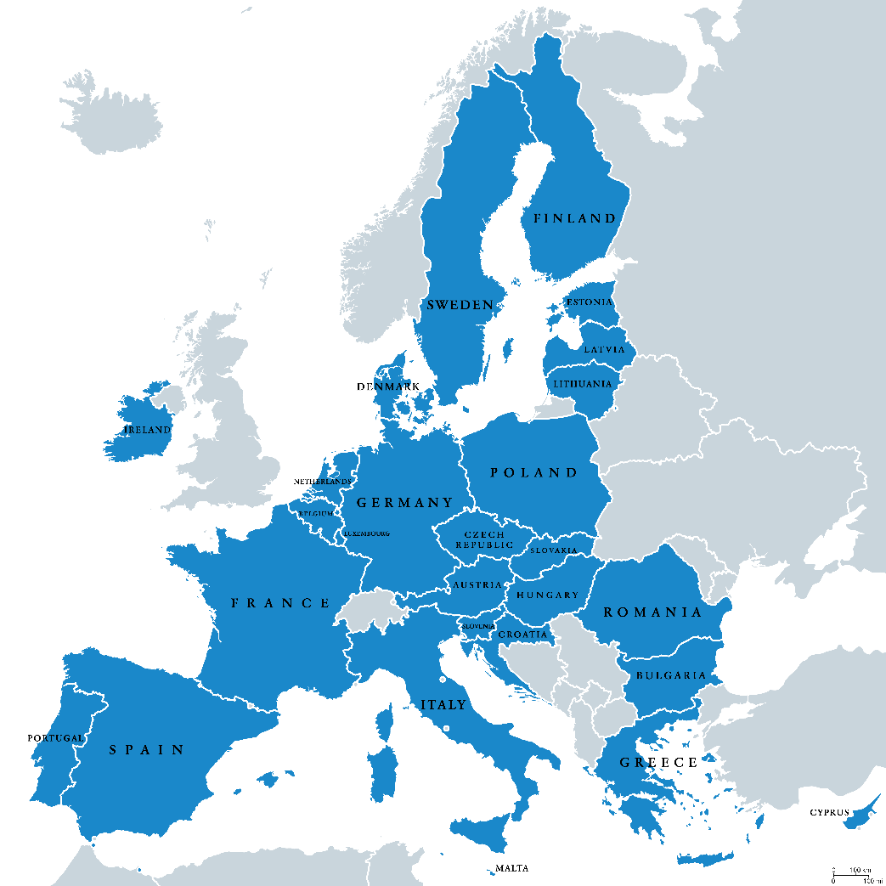

Accessible
Things are accessible when they are possible to use
by people with disabilities and all people.
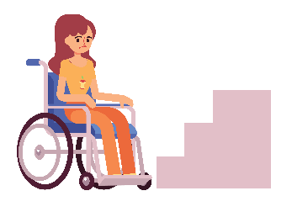
If things are not accessible,
people with disabilities can be left out.
For example:

- If buildings do not have ramps,
people in wheelchairs
will not be able get in.

- If information is not easy to read,
persons with intellectual disabilities
will not be able to understand it.

Refugees
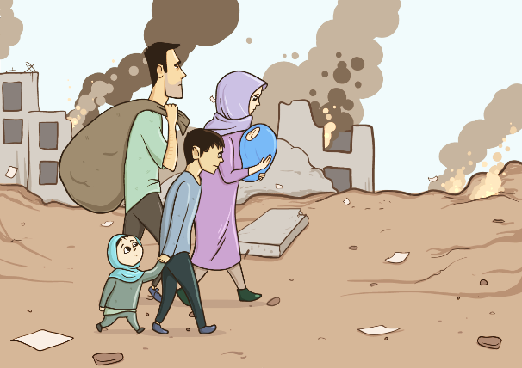
Refugees are people who leave
their country and their home
because it is not safe for them
to live there anymore.
For example,
they may have war in their country
and their life may be in danger.
In recent years,
many refugees have come to Europe
hoping for a better life.

Refugee camps
These are places where refugees have to stay at
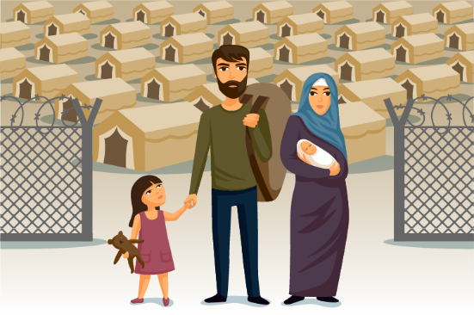
when they arrive in a new country.
They often have to stay there
for a long time
until the new country finds out more about their case
and until a decision is made
about their future.
Sadly, things can be hard
in refugee camps.
There may be too many people together
and they may live in bad conditions.
For example, they may live in tents even when the weather is cold.

Things can be even harder for refugees with disabilities
because many things in the refugee camps are not accessible for them.

Who we are
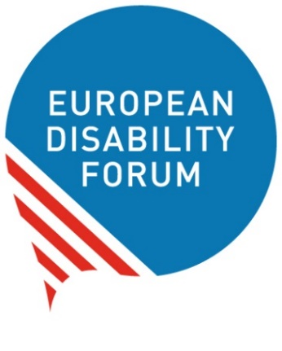
We are the European Disability Forum.
We are an organisation of people with disabilities
in Europe.
In short, we are called ‘EDF’.

At EDF, we work to protect the rights
of all people with disabilities in Europe.
We think that people with disabilities
should have the same chances in life
as all other people.

We also think that people with disabilities should decide about their lives.
Nothing should be decided about us
without us!

What this booklet is about
We wrote this booklet to talk about refugees with disabilities.
In the next few pages, you will learn:

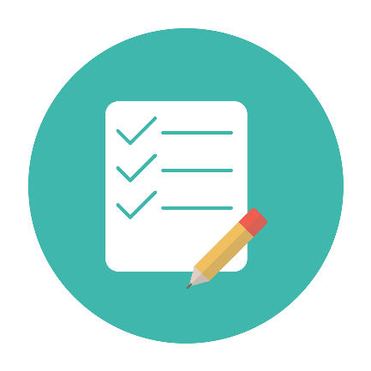
- How things are for refugees with disabilities who come to Europe.
- What laws and agreements there are
to protect the rights of refugees.
- How organisations like us
work to help refugees with disabilities
to have better chances in life.
- The story of a young refugee woman with disability.

How things are for refugees with disabilities
Refugees are people
who left their country and their home
because it was not good or safe
for them to live there anymore.
In recent years,
many refugees have come to Europe
hoping for a better life.

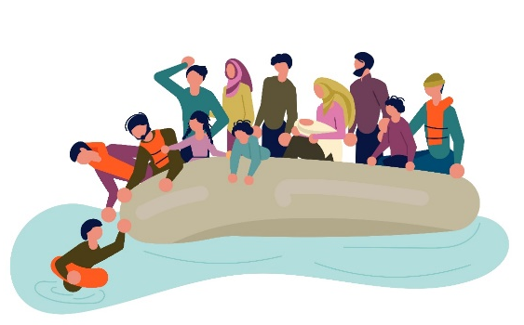
Their trip to Europe
is hard and dangerous.
Too many people die on the way.

But even if they make it to Europe, things keep being very hard for them.
Countries in Europe keep them
in refugee camps until it is decided
where they will go next.
This can take a long time
and it is very stressful for people
who have left their country.

Things are even harder
for refugees with disabilities because:
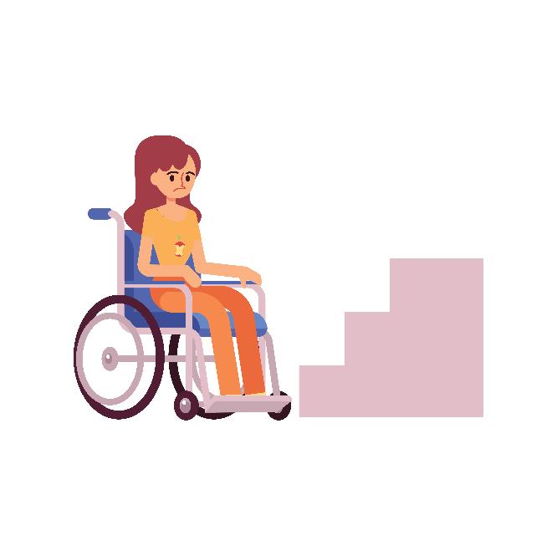
- Even basic things in the camps may not be accessible for them.
For example,
toilets may have stairs but no ramp
so people in wheelchairs
cannot use them.

- The people who work at the camps may not understand
if a refugee has a disability.
Or even if they understand it,
they may not know the right way to help them.

- Refugees with disabilities may not be able to see a doctor
and get health care when they are sick.
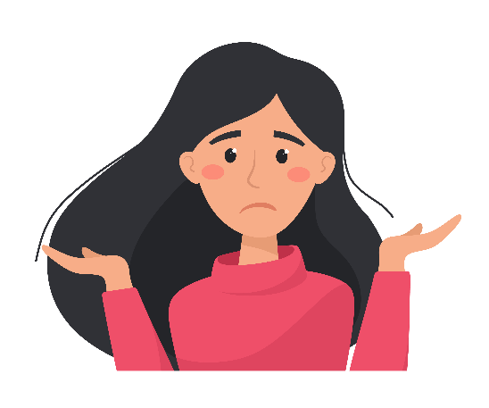
- Important information and documents may not be accessible
so refugees with disabilities
may not be able to understand them.
For example,
there may be no information
in sign language for deaf refugees,
or information in easy to read
for refugees with intellectual disabilities.

Laws and agreements that protect refugees
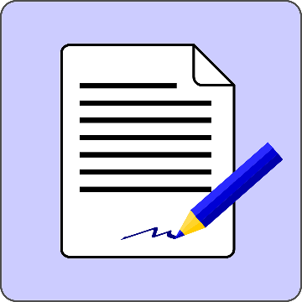
There are many laws and agreements
in the European Union and in the world
that protect the rights of refugees.

For example:

- The ‘1951 Geneva Convention
on the Status of Refugees’
This is a law that all countries in the European Union
have agreed to.
It helped countries to recognise who refugees are
and how to protect their rights.

- The ‘UN Convention on the Rights
of Persons with Disabilities’
This is an agreement that all countries in the European Union
have signed.
It says what rights people with disabilities have
and how countries should protect these rights.
Among others, it says that countries should protect
people with disabilities who are in danger
such as refugees with disabilities.

- The ‘Charter of Fundamental Rights of the European Union’
This is a law that the European Union made to protect the rights
of all the people in the European Union.
Many of the rights written in this law are important
for refugees with disabilities too.
For example:
  - the right to not be left out because of your disability,
  - the right to go to school and study,
  - the right to get health care when you are sick.

- The ‘Common European Asylum System’
This is an agreement that the European Union made to say that refugees who come to any country of the European Union
should be treated in the same fair way
and should get the same help.

The European Union has made other important documents
about refugees and people who leave their countries.
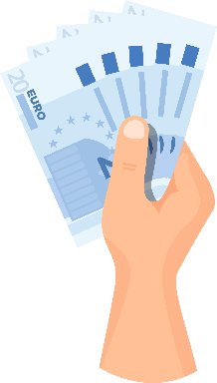
But often these documents do not take into account
refugees with disabilities.

Also, the European Union gives money to its countries
to help the work they do for refugees
including refugees with disabilities.

Helping refugees with disabilities
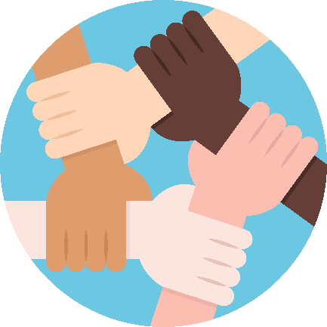
Many of our members and other organisations
work to help refugees with disabilities.
They have organised many projects
and activities to make things easier for them when they arrive in Europe.
For example:

- In Sweden, there is a project called ‘Disabled Refugees Welcome’.
This project tries to make things easier
and more accessible for refugees with disabilities
who arrive in Sweden by:

- Understanding their needs,
- Telling people who work with refugees what they can do
to help refugees with disabilities,
- Helping refugees with disabilities to have access
to things and services that are very important for their lives.

- In Greece, our members work on a project that tries to help refugees with disabilities who arrive in Greece by:

  - Training people
who work with refugees
about the needs
of refugees with disabilities.
This way, they can learn
how to help them.
  - Helping refugees with disabilities and their families
to get access to important things and services,
such as accessible houses and health care.
  - Bringing refugees with disabilities together
so their voices can be heard.

- In Italy, there is a project that tries
to make information accessible
for refugees with Down syndrome.
If they get information in easy to read,
it will be easier for them
to understand their rights
and how things work when they arrive in Italy.

- EDF and our members in Italy and Greece took part in a project
to support refugees with disabilities who arrive in Europe.
This project tries to make things and services accessible
so they are not left out because of their disability.

Ideas for future work
In the future, we will continue working
with our members and other organisations
to support refugees with disabilities.

We think it is important to:

- Help refugees with disabilities know more about their rights.
- Make sure more things and services
are accessible to them.
- Make sure refugees with disabilities are part of our work
and listen to their views.
- Pay attention to refugees with disabilities
who are at even higher risk of being treated badly,
such as women, older people
and people with intellectual disabilities.
No one should be left behind!
- Help people who work for refugees to understand the needs
of refugees with disabilities and know how to help them.
- Work all together to make things better and more accessible
for refugees with disabilities.

We also think it is important to work together with the European Union and its countries to make sure that:
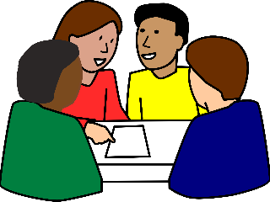
- They understand how hard things are
for refugees with disabilities
and take action to protect them.
- They think of the needs
of refugees with disabilities
when they make decisions and plans.
- They offer training to people who work with refugees
so that they know how to help them.

Nujeen’s story
Nujeen Mustafa is a young woman from the country of Syria.
She has a disability and she uses a wheelchair.
When war started in her country,
it was hard for her to leave because of her disability.
But she and her family managed to escape and come to Europe.

The trip was long and dangerous and many people told her family
to leave her behind because of her disability.
But her family did not give up on her and despite the hard trip,
they all made it to Europe.

First, they arrived in Greece which is a country of the European Union.
She had to stay in refugee camps
where many basic things
were not accessible for her.
Even toilets had steps but no ramps
so Nujeen could not get in
with her wheelchair.

After a long and hard time,
Nujeen and her family started a new life in Germany.
Nujeen went back to school and made dreams for her future.

But she could not forget other refugees with disabilities
who go through the same things as she did.
Now she is using her voice to talk about the rights
of refugees with disabilities.
She also wrote a book about her story
to show people how hard things are for refugees with disabilities.
She hopes that countries will work to help refugees with disabilities and make things and services accessible for them.

More information
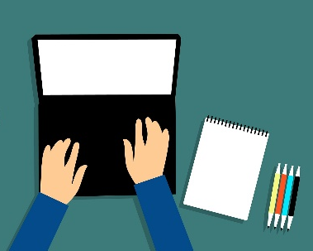
For more information
about EDF and our work,
you can visit our website at
www.edf-feph.org.
You can also send us an email at
info@edf-feph.org.

