European Year of Rail 2021 - Towards independent and spontaneous rail travel for all

Online Conference
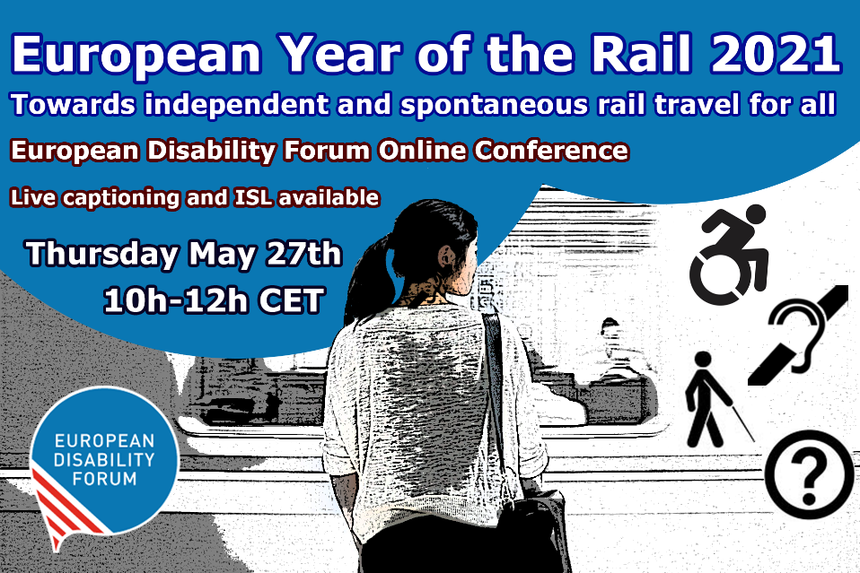
This year, we celebrate the “European Year of Rail”. In recent years, the European Union has adopted several important laws that have strengthened the rights of rail passengers with disabilities and improved accessibility. While we celebrate achieved success, we highlight that equal and independent access to rail travel for persons with disabilities remains a goal rather than a reality. Ensuring equal access to rail is paramount not only because the EU has obligations to do so under the UN Convention on Rights of Persons with Disabilities (UN CRPD), but also because it cannot achieve set goals under the EU Green Deal if it does not ensure that more than 100 million of its citizens with disabilities can fully and equally participate in supporting rail as a sustainable way of travelling.
We need accessible rail leading to an accessible and green future!

Objectives:

The conference will aim to:
- Give overview of EU legislation that already exists in the field of rail accessibility
- Create awareness of the current shortcomings to ensuring equal access and needs of persons with disabilities in order to travel independently
- Start the discussion on how we can achieve accessibility

Thursday, 27th May 2021
10:00 – 12:00 CET
Moderator: Marie Denninghaus, EDF Policy Coordinator

Opening remarks:
- Adina Ioana Vălean, EU Commissioner for Transport (video address)
- Yannis Vardakastanis, EDF President

Video presentation
Iedereen Mobiel! (Everyone Mobile!) – campaign by VFG, Belgium

Session 1: Making rail accessible: from EU policy to national implementation
- Pablo Fabregas Martinez, Member of Cabinet of EU Commissioner for Transport: EU laws and policies in support of rail accessibility
- Eddy Liegeois, Head of Unit, B.1 DG MOVE, European Commission: The role of the TEN-T Regulation in improving accessibility of rail travel
- Dovilė Juodkaitė, President, Lithuanian Disability Forum: Implementing EU law at national level

Q&A

Short break

Session 2: Rail accessibility in practice: from barriers to solutions
- Soufiane El Amrani, Self-advocate, easy-to-read expert, Inclusion Europe: accessibility barriers for persons with intellectual disabilities
- Laura Alčiauskaitė, Project coordinator, European Network on Independent Living (ENIL): barriers in rail services: perspective of persons with disabilities
- Blaž Pongračič, Senior Policy Adviser Passenger, Community of European Railway and Infrastructure Companies: Good practice example of accessible rail services

Q&A

Closing remarks: towards an accessible future
- Gunta Anca, EDF General Secretary

