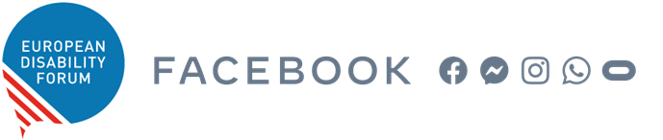

Facebook-EDF Policy roundtable on the European Accessibility Act
GAAD 2021 – Thursday, 20 May 2021
15:00 – 17:00 CET
Zoom. https://zoom.us/webinar/register/WN_YkPOCKkTQvmrrhzHkgzILw

Accessibility is a human right. It is equal access for persons with disabilities, and a precondition to enjoy independent living and full participation in society. However, it is not easy to include accessibility into legislation, particularly when this relates to the ever-evolving information and communication technologies. This is why the European Accessibility Act (EAA) is an opportunity which cannot be missed.
We are halfway through the time allocated for EU countries to translate the EAA into robust national laws. Besides, very soon we will need to work on developing the technical standards that will support the implementation of the Act. Market authorities must increase their knowledge on accessibility, industry must adapt to the legislation, users must know their rights, more accessibility professionals will be needed, and we all need to work together to exceed the objectives and expectations of our first cross-cutting legislation concerning accessibility.
Join us on the Global Awareness Accessibility Day (GAAD) to discuss, together with representatives from the European Commission and the European Parliament, Member States, standardization bodies, Facebook and the European Disability Forum, the challenges and opportunities of this landmark legislation, with a particular focus on the impact for the digital world.
Draft Agenda
15.00 - 15.05 Welcome and Housekeeping rules
15.05 - 15.15 Opening
- Monica Desai – Head of Global Connectivity and Access Policy, Facebook (tbc)
- Humberto Insolera – Executive Committee member, European Disability Forum
15.15 - 15.35 Keynote address - advancing ICT accessibility through the EAA
The EAA as a regional and global milestone for the implementation of the UN Convention on the Rights of Persons with Disabilities. Opportunities for private and public partnerships. How to promote a healthy EU ecosystem for accessibility in the EU. Is the EAA enough?
- Stein Erik Skotkjerra – digital accessibility expert.
15.35 - 16.40 Panel discussion - Implementing the EAA, challenges and opportunities
How the European Commission, Member States and industry are preparing for the EAA. Expectations of persons with disabilities. The role of the standardization process in the definition of technical accessibility requirements. Identified implementation difficulties.

Moderator
- Catherine Naughton – Director, European Disability Forum
Interactive discussion
- Inmaculada Placencia-Porrero – Senior Expert, Disability and Inclusion Unit, DG for Employment, Social Affairs, and Inclusion, European Commission – EU
- Zuzanna Raszkowska – Deputy Director of the European Affairs and International Cooperation Department, Ministry of Funds and Regional Policy, Poland – Member State
- Fernando Machicado – Secretary of CEN-CENELEC-ETSI Joint Working Group on eAccessibility – ESOs
- Johan Keetelaar – Head of EMEA Connectivity and Access Policy, Facebook – Industry
- Alejandro Moledo – Policy Coordinator, European Disability Forum – Persons with Disabilities
16.40 - 16.55 Questions & Answers
16.55 - 17.00 Closing
- Alex Agius Saliba – Member of the European Parliament

