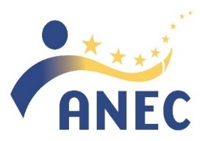
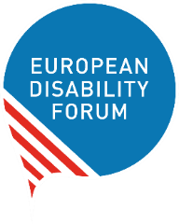

Introduction to Standardisation

Date and time:
Tuesday, 29 June 2021
15:30 – 17:00 CET

Registration:

https://zoom.us/webinar/register/WN_Ar4b0787QIuA5iR2YsoRhg

Concept:
Standardisation is important for the development of many services and products we use in our daily lives. For persons with disabilities accessibility standards are especially crucial as they helps ensure that products and services follow common technical requirements for accessibility, therefore resulting in consistency in how accessibility is achieved. But for standardisation to successfully achieve results that are beneficial for persons with disabilities, it is important that persons with disabilities and accessibility experts are engaged in the process at equal level with other stakeholders, such as industry.
Despite this importance, standardisation remains a ‘mystery world’ for many persons with disabilities because of its very technical nature, but also because the European standardisation system is not always very transparent and easy to understand.
Given that the European Commission just launched a standardisation request to European standardisation organisations to draft harmonised standards for the European Accessibility Act and that it is crucial for consumers with disabilities to actively engage in this process, EDF and ANEC are holding this introductory webinar to standardisation.

Objectives:
To support involvement of EDF member organisations in standardisation, and particularly in the development of standards harmonised for the European Accessibility Act by:
- Introducing the main concepts, bodies, and procedures of European standardisation.
- Highlight why standardisation is important for person with disabilities and how they can get involved.

Draft Agenda:

15:30 – 16:15
- Welcome and introduction, Mher Hakobyan, Accessibility Officer, EDF (5’)
  - House Rules/logistics
  - Presentation of the agenda
- Introduction to standardisation - Chiara Giovannini, Deputy Secretary-General, ANEC (15’)
  - What is standardisation and how does it work?
  - What are the main existing accessibility standards?
  - What can we expect from standardisation for the EAA?
- Q&A – max. 2-3 questions following the presentation (5’)
- The role of the Strategic Advisory Group on Accessibility (SAGA) - Malin Rygg, chair, SAGA (15’)
  - What is SAGA and its role within the European standardisation process?
  - How can SAGA support the successful development of the harmonised standards for the Accessibility Act?
- Q&A – max. 2-3 questions following the presentation (5’)

16:15 – 16:25
- Break (10’)

16:25 – 17:00
- Involvement of persons with disabilities in standardisation – Alejandro Moledo, Head of Policy, European Disability Forum (EDF) (15’)
  - Why are standards important for persons with disabilities and why should we get involved?
  - How does EDF plan to engage in standardisation for the Accessibility Act and how it will support EDF national members?
- Q&A – max. 2-3 questions following the presentation (5’)
- Q&A – remaining questions for all speakers (10’)
- Closing (5’)

Accessibility and house rules:
The language of the online discussion is English. We will provide International Sign interpretation and real-time captioning (English). We can also provide real-time captioning in other languages, please indicate it through the registration form.
The event will be recorded and shared publicly following the webinar.

Contact:
If you have any questions, write to Mher, EDF Accessibility Officer.

Useful Resources:
To get most out of this meeting, we strongly advise you to refresh your memory about the Accessibility Act by
- listening to the recoding of our webinar on the transposition of the European Accessibility Act and
- checking our toolkit for transposition of the European Accessibility Act

