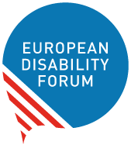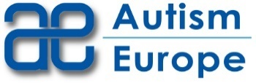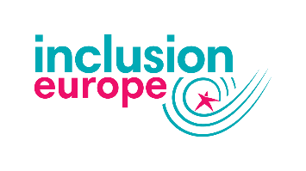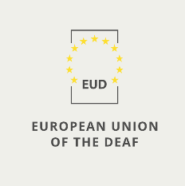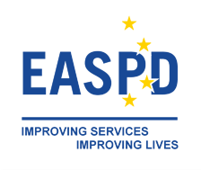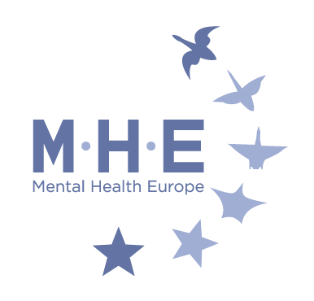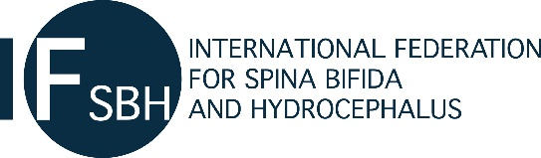

EDF workshop on access to health

Tuesday 15th of June
2:00-5:00 pm (CET)

Background
Article 25 of the UN Convention on the Rights of Persons with Disabilities highlights that “persons with disabilities have the right to the enjoyment of the highest attainable standard of health without discrimination on the basis of disability.” Under this article State Parties to the Convention have the obligation to ensure that persons with disabilities have access to the same range, quality and standard of free or affordable health care and programmes as provided to other persons.
Despite the Convention having been ratified by the EU and all Member States, persons with disabilities continue to face important barriers in accessing healthcare. The COVID-19 pandemic and its response have exacerbated cases of inequality and discrimination, with persons with disabilities not receiving accessible information on health and protection measures, and in some cases being denied treatment on the grounds of their disability. Even before the pandemic, persons with disabilities could not have equal access to quality healthcare due to inaccessible infrastructures and communication, and in some instances because of direct human rights violations such as involuntary treatment and placement in psychiatry, and forced sterilisation and abortion. It is also known that healthcare workers are rarely receiving training related to disability.
In 2021, 6 years after the adoption of Concluding observations on the EU by the CRPD Committee, what is the state of play for persons with disabilities in the EU? What role the EU can play to improve access to health and patients’ rights, including in cross border healthcare?
This workshop organised by the European Disability Forum, in collaboration with Autism Europe, the European Association of Service Providers for Persons with Disabilities, the European Union of the Deaf, Inclusion Europe, the International Federation for Spina Bifida and Hydrocephalus and Mental Health Europe, will look into the current situation in the EU and what is needed to ensure better access to quality healthcare for persons with disabilities.
Speakers include representatives from organisations of persons with disabilities, the Directorate General on Health of the European Commission and academic experts.
The workshop is open to EDF members and their members.

Objectives
- Present and discuss some of the issues faced by persons with disabilities in access to health in Europe
- Understand the role of the EU in relation to access to health, including cross-border healthcare
- Collect information from organisations of persons with disabilities on gaps and barriers in their countries

Accessibility settings
The workshop will be in English.
The plenary session with include international sign interpretation and live captioning in English.
All thematic sessions will include live captioning in English. In addition, thematic session no.2 will also provide international sign interpretation.

Registration
EDF members and their members are requested to register to the workshop in advance, indicating the thematic session of their choice. Several representatives can attend from each organisations.
Registration link: https://zoom.us/meeting/register/tJUoce2sqD0sHNPfICH4htOWSImMUo0TGwn7

Programme
Moderated by Maureen Piggot, EDF Executive Committee
2:00 – 2:10 Opening
Housekeeping rules
2:10 – 3:00 Health and disability in the European union
Moderated discussion on the current situation in Europe and what we need to protect our rights.
- Current state of play for persons with disabilities – Catherine Naughton, European Disability Forum
- Disability based discrimination in access to healthcare – Lisa Waddington, European Disability Forum Professor of European Disability Law, Maastricht University
- WHO work on disability inclusive health – Satish Mishra, Technical Manager, Disability and Rehabilitation WHO Europe
Q&A
3:00-3:30 Cross border healthcare: the Patient Mobility Directive
Presentation by Caroline Hager (DG SANTE) and Q&A
3:30-3:45 Break
3:45-4:30 Thematic sessions
Each thematic session will focus on specific topics and include short presentation by invited experts and EDF members. Action points for EDF and our members will be proposed and fed back to the plenary. Key documents will be made available to participants.
Participants are asked to register to the thematic session of their choice in advance, through the general registration link.
- General access to healthcare, including screening, sexual and reproductive health and rights
Co-organised with the International Federation for Spina Bifida and Hydrocephalus

Invited experts:
- Professor Hannah Kuper, London School of Hygiene & Tropical Medicine (LSHTM)
- Rhoda Garland, Executive Director of the Commission for the Rights of Persons with Disability (CRPD) and Equinet Board member

This session focuses on the barriers faced by persons with disabilities in general access to healthcare, including general screenings and access to sexual and reproductive health and rights.

- Access to information and communication
Co-organised with Autism Europe, European Union of the Deaf and Inclusion Europe

This session will discuss in more details access to information and communication related to health, including e-health and taking into account the different needs of persons with disabilities.

- Habilitation and rehabilitation
Co-organised with the European Association of Service Providers for Persons with Disabilities
In this session we will discuss what the CRPD says about Habilitation and rehabilitation and where the current barriers and good practices now are.

- Mental health
Co-organised with Mental Health Europe
This session will look into mental health and access to CRPD compliant mental health services as a determinant of health.
4:30-4:50 Reporting to plenary
4:50-5:00 Closing – Tilly Metz, Member of the European Parliament

