Report workshop on access to health

On the 15th of June, the European Disability Forum (EDF) organised an online workshop on access to health by persons with disabilities, jointly with Autism-Europe, the European Association of Service Providers for Persons with Disabilities, the European Union of the Deaf, Inclusion Europe, the International Federation for Spina Bifida and Hydrocephalus and Mental Health Europe.
The workshops gathered 61 participants from EDF memberships and members of EDF members. It also included the participation of several external experts, from the World Health Organisation, the European Commission, the European Network of Equality Bodies (Equinet) and from academia.
Contents
Report workshop on access to health 1
Summary of the workshop 2
Health and disability in the European Union 2
Cross border healthcare: the Patient Mobility Directive 4
Thematic sessions 5
Conclusions 9
References and additional information 9
Autism-Europe 9
European Commission 9
European Disability Forum 9
International Federation for Spina Bifida and Hydrocephalus 9
Mental Health Europe 10
World health organisation 10

Summary of the workshop
The workshop was opened by Maureen Piggot, member of EDF Executive who introduced the event and its objectives. Objectives identified by EDF, and partners were to (1) present and discuss some of the issues faced by persons with disabilities in access to health in Europe, (2) understand the role of the European Union (EU) in relation to access to health, including cross-border healthcare, and (3) collect information from organisations of persons with disabilities on gaps and barriers in access to health in their countries.

Health and disability in the European Union
The first session of the workshop was a moderated panel discussion on “Health and disability in the European Union”. This session looked into the current situation in Europe and measures needed to protect the right to health of persons with disabilities. It gathered Catherine Naughton (EDF Director), Lisa Waddington (European Disability Forum Professor of European Disability Law at Maastricht University) and Satish Mishra (Technical Manager, Disability and Rehabilitation at WHO Europe).
Catherine Naughton drew a picture of the numerous issues faced by persons with disabilities in accessing health. She reminded the audience of the definition of health enshrined in article 25 of the UN Convention on the Rights of Persons with Disabilities as “a state of physical, mental, and social well-being and not merely the absence of disease or infirmity” which is also a pre-requisite for participation in many activities. In relation to barriers to health she referred to unequal treatment, lack of accessibility of services, costs, diagnostic overshadowing and inaccessibility of facilities and equipment. She also highlighted inequalities between women and men, referring to data from the Gender Equality Index 2020 of the European Institute of Gender Equality. For example, on average in the EU, only 20,2% of women with disabilities and 22,8% of men with disabilities perceived themselves as being in good health comparing to 83,8% of women without disabilities and 85,5% of men without disabilities. She underlined barriers in e-health as new and growing concern and spoke about human rights abuses taking place in psychiatry, including involuntary treatment and placement, and the increase in the use of electro-convulsive “therapy”. She stressed that no EU countries is exempt from these issues. “COVID-19 brought home to us that these barriers are operating in each country in the EU”, she said.
Lisa Waddington made a presentation of a paper she wrote for EDF on disability-based discrimination in access to healthcare in the EU (to be published in September 2021). She started by giving a definition and examples of discrimination in access to health, and stressed that all States Parties to the CRPD have a duty to “prevent discriminatory denial of health care or health services” and “provide persons with disabilities with the same range, quality and standard of free or affordable health care as provided to other persons”. The CRPD can also be interpreted as requiring a reasonable accommodation duty in the context of healthcare. According to her research:
- 14 EU Member States have legislation that both prohibits disability discrimination and requires reasonable accommodation.
- 7 Member States have legislation that prohibit disability discrimination but does not require reasonable accommodation.
- One Member States does not prohibit disability discrimination but do require reasonable accommodation
- 5 Member States neither prohibit disability discrimination nor require reasonable accommodation.
Prof. Waddington also explained that it is sometimes possible for individuals to rely on constitutional provisions or the CRPD directly before the Court. She gave as example a judgment of the General Federal Constitutional Court of 30 January 2020 (Bundesverfassungsgericht,BVerfG) concerning the case of a person accompanied by a guide dog to access a physiotherapist’s practice. In that case the Court decided that the decision to prohibit access was discriminatory. The Court referred to the German non-discrimination law, the Constitution and the CRPD in reaching this verdict.
Satish Mishra presented the work by the World Health Organisation (WHO) Regional Office for Europe on disability inclusive health. He explained that there is a limited understanding of the needs and challenges faced by persons with disabilities and what is needed to include them. In addition, there is sometimes a lack of coordinated disability voice. He addressed the COVID-19 pandemic explaining that it deepened pre-existing inequalities whilst exacerbating pressures on healthcare systems and disrupting services. He presented the work done by WHO on the topic of disability during the pandemic, including several guidelines and a collaboration with EDF (e.g. videos). Satish Mishra explained that the three most pressing health needs in the world for the whole population are the same than for people with disabilities. These needs identified by WHO are: (1) universal health coverage, (2) protection from health emergencies (including preparedness), and (3) better health and well-being. He explained that there is a commitment from States to target these issues, taking as an example the World Health Assembly resolution EB148.R6, and the UN Disability Inclusion Strategy. He also informed about the strong emphasis on disabilities in the WHO programme budget for 2022-2023 adopted in May 2021. He concluded that it is important we support and equip governments to provide disability inclusive services, including health, and that partnership is key.
To conclude the session the three speakers were asked to highlight key recommendations:
Catherine Naughton referred to the need to collect disaggregated data on health (e.g. in the context of COVID-19 the European Centre for Disease Prevention and Control should have collected information on disability in relation to infection rates and death) and better involvement and cooperation between policy makers and organisations of persons with disabilities in health policies. She also mentioned the need to reform policy and legislation, including through harmonisation of non-discrimination legislation by the EU. She informed that EDF will continue to work on the whole CRPd, including the right of persons with disabilities to informed consent in healthcare, and campaign against the draft additional protocol to the Oviedo Convention of the Council of Europe.
Lisa Waddington talked about the importance of adopting the a horizontal equal treatment directive from 2008. This is still not adopted despite the recommendations by the CRPD Committee in 2015. If the directive were to be adopted, all EU Member States would need to prohibit disability-based discrimination and provide for reasonable accommodation in the field of healthcare. She added that such directive could also have an added value for the EU Member States that already have such legislation as it has a broader definition of discrimination than what exist in most national legislation – for instance covering multiple discrimination, discrimination by assumption and by association – and could cover accessibility.
Satish Mishra explained that although positive steps have been taken, disability inclusion is not yet a priority in health policy in many countries. He stressed the need for evidence based technical guidance, for example trialled/tested guidance. He also explained that there is a need to build a cohesive narrative around disability inclusion in the health sector, and to mobilise actors in the health sectors and ministries of health to advocate for disability inclusion in the health sectors.

Cross border healthcare: the Patient Mobility Directive
Caroline Hager, Team Leader on Cross Border Healthcare in the Directorate General on Health of the European Commission was invited to give a keynote presentation on the Directive on patients’ rights and cross border healthcare (Patient Mobility Directive) and its evaluation.
She explained that there are two routes to cross-border healthcare: under the coordination of social security systems (under Regulation No 883/2004 which include planned and unplanned healthcare) and, since 2011, under the Directive on the application of patients’ rights in cross-border healthcare (with and without prior authorisation). She explained that there is a lack of awareness about the Directive and that the patient must advance the cost of the healthcare services, which may explain why it is less used than the regulation. The Directive has an added value, but some barriers remain, such as complex system of reimbursement, administrative obstacle and inadequate information to patients. She explained that the EU has adopted actions to support better implementation (e.g. good practice workshops, Toolbox for National Contact Points) and is currently doing an evaluation of the directive. For example, it can assess whether the information on cross border healthcare is available and in an accessible format for people with disabilities which is a requirement under the directive. A research conducted in 2017, found that only 8 out of 31 national contact points websites had been tested by Blind and partly sighted people. In 2018, national contact points agreed guiding principles on enhancing information to patients, subject to available resources.
Finally, Caroline Hager explained that a public consultation was launched at the beginning of May with deadline the 27th of July, and that targeted consultations are also taking place. A report from the Commission to the European Parliament and the Council will be adopted in Q2 of 2022.
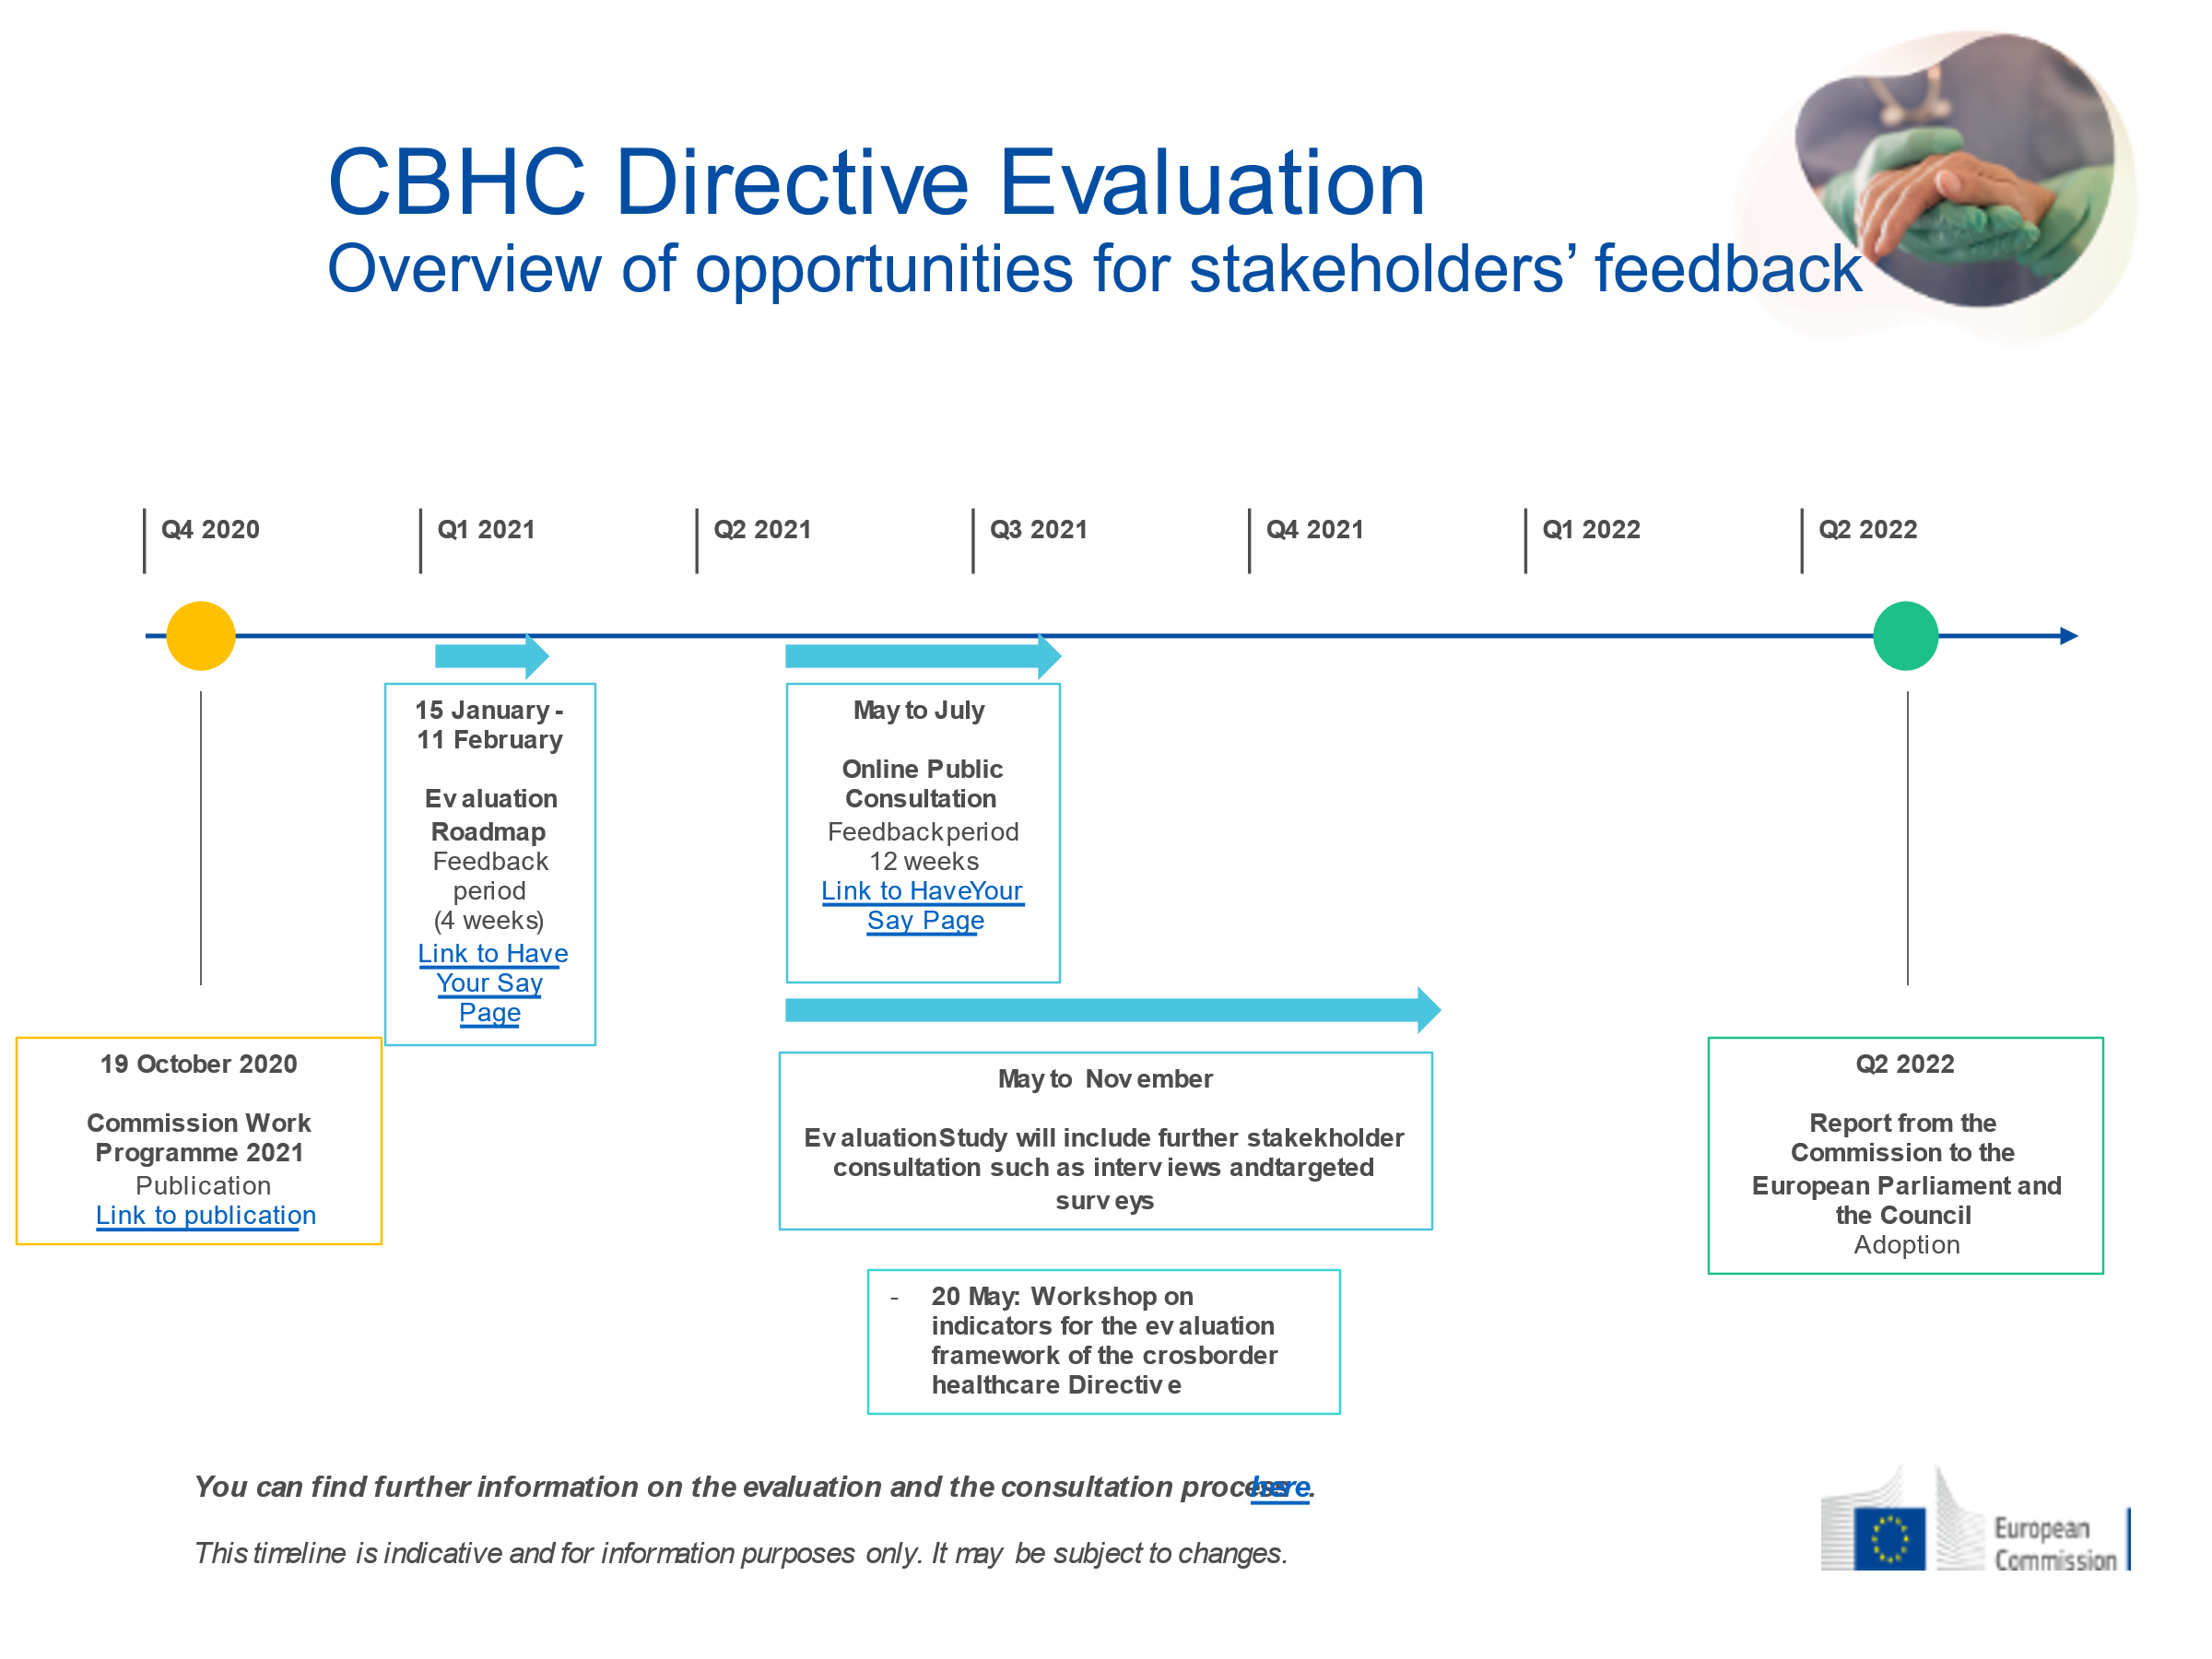

Thematic sessions
The workshop included four thematic sessions that gathered participants in smaller groups via breakout rooms.

General access to healthcare, including screening, sexual and reproductive health and rights
This session was co-organised with the International Federation for Spina Bifida and Hydrocephalus. It focused on the barriers faced by persons with disabilities in general access to healthcare, including general screenings and access to sexual and reproductive health and rights.
Speakers included Pirkko Mahlamäki (EDF Executive), Anđela Radovanović (Youth Group of International Federation for Spinabifida and Hydrocephalus), Professor Hannah Kuper (London School of Hygiene & Tropical Medicine) and Rhoda Garland (Executive Director of the Maltese Commission for the Rights of Persons with Disability and Equinet Board member).
Pirkko Mahlamäki and Anđela Radovanović addressed the difficult situations faced by persons with disabilities in accessing general healthcare, also through examples from their personal experience. “You become an educator for your doctor about your medical condition. People with intellectual disabilities are having their whole spectrum of health reduced to this one diagnosis and this one element of them” said Pirkko. Andela also addressed issues related to mental health and the stigma related to this, and issues particularly faced by women and young people with disabilities.
Several speakers and participants talked about the general need of medical professionals to be better trained in how to approach patients with disabilities and their rights, including in relation to sexual and reproductive healthcare services. For example, Pietro Cirrincione (Autism-Europe) pointed to health professionals whose lack of knowledge to manage behaviours of autistic people leads to sedating them even for simple pain, which can results in medical abuse. The audience agreed that it is very important to bridge the gap between medical and social model of disability, and thus limit bad experiences persons with disabilities too often have with health professionals.
Prof. Hannah Kuper explained that people with disabilities have greater healthcare needs but face more barriers accessing healthcare (including journey to healthcare centres, communication, etc) and that there is a lack of legislation on policy to address disability inclusion. She encouraged a structured way to analyse where countries are with their healthcare systems, and then see what we can recommend (legislation, training for health staff, etc).
Rhoda Garland talked about the role and initiatives from equality bodies and the need to actively engage with these independent bodies in order to create synergies and help them better represent the interest of right-holders in all areas, including healthcare. Among others, she shared the initiative of the Maltese CRPD regarding Disability equality training to health professionals and other stakeholders, which is organised by the Equality Body and carried out by persons with disabilities.

Access to information and communication
This session was co-organised with Autism-Europe, the European Union of the Deaf and Inclusion Europe. It focused on access to information and communication related to health, including e-health and taking into account the different needs of persons with disabilities.
Speakers included Izabela Misiorny (Siteimprove), Martyna Balciunaite (European Union of the Deaf), Christian Takow (Autism-Europe) and Helen Portal (Inclusion Europe).
Izabela Misiorny presented the outcome of an automatic evaluation done by Siteimprove on the accessibility of the 33 websites of the national contact points on cross border healthcare that will be published in EDF report on access to cross border healthcare in September 2021. She explained that the assessment was overall good: none of the sites had a score lower than 70, and 72% of the websites had a score above the industry benchmark. The most common accessibility issues concerned empty headings, links without alternative text, and insufficient colour contrast.
Martyna Balciunaite, Christian Takow and Helen Portal presented information and communication barriers related to different disability groups. Martyna explained the issues faced by Deaf people, including lack of qualified and specialised interpreters, lack of accessible information and lack of preparedness of medical professionals to communicate with Deaf patients. She said that the non-removal of communication barriers can lead to horrible consequences such as endangered lives and non-consensual situations. Christian explained that autistic people die on average 16 years earlier than general population (due to poor physical health, suicide, etc). He stressed the lack of awareness of medical professionals that commonly attribute a symptom or behaviour to the disability instead of looking to the actual health problems, and the lack of key reproductive healthcare due to misconception about autistic people’s sexuality. He highlighted the lack of accommodation for autistic adults and communication issues between autistic people and health professionals, which also happened during the pandemic. Helen explained the lack of accessible information on health for persons with intellectual disabilities and sometimes lack of option to be accompanied by a support person.
Other issues were also raised by participants during the discussion. A representative from the European Federation of Hard of Hearing mentioned lack of qualified support services as a problem (e.g. when it comes to captioning). Rados Karavica highlighted issue of children with disabilities who are presumed to not be able to give consent or not have the capacity to take decisions.

Habilitation and rehabilitation
This session was co-organised with the European Association of Service Providers for Persons with Disabilities (EASPD). It discussed the concept of habilitation and rehabilitation in light of the CRPD and the current barriers and good practices available.
Speakers included Luk Zelderloo (EASPD), Dr. Nikoletta Mavroidi (Kpechios Child and Adolescent Centre) and Loredana Disci (EDF). It was moderated by Cato Li (President of IF and Board member of EDF).
The speakers addressed several barriers to rehabilitation in the EU including: lack of follow-up to life course, financial barriers to access services and lack of investment in the past, lack of training and knowledge of professionals on disability issues, inaccessible printed and online information and online services, cutting back or freezing of services based on the pandemic, high costs and lack of support in using assistive technology and rehabilitation equipment, and insufficient adoption of the human rights based approach instead of the medical approach. They explained that rehabilitation services are predominated by medical model thinking. The result is that the broader will, preferences, and needs of the person are not at the centre of rehabilitation services. Linked with this medical model is the outdated approach of institutional based care. Community-based support needs to be developed so that people can live where and with whom they wish and have access to the rehabilitation services that they need. Under no circumstances should people be put in rehabilitation care for life - which still happens today in Europe.
While health policy and rehabilitation services are mainly a national competence of European Member States, participants identified the range of areas where EDF and its members can co-operate to improve access to rehabilitation services in Europe for people with disabilities.
- The ‘framework for services of excellence’ anticipated by the European Commission in 2023 offers us an opportunity to create a vision for person centred, human rights based , community- based rehabilitation services in Europe
- Good practices should be collected of the kind of services that should be developed . Some good practice examples were raised in the breakout session.
  - Services in Greece were presented which are regularly getting feedback from service users and adjusting their services according to feedback
  - One participant with low vision who was hospitalised during the COVID-19 pandemic explained she was amazed by how well the medical and support staff worked with her. When she inquired as to how they did this so well she found out that they had been working with the association of the Blind and had training on how to provide services well to blind and partially sighted people.

Mental health
This session was co-organised with Mental Health Europe (MHE) and looked into mental health and access to CRPD compliant mental health services as a determinant of health.
Speakers included Jonas Bull (MHE), Ferran Blanco (Support-Girona), Michael John Norton and Gina Delaney (Mental Health Ireland).
The session discussed the challenges and recommendations to be implemented in relation to mental health services, especially for people with psychosocial disabilities. One presentation focused on the recent WHO Guidance community mental health support based on human rights – among others this guidance should be used when engaging with governments working on mental healthcare and as a possibility to engage among service providers. Another prominent topic was to look more at how to enable active dialogue between stakeholders at national level, an example given by Support Girona of open collaboration and dialogue with the community, services and policy makers. This was helpful to combat stigma surrounding mental health. In a final presentation, the importance of co-production was highlighted as a way to include different types of stakeholders and meaningfully include persons with lived experiences. All speakers recommended to integrate the recovery approach to the service provision and work in general – as an approach based on putting the person at the centre and understanding that mental health problems are not necessarily something to be “cured”. Through co-production support interventions should be jointly decided by the service provider and the person with lived experience as service user.

Conclusions
Due to unforeseen circumstances MEP Tilly Metz was not available to close the workshop. Conclusions were given by Catherine Naughton, EDF Director. She explained that the objective of the workshop was to get a broad spectrum of inputs from EDF members on key issues on health. The discussions confirmed that issues are extremely wide and many of them have to do with national policy-making. However, there are also a lot of opportunities for European wide collaboration. Catherine explained that EDF is planning to give input to the evaluation of the Patient Mobility Directive. A lot of elements on healthcare will also be included in EDF’s work for the review of the EU by the CRPD Committee and all the work on the EU Disability Rights Strategy 2021-2030. In line with the CRPD, EDF will also continue to work against involuntary treatment and placement and promote informed consent in access to health. Finally, EDF has applied for official relations with WHO Euro-region and will strengthen this work and collaboration in the region.

References and additional information

Autism-Europe
- AE’s work and resources on the right to health

European Commission
- Overview of EU health policy
- Toolbox for Cross-Border Healthcare
- Regulation (EC) No 883/2004 of the European Parliament and of the Council of 29 April 2004 on the coordination of social security systems
- Directive 2011/24/EU of the European Parliament and of the Council of 9 March 2011 on the application of patients’ rights in cross-border healthcare

European Disability Forum
- EDF’s work on health
- Human Rights Report on the impact of COVID-19 on persons with disabilities (2021)
- EDF recommendations on the European Health Union Package (2021)
- Blog #DisabilityRealities: Healthcare Status: When You Belong to Nowhere (2020)
- EDF-MHE campaign #WithdrawOviedo against the draft additional protocol to the Oviedo Convention

International Federation for Spina Bifida and Hydrocephalus
- IF’s work on the right to health
- Report on the right to health: reality of persons with spina bifida and hydrocephalus (2016)
- Report on the Impact of cross-border healthcare on persons with disabilities and chronic conditions (2016)

Mental Health Europe
- Mental Health Europe, Reflection Paper on Access to Justice (2021)
- Mental Health Europe, Implementing supported decision-making. Developments across Europe and the role of National Human Rights Institutions (MHE & ENNHRI, 2020)
- Mental Health Europe, Promising practices in prevention, reduction and elimination of coercion across Europe (2019)
- Mental Health Ireland: Family Recovery Education & Coproduction

World health organisation
- WHO World Report on Disability (2011)
- WHO Policy on Disability
- WHO QualityRights Initiative
- Infographic - Better health for people with disabilities
- WHO Disability considerations during the COVID-19 outbreak (2020)
- WHO-EDF Videos on Inclusive and accessibility public health messages about COVID-19 (2021)
- WHO Guidance on community mental health services: promoting person-centred and rights-based approaches (2021)
- Disability considerations for COVID-19 vaccination: WHO and UNICEF policy brief (2021)
- A new landmark resolution on disability adopted at the 74th World Health Assembly (May 2021)

