Climate Justice
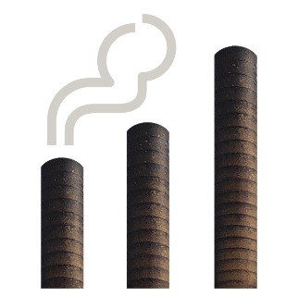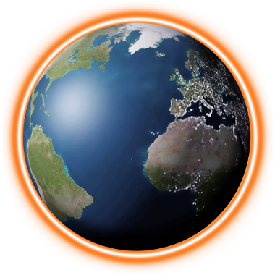 | Climate change is how the temperature of the earth is rising  because of things like pollution.  It is causing extreme weather.
Climate justice is when people come together to try
to find solutions to climate change.
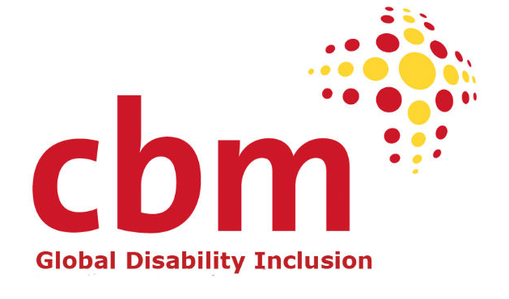 | EDF and CBM Global made a video on inclusive climate justice.  In the video  people from many countries talk about:
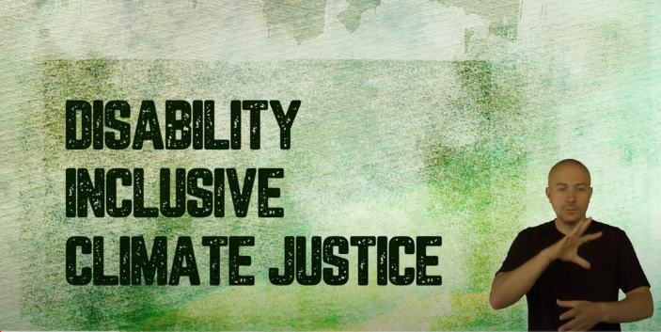 | - How climate change affects people with disabilities  - How people with disabilities can help find solutions to climate change.  Watch the video here: https://bit.ly/disclimatejustice

Easy to Read translation by Naomi Mabita
Checked by Building Bridges
Images: Photosymbols.com

