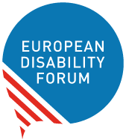

Disability Rights Strategy
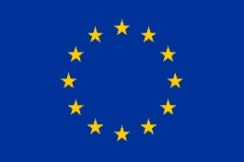 | The European Commission makes laws for the European Union.  The European Commission made the Disability Rights Strategy.  The Disability Rights Strategy is a plan to make the European Union more accessible for persons with disabilities within the next 10 years.

Council Presidency Conclusions
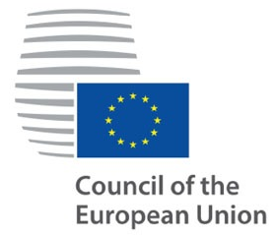 | People who make decisions  in every country of the European Union  come together and make  the Council of the European Union.
 | Portugal was the leader of the Council for 6 months.
 | Council Conclusions are plans to find solutions to problems of the European Union.
 | EDF thinks the Portuguese Council Conclusions were not good enough to find solutions for people with disabilities.
Easy to Read translation by Naomi Mabita
Checked by Building Bridges
Images: Photosymbols.com

