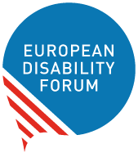

Disability Rights Strategy
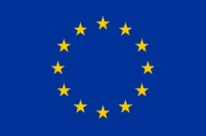 | The European Commission makes laws for the European Union.  The European Commission made the Disability Rights Strategy.  The Disability Rights Strategy is a plan to make the European Union more accessible for persons with disabilities within the next 10 years.

External Action
External action is a part of the Disability Rights Strategy
for projects outside of the European Union.
IDDC stands for International Disability and Development Consortium.
EDF and the IDDC think the external action part of the Disability Rights Strategy is not good enough.
It does not have a clear time for its plan.

Easy to Read translation by Naomi Mabita
Checked by Building Bridges
Images: Photosymbols.com

