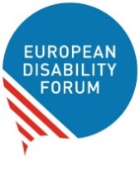
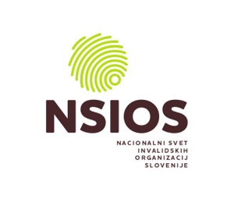

Discussion on the future of the European Disability Card: What kind of Card do we want?
16 September 2021, 10:00 – 12:00 (CET)

Draft Programme (last updated 9 August 2021)
Moderator: Marie Denninghaus, EDF

Introduction
10:00 – 10:05
What is the European Disability Card and what is the purpose of todays’ discussion?

Opening
10:05 – 10:20
- Ms Lucie Davoine, Deputy Head of Unit, European Commission – What does the Disability Strategy promise? What are the results of the pilot project evaluation? What has the Commission done so far to get the process started? (tbc)

Breakout sessions
10:20 - 11:20
Each breakout session should appoint a rapporteur to feed back to plenary. Each speaker will be asked some specific questions for ca. 5 minutes, afterwards there is an open discussion with the audience.

Session 1: Scope - What areas should the Card cover?
Moderator: Marie Denninghaus, EDF
[This session will include an interactive element]

- Mr Kamil Goungor, Chair of EDF Youth Committee
- Ms Anne-Laure LeMerre, International Association of Public Transport (UITP)
- Mr Goran Kustura, NSIOS, Slovenia

Session 2 : Legal base – What could the Card look like and what functions and characteristics will it have? What have we learned from other European Cards, including the Parking Card?
Moderator: Alejandro Moledo, EDF

[This session will include an interactive element]

- Ms Marthese Mugliette, Malta Federation of Organisations of Persons with Disability
- Mr Carlo Castellano, Expert on the European Parking Card, PARK4DIS
- Ms Gabriela Humar, Expert on the European Health Insurance Card, DG EMPL, European Commission
- Mr Manel Sánchez, Director, European Youth Card Association

Session 3: Use and promotion - What will be needed to make the Card a success? How will it have to be promoted?
Moderator: tbc

- Ms Saša Mlakar, Ministry of Labour, Family, Social Affairs and Equal Opportunities, Slovenia
- Ms Antonia Pavli, Researcher at Observatory on Disability Issues, National Confederation of Disabled People – NCDP
- Ms Sotiroula Kythreoti, User of the European Disability Card, Cyprus (tbc)

Break
11:20 – 11:30

Feedback to plenary
11:30 – 11:50
- Rapporteur of Session 1
- Rapporteur of Session 2
- Rapporteur of Session 3

Conclusions
11:50 – 12:00
- Ms Gunta Anča, Secretary General, European Disability Forum

Contact
Marie Denninghaus | Policy Coordinator | marie.denninghaus@edf-feph.org

