European Year of Rail 2021 - Towards independent and spontaneous rail travel for all

Online Conference
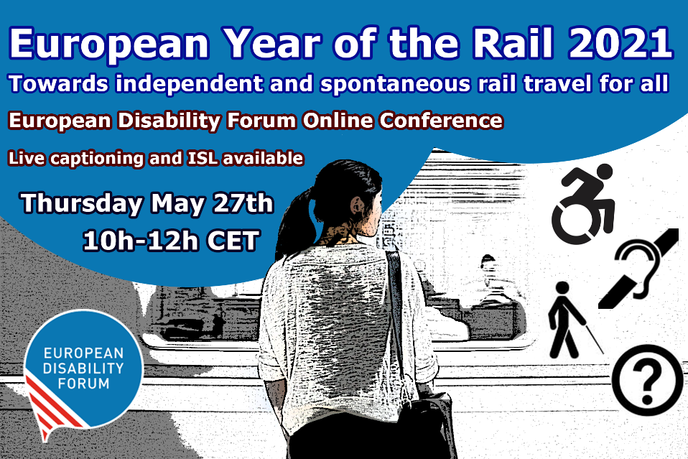
Contents
Online Conference 1
Get on our social media train! 2
Introduction 2
Objectives: 2
Conference Agenda 2
Speakers and contributions 3
Background information 6
Contact 8
The European Disability Forum 8

Get on our social media train!
Want to follow live tweets from the conference or share your own thoughts about rail accessibility? Use #AccessibleRail and #EUYearOfRail to find us or to tweet your ideas!

Follow @MyEDF and @EDFAccess for more.

Introduction
This year, we celebrate the “European Year of Rail”. In recent years, the European Union has adopted several important laws that have strengthened the rights of rail passengers with disabilities and improved accessibility. While we celebrate achieved success, we highlight that equal and independent access to rail travel for persons with disabilities remains a goal rather than a reality. Ensuring equal access to rail is paramount not only because the EU has obligations to do so under the UN Convention on Rights of Persons with Disabilities (UN CRPD), but also because it cannot achieve set goals under the EU Green Deal if it does not ensure that more than 100 million of its citizens with disabilities can fully and equally participate in supporting rail as a sustainable way of travelling.
We need accessible rail leading to an accessible and green future!

Objectives:

The conference will aim to:
- Give overview of EU legislation that already exists in the field of rail accessibility
- Create awareness of the current shortcomings to ensuring equal access and needs of persons with disabilities in order to travel independently
- Start the discussion on how we can achieve accessibility

Conference Agenda
Thursday, 27th May 2021, 10:00 – 12:00 CET
Moderator: Marie Denninghaus, EDF Policy Coordinator

Opening remarks:
- Adina Ioana Vălean, EU Commissioner for Transport (video address)
- John Patrick Clarke, EDF Vice President (on behalf of EDF President)

Video presentation
Iedereen Mobiel! (Everyone Mobile!) – campaign by VFG, Belgium

Session 1: Making rail accessible: from EU policy to national implementation
- Pablo Fabregas Martinez, Member of Cabinet of EU Commissioner for Transport: EU laws and policies in support of rail accessibility
- Eddy Liegeois, Head of Unit, B.1 DG MOVE, European Commission: The role of the TEN-T Regulation in improving accessibility of rail travel
- Dovilė Juodkaitė, President, Lithuanian Disability Forum: Implementing EU law at national level

Questions & Answers

Short break

Session 2: Rail accessibility in practice: from barriers to solutions
- Soufiane El Amrani, Self-advocate, easy-to-read expert, Inclusion Europe: accessibility barriers for persons with intellectual disabilities
- Laura Alčiauskaitė, Project coordinator, European Network on Independent Living (ENIL): barriers in rail services: perspective of persons with disabilities
- Blaž Pongračič, Senior Policy Adviser Passenger, Community of European Railway and Infrastructure Companies: Good practice example of accessible rail services

Questions & Answers

Closing remarks: towards an accessible future
- Gunta Anca, EDF General Secretary

Speakers and contributions

Moderator

Marie Denninghaus, EDF Policy Coordinator
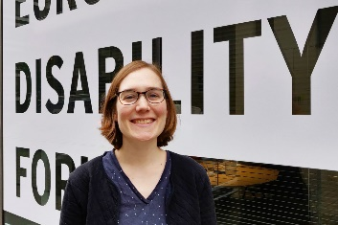
Marie Denninghaus is responsible for the coordination of our work on freedom of movement (accessibility of transport and the built environment, tourism, and consumer issues, sustainability, and the Disability Card). She also coordinates the work on our annual Work Programme and the advocacy towards the Council of the EU and its Presidencies. Her previous work experience includes communication work related to passengers’ rights and with the European Commission.

More about Marie Denninghaus.

Opening remarks:

Adina Ioana Vălean, EU Commissioner for Transport
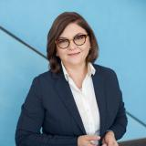
(video address)
Adina Vălean has been serving as European Commissioner for Transport under the leadership of President of the European Commission Ursula von der Leyen since 2019. She previously served as a Member of the European Parliament from 2007 until 2019, where she chaired of the European Parliament Committee on Industry, Research and Energy in 2019.
More information about Adina Vălean.

John Patrick Clarke, EDF Vice President
(on behalf of EDF President Yannis Vardakastanis)
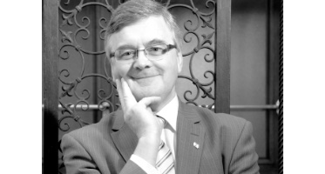
Pat Clarke is the Vice President of the European Disability Forum having retired as Chief Executive of Down Syndrome Ireland and Past- President of Down Syndrome International. Pat is immediate past Chair of the Disability Federation of Ireland and has served on the boards of the Children Rights Alliance Ireland and on the governing body of the International Disability Alliance.
More about Pat Clarke.

Video presentation

Iedereen Mobiel! (Everyone Mobile!) – campaign by VFG, Belgium
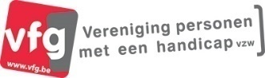
VFG is a user organization that works for the interests of all persons with disabilities. The “Everyone Mobile!” campaign highlights public transport barriers and calls for accessible public transport!
More about the campaign (website in Dutch).

Session 1: Making rail accessible: from EU policy to national implementation

Pablo Fabregas Martinez, Member of Cabinet of EU Commissioner for Transport
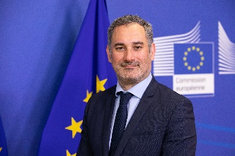
Pablo Fábregas Martínez is a Member of the Cabinet of Commissioner for Transport Adina Vălean. He is responsible in the Cabinet of infrastructure investments and Ten-T policy, transport social agenda and accessibility. Before joining the Cabinet, he has worked in the European Parliament as a political advisor working in the areas of transport and digital policies. He holds a degree in Political Science and a Master in EU law.
More about Pablo Fabregas Martinez.

Eddy Liégeois, Head of Unit, B.1 DG MOVE, European Commission
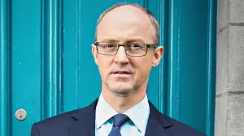
Eddy Liégeois is Head of the Transport Networks unit since January 2021. He is responsible to formulate policies and provide overall direction of the activities in the area of TEN-T projects and transport infrastructure development including provision of support for the work of the European Transport Coordinators. Previously Eddy was Head of Road transport unit (2015-2020), Head of the legal unit (2010-2015), and assistant of the Director General in DG MOVE (2005-2010). Before joining the European Commission in 1996, Eddy has worked in the private sector. He studied law in Louvain-La-Neuve.
More about Eddy Liégeois.

Dovilė Juodkaitė, President, Lithuanian Disability Forum
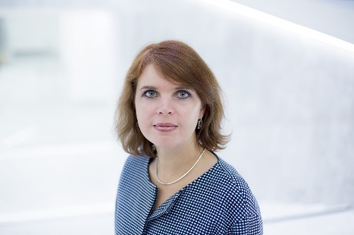
Dovilė Juodkaitė is a lawyer by profession. Since June 2013 she is the president of Lithuanian Disability Forum, which is the umbrella organisation of people with disabilities in her country. She has extensive legal and advocacy background in human rights and disability, non-discrimination, mental health care, legal capacity, and social inclusion. In May 2017 she has been elected as a member of EDF Board of Directors.
More about Dovilé Juodkaité.

Session 2: Rail accessibility in practice: from barriers to solutions

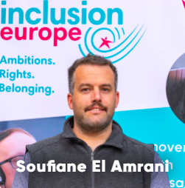
Soufiane El Amrani, Self-advocate, easy-to-read expert, Inclusion Europe
Soufiane El Amrani is the easy-to-read and advocacy expert at Inclusion Europe since 2008. As part of that he has given many trainings in making information accessible and how to consult people with intellectual disabilities in decision affecting them. He is also part of the European Platform of Self-Advocates and the Empower Us Team. Since November 2020, Soufiane is the representative of self-advocates for Europe at the Council of Inclusion International.
More about Soufiane El Amrani.

Laura Alčiauskaitė, Project coordinator, European Network on Independent Living (ENIL)
Laura Alčiauskaitė is the TRIPS project coordinator for the European Network of Independent Living with more than 10 years of experience on fields of disability, social inclusion and accessibility. Laura is a PhD student in Psychology at Vytautas Magnus University in Lithuania. Her PhD thesis is focused on positive psychology and is about psychological resources and their impact to acceptance to disability among people with mobility disabilities. She also works as a Human Rights activist since 2012, especially focusing on the implementation of human and social for people with disabilities.
More about Laura Alčiauskaitė (also here).

Blaž Pongračič, Senior Policy Adviser Passenger, Community of European Railway and Infrastructure Companies
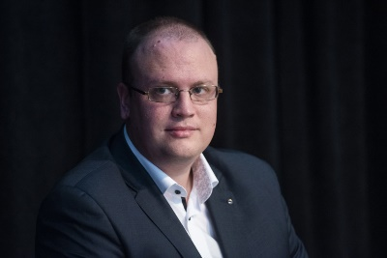
Blaž Pongračič joined CER as Senior Policy Adviser - Passenger on 1 March. Blaž has joined CER after ending the mandate in the Cabinet of former European Commissioner for Transport Ms Violeta Bulc and following time at DG MOVE. In the Cabinet he was responsible for Passenger Rights, space related topics in transport, questions of European Parliament and EU Member states of Estonia, Latvia, Lithuania, and Slovenia.
He is Slovenian and has started working in Brussels in 2014 with the start of the Juncker Commissioner. Before he worked in Slovenia, where he led projects in the field of training and education, leading a consortium of companies in the field of Robotics. He has over 10 years of experience in soft-skills training, facilitation, and participatory leadership.
More about Blaž Pongračič.

Closing remarks: towards an accessible future

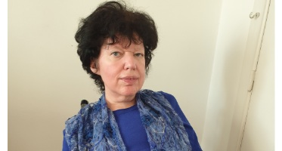
Gunta Anca, EDF General Secretary
Gunta Anca has been a proactive disability rights activist throughout her career. Since 2002, she is the Chair of the Latvian Umbrella Body for Disability Organisations (Sustento).
Since 2005, she is a Board member within the European Disability Forum. Since 2006, she is a member of the European Economic and Social Committee (EESC), an EU consultative body that gives representatives of Europe’s socio-occupational interest groups, and others, a formal platform to express their points of views on EU issues.
More about Gunta Anca.

Background information

UN Convention on the Rights of Persons with Disabilities
As signatories to the United Nations Convention on the Rights of Persons with Disabilities (UN CRPD), the European Union (EU) and all Member States are legally obliged to take appropriate measures to ensure to persons with disabilities access, on an equal basis with others, to the physical environment, to transportation, to information and communications, including information and communications technologies and systems, and to other facilities and services open or provided to the public, both in urban and in rural areas (Article 9 – Accessibility).
Read the UN Convention on the Rights of Persons with Disabilities (UN CRPD); and General Comment No 2 on Article 9 of the UN CRPD Committee.
What is the UN CRPD? Watch Inclusion Europe’s easy-to-understand video to find out!

EU Treaties – Freedom of Movement
Accessible transport, including rail, is a vital condition for guaranteeing one of the main freedoms granted by Treaties of the European Union - free movement of citizens, including of 100 million persons with disabilities in the EU.

Strategy for the Rights of Persons with Disabilities 2021-2030
Accessibility as an enabler of rights, autonomy and equality is highlighted in the European Union’s Strategy for the Rights of Persons with Disabilities 2021-2030. The Strategy recognizes that “Millions of persons with disabilities experience barriers to use transport, to access buildings or to receive information” and proposes revision of TEN-T Regulation in 2021 “to strengthen the provision on accessibility.”
Read the Union of Equality: Strategy for the Rights of Persons with Disabilities 2021-2030 and EDF short analysis of the Strategy.
We also have a simple overview of our reactions to the Strategy in this document.

EU Green Deal
The EU has committed to taking serious measures to tackle climate change. The EU Green Deal was adopted with the aim to make the EU's economy sustainable. The Deal acknowledges the importance of just and inclusive transition for all. EDF has further emphasized that accessibility is crucial for ensuring that green transition is inclusive of persons with disabilities and has made recommendations on inclusive sustainable mobility.
Read the European Commission: A European Green Deal and EDF Position on An inclusive Green Deal for Europe

EU Sustainable and Smart Mobility Strategy
The EU Sustainable and Smart Mobility Strategy is one of the initiatives under the EU Green Deal. Flagship 9 of the Strategy “Making mobility fair and just for all” concerns persons with disabilities directly. The Strategy recognizes the need for affordable, accessible and fair mobility for passengers, and notes that any future proposal for transport will be compliant with the EU Disability Strategy. Revision of TEN-T is foreseen within implementation of this Strategy.
Read EDF analysis of the EU's Sustainable and Smart Mobility Strategy.

TEN-T Policy
The Trans-European Transport Network (TEN-T) policy addresses the implementation and development of a Europe-wide network of railway lines, roads, inland waterways, maritime routes, ports, airports and railroad terminals. EDF has prepared a position paper to call for further improvement of accessibility of transport infrastructure for persons with disabilities.
Read EDF Position Paper on the TEN-T Policy.

Other relevant policy and legislative initiatives
Other EU-level policy and legislative initiatives relevant for accessible rail:
- European Accessibility Act (digital aspects of transport infrastructure)
- Rail Accessibility Regulation (TSI-PRM)
- Urban Mobility Package
- EU Directive on Alternative Fuels Infrastructure (recharging for electric cars)
- Intelligent Transport Systems Directive (real-time transport information)
- EU Rail passengers’ rights regulation
- EU Green Paper on Ageing (recognizes accessibility for older persons)
- European Standards on 1. accessibility of the built environment (EN17210); and 2. accessibility of digital services and goods (EN301 549)
- We demand accessible train travel for people with disabilities! Easy-to-read, Inclusion Europe.

TRIPS project
TRIPS is a 3-year European project, which was launched in the beginning of 2020 and is funded by the European Commission through Horizon 2020. The main aim of the project is to make the transport in seven European cities – Bologna, Brussels, Cagliari, Lisbon, Sofia, Stockholm, and Zagreb – more accessible for everyone, including persons with disabilities. The European Network on Independent Living (ENIL) representing persons with disabilities is one of the main partners in this project working with cities and other partners in co-production groups for accessible transport solutions.
More about the TRIPS project.

Contact
For more information contact Mher Hakobyan, EDF Accessibility Officer at mher.hakobyan@edf-feph.org.

The European Disability Forum
The European Disability Forum is an independent NGO that represents the interests of 100 million Europeans with disabilities. EDF is a unique platform which brings together representative organisation of persons with disabilities from across Europe. EDF is run by persons with disabilities and their families. We are a strong, united voice of persons with disabilities in Europe.

Please note, the initiatives are not always listed with their official names. Contact EDF if you need clarification.

