What does EDF do?
 |  | The European Union is very important for everybody in Europe.
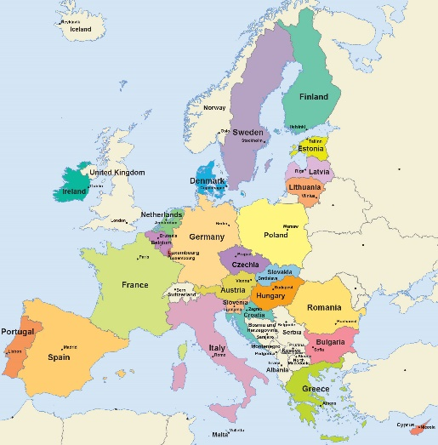 |  | The European Union is a group of European countries  working together to give a better life to the people living in Europe.  We use “EU” as short for “European Union”.  Click here to see which countries are in the European Union.
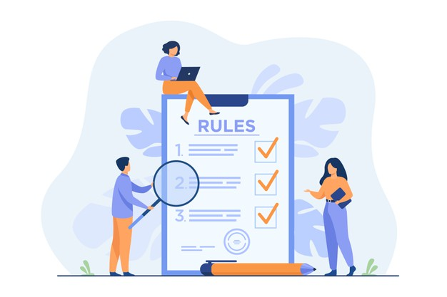 |  | The EU writes laws and takes important decisions.  The work of the EU creates changes  in the lives of people living in Europe.
EDF makes the work of the EU better.
EDF talks to the people of the EU
to make sure they do not forget disabled people.

EDF proposes the EU new laws.
These new laws will make the lives of disabled people better.
For example, EDF worked with the EU on a law
against discrimination.
EDF wants the rights of disabled people to be respected
in all European countries.

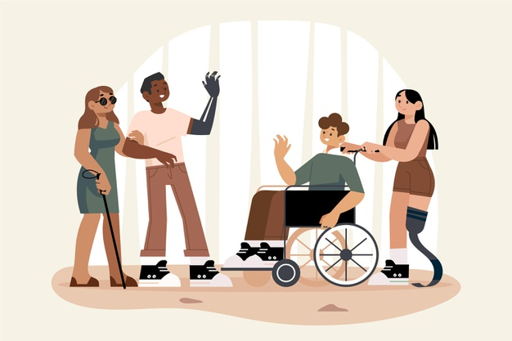 |  | This means that  - disabled people should not be discriminated against anymore
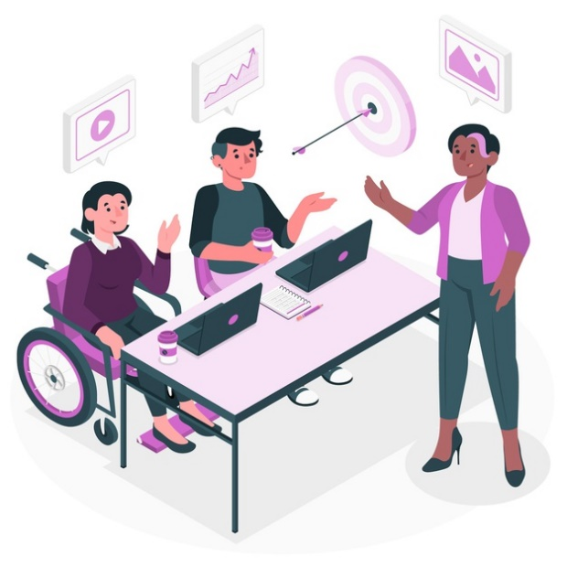 |  | - disabled people have the right to work  - disabled people have the right to make decisions  about their own life
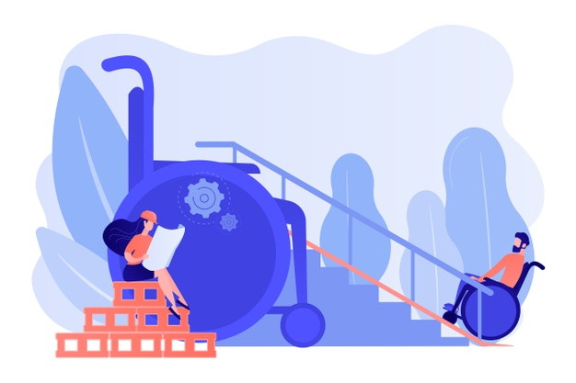 |  | - buildings must all be accessible for disabled people  for example with lifts or ramps for wheel chair users
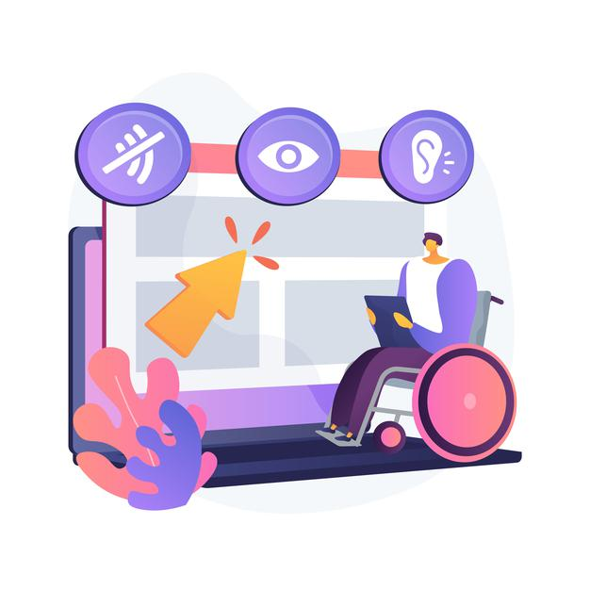 |  | - things like TV, internet and mobile phones  must be accessible for disabled people
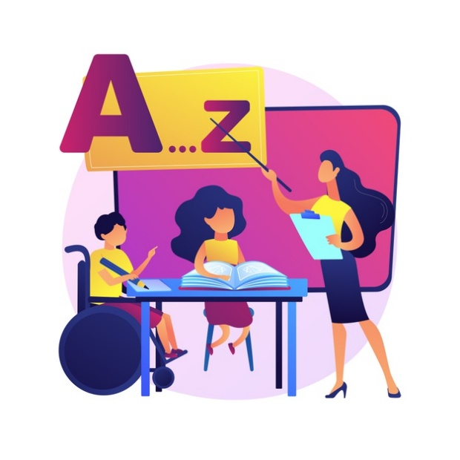 |  | In education,  disabled people have the right  - to good education  - to lifelong learning,  which means learning things during your whole life  - to choose which school they want to go to  - to be able to study abroad
- to get books and material in an accessible format.
This means for example
• books in easy-to-read for people with intellectual disabilities
or
• books read out loud on tapes for people who cannot read.

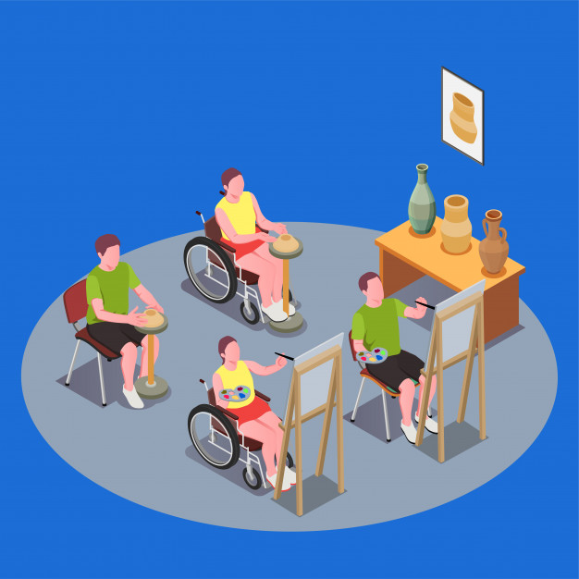 |  | - to ask the teachers to give lessons and material  which are accessible.
In transport, it means that
- all transport must be accessible for disabled people
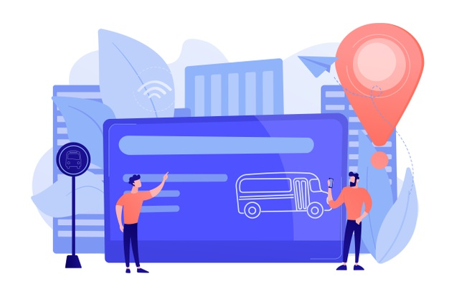 |  | - the information about the time  and about the place of departure and arrival  must be given in an accessible form
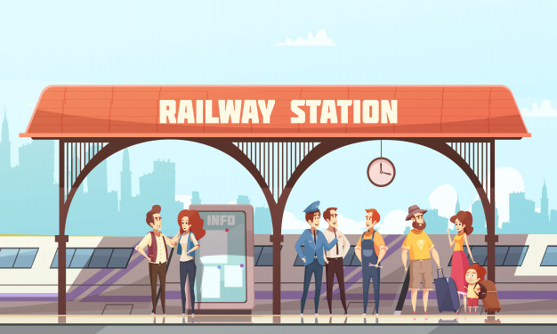 |  | - support staff must be available  to help disabled people when they need it.  For example someone must be available at the station  to help disabled people find the right platform.
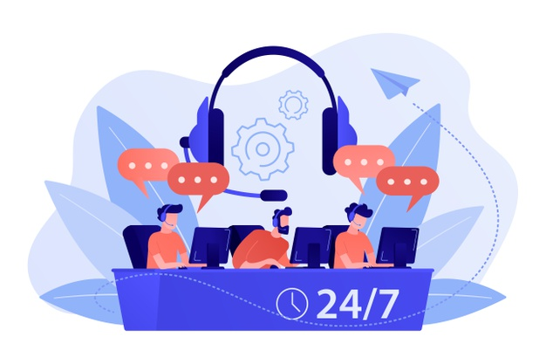 |  | - drivers and all staff working in the transports  need to be trained to speak with and help disabled people

Image credits: Freepik.com

