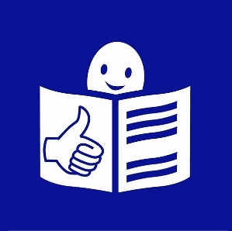

What is EDF?

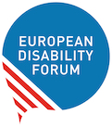 | The European Disability Forum (EDF):  the voice of disabled people in Europe.
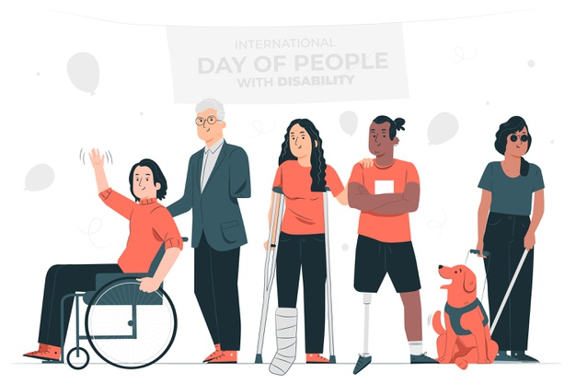 | There are a lot of people with disabilities in Europe.  Over 100 million.
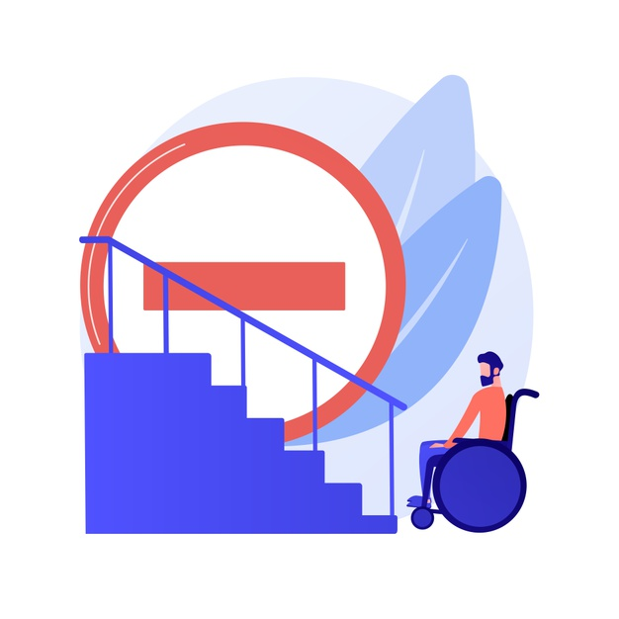 | Many of them still face discrimination  Many of them are still excluded from society.
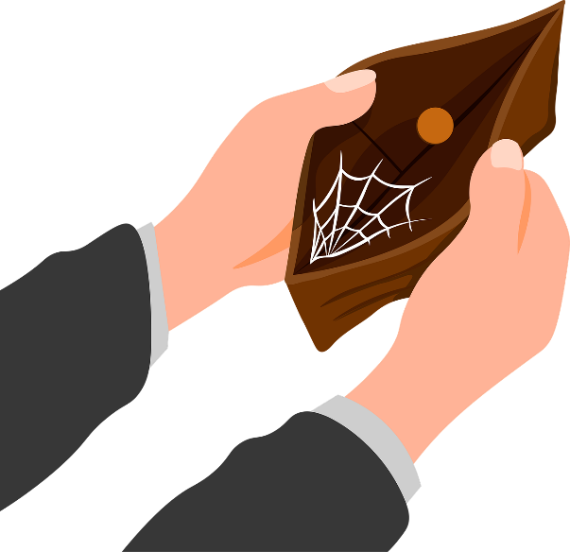 | Many of them often live alone and do not have a lot of money.  This is not right.  It must be changed.
In 1996, some people created an association to change this.
It is called the European Disability Forum.
In short, they call it “EDF”.
EDF was created to bring better life for people with disabilities.
EDF was created to protect the rights of people with disabilities.

EDF is an association of disabled people.
This means that it is run by disabled people themselves.
EDF is run by people with all kinds of disabilities.
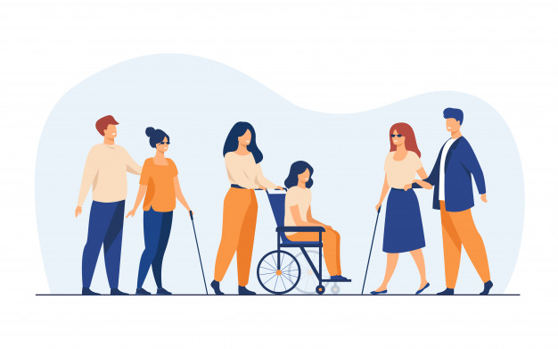 | But people who have severe disabilities are not able to help other disabled people run EDF.  In this case, family members get involved in EDF to represent them.
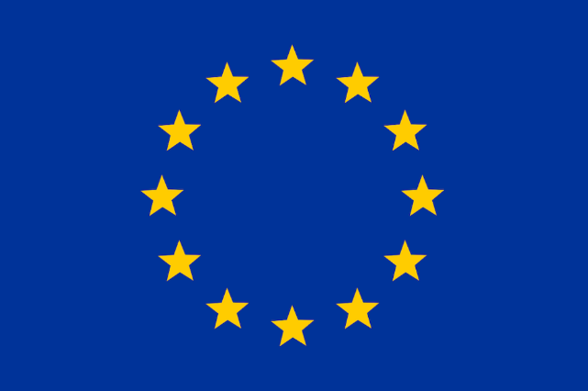 | EDF speaks and works for all disabled people in Europe.  EDF is the link between people with disabilities  and the European Parliament or the European Commission.  EDF makes sure that disabled people are not forgotten,  when new laws are written for all European countries.
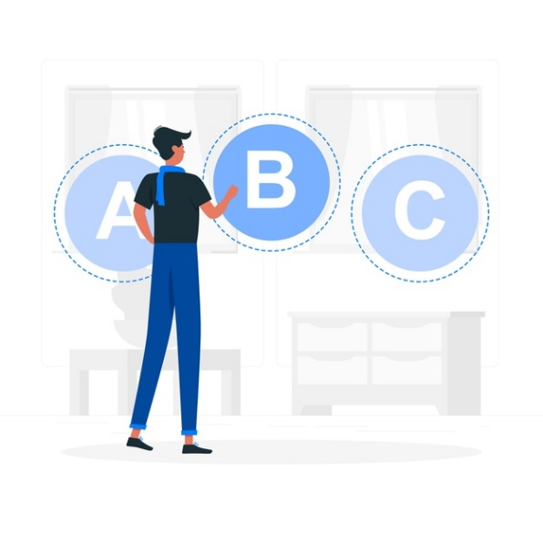 | EDF is independent.  Being independent means you take your decisions by yourself.  Decisions about EDF’s work are taken only by EDF members,  not by anybody else.
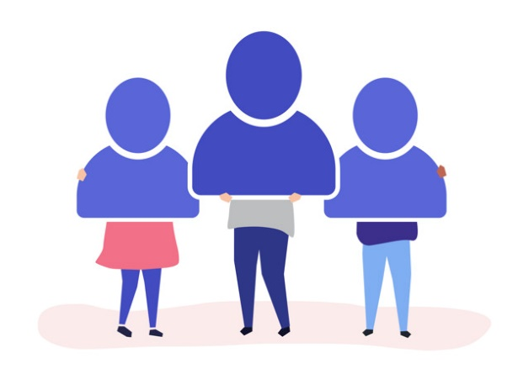 | EDF does not work for the European Union.  EDF works for its members.
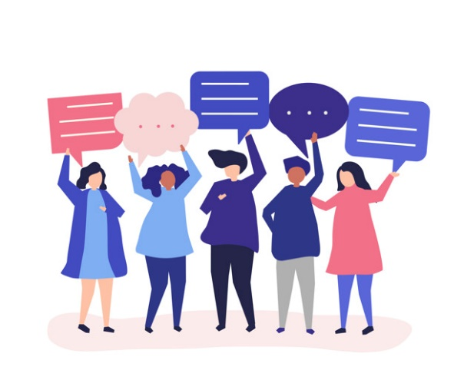 | EDF is also democratic.  This means that all members can have a say.  Decisions are not taken by one person alone.  EDF is working for disabled people.
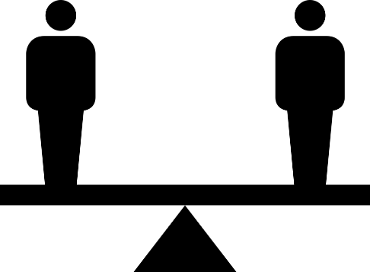 | This means that EDF fights  - For equal opportunities  - To protect the human rights of disabled people
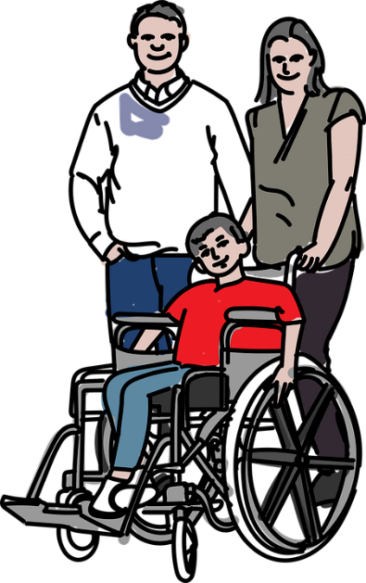 | - To make sure that no decisions about disabled people are taken without them.
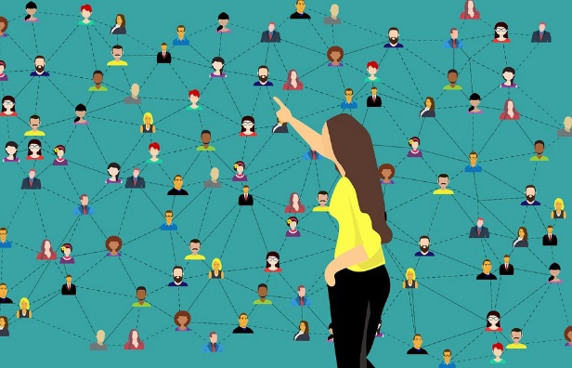 | EDF has 100 members.  EDF members come from all over Europe.  They work with many kinds of disabilities.  Some are big organisations, others are rather small.  Some members are European associations.  Others are national or local associations.
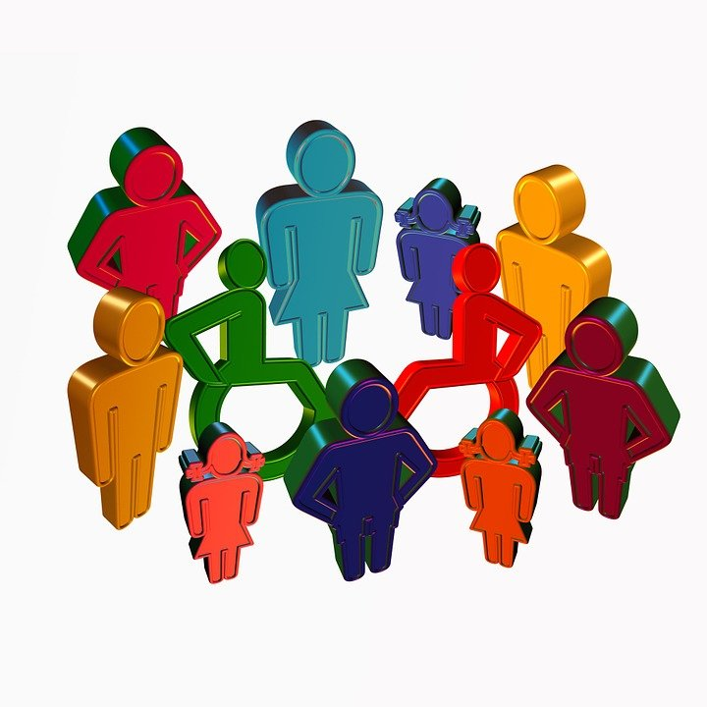 | EDF thinks that disabled people must be included in the society.  Our society would be better in this case.
Image credits:
- People vector created by stories – www.freepik.com
- People vector created by vectorjuice – www.freepik.com
- People vector created by pch.vector – www.freepik.com
- Button vector created by stories – www.freepik.com
- Background vector created by rawpixel.com - www.freepik.com

