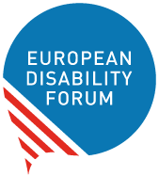

Inclusive vaccination
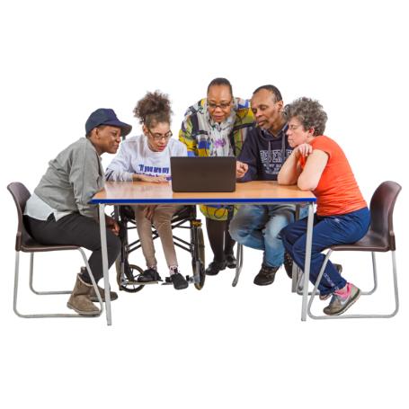 | EDF took part in an online conference called  ‘Sharing good practices for increasing COVID-19 vaccination uptake for socially vulnerable populations in Europe’.
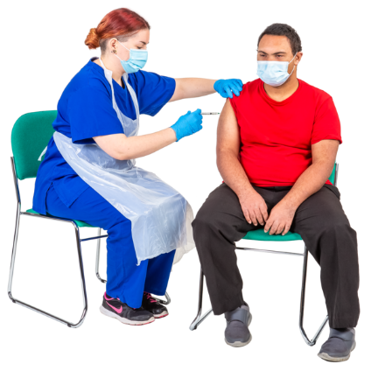 | Many European organisations talked about how they are including people with disabilities in vaccination campaigns.
Easy to Read translation by Naomi Mabita
Checked by Building Bridges
Images: Photosymbols.com

