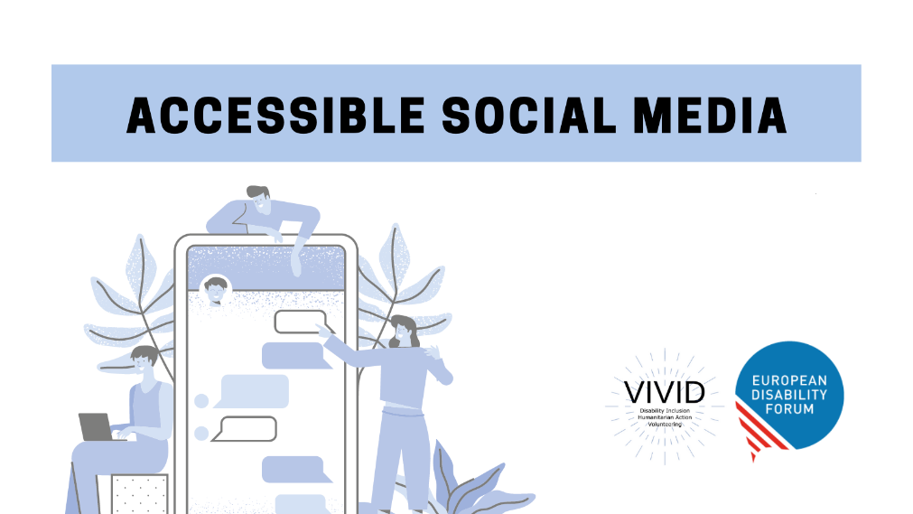

Toolkit

Accessible

Social Media
  - European Disability Forum
  - By Roberta Lulli | July 2021
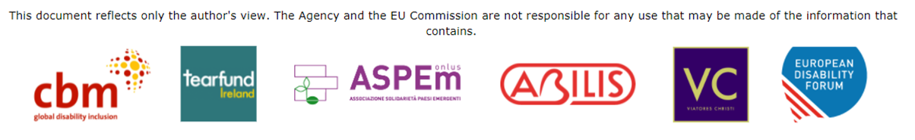
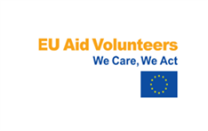 | This publication has received financial support of the EU Aid Volunteers initiative of the European Union. The information contained in this publication does not necessarily reflect the official position of the European Commission.

Introduction
Accessible Social media accessibility is not technically required under the WCAG 2.1 accessibility standards.
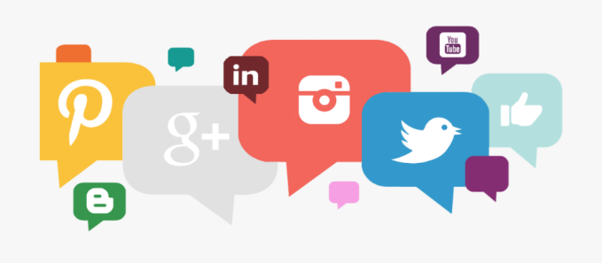
- We can’t change social media platforms
- We can improve the accessibility of the content that we are posting
- We can use the accessible features built directly into social platforms
Accessible and inclusive content is beneficial to everyone.

Is Social Media accessible?

The challenge with social media is that most platforms are not fully accessible. They have made recent accessibility updates.

Facebook Live>Automatic captioning, Alt Text
Instagram IGTV>Automatic captioning, Alt Text
Twitter is mostly accessible, including keyboard accessibility.

Twitter
Twitter is mostly text-based and it is considered the most accessible medium.
- We can send message no more than 280 characters
- Use hashtags # you can create new or existing ones
- Tag people related to the content @
- You can use emojis
- You can add picture, infographics, links to webs and documents

What do tweets look like ?

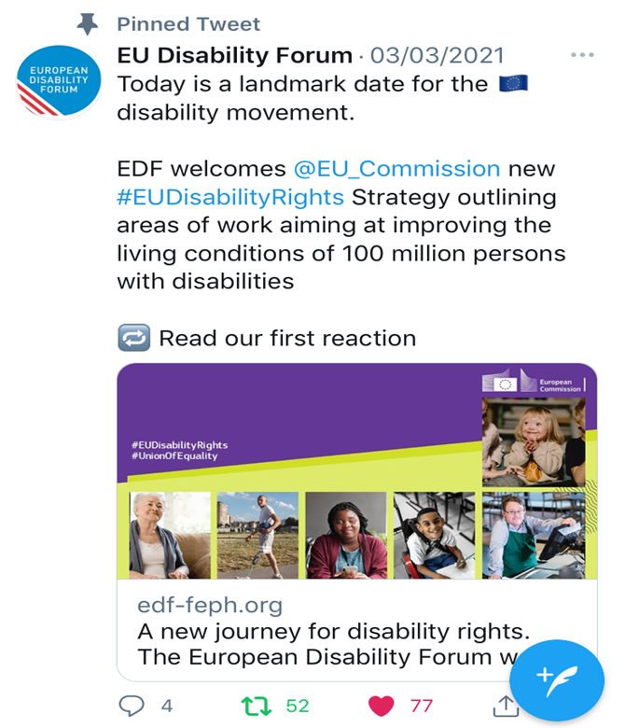

Make your check list!

Make sure everyone can interact with your Tweets

- Make the text accessible
- Alternative Text Descriptions for Images
- Use camel case for multi-word hashtags
- Make your link text short and understandable
- Include video captions

Accessible content
Writing with clarity makes text more accessible and understandable.

- Aim to keep every Tweet focused on one specific message, rather than trying to communicate multiple ideas.
- Simple and plain language: easy to read, understand and use.

Avoid × Better ✔
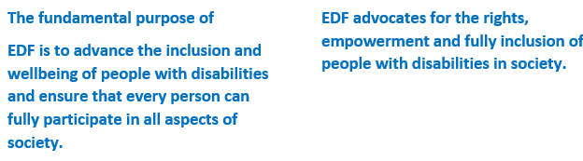

Accessible Fonts

Avoid using online “Fancy text characters”

𝔢𝔵𝔞𝔪𝔭𝔩𝔢: bolder or italic or 𝒸𝓊𝓇𝓈𝒾𝓋𝑒 or different ｃｈａｒａｃｔｅｒ ｓｐａｃｉｎｇ or 𝖒𝖊𝖉𝖎𝖊𝖛𝖆𝖑.
This makes the post unreadable by a screen reader

- If possible, avoid abbreviations or acronyms that would sound strange if read by a screen reader.
Looking FWD: Forward / AFAIK: As Far as I Know

Describe the content
When you post or tweet a hyperlink you can explicitly describe the content you are linking to or featuring in your social media post giving indication (e.g., [PIC], [VIDEO], [AUDIO], [GIF]).
“Thanks to all for joining us on today, looking at human rights-based counter narratives and how best to communicate them. [PIC] https://bit.ly/3fTqb9V“
Did you know… Doing so lets users, including those with screen readers know what to expect before clicking a link.

Add Alternative Text for Images
- In the lower right corner of the image, tap "+ALT”.
- This is the button that lets you add a description to any image that you directly include in a tweet.
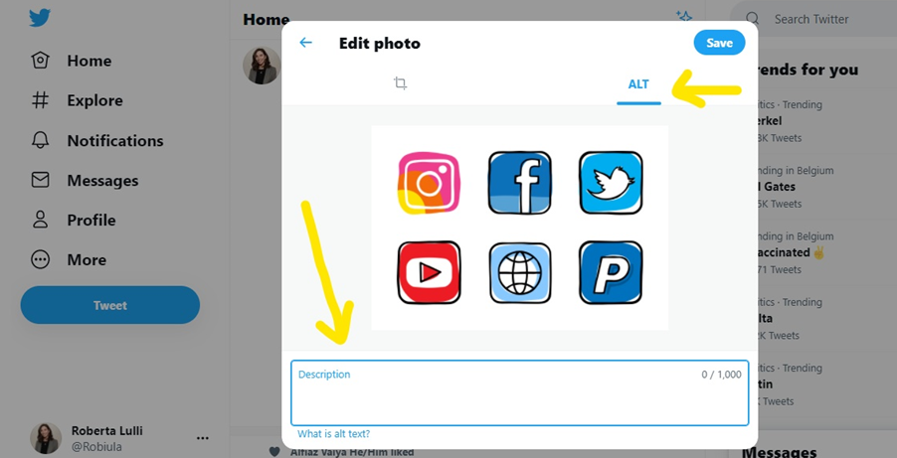

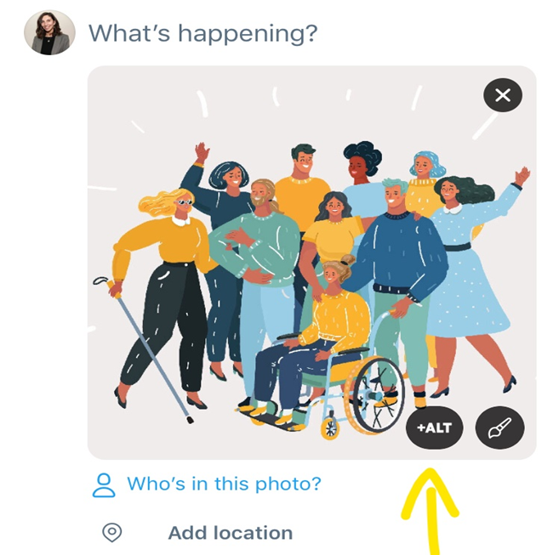

Steps to enable Alternative Text
- Home > More > Setting and privacy:
Accessibility > Vision
Compose image descriptions

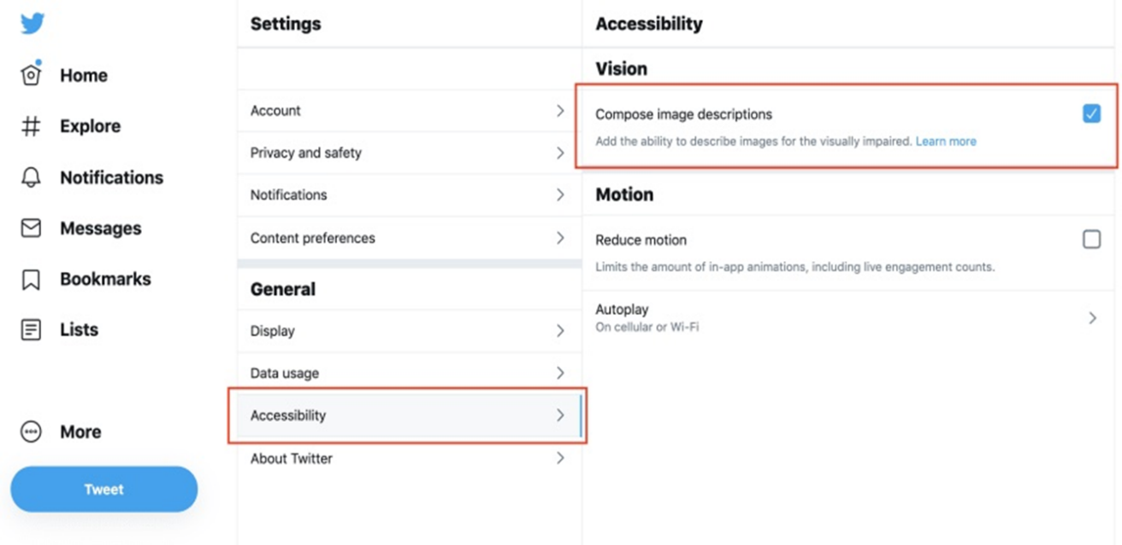

How to add ALT - Text

- To insert descriptive text, click +ALT button.
- Type your description of the image and click the Done button.
- To edit the description, re-open the Add description or +ALT to posting the Tweet. The limit is 1000 characters.
- You can add a description to each image in a Tweet
Note: Image descriptions cannot be added to videos

Did you not… Just adding an Alt-text may not be enough. You can describe the image in the body of the tweet.

Text in Tweet’s image
- If you must include text in your Tweet's image, be sure to add in an alternative text.
- Add info in the main text of the tweet
- Check colours contrast: If your tweet contains an infographic, make sure the colours are well contrasted.
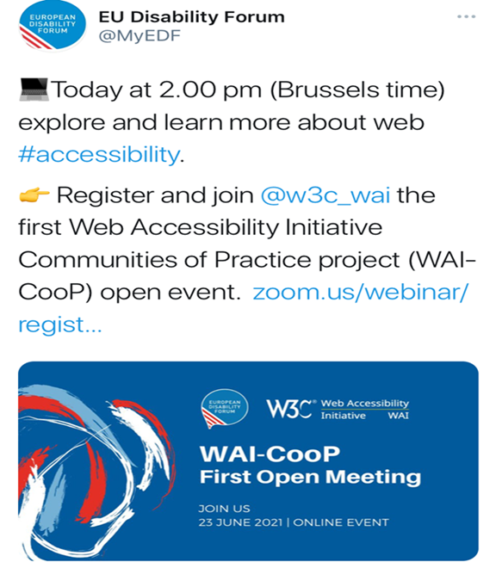

Animated GIFs
Twitter allows alternative text descriptions on GIFs. When you use GIFs add alternative text.
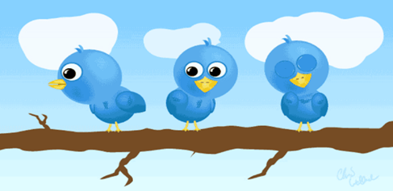
Many users who do not use screen readers may have trouble reading images of text in a GIF that are low-resolution, low-contrast, distorted or only shown briefly.

Emojis and Emoticons
When someone uses a screen reader to read an emoji, they hear the assigned description for that character.
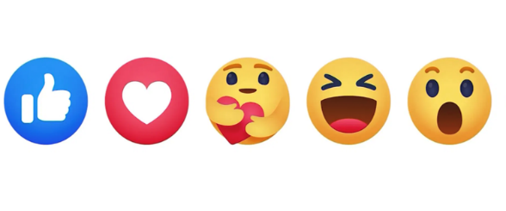
- We can use emojis in small amounts
- Place spaces between them

Did you know…
When creating emoticons with text, consider the experience for screen reader users. Eg. “shrug” ¯\_(ツ)_/¯ will be read by a screen reader as: “Macron, backslash, underline, katakana, underline, slash, macron.”

Using emojis on twitter

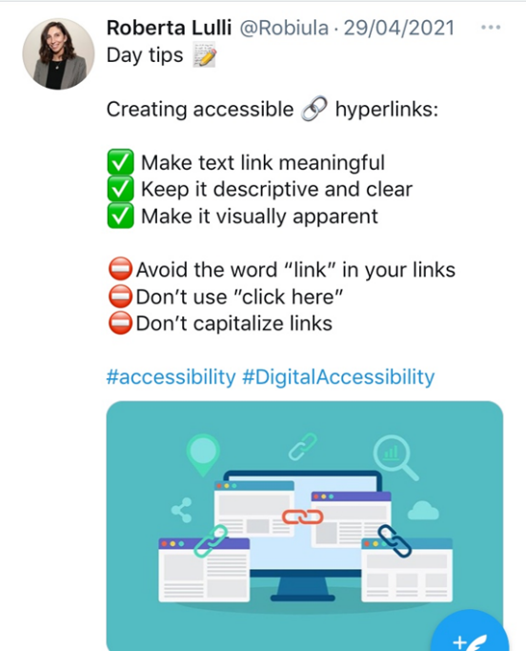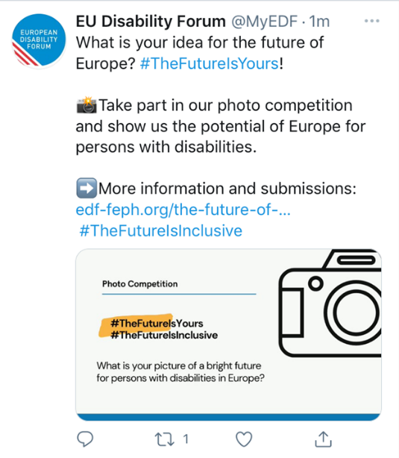

Hashtags #
A hashtag is a label for content. It helps others who are interested in a certain topic, quickly find content on that same topic.
#Disability #Volunteering ~ #Accessibility #HumanRights

- Limit to 1-2 hashtags per Tweet
- Place hashtags at the end of posts if you can

Use CamelCase hashtags
The name comes from the hump or humps that seem to appear in any CamelCase hashtag.

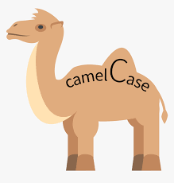
- Capitalising the first letter of each word in a hashtag.
Not lowercase #accessiblesocialmedia
Yes CamelCase #AccessibleSocialMedia

By simply capitalising each word, #AccesibleSocialMedia becomes three words instead of one.

Why CamelCase ?
Camel case is an important accessibility requirement.
- It is good for screen readers users
- As hashtags are all one word, screen readers do not understand that there might be multiple words present.
- When we use CamelCase it is more likely a screen reader will understand that there are multiple words present in the hashtag
- Camel case improves understanding and readability for everyone including people with cognitive disabilities or dyslexia

Use links
- Avoid saying “click here.”
- Use descriptive call-to-actions like: Sign up, Try it for free, or subscribe.
- You can a URL shortener that allows to retain characters
Free URL shortener: Bitly
When you share a link make sure:
your documents, PDF, banners, infographics, videos are accessible!
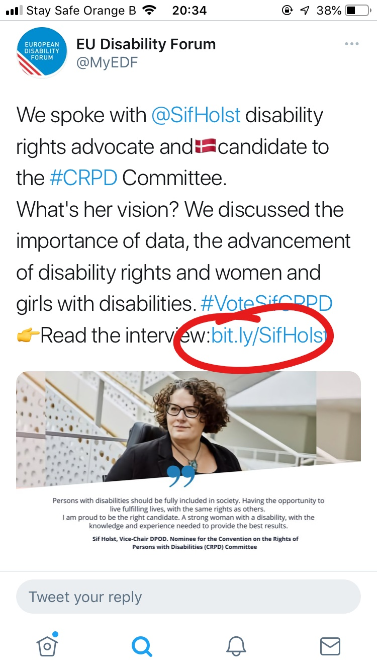

Videos on twitter
Twitter is a great place to add Video even if it performs worse than images.
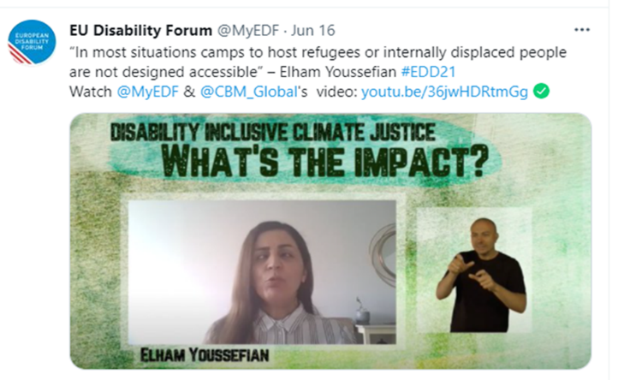
To be accessible a video needs:
- Captions
- Audio description
- Sign language interpretation
There are no features on Twitter that allow you to add audio descriptions or sign language, but apparently it supports the closed captioning available for users who opt into accessibility tools in their settings.

Accessibility Features
Now that you know how to make your social media content accessible and use accessibility features:
- Keep alert for new accessibility features
- Don't forget to regularly check for new accessibility features on the relevant platforms you use.
Follow Twitter Accessibility
@TwitterA11y

Facebook
Make sure your posts, images and videos on Facebook are accessible!

Accessible content
- Don’t overuse hashtags and emoticons.
If you do use hashtags, use camel case.

- Choose background colours wisely.
On text posts, Facebook offers several colourful and decorative backgrounds. Use contrasting colours.

Add alt-text to images
Facebook has a feature that auto-generates a description of images, but the information is typically very vague and sometimes inaccurate.
- You can edit the automatic alt-text and add your description.

Did you know… When sharing an image posted by someone else and you are not sure if the image has already a description you can share it and add a description in the post or add “Description in comments”.

Video captions
Facebook adds automatic captions to videos, as does Youtube, but do not rely on the auto-captioning provided by platforms add you own captions.
- Automatic closed captioning is also available for Facebook Live
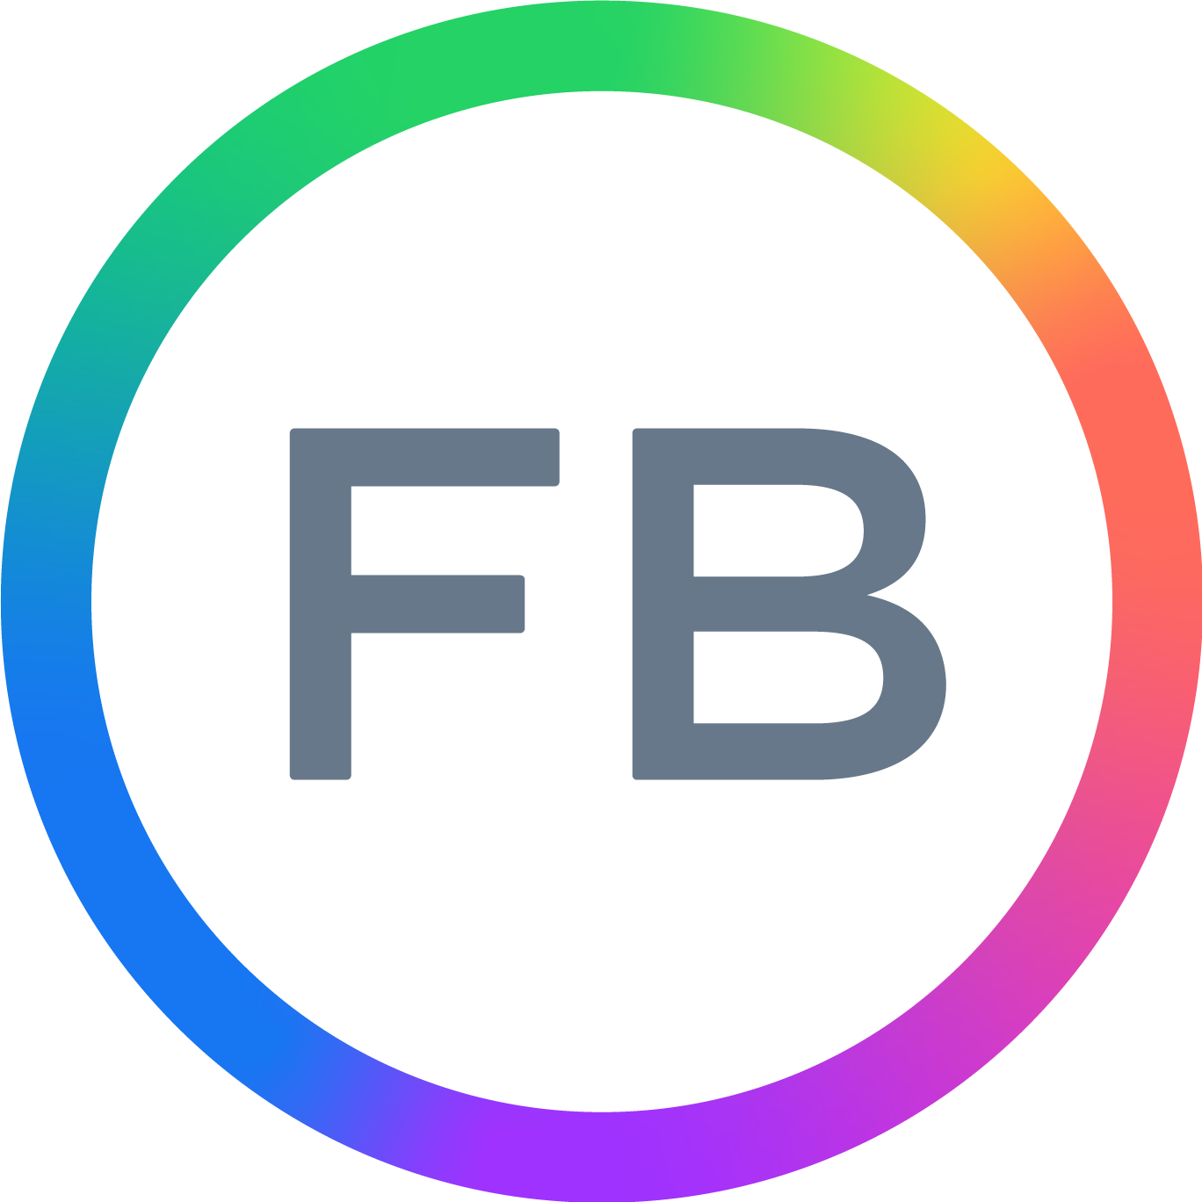 Follow Facebook Accessibility page @accessibility

Supporting Resources
- How to be more accessible on social media, by Siteimprove
- Making Twitter more accessible, Twitter blog
- How to make images accessible for people, Twitter blog
- Inclusive Design for social media, Hootsuite blog
- Making Audio and Video Media Accessible,W3C
- Tools for Promoting Disability Access and Inclusion, Explore Access
- 5 ways to make your tweets accessible, by AbilityNet
- WebAIM contrast checker for testing text colors for accessibility.
- Contrast checker based on Web Content Accessibility Guideline.
- 10 Tips for choosing accessible fonts, by FontSmith
- Effective Alternative Text by WebAIM
- WebAIM contrast checker for testing text colors for accessibility.
- Contrast checker based on Web Content Accessibility Guideline.
- Color Oracle a colour blindness simulator.
- Fonts readability by WebAIM

Roberta Lulli
Digital Accessibility Trainer VIVID-T project
Roberta.lulli@edf-feph.org - Twitter: @robiula
The European Disability Forum
Avenue des Arts 7-8
1210 Brussels, Belgium.
www.edf-feph.org
info@edf-feph.org

