Police Brutality
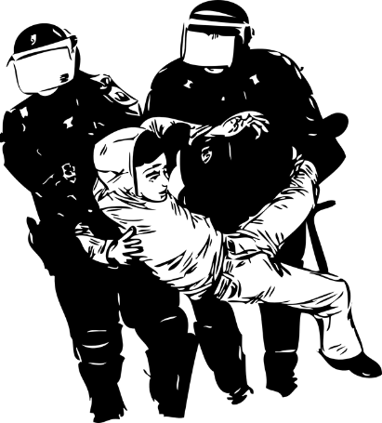 | Police brutality is when police  hurt people they are supposed  to protect.
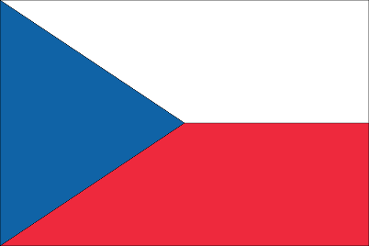 | Stanislav Tomáš was a Romani man in Czech Republic.  He died because of police brutality in June 2021.
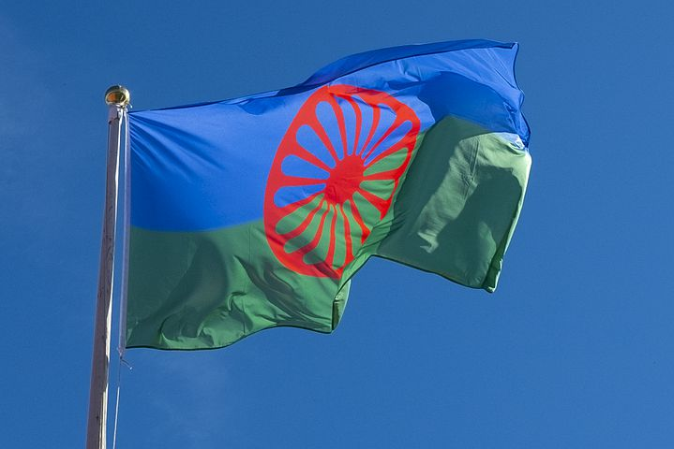 | Romani means he is from the Roma community.  The Roma community are an ethnic minority in Europe.  The Roma community face a lot of discrimination.
 | EDF signed a letter by Roma Grassroots Organisations and other anti-racist organisations.
The letter says the Czech government and the European
Union should:
 | - Investigate what happened to Stanislav Tomáš.
- Punish the police officers who killed Stanislav.
- Protect Stanislav’s family and any witnesses.
A witness is somebody who saw what happened.
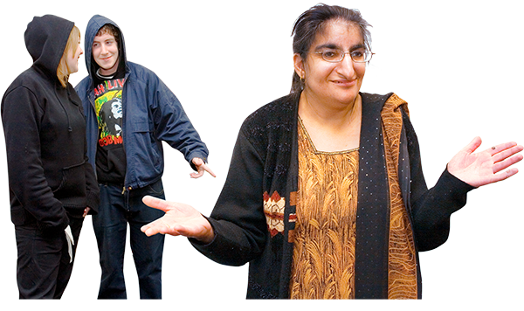 | - Check if this was a racist killing.  Racism is when someone hurts someone else because they are a different race.
The letter also says European institutions should check how police act all over to Europe.
Police brutality must end.

Easy to Read translation by Naomi Mabita
Checked by Building Bridges
Images: Photosymbols.com / freepik.com

