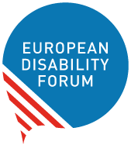

EDF Youth Committee

2020 Annual Report
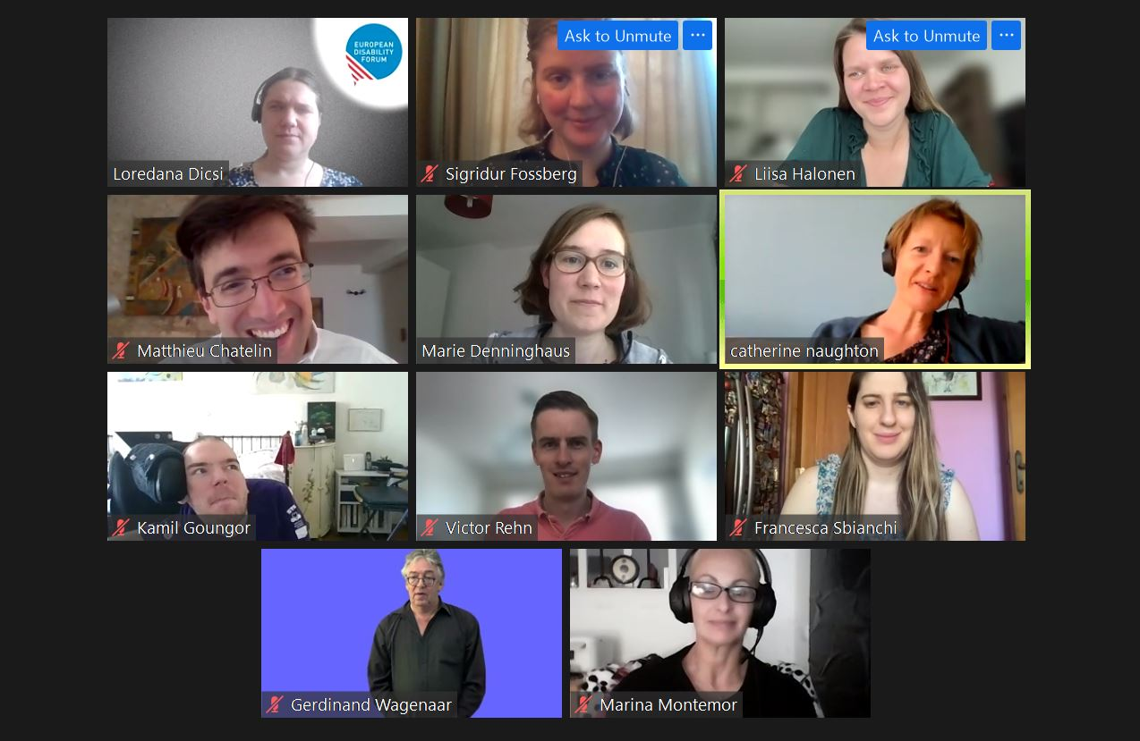
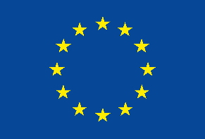 | This publication has received financial support from the European Union. The information contained in this publication does not necessarily reflect the official position of the European Commission.

Table of Contents
Table of Contents 2
Introduction 2
Easy to Read 3
Activities in 2020 5
Representation and Participation of EDF Youth Committee 6
The Youth Committee as a Resource 7
Bringing the Youth Perspective in EDF Work and Policy 7
Publications 8
The EDF Youth Committee 8
Document credits 13

Introduction
For 2020 the youth Committee held its activities under the topic of the Freedom of Movement but in March, Europe entered a never seen before period. The COVID-19 pandemic changed most plans, but never destroyed the dream of freedom of movement, it reinforced it.
The pandemic stopped face-to-face meetings, but it gave the committee more energy and opportunities to be even more active and take the isolation imposed as a moment to reflect and act as soon as possible.
The Committee organised four webinars, three workshops, and two statutory meetings. The Committee also wrote a report on COVID-19, a newsletter on Youth, and messages for Youth Day and the European Day of Persons with Disabilities. Members of the Committee participated in various events.
There was a change in the composition of the Committee: Danny Canal who was representing deaf young people was replaced in March 2020 with Liisa Halonen from the same organisation. Thank you, Danny, and welcome Liisa.

Easy to Read
The EDF Youth Committee is a group of young people with disabilities.
They talk about
- Problems of young people with disabilities.
- How to make things better for young people with disabilities.
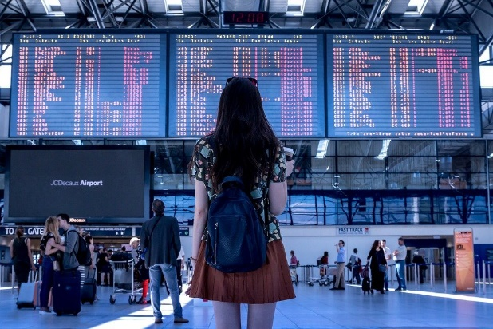 |  | In 2020 the Youth Committee talked about Freedom of Movement.  Freedom of Movement is being able to travel anywhere within the European Union.  All the meetings were online because of coronavirus.
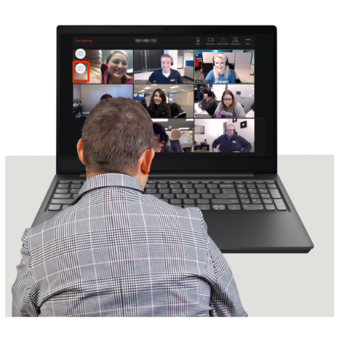 |  | The Youth Committee organised  - 3 talks  - 2 trainings  - 1 meeting at the European Youth Event.  The European Youth Event is a big meeting for young people.  The Youth Committee took part in many European and international meetings.
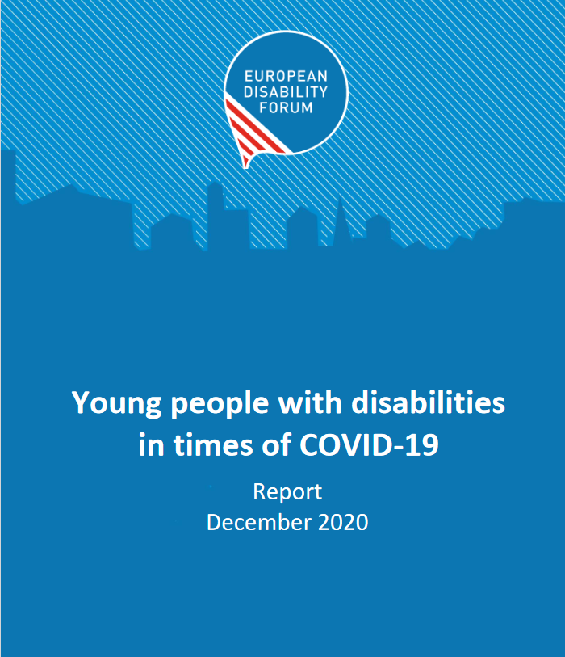 |  | The Youth Committee wrote  - A report about coronavirus and young people.  - A newsletter about young people.  - A message on International Youth Day.  - A message of the European Day of Persons with Disabilities.
 |  | The Youth Committee helped the European Union make new rules.
 |  | If you want more of this document in Easy to Read
+ 32 2 329 00 56 | info@edf-feph.org | You can phone us at  + 32 2 329 00 56  Or email us at  info@edf-feph.org

Activities in 2020
Freedom of Movement was chosen as a topic for several reasons and reflects the two main mobility programmes for young people: the Erasmus+ and the European Solidarity Corps, which were under “construction”. The new regulations were being reformed so the consultations Co-Creating Erasmus+ and European Solidarity Corps took place. The Committee participated at both. Three webinars on the topic with the presence of Commission staff feed in the topic and testimonials from young people who participated in these programmes.
1,4% of students who participated in Erasmus+ were identified as with a disability and 2,55% in the European Solidarity Corps the volunteering programme for young people in the EU. We wanted to know why there was such a low level of participation, and what the new programmes were preparing to support the participation of persons with disabilities.
The pandemic added a layer to the topic, as people were blocked during their mobility, or were not able to go to their mobility place, job loss, inability to attend school, and isolation. This urged the Youth Committee to take a look into the subject and it was clear that the mental health of young people suffered a lot. The Report on COVID-19 on youth gives an idea on the areas where young people were severely affected.
Other activities were organised by the Youth committee that can be considered from three perspectives:
- Representation and participation
- The youth committee as a resource: giving workshops and taking the floor
- Bringing the youth perspective in policy work

Representation and Participation of EDF Youth Committee
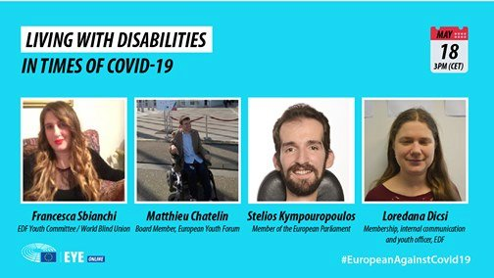
In 2020 the Committee organised or co-organised 5 webinars or online meetings, 2 Committee meetings, 1 face to face event, gave 3 workshops and took the floor in I events. In five of the events high level persons were present, in the webinars on the mobility programmes, Representatives of the European Commission and in two other online events of which one within the European Youth Event EYE2020 MEP Stelios Kympouropoulos was part of the programme.
Below are some of the Important event where the Youth Committee has participated represented by one or more members and often took the floor.
- Webinar on DiscoverEU Initiative of the European Commission with testimonial of a participant, the presence of the Committee Chair Kamil Goungor and a representative of the Commission in charge of the program. There were more than 50 participants.
- Meetings of the Inclusive Mobility Alliance, organised by EDF on 3rd March. And by SIHO on November 24. EDF chaired the first half of the year this group.
- Young People with disabilities in times of COVID-19, within the European Youth Event online version on May 18th . The event was co-organised with the Youth outreach Unit of the European Parliament and Stelios Kympouropoulos member of the European Parliament was part of the event. This event replaced the foreseen activities for the European Youth Event that was to be organised in Strasbourg. There were 15 thousands views 31 shares, 18 comments. The event was live streamed on Facebook as all events within the online European Youth Event.
- Webinar on Erasmus+ on May 14th Organised by EDF, with speaker from the Commission moderated by Loredana Dicsi, Kamil Goungor the Youth Committee chair with 86 participants.
- Online meetings of the Youth Committee on May 28th and November 30th.
- Round table and webinar (to launch statement and recommendation) on COVID-19 children and young people with disabilities Recommendations were endorsed by the Executive and the entire Youth Committee.
- Webinar on the European Solidarity Corps on September 24th with speaker from the Commission and 30 participants.
- European Youth Work Convention Participation of 2 members Sigridur Torlesius and Kamil Goungor, the latter one had the opportunity to speak December 7-10
- Event with International Federation for Spina Bifida and Hydrocephalus (IF) on Disability and Health Sexual Rights 7 December Erika spoke during the event.

The Youth Committee as a Resource
The members of the EDF Youth Committee can provide interventions, trainings or workshops. One of our members and two members of the Inclusive Mobility Alliance (which we are a member of) have invited them to facilitate workshops:
- How to make our activities Inclusive, during a study visit Session organised by OBESU.4 July Loredana Dicsi.
- Training on Independent Living for young people from Croatia with our member SOIH on October 7th more than 50 young participants from Croatia.
- EURODESK Making accessible and inclusive events for young people Liisa Halonen with two EDF staff members gave presentation.

Bringing the Youth Perspective in EDF Work and Policy
The main mission of the Youth Committee is to bring the youth perspective within EDF and within the disability movement in general. Here are some items and publications where the Youth Committee brought its contribution.
- Feedback on social dialogue and resolution of the European Parliament on strengthening the Youth Guarantee.
- EU Disability Rights Strategy
- COVID-19
- DiscoverEU
- Erasmus+
- European Solidarity Corps

Publications
- Messages for the International Youth Day 2020
- Disability Voice 6 Dedicated to youth
- Report on COVID and Young people with disabilities
- Messages from the Youth Committee on the European Day of Persons with Disabilities 1-2 December 2020.
- Video for European Youth Work Convention

The EDF Youth Committee

What is the Youth Committee?
The Youth Committee is an advisory governing body of EDF. It is composed of eight members aged 25 to 35 from all over Europe who represent all categories of disability. It is chaired by one of its members, who is supported by one of the Executive members and by a staff from the secretariat to achieve its plans. The Youth Committee is devoted to representing the interests of young persons with disabilities – within the EDF and throughout Europe.

Members of the Youth Committee
Below you can get to know the members of the Youth Committee.
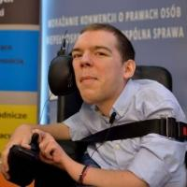 | Kamil Goungor was born in 1988 in Athens, Greece, where he lives. He has studied communication, media and culture. He is actively involved in the Independent Living movement in Greece and abroad, as well as in the fields of disability and youth in general. He is working as the Development Officer of our member ENIL (European Network on Independent Living), and he is a co-founder and board members of i-living, the Independent Living Organization of Greece.
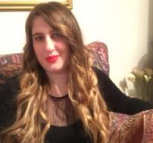 | Francesca Sbianchi was born in 1987 in Assisi, Italy. She is partially sighted and works at the office of the Umbria Regional Government. She has a degree in International Relations. Since 2010 she has been involved as a volunteer in activities regarding low vision and blindness: at national level she is the Chair of the Council of the Italian Union of the Blind and Partially Sighted (UICI) in the Umbria region, being the link person between the UICI Board and the UICI Youth Committee, and as the Coordinator of the UICI International Relations Office. At international level, she represents the EBU at the WBU Youth Committee, and the Italian Disability Forum at the European Disability Forum Youth Committee.
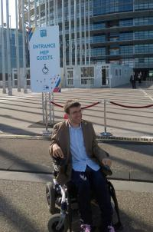 | Matthieu Chatelin is a 28 year old EU Citizen of French Origin who represents the Cerebral Palsy European Communities' Association (unincorporated branch of I.C.P.S). He has a master’s in human Rights and a master’s in International Affairs, Civil Society Development and Conflict Resolution.
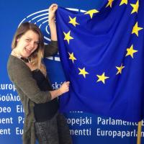 | Liisa Halonen was born in 1989 in Finland. She lives in Ghent in Belgium. She graduated as a Community Educator from the bachelor degree program of Civic Activities and Youth Work. She is working as a Secretary General in the European Union of the Deaf Youth (EUDY). At the age of 3 Liisa was diagnosed as profoundly deaf. When advocating for the rights of persons with disabilities, she always states that the persons with disabilities themselves are the best experts in the disability issues.
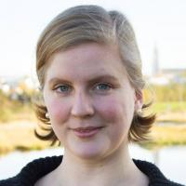 | Sigridur Fossberg Thorlacius was born in 1987 in Reykjavik, the capital of Iceland. She lives in Reykjavik and is a student of culture and web communication. Her motto is "Be open to new experiences, you never know what you might discover!". Sigridur is a human rights activist with a background in education studies, language and culture.
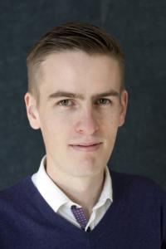 | Victor Rehn was born in Espoo, Finland in 1989 and lives in Helsinki, Finland. He is a master’s student at the University of Helsinki in political science with a focus on social work and social politics. He has been involved in the hard of hearing scene in Finland for a long time and continues to be. Internationally he is involved in the European Federation of Hard of Hearing and the International Federation of Hard of Hearing Young People.
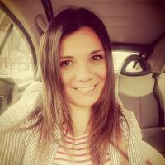 | Erika Becerra is a Designer from Rome based in York, UK. She is a person with autism. Since 2011 she has campaigned for Disability Rights and is a pioneer of the Autistic Pride Movement, establishing in Italy the first Not-for-Profit Self Advocacy organisation for Autism and Learning Difficulties. She joined the EDF Youth Committee in 2012 and takes active part in the discussions of the Forum. Erika Becerra has dedicated her whole life to the Human Rights and the Charitable Causes and is interested in designing new strategies to support the minorities and Solving Poverty. She built her career inter-disciplining visual communication, design, campaign with lived experience working in contact with the Health and Social and Charity Sector. www.erikabecerra.co.uk
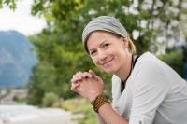 | Dominique de Marné was born in 1986 in Munich, Germany. She is a freelance – Writer and Mental Health Advocate. Dominique was diagnosed with Borderline Personality Disorder, Depression and Addiction in 2013 after living with it for almost half her life. She has since worked hard – alone and with help – and is now on the mission to change how we talk about mental health. Not all disabilities, specialties and impairments are visible, nor are people's wishes and needs – even if they share a diagnosis. Only if we start and learn to talk – AND listen – more openly to one another do we have a chance to initiate change. Communication is the ultimate weapon!

Document credits
This document was prepared by Loredana Dicsi with the contribution of the EDF Youth Committee
Easy to read translation by Naomi Mabita
The European Disability Forum
Mundo Madou
Avenue des Arts 7-8
1210 Brussels, Belgium.
www.edf-feph.org
info@edf-feph.org
This publication has received financial support from the European Union. The information contained in this publication does not necessarily reflect the official position of the European Commission.

