Your rights
in the European Union

Easy to read version

Who are we?
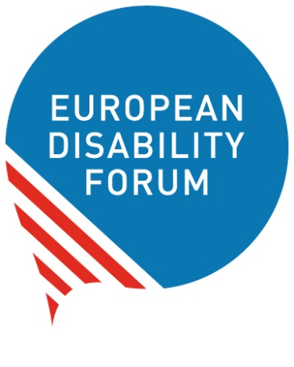
We are the European Disability Forum.
We are an organisation of people with disabilities
in Europe.
In short, we are called ‘EDF’.

At EDF, we work to protect the rights
of all people with disabilities in Europe.
We think that people with disabilities
should have the same chances in life
and take part in the community as everyone else.

We also think that people with disabilities should decide about their lives.
Nothing should be decided about us without us!

What is this booklet about?
We wrote this booklet to talk about
the rights of people with disabilities in Europe.

This booklet can help you learn:

- What the European Union is
and how it works.
- What the European Union does for people with disabilities.
- What stills needs to be done
so that people with disabilities have better lives.
- Who you can contact if you feel that your rights are not respected and that you are treated unfairly.

What is the European Union?
The European Union is a group of 27 countries in Europe.
These countries came together
to make things better, easier and safer for people.
They agreed to work together and help each other.
These countries are:

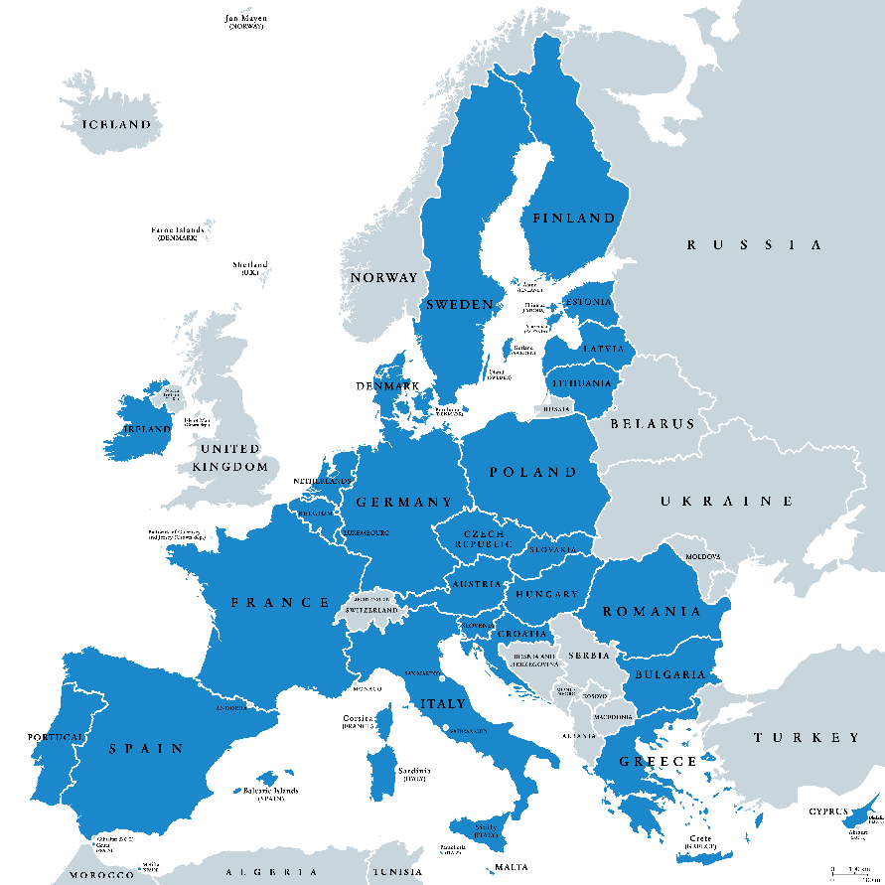
- Austria
- Belgium
- Bulgaria
- Croatia
- Cyprus
- Czech Republic
- Denmark
- Estonia
- Finland
- France
- Germany
- Greece
- Hungary
- Ireland
- Italy
- Latvia
- Lithuania
- Luxembourg
- Malta
- Netherlands
- Poland
- Portugal
- Romania
- Slovakia
- Slovenia
- Spain
- Sweden

How does the European Union work?
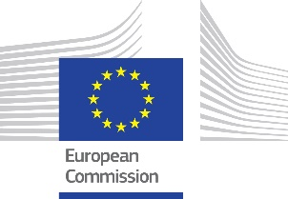
The European Union has 3 main bodies:
- the European Commission
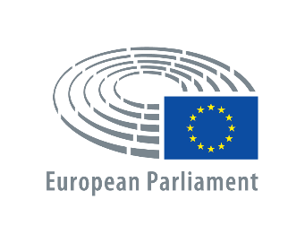
The people of the European Commission
suggest laws for the European Union.
- the European Parliament
The people of the European Parliament
are elected by all people in Europe
to stand for their rights.
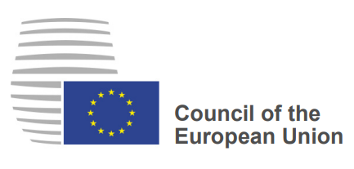
- the Council of the European Union
People who make decisions
in every country of the European Union
come together and make
the Council of the European Union.

These 3 bodies are very important for the European Union.
They work closely together to make things better in Europe:

- The European Commission suggests laws.
- The European Parliament
and the Council of the European Union
discuss these laws and decide if they want these laws
to happen in Europe.
- If they decide that a law must happen in Europe,
all countries of the European Union
must work to make this law happen in them.

How does the European Union protect
people with disabilities?
The European Union must work to protect the rights of all people.
It should protect the rights of people with disabilities too.
It must make sure that they are treated fairly
and they have the same chances in life as all other people.

- The European Union and its countries
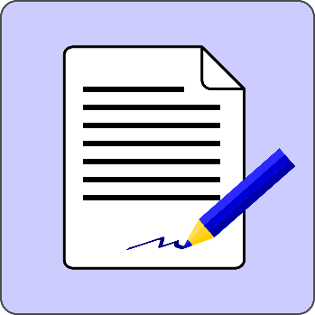
have signed the ‘UN Convention
on the Rights of Persons with Disabilities’.
In short, we call it the ‘UN Convention’.

The UN Convention is a document that says
what rights people with disabilities have
and how countries should protect these rights.

By signing the UN Convention,
the European Union agreed to do what the UN Convention says
to protect people with disabilities.
For example, the European Union agreed to make sure
that all people with disabilities:

- Have the same chances in life as all other people,
- Are not treated unfairly or badly
just because they have a disability,
- Can take part in the community like everyone else.

- The European Union has made an important law
that protects the rights of all people.
This law is called the ‘European Charter of Fundamental Rights’.
This law protects people with disabilities too.
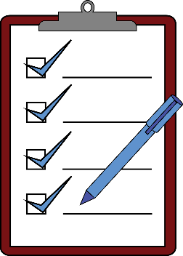
For example, it says that people with disabilities
have the right to:

- Live an independent life.
- Have a job.
- Be part of the community.
- Take part in all things in life
like all other people.

It also says that it is against the law to treat people unfairly
just because they have a disability.

- The European Union makes important plans
in order to better organise its work
on the rights of people with disabilities.
We call these plans ‘Disability Strategies’.
These strategies help the European Union
to plan their work ahead and make things better
for people with disabilities in Europe.
Right now, the European Union is preparing a plan
for the next 10 years.

- The European Union asks its countries
to use the European money for the good of all people.
The European Union gives money to its countries.
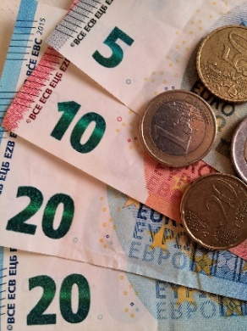
The countries should spend this money
to make schools, streets and other things
that are important for people.

This money is very important
for people with disabilities too.
It can be used to make things accessible
so that people with disabilities can use them.
For example, this money can be used
to make schools, offices, metros, buses and other things accessible. This way people with disabilities can study, work
and take part in life like everyone else.
To get this money from the European Union,
countries should agree to use this money
for the good of people with disabilities too.
They should not use this money for things
that leave people with disabilities out.
They should use this money to make things
accessible for them.

- The European Union has made laws that allow people and things
to move freely among its countries.
We call this ‘Freedom of Movement’.
Freedom of movement means that
all people in the European Union have the right to:

- Move, work, study and live
in any country of the European Union.
For example, a German person can move to France
to study or work.

- Buy and sell things and services in other countries
of the European Union more easily.
For example, a Spanish person can buy a computer from Italy without extra taxes.

- Transfer money, open a bank account or buy a house
in other countries of the European Union.
For example, a French person can buy a house in Greece
and pay the same price as people who live in Greece.

Freedom of movement is a very important right.
The European Union works to make sure
that people with disabilities enjoy freedom of movement too.

In the next pages, you will read
how the European Union tries to make freedom of movement
happen for people with disabilities
and what rights people with disabilities have in the European Union.

Your rights when you travel
Did you ever have problems
when travelling in the European Union?
The European Union has laws that protect you.

For example:

- People with disabilities have the right to get help
when they are travelling by plane, train, boat or bus.
They have the right to get this help for free.
It is better if people with disabilities ask for this help in advance
so that it is ready when they need it.

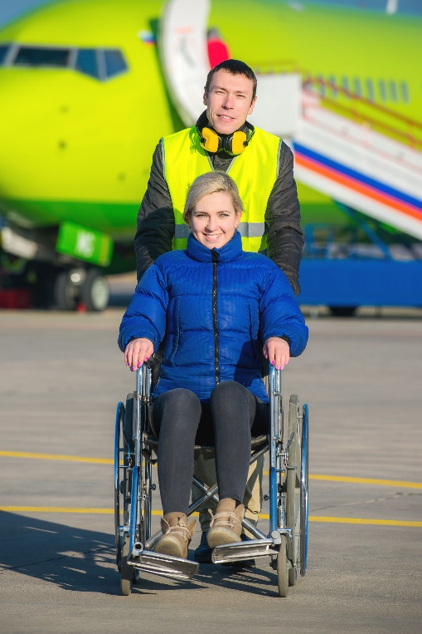
When travelling by plane, boat or train,
people with disabilities should say
they need help 48 hours before their trip.

When they travel by bus,
they should say they need help
36 hours before their trip.

This way,
the air, bus, train or boat companies
have enough time to prepare
and give people with disabilities
the help they need.

If people with disabilities
ask for help at last moment,
companies should still try to help them
but there may not be enough time to do so.

- If your wheelchair gets lost or damaged
by the company you travel with,
the company should pay for the cost to fix it or get a new one.

- Companies cannot refuse people
from entering a plane, a boat, a train or a bus
just because they have a disability.
They can only refuse if travelling could be dangerous
for people with disabilities.

- When you travel by bus or boat,
you can have a person with you to help you.
This person can travel with you for free.

You can find more information
on the website of the European Union here:
https://europa.eu/youreurope/citizens/travel/passenger-rights

Travelling by plane
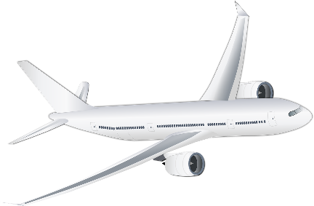
You have certain rights when you travel by plane.

If they don’t accept you in the plane
or if your flight is cancelled
or late for more than 3 hours,
the company should:

- offer you another flight
or
- give you your money back.

In some cases, the company should give you
250 to 600 euros for the trouble you had at your trip.
That happens only if the delay was the company’s fault.
If the delay was due to other problems like bad weather,
the company doesn’t pay you any money.

You can find more information
on the website of the European Union here:
https://europa.eu/youreurope/citizens/travel/passenger-rights/air

Travelling by train
You have certain rights when you travel by train.
If your train is late for more than 1 hour, you can:

- Leave the train and ask the money of your ticket back.

- Take another train without any extra charge.

- Stay on the train and wait.
In this case, you have the right
to get back part of the money you paid for the ticket.
But if the delay was not the company’s fault,
you don’t get money back.

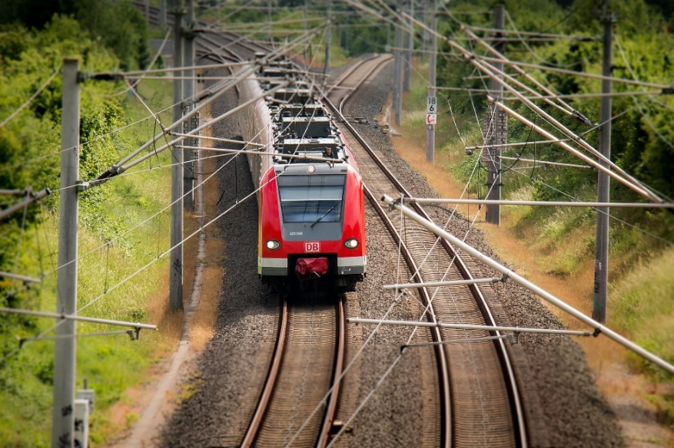

You can find more information
on the website of the European Union here:
https://europa.eu/youreurope/citizens/travel/passenger-rights/rail

Travelling by bus
You have certain rights when you travel by bus.
If you plan to take the bus for a long distance
and it is cancelled or late for more than 2 hours,
the company of the bus should:
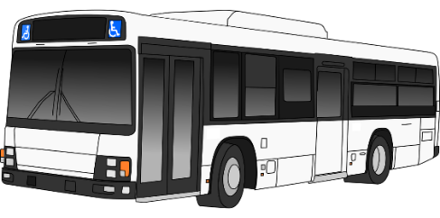
- give you back
the money you paid for the ticket

or
- help you take another bus
with no extra cost.
If the company doesn’t help you with this,
you can make a complaint.
This way, you may get money for the trouble you had.

You can find more information
on the website of the European Union here:
https://europa.eu/youreurope/citizens/travel/passenger-rights/bus-and-coach

Travelling by boat
You have certain rights when you travel by boat.
If you travel by boat and the boat is cancelled
or late for more than 1.5 hour,
the company of the boat should:

- give you back the money you paid for the ticket
or
- help you take another boat with no extra cost.

If you arrive at your destination late for more than 1 hour,
the company should pay you some money for the trouble you had.

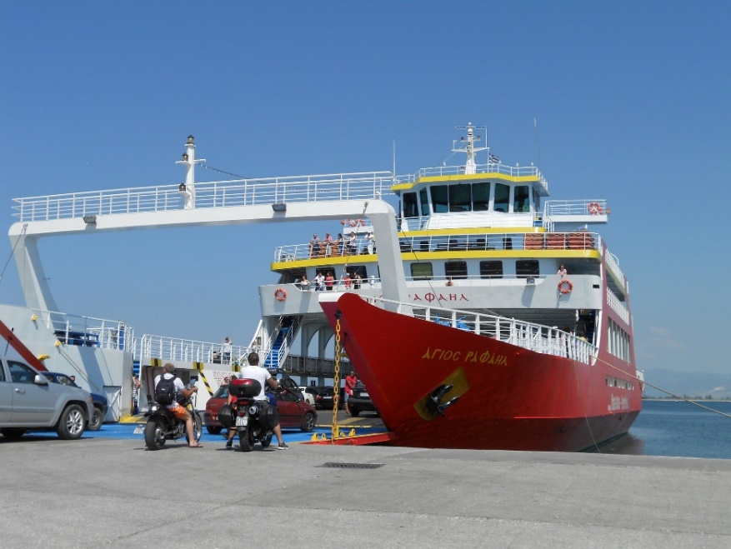

You can find more information
on the website of the European Union here:
https://europa.eu/youreurope/citizens/travel/passenger-rights/ship

The European parking card
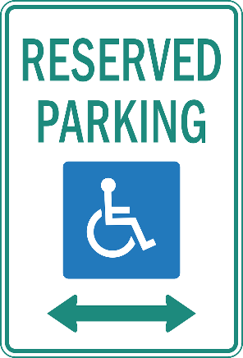
The European Union has made a parking card
for people with disabilities.
With this card, you can have access to parking areas
for people with disabilities in all countries
in the European Union.

You can get your parking card
from the responsible office in your country.
You can find more information
on the website of the European Union here: https://europa.eu/youreurope/citizens/national-contact-points

The right to work
The European Union has laws
that protect the right of people with disabilities to work.

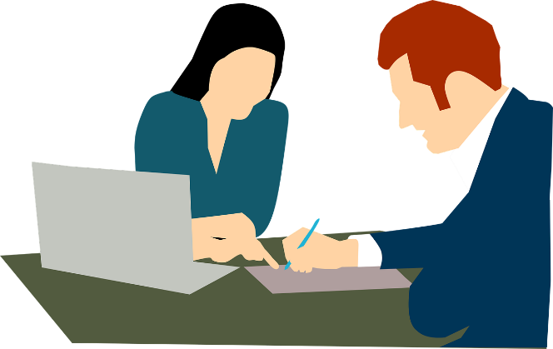

The laws say that people with disabilities have the right to work
like everyone else.
They should not be treated badly or unfairly
just because they have a disability.
Offices and other things should be accessible for people with disabilities.
For example:

- Offices should have ramps
so that people in wheelchairs can go in.

- Blind or deaf people should have access to the right technology
so that they can work without problems.

Also, the European Union makes it possible
to move to another country of it and work there.
You will then have the same rights as the people who live in this country.

You can find more information
on the website of the European Union here:
http://ec.europa.eu/social/main.jsp?catId=25&langId=en

Social security benefits
‘Social security benefits’ means that a country gives money
or other things to people in need.
For example, a country may:

- Give people with disabilities some money
to help them have a better life.

- Give poorer people some money or a house to live in.

- Give money to people who do not have work
or help them find a job.

- Pay for a person who is sick to go to the hospital.

- Give money to older people when they stop working.

These social benefits are really important for all people.
Anyone may need support sometime.
So it is important that all people have access to social benefits.

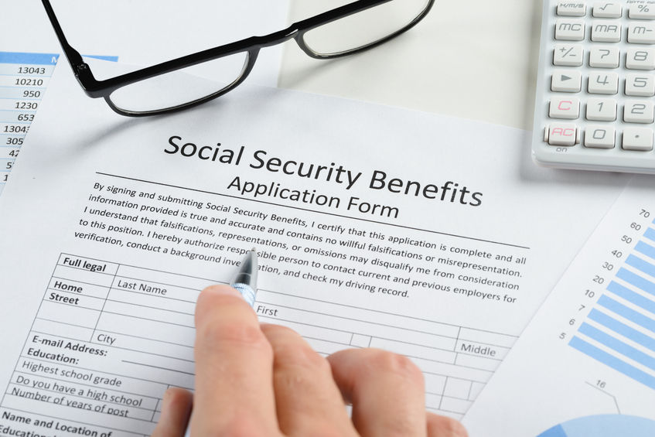

Thanks to the European Union, you can get these benefits
wherever you live in the European Union.
If you move to another country of the European Union,
you have the right to get social benefits from this country
like the people who live there.

You can find more information
on the website of the European Union here:
http://ec.europa.eu/social/main.jsp?catId=849&langId=en

The right to study
The European Union gives people the right to study
at the university of any country in the European Union.
For example, a Belgian student can go study at a university in Romania and pay the same money as students in Romania.

The European Union has programmes that help students go study
in other countries in the European Union.
For example, the ‘Erasmus programme’.
With the Erasmus programme, the European Union
gives money to students to do part of their studies
in another country of the European Union.
This way, students have the chance
to get to know another country and its culture,
meet other students, learn and have a good time.

Students with disabilities should have this chance too.
They can also ask the European Union for more money
if they need to have a support person with them or other kind of help.

You can find more information
on the website of the European Union here:
https://ec.europa.eu/programmes/erasmus-plus/opportunities/individuals/physical-mental-conditions_en

The European Youth Card
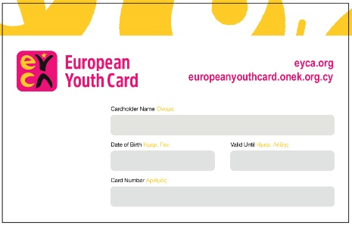
The European Union has made
the European Youth Card.
Young people up to 30 years old
can get this card
and use it in many countries in Europe.
With this card, young people get discounts
in many activities.
For example, they pay less to visit a museum,
eat out or get a place to stay.

You can find more information on this website:
www.eyca.org

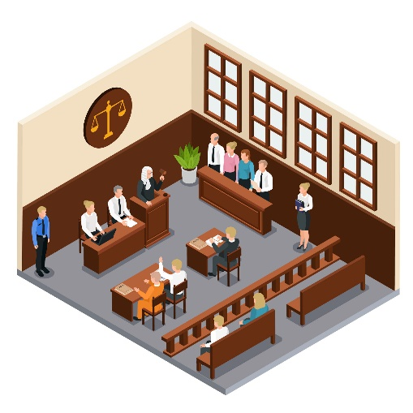
The right to justice
The European Union has laws that protect people who have been treated badly
or unfairly.
These people can go to court and report
the bad things that happened to them.
This way, the court can act to protect them.
In all this process,
people with disabilities and all people
should have the right to:

- Understand all steps and make their point clear.
- Be informed about their rights.
- Get the support they need for free.
- Be safe from the people who treated them badly
and from any other risk.

You can find more information
on the website of the European Union here:
https://ec.europa.eu/info/policies/justice-and-fundamental-rights/criminal-justice/victims-rights_en

People who are taken to court
because they did something against the law,
also have certain rights.
For example, they have the right to:

- Be informed about their rights.
- Have a person to help them understand
if they do not speak the language.
- Have a lawyer to help them make their point clear at the court.

You can find more information
on the website of the European Union here:
https://ec.europa.eu/info/policies/justice-and-fundamental-rights/criminal-justice/rights-suspects-and-accused_en#designingcriminallaw

The right to health care
As a person living in the European Union,
you have the right to health.
That means you can go to the hospital, see a doctor
and buy the medicine you need when you are sick.

If you travel in another country of the European Union,
you have this right too.
If you need to pay for the hospital or the doctor
in another country,
you may get the money back when you go back to your country.

You can find more information about your right to health
on the website of the European Union here:
https://ec.europa.eu/health/cross_border_care/overview_en

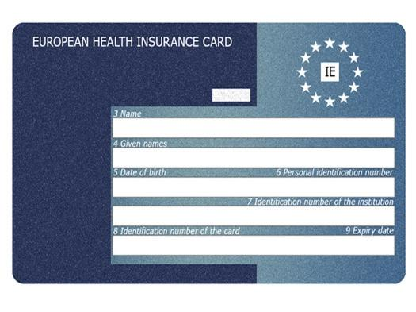
You can also get a free
European Health Insurance Card.
This card is really helpful
if you travel to another country in Europe
and you need to go to the hospital.
With this card, you can go to the hospital
in the same way and with the same cost
as the people who live in this country.
You can ask for this card from your country
through this website:
https://ec.europa.eu/social/main.jsp?catId=563&langId=en#nationalinfo

Buying things from other countries
The European Union protects your rights
when you buy things from other countries of the European Union.
For example, you have the right to:
- Get clear and right information
about the thing you want to buy
and how much it costs.
You should also get this information
in accessible ways that work for you.
For example,
people with intellectual disabilities
should get information in easy to read.

- Buy things at the same price
as the people of this country.
You should not pay more just because
you are from another country.

- Return a thing you bought online and get your money back
if it has a problem.

- Cancel your order or return a thing up to 14 days later.

You can find more information
on the website of the European Union here:
https://europa.eu/youreurope/citizens/consumers/shopping/pricing-payments/index_en.htm

Accessible things and services
Things and services in Europe should be accessible
so that people with disabilities can use them
to take part in the community as all other people.
EDF has been asking the European Union
to make a strong law
that will make things and services accessible
so that all people can use them.

As a result of this work, in 2019 the European Union
made this law happen.
We call this law the ‘European Accessibility Act’.
In the coming years, all countries in Europe should work
to make this law happen in each of them.
If that happens, many things and services in Europe
will become accessible for people with disabilities.
For example:
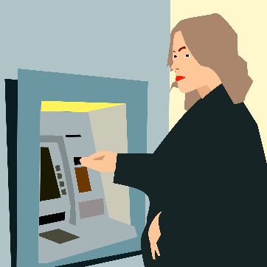
- Cash machines
- Computers
- Televisions
- Ticket machines

You can find more information
on our website here:
http://edf-feph.org/european-accessibility-act-1

Accessible websites
The European Union made a law that says that
public websites in Europe should be accessible.
For example, the website of your hospital or the community you live in should be accessible.

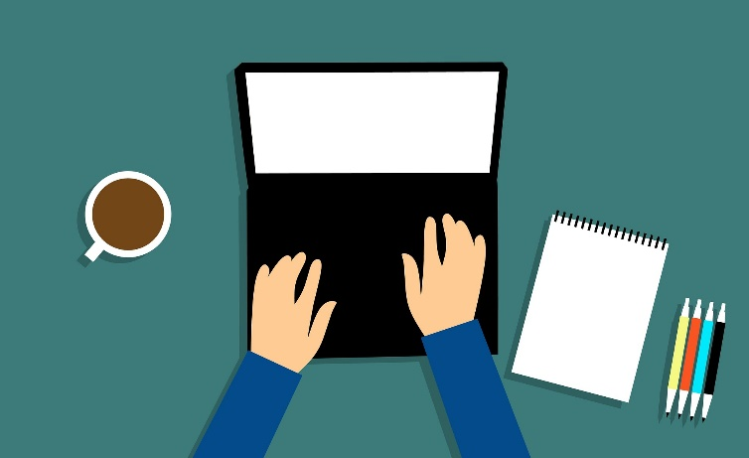

This way, people with disabilities and all people could use them
and find important information.
The law says that public websites in Europe should be accessible
by September 2020.

You can find more information on our website here:
http://edf-feph.org/web

Accessible phones and internet
Today we use different kinds of technology to communicate.
For example, phones and the internet.
This technology should be accessible
so people with disabilities can use it like other people.
For example, blind people may need a system
that reads them the text messages they get on their phone.

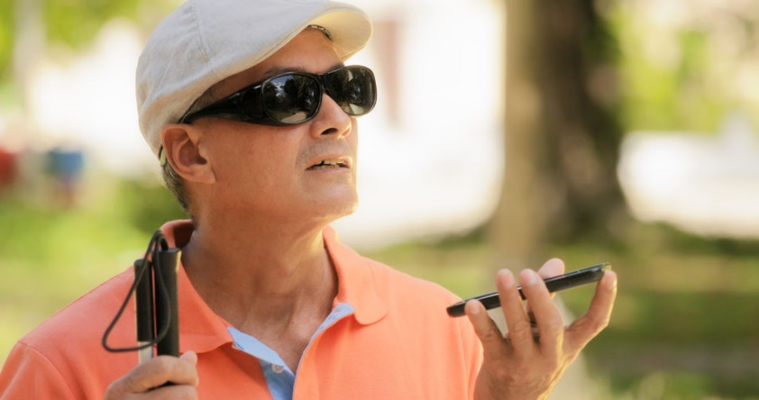

The European Union has laws and rules to make sure that
this technology is accessible so people with disabilities
can use it as everyone else.
In the coming years, all countries in Europe should work
to make technology, like phones and internet, accessible
so people with disabilities can use it.

The European Union has also made a number you can call
from anywhere in Europe if you need to ask for help.
For example, if you have an accident in the street or if you are in danger. This number is 112 and you can call it for free
from anywhere you are in Europe.

You can find more information
at the website of the European Union here:
https://ec.europa.eu/digital-single-market/en/eu-rules-112

Access to television
The European Union works to make sure that
programmes we watch on television or on the internet
are accessible for people with disabilities.
For example, there should be subtitles and sign language
for deaf people and people who cannot hear well.

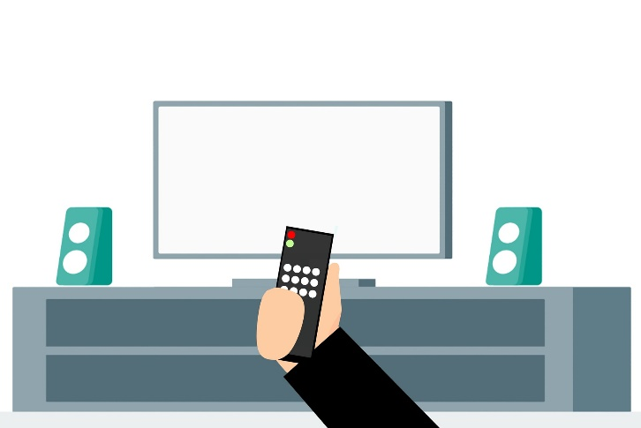

The European Union has made important laws to make these things more accessible for people with disabilities.
All countries in the European Union should respect these laws
and work to make them happen.
If the programmes on television or on the internet are accessible,
people with disabilities can watch the programmes they want
like all other people.
Also, these laws say it is forbidden to make fun or talk badly
about people with disabilities on television programmes.

You can find more information
at the website of the European Union here:
https://ec.europa.eu/digital-single-market/en/policies/audiovisual-media-services

Access to books
Books should be accessible
so people with disabilities can read them too.
Sadly, many books are not accessible and people with disabilities cannot read them like everyone else.

The European Union works to make more books accessible
for people with disabilities.
In 2018, the European Union signed the ‘Marrakesh Treaty’.
This is a text that talks about what countries should do
to make access to books easier for blind people
and other people with disabilities who cannot read.
By signing this text, the European Union agreed to work
to make access to books easier for these people.

You can find more information about the Marrakesh Treaty here:
http://www.euroblind.org/campaigns-and-activities/current-campaigns/marrakesh-treaty

The right to vote
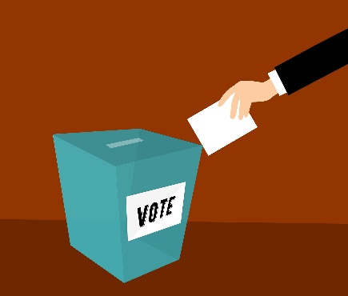
The right to vote is very important.
All people in Europe
should have the right to vote and choose
who will make decisions and laws in Europe.

It is also important to stand for elections.
That means that people can vote
and choose you to make decisions in Europe.

All people with disabilities
should have the right to vote too.
Their voice counts like everyone else’s.

If you live in another country of the European Union,
you have the right to vote or stand for elections in this country
like all other people of this country.
You should not be left out from elections
just because you come from another country.

You can find more information
on the website of the European Union here:
https://ec.europa.eu/info/policies/justice-and-fundamental-rights/eu-citizenship/electoral-rights_en

The European Disability Card
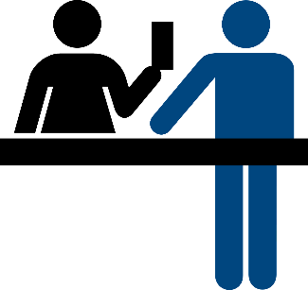
The European Union made
the ‘European Disability Card’.
This card could make things easier
for people with disabilities
when they visit or live in another country
of the European Union.
The card gives people with disabilities
some advantages in culture, sports and other activities.
For example, people with disabilities can use this card
to pay less when they buy tickets for museums
or football matches.
Or people with intellectual disabilities can use this card
and get information that is easy to read and understand.

For the moment, only 8 countries in the European Union use this card:

- Belgium
- Cyprus
- Estonia
- Finland
- Italy
- Malta
- Romania
- Slovenia

That means that the card can be used by people with disabilities
only if they are travelling among these countries.
For example,
a person with disability from Belgium who travels to Italy
can use this card.

You can find more information
on the website of the European Union here:
http://ec.europa.eu/social/main.jsp?catId=1139

Problems people with disabilities still face in Europe
The rights we talked about in the previous pages are very important.
The European Union has done much work to make things better
for people with disabilities.
But there are still many problems that make it hard
for people with disabilities to enjoy their rights as all other people.

For example:

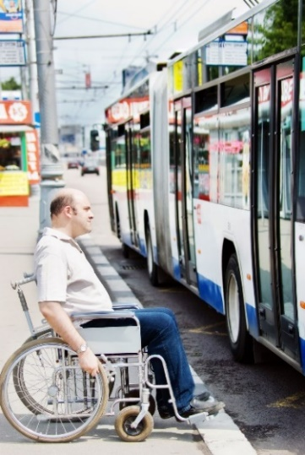
- It is still hard for people with disabilities
to travel to another country
in the European Union to study or work.
This is because many things
are still not accessible
so people with disabilities cannot use them.
For examples, many trains and buses
may not be accessible,
so people with disabilities cannot use them
to move around.

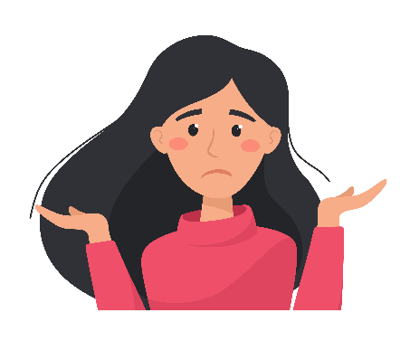
- If you move to another country
of the European Union,
it may be hard
to get the support you need
to have a good life in this country.
This country may take a long time
to recognise that you have a disability
and accept to give you the help you need.

- Some people with disabilities have lost
their legal capacity.
That means that they cannot take decisions
for their lives.
Someone else is taking decisions for them.
They cannot vote in the elections either.
That is really unfair.
All people should have the right to decide for their lives.

- Too many people with disabilities in Europe
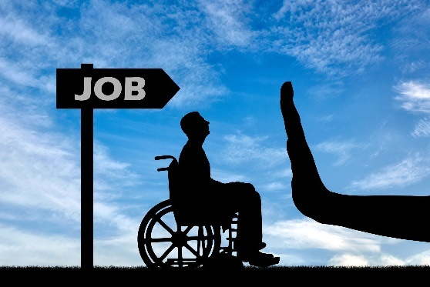
do not have jobs.
Without a job,
it is hard to be independent
and be part of the community.
Things are even harder
for women with disabilities.
But even if people with disabilities
have a job,
they are often paid less
than people without disabilities.
This is unfair.

- It is still hard for people with disabilities
to go to the police or to court
if they are treated badly or unfairly.
That is because too many things
are still not accessible for them
and they may not get the support
they need.
For example,
people with intellectual disabilities
may not get information
in easy to read.
This way, they may not be able
to understand the steps they have to take
to report something bad that happened to them.

- The European Union does not always ask
for the views of people with disabilities
and their organisations,
when they make laws and decisions.
Laws and decisions in Europe
concern people with disabilities too,
so their voices should be heard.
Things that concern the lives of people with disabilities
should be decided together with people with disabilities.
Nothing should be decided about us without us!

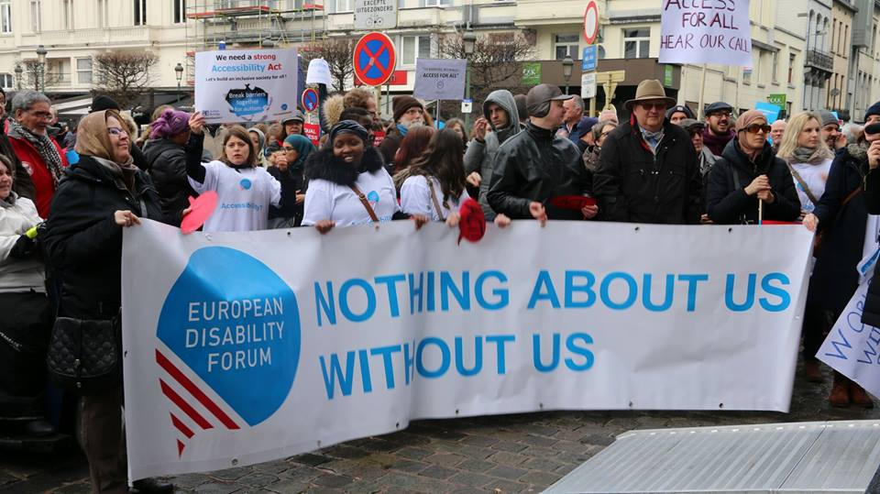

What else should the European Union do
to protect people with disabilities?
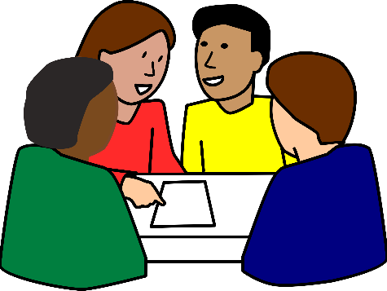
The European Union should:

- Listen to people with disabilities
and their organisations.
Nothing should be decided about us without us!

- Make sure that people with disabilities are treated fairly and have the same chances in life
as everyone else.

- Work to make all things and services in Europe accessible
so that people with disabilities can use them like everyone else.

- Make sure that all people with disabilities enjoy their rights
and have access to health care, jobs, schools and other things.

- Make sure that people with disabilities have social security benefits wherever in Europe they decide to live.

- Make sure that transport like planes, boats, trains and buses
are accessible so that people with disabilities
can travel anywhere they want without problems.

- Make sure that the European money is spent on things
that are accessible for people with disabilities too.

What to do if your rights are not respected
If you feel that your rights are not respected
or that you are treated unfairly,
it is important to raise your voice!

There are many organisations you can send your complaint to.
They can help you deal with the problem you face.

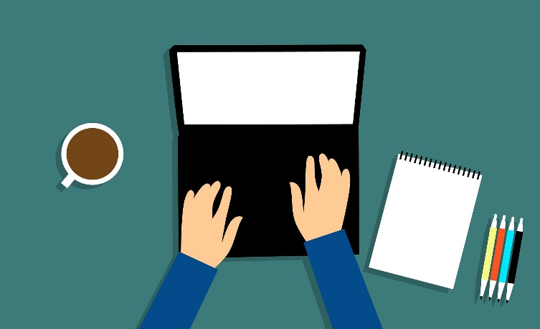

For example:

- You can send your complaint to the people of the European Union by filling this form online here:
https://ec.europa.eu/assets/sg/report-a-breach/complaints_en/
Or you can send your complaint by post in this address:
European Commission
Secretary-General
B-1049 Brussels
Belgium

You can also contact the office of the European Union
in your country.
You can find more information here:
https://ec.europa.eu/info/about-european-commission/contact/local-offices-eu-member-countries_en

- You can contact ‘Equinet’.
‘Equinet’ is an organisation that fights
for the right of all people to be treated fairly.
‘Equinet’ has members in all European countries.
You can find more information on their website here:
https://equineteurope.org/equinet-at-a-glance/#treated-unfairly

- If you have problems while travelling by plain, boat, train or bus,
there are offices in all countries in Europe
that can help you with your complaint.
You can find more information here:
https://ec.europa.eu/transport/themes/passengers/neb_en

- If you find that a public website in your country,
like the website of your hospital or the community you live in,
is not accessible,
you can report it through the website of the European Union here:
https://ec.europa.eu/digital-single-market/en/member-states-bodies-charge-monitoring-reporting-and-enforcement-web-accessibility-directive

- If you buy something online
and you have a problem with the company that sold it to you,
you can ask for help from the European Union
through this website:
https://ec.europa.eu/consumers/odr/main/?event=main.home2.show

- If you feel you are treated badly or unfairly due to your disability, you can talk to the ‘UN Special Rapporteur
on the Rights of Persons with Disabilities’.
This person is working to protect the rights
of all people with disabilities
and may be able to help you with your problem.
You can find more information here: https://www.ohchr.org/EN/Issues/Disability/SRDisabilities/Pages/SRDisabilitiesIndex.aspx

- You can always contact us at EDF.
We can advise you on your rights and help you to find
who to contact when you have a complaint.
You can send us an email at: info@edf-feph.org.
You can also contact our members.
We have members in almost all European countries.
You can find a list of our members here:
http://edf-feph.org/about-us/members/full-member

- If you want to know more about the rights you have
in the European Union
you can check this website here:
https://europa.eu/youreurope/citizens/index_en.htm?cookies=disabled

